[College Name]
[Department]
A PROJECT REPORT
on
SMART CAMPUS SERVICE BOOKING
AND MANAGEMENT SYSTEM
Grove
Submitted in partial fulfillment of the requirements of
[Degree Programme]
Submitted by
Shayaan
Roll Number: [Roll Number]
Under the guidance of
[Guide Name]
[Academic Year]
Report prepared on 14 October 2026.
The figures in this report were captured from the running Grove application.

Contents
Each figure below is a screenshot from the running application.
1. Introduction and Problem Statement
2. Objectives and Scope of the Project
3. Requirement Analysis – Functional and Non-Functional Requirements
4. System Architecture and Technology Stack
5. UI/UX Design – Wireframes and Responsive Layout
6. Frontend Development Using HTML, CSS, JavaScript and React.js
7. Backend Development Using Node.js and Express.js
8. Database Design and Integration Using MongoDB
9. User Authentication, Authorization and Role-Based Access
10. Service Listing, Search, Filtering and Booking Management
11. Payment Integration and Booking Status Tracking
12. REST API Design and Integration
13. Form Validation, Error Handling and Security
14. Admin Dashboard and Analytics
15. Testing and Validation
16. Deployment and Hosting
17. Results, Screenshots and Demonstration
18. Challenges Faced and Solutions Implemented
19. Future Enhancements
20. Conclusion and References

List of figures
Figure 5.1 — Wireframe: service catalog.
Figure 5.2 — Wireframe: reserve a slot.
Figure 5.3 — Wireframe: my bookings.
Figure 5.4 — Wireframe: admin overview.
Figure 6.1 — React home screen.
Figure 6.2 — Service detail and reserve panel.
Figure 11.1 — Sandbox payment form.
Figure 11.2 — Payment receipt.
Figure 14.1 — Admin overview.
Figure 14.2 — Admin services.
Figure 17.1 — Home.
Figure 17.2 — Catalog with a filter.
Figure 17.3 — Service booking.
Figure 17.4 — Payment receipt.
Figure 17.5 — Booking status.
Figure 17.6 — Admin overview.
Figure 17.7 — Admin services.
Figure 17.8 — Admin users.
Figure 17.9 — Mobile layout.

1. Introduction and Problem Statement
A campus offers many bookable things that are not classes: a study room, a lab bench, a court, a clinic minute, a shuttle seat, a seminar hall. When those holds live on paper chits, phone calls, or separate desk registers, two students can be promised the same slot, a paid booking can have no receipt, and the office cannot see which services are actually used. Grove is the Smart Campus Service Booking and Management System built to put that work in one web application.
Grove is a student-and-office product. A visitor can search the catalog without an account. A student can register, reserve a slot, pay in a sandbox when the service has a price, cancel, and review a booking after the office marks it complete. An administrator can maintain the catalog, move bookings through their statuses, suspend accounts, and read totals for bookings, revenue, ratings, and recent activity. The product name shown in the interface is Grove. The full title used in this report is Smart Campus Service Booking and Management System.

The problem the software addresses
The practical problem is coordination under a shared capacity. A service has a location, a duration, a price in Indian rupees, and a list of clock times it is offered. Each time has a capacity. A booking holds one place in one slot on one calendar date. Cancelled bookings must release that place. Free services, such as a clinic consultation or a mock interview in the sample catalog, should confirm without a payment. Paid services should stay pending until a sandbox charge succeeds, and a later cancellation of a paid booking should mark that payment refunded. The office also needs a record that survives a restart and a way to retire a service without deleting the bookings already attached to it.
Grove answers that problem with a React client and an Express API. Accounts are students or administrators. Passwords are hashed with bcrypt. After login the client sends a JSON Web Token in the Authorization header. All campus dates that decide whether a day is still open use the Asia/Kolkata calendar, so the meaning of “today” does not follow the time zone of whatever machine happens to run the server. Money is stored as a whole-rupee amount. The payment module is a sandbox: it checks a card, can decline one specific test number, and writes only the brand, the last four digits, the amount, and a transaction id.

What this report covers
The sections follow the repository: routes, validation, roles, the sample catalog, the API tests, and Docker. Visual sections say what a printout should show and leave a bordered blank for a screenshot pasted later. College, department, guide, roll number, degree, and academic year are blanks because they are not in the software. Demonstration logins are admin@grove.edu / Admin@123 and ananya@grove.edu / Student@123. Other seeded students use Student@123. Those names are sample records, not the author of this report.

2. Objectives and Scope of the Project

Objectives
The project set out to build one campus booking desk that a student can use from a browser and that an administrator can operate without a separate tool. The objectives that the finished software meets are these.
• Let a visitor search, filter, and sort active campus services, and open a service to see its description, price, location, reviews, and remaining seats.
• Register a student, sign that student in, and keep the session as a bearer token for seven days. Registration always creates a student, even if the request body asks for an administrator role.
• Reserve a future slot only when the service is active, the clock time is one of that service’s slots, and the number of non-cancelled holds is still below capacity.
• Confirm a free service at once with payment status not_required, and leave a priced service pending until the sandbox payment succeeds.
• Charge a sandbox card or a campus wallet, refuse a second charge, decline the test card 4000000000000002, and never store the full card number or CVV.
• Cancel a booking by its owner or by an administrator, and mark a paid payment refunded when that cancellation happens.
• Let only an administrator change booking status, create or edit services, and suspend or reinstate accounts.
• Show office totals: bookings by status and category, paid revenue over six campus months, the five most booked services, recent bookings, and recent reviews.
• Prove the API with an automated suite that uses a temporary data file and does not rewrite server/data/db.json.
• Run the API and the built client together with npm, and ship the same process in Docker.

Scope
In scope are client/, server/, the collections users, services, bookings, payments, and feedback, the pages /design and /api-map, and Dockerfile with docker-compose.yml. Development serves the client with Vite on port 5173 and proxies /api to port 4000. In production the API can serve client/dist on the same port.
A live MongoDB server, an online payment gateway, email or SMS, file uploads, and a waitlist are not in this build. Section 8 still specifies the MongoDB collection design for the documents the application already stores. The running build writes those documents to a local JSON file. There is no Mongoose model and no database connection string in the repository.

Users and demonstration accounts
Role | What that person can do | Demonstration login
Visitor | Read the catalog, a service, availability, public reviews, and the API map. | No account
Student | Register, book, pay, cancel own future bookings, review a completed booking, edit profile. | ananya@grove.edu / Student@123
Administrator | Everything signed-in users can read, plus catalog edits, all bookings, status changes, user suspension, and /admin. | admin@grove.edu / Admin@123

Seeded students Rohan Mehta (rohan@grove.edu), Priya Nair (priya@grove.edu), Kabir Das (kabir@grove.edu), and Sara Iqbal (sara@grove.edu) also sign in with Student@123. The seeded administrator is Meera Iyer. Ananya’s sample holds, which the home data is built to show, are an unpaid study-room booking, a paid shuttle seat, and a completed mock interview that does not yet have a review.

3. Requirement Analysis – Functional and Non-Functional Requirements
Requirements below are taken from behaviour implemented in the client pages and the Express routes, and from the cases in server/tests/api.test.js. Each functional item is something the running system does. Non-functional items are constraints the code actually enforces, such as header hardening, request size, password rules, and the rule that a production process will not start without JWT_SECRET.

Functional requirements
ID | Requirement | Where it is enforced
FR1 | Public health check returns ok and the service name grove. | GET /api/health
FR2 | Public metadata lists six categories, departments, slots, booking statuses, currency INR, and public totals. | GET /api/meta
FR3 | Visitors search services by text, category, and price bounds, and sort by name, price, rating, or newest. | GET /api/services and the catalog page
FR4 | A service page shows up to twelve recent reviews and remaining seats for a chosen date. | GET /api/services/:id and /availability
FR5 | A new account is always a student. Email and student ID must be unique. The password hash is not returned. | POST /api/auth/register
FR6 | Login returns a public user and a JWT, or one generic failure if the email or password is wrong. | POST /api/auth/login
FR7 | A suspended account cannot sign in. The message tells the person to contact the campus office. | Login status check
FR8 | A student books a slot with an optional note. HTML in the note is stripped. Past dates are rejected. | POST /api/bookings
FR9 | A full slot returns a conflict. Cancelled holds do not count toward capacity. | heldCount and the booking route
FR10 | Price zero confirms immediately with payment status not_required. Any other price stays pending and unpaid. | POST /api/bookings
FR11 | The owning student pays by card or campus wallet. A declined test card returns HTTP 402. A second payment returns HTTP 409. | POST /api/payments
FR12 | The owner or an administrator can cancel a booking that is not completed. A paid charge is marked refunded. | POST /api/bookings/:id/cancel
FR13 | Only an administrator changes status among pending, confirmed, in_progress, completed, and cancelled. | PATCH /api/bookings/:id/status
FR14 | A student reviews a completed own booking once, with a rating from 1 to 5 and a comment. | POST /api/feedback
FR15 | An administrator creates, replaces, and deletes services. A service that already has bookings is marked inactive instead of removed. | Service write routes
FR16 | An administrator lists and searches users, changes role, and suspends or reinstates, but cannot change their own access. | /api/admin/users
FR17 | The office overview aggregates totals, six months of paid revenue, category counts, top services, and recent activity. | GET /api/admin/stats
FR18 | A signed-in user updates name, department, phone, and student ID, and can change password after the current password matches. | PATCH /api/users/me and /me/password

Non-functional requirements
ID | Constraint | How the build meets it
NFR1 | Passwords are stored only as bcrypt hashes with cost factor 10. | bcryptjs in the auth and user routes
NFR2 | Login and registration are rate limited to 30 requests in 15 minutes, except when NODE_ENV is test. | authLimiter
NFR3 | Browser responses get a Helmet content-security policy, including frame-ancestors none and object-src none. | helmet() in app.js
NFR4 | JSON bodies larger than 200 kilobytes are refused by the parser. | express.json({ limit: '200kb' })
NFR5 | Text fields are trimmed, length-capped, and stripped of HTML tags before they are stored. | cleanText
NFR6 | Card number and CVV are used only for the sandbox check and are not written to the data file. | charge() keeps brand, last4, and transaction id
NFR7 | The API refuses to listen in production if JWT_SECRET is missing. | index.js startup check
NFR8 | The interface remains usable from 980 pixels and from 720 pixels downward. | CSS breakpoints and the wireframe page
NFR9 | Campus “today” follows Asia/Kolkata, independent of the host time zone. | lib/dates.js
NFR10 | Automated tests run against a temporary file and leave server/data/db.json alone. | tests set DB_PATH under the OS temp directory
NFR11 | The project runs on Node.js 20 or newer. The Docker image uses Node 22. | package.json engines and Dockerfile
NFR12 | Unknown API paths return a JSON 404. Unexpected server errors do not leak the exception text. | Final /api handler and errorHandler

Two actors cover the signed-in product. The student actor books and pays. The administrator actor runs the catalog and the office screens. A visitor is an unsigned actor with read access to the catalog. The client also blocks a student from opening /admin and shows the short message “That area is for campus administrators.” The server repeats the role check, so hiding a link is not the access control.

4. System Architecture and Technology Stack
Grove is an npm workspace named grove-campus, version 1.0.0, with two packages: client and server. The root scripts start them together in development, build the client, start the server, run the API tests, and reset the sample data. The client never talks to the data file. Every screen calls the API with fetch. In development, Vite on port 5173 proxies any path that starts with /api to http://localhost:4000, so the browser sees one origin and the token can be sent without a cross-origin setup beyond that proxy. In production, Express serves client/dist itself and the browser calls the API on the same host.

Layers
Layer | Responsibility | Main files
Pages | Routes for home, catalog, booking, profile, wireframes, API map, and the office. | client/src/App.jsx and client/src/pages
Session | Keep the signed-in user, login, register, and logout. | client/src/auth.jsx, token key grove_token
HTTP client | Attach the bearer token, parse JSON errors, and clear the session on 401. | client/src/api.js
HTTP server | Security headers, CORS, JSON parsing, routes, production static files. | server/src/app.js, server/src/index.js
Domain routes | Auth, services, bookings, payments, feedback, profile, admin. | server/src/routes
Rules | Validation, payment sandbox, date helpers, response shaping. | server/src/lib
Documents | Load, cache, and write the five collections. | server/src/db.js and server/data/db.json

A typical booking crosses those layers in order. The service page asks GET /api/services/:id/availability?date=YYYY-MM-DD. The student submits the reserve form. The client POSTs /api/bookings with the bearer token. The booking route checks the role, the date, the slot, and capacity, appends a booking document, and save() writes the whole JSON file. The client then opens /bookings/:id. If the amount is not zero, that page posts /api/payments. The payment route calls charge(), and on success appends a payment document and sets the booking to paid and, if it was pending, confirmed.

Technology stack
Piece | Declared choice | Role in Grove
Runtime | Node.js >= 20; Docker image node:22-alpine | Runs the API and the test runner
HTTP | Express ^4.21.2 | Routes, JSON, static files
Auth hash | bcryptjs ^3.0.2 | Password hashes at cost 10
Token | jsonwebtoken ^9.0.2 | HS256 bearer tokens, seven-day expiry
Headers | helmet ^8.1.0 | Content-Security-Policy and related headers
Abuse limit | express-rate-limit ^8.1.0 | 30 attempts per 15 minutes on credential routes
Config | dotenv ^17.2.3 | PORT, JWT_SECRET, CLIENT_ORIGIN, NODE_ENV, DB_PATH
UI | React ^19.2.0 and react-dom ^19.2.0 | Pages and components
Routing | react-router-dom ^7.9.4 | Browser routes and protected areas
Build | Vite ^7.1.10 and @vitejs/plugin-react ^5.0.4 | Dev server, proxy, production bundle
Process helper | concurrently ^9.2.1 | Runs API and Vite together
Tests | node:test with supertest ^7.1.4 | HTTP assertions against the Express app

The interface is custom CSS, not a component library. Headings use Fraunces and text uses Outfit, from Google Fonts, with Georgia and Segoe UI as fallbacks. The palette is paper (#f7f1e6), navy (#1e3a5f, #0e1c36), and copper. Helmet allows those font hosts and data-URI images. Office charts are CSS bars, not a chart library. Configuration is read from server/.env and a root .env. The example sets PORT=4000, a placeholder JWT_SECRET, CLIENT_ORIGIN=http://localhost:5173, and NODE_ENV=development. If the secret is absent, development uses grove-dev-secret-change-me, and production refuses to start. CLIENT_ORIGIN may be a comma-separated list, and * reflects the request origin. DB_PATH replaces server/data/db.json. Tests set it. Compose instead mounts a volume at /app/server/data.

5. UI/UX Design – Wireframes and Responsive Layout
The visual design is documented inside the product at /design, not only in this report. That page is titled Wireframes. It states that the blocks are the low-fidelity layouts the live screens follow, and that the same regions reflow at tablet and phone widths. The flow printed on the page is: find a service, pick a date and slot, pay if there is a charge, track status, and review when it is complete. Four frames are drawn there: Catalog, Reserve, My bookings, and Admin overview.

What each frame specifies
• Catalog. Filters stay on the left. Cards carry category, place, price, and rating. The live page is /services.
• Reserve. The service story is on the left. Date, slots, and the charge sit in a side panel. The live page is a service detail route.
• My bookings. Each hold is a row with status and payment. Opening it shows the pass and the receipt. The live page is /bookings.
• Admin overview. Totals come first, then revenue and category charts, then the latest bookings and reviews. The live page is /admin.
From 980 pixels upward, filters sit beside the cards, booking details use two columns, and the office keeps a side menu. Under 980 pixels the hero and charts stack and cards become two columns. Under 720 pixels the header collapses to a Menu button, filters and forms stack, office links scroll sideways, and wide tables scroll. Those are the max-width rules in client/src/index.css. The header shows the Grove mark, Services, My bookings when signed in, Admin for administrators, Wireframes, the first name, and Log out. Visitors see Log in and Create account. A skip link targets main. Print styles hide the header, footer, breadcrumb, and noprint controls so a receipt prints without the payment form.
The four wireframes below were captured from the design page.

Figure 5.1 — Wireframe: service catalog.
Captured from the running Grove application.
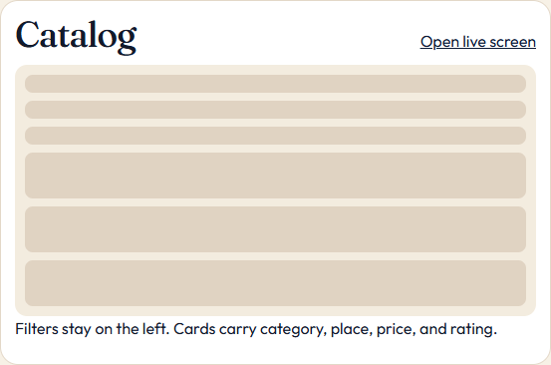

Figure 5.2 — Wireframe: reserve a slot.
Captured from the running Grove application.
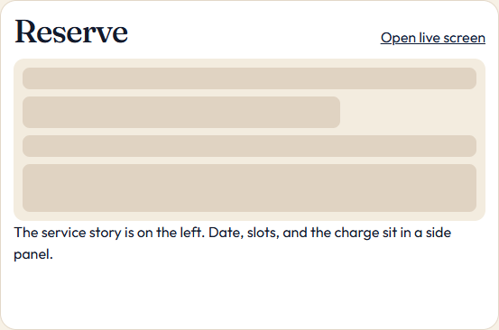

Figure 5.3 — Wireframe: my bookings.
Captured from the running Grove application.
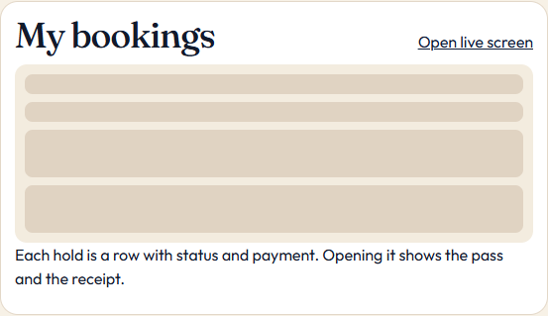

Figure 5.4 — Wireframe: admin overview.
Captured from the running Grove application.
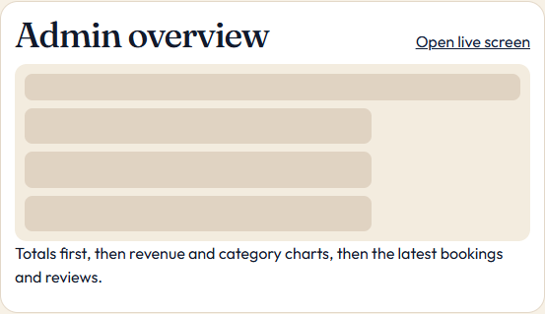

6. Frontend Development Using HTML, CSS, JavaScript and React.js
The client is a React 19 application mounted from client/src/main.jsx. It renders App inside StrictMode, BrowserRouter, and AuthProvider, and it loads index.css. index.html sets the viewport, a description of Grove, theme colour #0e1c36, and an inline SVG favicon. There is no TypeScript and no global state library. Page components keep their own state with useState and useEffect, and the catalog keeps its filters in the URL search string so a filtered link can be shared.

Routes
Path | Screen | Access
/ | Home: hero, category links, three steps, six services by rating | Public
/login | Email and password. Demo accounts are printed on the card. | Public; redirects if already signed in
/register | Student registration. Confirm-password is checked only in the browser. | Public
/services | Search, category chips, price band, sort | Public
/services/:id | Description, facts, reviews, reserve form | Public to view; student to reserve
/bookings | Upcoming, all, completed, and cancelled tabs | Signed in
/bookings/:id | Status track, payment, receipt, cancel, review | Signed in; server checks owner
/profile | Profile form and password form | Signed in
/design | Wireframes | Public
/api-map | Live table from GET /api | Public
/admin | Overview | Administrator
/admin/services | Service table and editor | Administrator
/admin/bookings | All bookings, search, status select | Administrator
/admin/users | Directory, role, suspend | Administrator

Protected waits on the session check, sends an unknown user to /login, and shows the office-only message when the role does not match. Login sends an administrator to /admin and a student to /bookings. Registration opens /services.

How the browser talks to the API
api.js stores grove_token and sends Authorization: Bearer. A 401 outside /api/auth/ clears it. AuthProvider calls GET /api/auth/me on load. Search waits 250 milliseconds. Price bands map to maxPrice 0, 200, or 500, or minPrice 501. Sort is name, price, rating, or newest. A slot with no seats is disabled. Zero rupees is shown as Free. Paste the running home screen and the reserve panel.

Figure 6.1 — React home screen.
Captured from the running Grove application.


Figure 6.2 — Service detail and reserve panel.
Captured from the running Grove application.
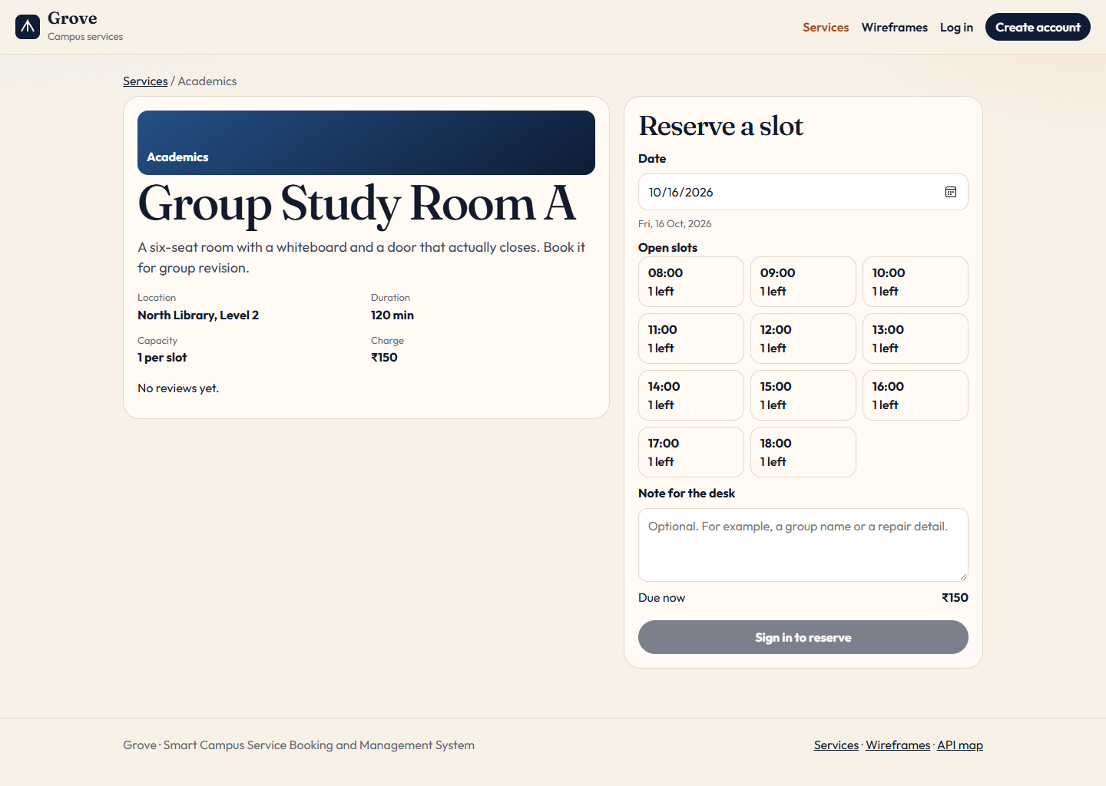

7. Backend Development Using Node.js and Express.js
The API process starts at server/src/index.js. It loads configuration, refuses a production start when JWT_SECRET is unset, calls initDb(), and listens on PORT or 4000. The log line is “Grove API listening on http://localhost:<port>”. The Express application itself is created in app.js so the tests can import it without listening on a port.

Middleware order
In production the app sets trust proxy to 1 so a reverse proxy’s address can be used by the rate limiter. Helmet then sets a content-security policy: default-src and script-src and connect-src and base-uri are 'self'; style-src adds https://fonts.googleapis.com; font-src adds https://fonts.gstatic.com; img-src allows 'self' and data:; object-src is 'none'; frame-ancestors is 'none'. CORS follows, using CLIENT_ORIGIN. express.json rejects oversized and, through the error handler, syntactically invalid JSON. Routes are mounted at /api/auth, /api/services, /api/bookings, /api/payments, /api/feedback, /api/users, and /api/admin. A catch-all under /api returns 404 with “That API route does not exist.” Only when NODE_ENV is production and client/dist exists does Express serve that folder and, for GET and HEAD, fall back to index.html so client routes refresh correctly. The error handler is last.

Route modules
• auth.js registers and logs in a user and returns the current user at GET /me. Credential routes use authLimiter.
• services.js lists, reads, and reports availability publicly. Create, replace, and delete require an administrator. optionalAuth lets an administrator pass includeInactive=1.
• bookings.js lists the caller’s bookings, or every booking if the caller is an administrator. Create requires a student. Cancel is the owner or an administrator. Status change is an administrator.
• payments.js accepts one student charge per booking.
• feedback.js lists reviews for a service publicly. Without a service id, only an administrator receives every review. Creating a review requires the student who owns a completed booking.
• users.js updates the caller’s profile and password.
• admin.js applies requireAuth and requireRole('admin') to the whole router, then serves statistics and the user directory.
asyncHandler forwards rejected promises to the error handler. Malformed JSON is HTTP 400, “The request body is not valid JSON.” Other errors use err.status or 500. A 500 is replaced with “Something went wrong. Please try again.” and logged. Routes usually send their own JSON, with an error string and often a fields map. Identifiers are crypto.randomUUID() strings. initDb seeds only when users is empty, so a restart keeps existing accounts. npm run reset deletes the file and seeds again. The API caches the parsed file, so reset is reliable only when the API is stopped; a live process can write the old cache back on the next save. node --watch restarts on source changes, not when only the JSON file changes.

8. Database Design and Integration Using MongoDB
The logical database is five collections of documents: users, services, bookings, payments, and feedback. Relationships are string ids, not embedded copies. present.js joins them when it builds a response, by finding the service, the user, the latest payment for a booking, and the feedback for a booking. Ratings are not stored on the service. They are the mean of feedback ratings for that service, rounded to one decimal place. A service response also adds reviewCount and bookingCount, the latter excluding cancelled bookings. Those three fields are computed. They are not columns to persist.
This build persists the same documents in a local JSON file, server/data/db.json, so the project runs without a separate database server. The shapes, relationships, and indexes in this section are the MongoDB collection design for integration. The repository does not contain Mongoose models, a MongoDB driver, or a connection string. db.js reads DB_PATH or the default JSON path, keeps one in-memory object, and rewrites the file on save(). A missing file starts as five empty arrays, and initDb seeds sample documents when there are no users. Pointing the same document shapes at MongoDB collections would replace that file without renaming fields or inventing a second schema.

Document shapes
Collection | Fields written by the API | Notes
users | id, name, email, passwordHash, role, studentId, department, phone, status, createdAt | role is student or admin. status is active or suspended. passwordHash is omitted from every API response.
services | id, name, category, description, location, price, durationMinutes, capacity, status, slots, createdAt, updatedAt | category is one of six fixed names. status is active or inactive. slots are a subset of the campus clock times, stored in day order.
bookings | id, userId, serviceId, date, timeSlot, notes, status, paymentStatus, amount, cancelReason, createdAt, updatedAt | date is YYYY-MM-DD. paymentStatus is unpaid, paid, refunded, or not_required. amount copies the service price at booking time.
payments | id, bookingId, userId, amount, method, brand, last4, status, transactionId, createdAt | method is card or campus_wallet. last4 is null for a wallet. No card number, expiry, or CVV field exists.
feedback | id, bookingId, userId, serviceId, rating, comment, createdAt | One review per booking. rating is an integer from 1 to 5.

Relationships and indexes
A booking belongs to one user and one service. A payment belongs to one booking and the user who paid. Feedback belongs to one booking, and it repeats userId and serviceId so a service page can list reviews without scanning bookings. Nothing in the file enforces these links as foreign keys. The routes check them: a missing service is a 404, a booking for an inactive service is refused, and a review for an unknown booking is a 404. Deleting a service that already has bookings does not cascade. The service stays, with status inactive, so old bookings still resolve a name and a location.
If these collections are created in MongoDB, the indexes that match the queries already in the routes are: a unique index on users.email and on users.studentId; an index on services.status and services.category; an index on bookings.userId; a compound index on bookings.serviceId, bookings.date, and bookings.timeSlot for the capacity count; an index on payments.bookingId; a unique index on feedback.bookingId; and an index on feedback.serviceId. A text index on service name, description, location, and category would correspond to the catalog search, which today is a case-insensitive substring over those four strings. These indexes are a design for the integration. This build does not create them, because it does not open a MongoDB server.

Example documents
The following documents use obvious example ids. Live ids are random UUIDs from crypto.randomUUID(). The password hash is shown as a placeholder; a real value is a bcrypt string and is never returned by the API. The card example records only the last four digits of a successful sandbox charge.
{
"id": "user-ananya",
"name": "Ananya Rao",
"email": "ananya@grove.edu",
"passwordHash": "<bcrypt hash of Student@123>",
"role": "student",
"studentId": "CS26AN01",
"department": "Computer Science",
"phone": "9845001001",
"status": "active",
"createdAt": "2026-10-14T09:00:00.000Z"
}

{
"id": "service-study-a",
"name": "Group Study Room A",
"category": "Academics",
"description": "A six-seat room with a whiteboard and a door that actually closes. Book it for group revision.",
"location": "North Library, Level 2",
"price": 150,
"durationMinutes": 120,
"capacity": 1,
"status": "active",
"slots": ["08:00", "09:00", "10:00", "11:00", "12:00", "13:00", "14:00", "15:00", "16:00", "17:00", "18:00"],
"createdAt": "2026-10-14T09:00:00.000Z",
"updatedAt": "2026-10-14T09:00:00.000Z"
}

{
"id": "booking-study",
"userId": "user-ananya",
"serviceId": "service-study-a",
"date": "2026-10-16",
"timeSlot": "10:00",
"notes": "Group revision for the networks quiz.",
"status": "pending",
"paymentStatus": "unpaid",
"amount": 150,
"cancelReason": "",
"createdAt": "2026-10-14T09:00:00.000Z",
"updatedAt": "2026-10-14T09:00:00.000Z"
}

{
"id": "payment-shuttle",
"bookingId": "booking-shuttle",
"userId": "user-ananya",
"amount": 40,
"method": "campus_wallet",
"brand": "Campus wallet",
"last4": null,
"status": "paid",
"transactionId": "GRV-WLT-EXAMPLE-AB12CD",
"createdAt": "2026-10-14T09:00:00.000Z"
}

{
"id": "feedback-lab",
"bookingId": "booking-lab",
"userId": "user-ananya",
"serviceId": "service-cs-lab",
"rating": 5,
"comment": "The machine was imaged correctly and I finished the lab without switching seats.",
"createdAt": "2026-10-06T08:30:00.000Z"
}

9. User Authentication, Authorization and Role-Based Access
Authentication is a bearer JWT. signToken puts the user id in the sub claim and the role in the role claim, signs with JWT_SECRET, and sets expiry to seven days. requireAuth reads the Authorization header, requires the prefix “Bearer ”, verifies the token, and loads the user. A missing header returns 401 “Sign in to continue.” A bad token, a missing user, or a user whose status is not active returns 401 “Sign in again to continue.” The object attached to the request is the public user: toPublicUser deletes passwordHash before the rest of the document is copied. optionalAuth used by the catalog and the feedback list does not fail when the header is absent or invalid; it simply leaves req.user empty.

Passwords and registration
Registration accepts name, email, password, studentId, department, and phone. The department must be one of Computer Science, Electronics, Mechanical, Civil, Management, Sciences, Humanities, or Administration. The client’s registration form hides Administration, because that department is used by the seeded office account, but the API still allows it if a caller sends it. The role on the stored user is the literal student. The test “rejects a weak password and ignores a forged admin role” posts role admin and asserts that the saved role is student, that the student id cs26neel is stored as CS26NEEL, and that passwordHash is absent from the JSON.
The password rule is 8 to 72 characters with at least one lowercase letter, one uppercase letter, and one digit. bcrypt’s practical input limit is 72 bytes, which is why the validator stops there. Hashes use cost factor 10. Login looks up the email and compares the password with bcrypt. If the email does not exist, the compare still runs against a placeholder hash created at startup, so the failure does not skip the hash work and the response stays “Email or password is incorrect.” A matching password on a suspended user returns 403. Changing a password requires the current password, a new password that passes the same rule, and a new value that differs from the current one. That route is rate limited with the same limiter as login and registration.

Authorization
requireRole returns 403 “You do not have access to that action.” It guards service writes, booking creation, payments, reviews, booking status, and the whole admin router. A student can read, pay, review, or cancel only that student’s own bookings. An administrator can read and cancel any open booking, but cannot book or pay. PATCH of the caller’s own user returns 409 “You cannot change your own access.” The token lives in localStorage, not an HttpOnly cookie. The content-security policy limits scripts to 'self'. Logout deletes the local token only; the JWT stays valid until expiry or suspension. Every authenticated request reloads the user and rejects a status other than active, so suspension works before the token expires.

10. Service Listing, Search, Filtering and Booking Management
The catalog query accepts q, category, sort, minPrice, maxPrice, offset, and limit. q is cleaned to 80 characters and matched, case-insensitively, against name, description, location, and category. An unknown category or sort is HTTP 400. Price bounds must be whole numbers from 0 to 100000. Inactive services are hidden unless the caller is an administrator and includeInactive is 1. The default page size is 50 and the maximum is 100. The response is { services, total, limit, offset }. The React catalog does not send offset, because the seeded catalog has fourteen services and fits in the default page. Sort by rating places unrated services last. Sort by newest uses createdAt. Name is the default.

Availability and the booking write
Availability requires a real ISO date that is today or later in Asia/Kolkata. The service must exist and be active. Each of the service’s slots is returned with capacity and remaining, where remaining is capacity minus the count of bookings for that service, date, and time whose status is not cancelled. The booking write repeats those checks so a caller cannot depend on a stale availability response. Notes are optional and capped at 400 characters after tag stripping. The test books the clinic with the note “<b>Bring</b> the health card” and asserts the stored note is “Bring the health card”, status confirmed, and payment status not_required.
A priced booking is stored as pending and unpaid, with amount set to the service price at that moment. Later edits to the service price do not rewrite old bookings. A second student who takes the last seat receives 409 “That slot is full. Choose another time.” The capacity test creates an Optics Bench with capacity 1, fills 10:00, and shows availability remaining 0 at 10:00 and 1 at 11:00. Students list only their own bookings. The My bookings screen then splits that list locally into Upcoming (date on or after today, and not completed or cancelled), All, Completed, and Cancelled. A banner counts bookings whose payment status is still unpaid.

Seeded catalog
The sample services are created in server/src/seed.js. Prices are whole rupees. “Day” slots run hourly from 08:00 through 18:00. “Office” slots run hourly from 09:00 through 17:00. This table is the catalog a reset database contains.
Service | Category | Price | Minutes | Capacity | Slots
Group Study Room A | Academics | 150 | 120 | 1 | Day
Silent Carrel Bay | Academics | 40 | 180 | 10 | Day
CS Lab Workstation | Academics | 100 | 120 | 16 | Office
Chemistry Bench | Academics | 220 | 180 | 8 | 10:00, 11:00, 14:00, 15:00
Basketball Half Court | Sports | 300 | 60 | 1 | 08:00, 16:00, 17:00, 18:00
Badminton Court 2 | Sports | 180 | 60 | 2 | Office
Clinic Consultation | Health | Free | 20 | 1 | 09:00–12:00, 14:00, 15:00
Counseling Session | Health | Free | 50 | 1 | 10:00, 11:00, 14:00–16:00
Main Auditorium | Facilities | 2500 | 180 | 1 | 09:00, 13:00, 16:00
Seminar Hall B | Facilities | 700 | 120 | 1 | 09:00, 11:00, 14:00, 16:00
Hostel Maintenance | Facilities | Free | 60 | 6 | 09:00, 11:00, 14:00, 16:00
City Shuttle Seat | Transport | 40 | 45 | 12 | 08:00, 09:00, 17:00, 18:00
Print and Binding Desk | Facilities | 80 | 30 | 4 | Office
Mock Interview | Career | Free | 30 | 2 | 11:00, 14:00, 15:00, 16:00

The seed also writes completed, paid history for the dashboard, spread over earlier campus months, plus a few current holds: Ananya’s pending study room two days ahead at 10:00, her paid shuttle three days ahead at 17:00, her completed mock interview four days ago, and her reviewed lab session. Rohan has a clinic visit marked in_progress on the campus today. Priya has a paid seminar hall. Kabir has a free hostel-maintenance visit. Sara has a completed chemistry booking with a review. Those dates are computed from the campus clock at seed time, so they stay “upcoming” or “past” relative to the day the data is generated.

11. Payment Integration and Booking Status Tracking
Payment is a sandbox inside server/src/lib/payment.js. It is not a call to a bank or a payment company. The only methods accepted are card and campus_wallet. A student may pay only a booking they own. A cancelled booking cannot be paid. A booking with payment status not_required returns 400 “This service has no charge.” A booking already paid returns 409 “This booking is already paid.”

Card checks and what is stored
Campus wallet approves immediately, with brand “Campus wallet”, last4 null, and a transaction id prefixed GRV-WLT. A card is checked in memory. The name is 2 to 60 characters. The number must pass the Luhn checksum and be 13 to 19 digits. Expiry is MM/YY in the server clock’s current month or later. The CVV is 3 or 4 digits. Those failures are HTTP 400. The number 4000000000000002 is then declined with HTTP 402. Any other Luhn-valid number is approved. The success number in the README and the tests is 4242424242424242. Brand is Visa for a leading 4, Mastercard for 51–55 or 22–27, RuPay for a leading 6, and otherwise Card. A card transaction id is GRV-CRD-, a base-36 timestamp, and six hex characters. The stored payment has id, bookingId, userId, amount, method, brand, last4, status, transactionId, and createdAt. The test checks that the response and the file omit the full number and the keys cvv and number. A successful charge sets payment status paid and, if the booking was pending, status confirmed. The receipt shows transaction id, brand, last four digits, amount, status, and time, and Print receipt uses the print stylesheet.

Status tracking and refunds
The track is pending, confirmed, in_progress, completed. The owner may cancel those states, but not a past date. An administrator may set any status, including cancelled. A paid cancellation sets the booking and the latest paid payment to refunded. Free bookings show “No charge” and store no payment. A review requires completed, one comment of 8 to 600 characters, and a rating from 1 to 5. Ananya Rao is shown as “Ananya R.” Paste the payment form and a receipt that has a transaction id and no full card number. The seeded shuttle is already paid.

Figure 11.1 — Sandbox payment form.
Captured from the running Grove application.
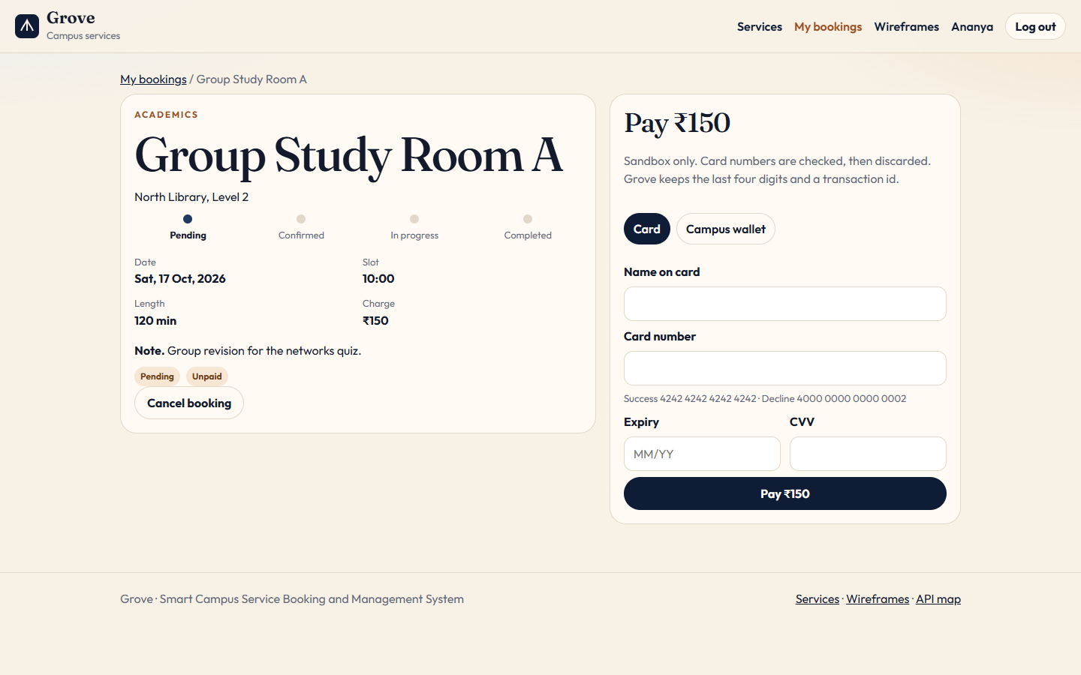

Figure 11.2 — Payment receipt.
Captured from the running Grove application.
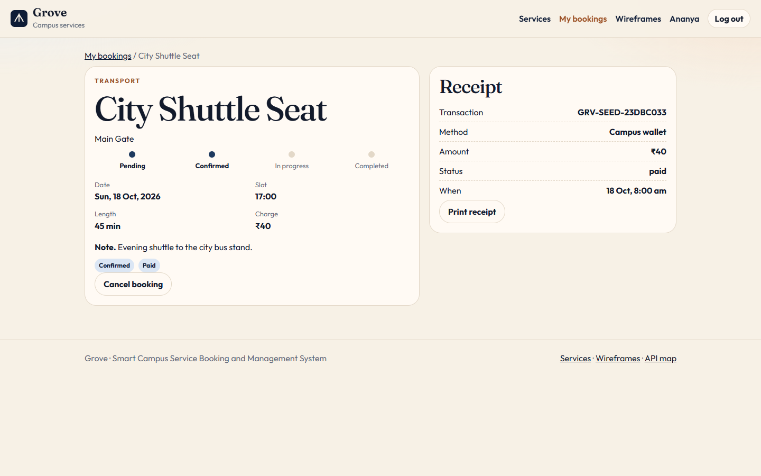

12. REST API Design and Integration
The API is a JSON HTTP API under /api. GET /api returns the name “Grove Campus API”, version 1.0.0, the auth scheme “Authorization: Bearer <token>”, and the endpoint catalog that the /api-map page renders. Resources use the method that matches the action: GET to read, POST to create or to run cancel and pay, PUT to replace a service, PATCH to change part of a user, a password, or a booking status, and DELETE to remove or retire a service. Identifiers are path parameters. Filters are query parameters. Bodies are JSON. Errors are JSON objects with an error string and, when a form is wrong, a fields object whose keys are the input names. Success codes used in the routes are 200 and 201. Client errors used are 400, 401, 402, 403, 404, and 409. The rate limiter answers with its own JSON message when the window is exceeded.

Endpoint catalog
This table is the catalog constant in server/src/lib/constants.js. The running GET /api response is the same list.
Method | Path | Access | Purpose
GET | /api/health | Public | Check that the API is running
GET | /api | Public | Read this API map
GET | /api/meta | Public | Categories, departments, slots, and campus totals
POST | /api/auth/register | Public | Create a student account
POST | /api/auth/login | Public | Sign in and receive a JWT
GET | /api/auth/me | Signed in | Read the current user
PATCH | /api/users/me | Signed in | Update profile details
PATCH | /api/users/me/password | Signed in | Change password
GET | /api/services | Public | Search, filter, and sort services
GET | /api/services/:id | Public | Service detail and reviews
GET | /api/services/:id/availability | Public | Remaining seats for a date
POST | /api/services | Admin | Create a service
PUT | /api/services/:id | Admin | Update a service
DELETE | /api/services/:id | Admin | Delete or retire a service
GET | /api/bookings | Signed in | List own bookings, or all bookings for admins
GET | /api/bookings/:id | Owner or admin | Booking detail, payment, and feedback
POST | /api/bookings | Student | Reserve a slot
POST | /api/bookings/:id/cancel | Owner or admin | Cancel a booking and refund a payment
PATCH | /api/bookings/:id/status | Admin | Move a booking through its lifecycle
POST | /api/payments | Student | Pay for a booking in the sandbox
POST | /api/feedback | Student | Review a completed booking
GET | /api/feedback | Public or admin | Reviews for a service, or every review for admins
GET | /api/admin/stats | Admin | Dashboard totals, revenue, and recent activity
GET | /api/admin/users | Admin | Search campus accounts
PATCH | /api/admin/users/:id | Admin | Change a role or suspend an account

Worked requests
Login returns a public user and a JWT. The user object has no passwordHash. A card payment sends the booking id and the card; spaces are removed before the Luhn check. presentBooking nests the service, user, and payment. The client calls these paths through the Vite proxy in development and on the same origin in production. The /api-map screen renders GET /api.
POST /api/auth/login
{ "email": "ananya@grove.edu", "password": "Student@123" }
200 { "user": { "role": "student", "studentId": "CS26AN01" }, "token": "<jwt>" }

POST /api/payments
Authorization: Bearer <student jwt>
{ "bookingId": "<uuid>", "method": "card",
"card": { "name": "Ananya Rao", "number": "4242424242424242", "expiry": "12/30", "cvv": "737" } }
201 { "payment": { "brand": "Visa", "last4": "4242", "status": "paid",
"transactionId": "GRV-CRD-<stamp>-<salt>" },
"booking": { "status": "confirmed", "paymentStatus": "paid" } }

13. Form Validation, Error Handling and Security
Validation is shared. collect() runs a rule per field and returns either a cleaned value or a field error. badRequest sends HTTP 400 with “Please check the highlighted fields.” and the fields map, unless the caller passes another summary. The React Field component prints that per-field string under the input, and a Banner prints the summary. Forms use noValidate so the browser does not replace these messages with its own bubbles; the checks still run on the server, which is the check that matters.

Field rules
Field | Rule
Name | 2 to 80 characters, letters, spaces, periods, apostrophes, and hyphens, starting with a letter.
Email | A single @ and a dot in the domain, lower-cased, at most 120 characters.
Password | 8 to 72 characters, with a lowercase letter, an uppercase letter, and a digit.
Student ID | 4 to 16 letters or digits, stored in uppercase.
Department | One of the eight department names.
Phone | Optional. If present, a plus and digits, stored with spaces and hyphens removed.
Service name | 3 to 80 characters. Description 20 to 800. Location 3 to 120.
Price | Whole rupees from 0 to 100000. Duration 15 to 480 minutes. Capacity 1 to 200.
Slots | At least one, each drawn from 08:00 through 18:00 on the hour.
Booking date | A real calendar date, today or later in Asia/Kolkata. Slot must be one the service offers.
Notes / reason | Notes up to 400 characters. Cancel reason up to 200. Both tag-stripped.
Review | Rating integer 1 to 5. Comment 8 to 600 characters.
Card | Name 2 to 60, Luhn number, future MM/YY, CVV of 3 or 4 digits. Checked only in memory.

cleanText removes HTML tags, collapses whitespace, trims, and cuts to a maximum length. That is why a note cannot store a script or a bold tag. Integer parsing accepts a real integer or a string of digits, including a leading minus, and rejects anything else, so a price of 10.5 or an empty string does not become a surprise number. Duplicate email and duplicate student id return 409 with a field message. A service description under 20 characters fails on both the admin form, which hints “At least 20 characters,” and the API.

Security controls present in this build
The controls are ordinary web-application controls, applied where the code shows them. Passwords are hashed and are removed from responses. Login uses one error text whether the account is missing or the password is wrong, and it still runs a compare when the account is missing. Credential routes are rate limited outside the test environment. Helmet sets the policy described in the backend section, which reduces framing, plugin content, and unexpected script sources. CORS is limited to the configured origin. Production will not boot on the development JWT fallback. JSON size is capped. Service deletion cannot erase booking history. Administrators cannot demote themselves. Card data is not a stored field, and the test suite checks the serialized database for the full number and for the keys cvv and number.
These choices line up with public guidance without claiming a formal audit. The OWASP Authentication Cheat Sheet and Password Storage Cheat Sheet recommend slow password hashes, generic login errors, and rate limits. The stored hash is bcrypt. RFC 7519 describes the JWT structure this API uses. The content-security policy addresses a common injection path by refusing inline scripts from other origins. What this build does not do should stay visible: there is no account lock beyond the rate limit, no refresh-token rotation, no server-side session store, and no encryption of the JSON file at rest. The development secret is a known string. A deployment must set JWT_SECRET, as the README and the production startup check both require.

14. Admin Dashboard and Analytics
The office area is /admin, wrapped in a layout with links to Overview, Services, Bookings, and Users. Every API under /api/admin requires an administrator token. A student who requests /api/admin/stats receives 403. A request with no token receives 401. The client route shows the office-only page if a student types the URL.

What the overview calculates
GET /api/admin/stats returns student count, suspended count, active services, bookings, the sum of payments still marked paid, average rating, and review count. The screen’s four cards are bookings, revenue, students, and average rating. byStatus counts every status. byCategory and the top five services ignore cancelled bookings. revenueByMonth is six Asia/Kolkata months of payments whose status is paid. recentBookings is six rows and recentFeedback is four. Bars are sized against the largest value in that group.

Operating the catalog, the bookings, and the directory
Manage Services loads includeInactive=1 so retired rows stay visible. Columns are name, location, category, price, capacity, status, and booking count. Remove asks for a second click. A service that already has a booking is set inactive, and the screen says so; otherwise it is deleted. The modal edits name, category, description, location, price, duration, capacity, status, and the hourly slots from 08:00 to 18:00. Manage Bookings filters by text and status and can set any of the five statuses; cancelled refunds a paid booking. Manage Users searches name, email, student id, and department, and can change role or suspend. Those controls are disabled on the signed-in administrator, and the API returns 409 if that row is patched anyway.
Paste the overview and the services table while signed in as admin@grove.edu. Include the four totals and one chart, and the seeded catalog with price and status. The users screen is reserved for section 17.

Figure 14.1 — Admin overview.
Captured from the running Grove application.
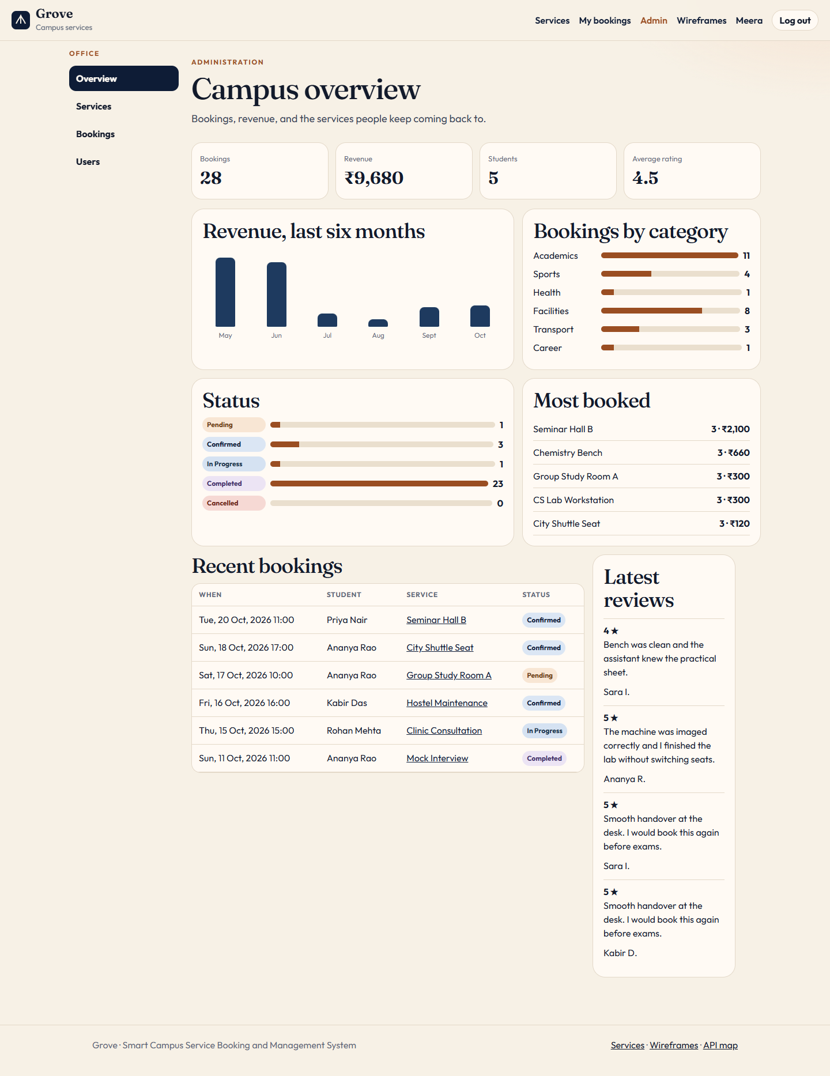

Figure 14.2 — Admin services.
Captured from the running Grove application.
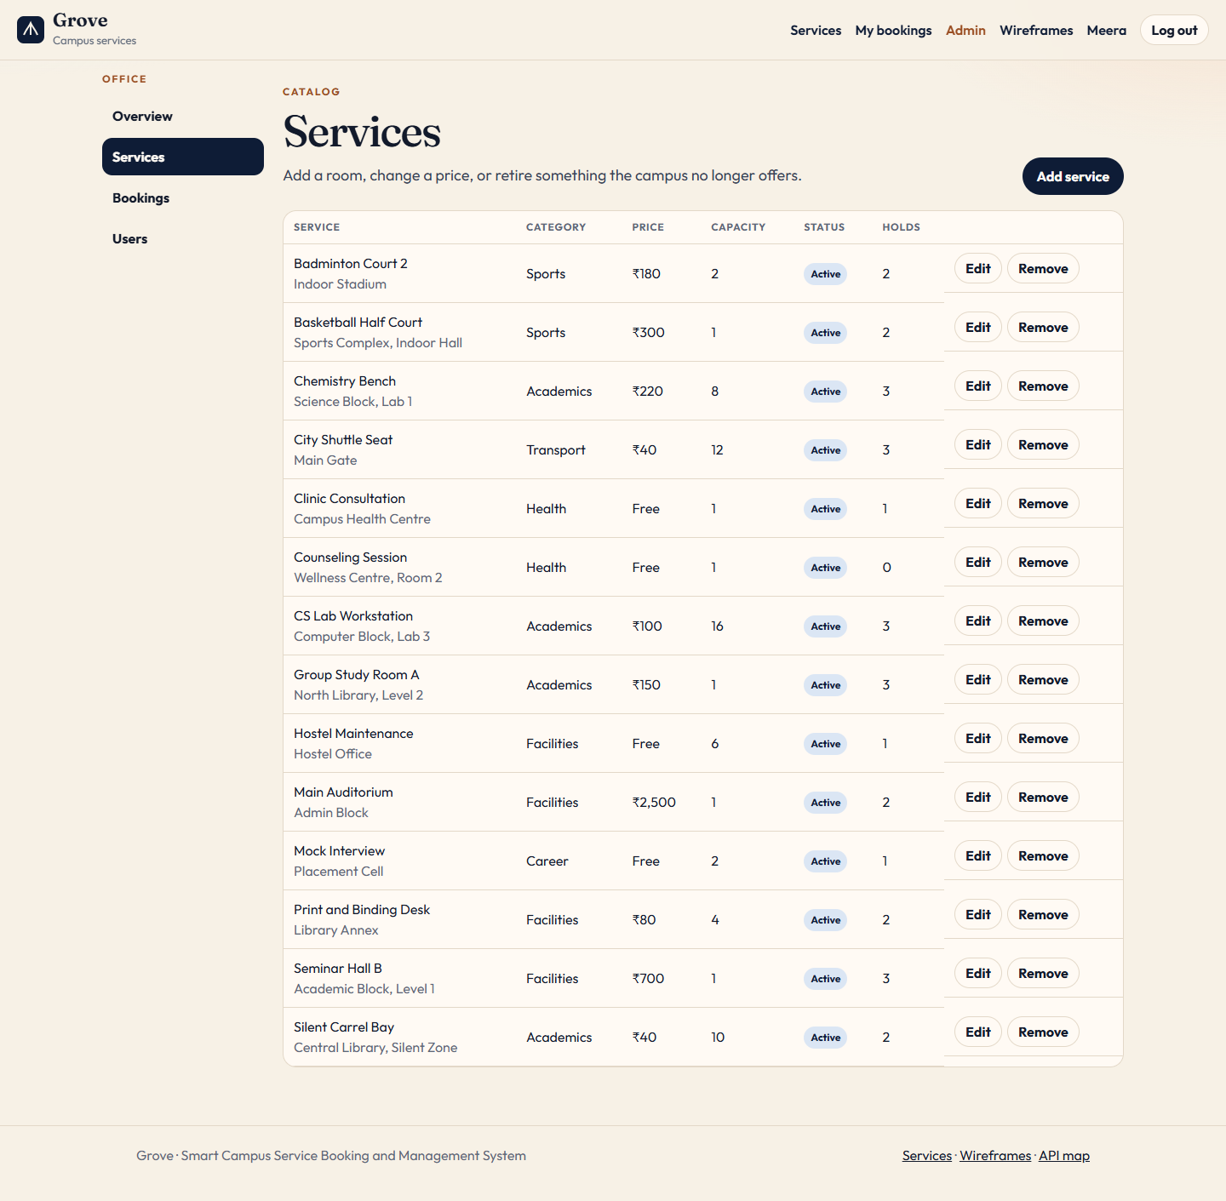

15. Testing and Validation
Automated testing is the API suite server/tests/api.test.js. The root command npm test runs npm run test in the server workspace, which executes node --test tests/*.test.js. The file sets NODE_ENV to test, JWT_SECRET to test-secret, and DB_PATH to a JSON file in the operating-system temporary directory named with the process id and the time. It then imports the Express app and resets the database, which seeds the sample campus into that temporary file. after() deletes the temporary file. Because the path is not server/data/db.json, a test run does not replace the data a developer is looking at in the app. The rate limiter is skipped when NODE_ENV is test, so a long suite cannot lock itself out.

Cases and what they assert
Test | Result the suite requires
Health, API map, and metadata | Health is 200 and ok. The map lists /api/payments. Metadata includes Sports and at least ten services.
Weak password and forged role | Password “short” is 400 with a password field. A registration that sends role admin is stored as student, id upper-cased, with no passwordHash in the body.
Wrong password | ananya@grove.edu with WrongPass1 is 401 and the body has no token.
Catalog search | Sports sorted by price is ordered by price. Query shuttle finds City Shuttle Seat. Category Dining is 400.
Service writes | A student POST is 403. An administrator can create Night Lab Bench and delete it when it has no bookings.
Free booking and past date | Clinic on yesterday is 400. A future clinic booking is confirmed, not_required, and the HTML in the note is stripped.
Capacity and payment | A second seat on a capacity-1 slot is 409. Remaining seats match. Card 4242…4242 confirms, stores last4 4242, and does not store the full number or CVV. A second charge is 409. Card 4000…0002 is 402. A failed Luhn number is 400 on the number field.
Wallet refund | A paid wallet booking becomes cancelled and refunded on the booking and on the payment.
Review rules | Review before completion is 409. A student cannot set status. An administrator can complete it. One review is stored as author Ananya R. A second review is 409. Another student is 403.
Admin boundary | Student stats are 403. Users without a token are 401. Stats return six revenue months. Suspending Sara blocks her login with 403. The administrator cannot change their own access. Sara is restored.
Retire instead of delete | Optics Bench, which has bookings, is deactivated rather than removed.
Profile and password | Neel’s name can be updated. The password can be rotated from NeelPass1 to NeelPass2 and the new password logs in.

The suite does not render React, so breakpoints and focus order are checked by running the client and by the printouts. The project does not record a coverage percentage. Re-run the evidence with npm test from the project root. The same behaviours are walked through by hand in section 17: catalog filter, office lockout, free confirmation, a full slot, the decline card, last four digits only, a refund on cancel, a review only after completion, and a suspended login.

16. Deployment and Hosting
Local development needs Node.js 20 or newer. From the project root, npm install installs the workspaces. npm run dev starts the API and Vite together, labelled api and web in the console. The site is http://localhost:5173 and the API is http://localhost:4000. The first start creates server/data/db.json if it is missing and fills it because there are no users. npm run reset rebuilds that sample campus. Stop the API first, run the reset, then start again, so the process reads the new file instead of keeping its old cache and writing it back.

Scripts and environment
Command | What it runs
npm run dev | concurrently: server dev (node --watch src/index.js) and client dev (vite)
npm test | server tests with node --test
npm run build | vite build, writing client/dist
npm start | node server/src/index.js. In production, also serves client/dist if that folder exists.
npm run reset | node server/src/reset.js, which deletes the data file and seeds it
npm run dev -w server | API only, with restart on source changes
npm run preview -w client | Vite preview of a build, still expecting an API for /api

Variable | Behaviour when unset | Used for
PORT | 4000 | API listen port
JWT_SECRET | Development fallback; production refuses to start | HMAC key for JWTs
CLIENT_ORIGIN | http://localhost:5173 | CORS allow-list, or * for any origin
NODE_ENV | unset, treated as not production | Proxy trust, static files, secret check, rate-limit skip when test
DB_PATH | server/data/db.json | Document file. Tests override it.

Docker and a Node host
The Dockerfile has two stages on node:22-alpine. The first installs and builds the client. The second sets NODE_ENV=production, installs server dependencies with --omit=dev, copies the server and client/dist, exposes port 4000, and runs node server/src/index.js. Compose publishes 4000:4000, sets PORT and NODE_ENV, and takes JWT_SECRET from the shell or the placeholder change-this-before-real-use. The volume grove-data is mounted at /app/server/data. Compose does not start MongoDB. The README command is docker compose up --build, then open http://localhost:4000, after a real JWT_SECRET is set.
On a Node host the README sequence is npm install, npm run build, then NODE_ENV=production with a long JWT_SECRET, then npm start. One process serves the API and client/dist. Back up the JSON file or the Docker volume to keep bookings. Deleting that file, or leaving users empty, makes the next cold start seed the demonstration campus again.

17. Results, Screenshots and Demonstration
This section is the demonstration script and the blank pages for its printouts. Run it against a freshly seeded campus so the bookings named here still exist. Stop the API, run npm run reset from the project root, then npm run dev. Open http://localhost:5173. Do not type card numbers into any tool other than the Grove payment form in the browser. The success card is 4242 4242 4242 4242. The decline card is 4000 0000 0000 0002. Any future MM/YY and any three digits work as expiry and CVV. The application will not show the full number again after a successful charge.

Student path
• Stay signed out. On the home page, record the open-service count, the category count, and the average rating, and the sample pass for Group Study Room A. Paste that screen as Figure 17.1.
• Open Services. Choose the Transport chip, or search shuttle, so City Shuttle Seat is visible and the filter is obvious. Paste that screen as Figure 17.2.
• Open Group Study Room A. Choose a date two or more days ahead and a slot that still has seats. The reserve panel should show the charge of ₹150. You can paste this before signing in; the button then reads “Sign in to reserve.” Paste it as Figure 17.3.
• Sign in as ananya@grove.edu with Student@123. Open My bookings. You should see the unpaid study room still pending, the shuttle already confirmed and paid, and older completed rows including the mock interview.
• Open the City Shuttle Seat row. The receipt should show a transaction id, Campus wallet, the amount, and status paid. Paste that receipt as Figure 17.4. Do not expect a card number.
• Open the completed mock interview, which has no review yet. Paste the status track and the review form as Figure 17.5. Optional checks: pay the pending study room with the wallet or the success card; try the decline card on another unpaid booking; book Clinic Consultation and confirm that a free service shows No charge.

Administrator path and the phone layout
• Log out. Sign in as admin@grove.edu / Admin@123. The app lands on /admin. Paste the four totals and the charts as Figure 17.6.
• Open Services. Paste the table as Figure 17.7. Removing a service that already has bookings marks it inactive.
• Open Users. Paste the directory as Figure 17.8. The signed-in administrator cannot suspend that same row. Sara Iqbal is the account the automated test suspends and then restores.
• Narrow the window below 720 pixels and open Services. Menu should replace the full header, and the filters should stack. Paste that as Figure 17.9.
Useful in a viva, without extra blank pages, are /design, /api-map, /profile, and the office bookings table. The figure pages show the screens captured for this demonstration.

Figure 17.1 — Home.
Captured from the running Grove application.

Figure 17.2 — Catalog with a filter.
Captured from the running Grove application.
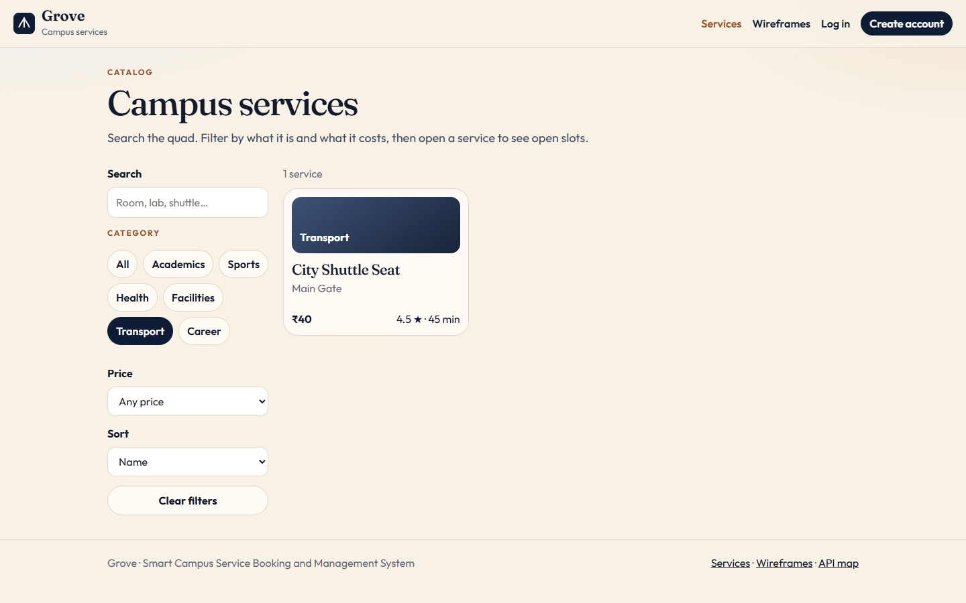

Figure 17.3 — Service booking.
Captured from the running Grove application.

Figure 17.4 — Payment receipt.
Captured from the running Grove application.

Figure 17.5 — Booking status.
Captured from the running Grove application.
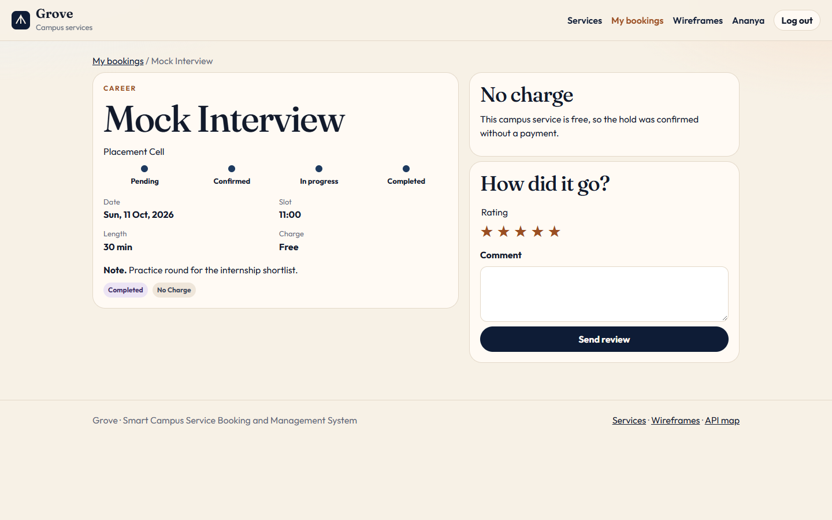

Figure 17.6 — Admin overview.
Captured from the running Grove application.

Figure 17.7 — Admin services.
Captured from the running Grove application.

Figure 17.8 — Admin users.
Captured from the running Grove application.
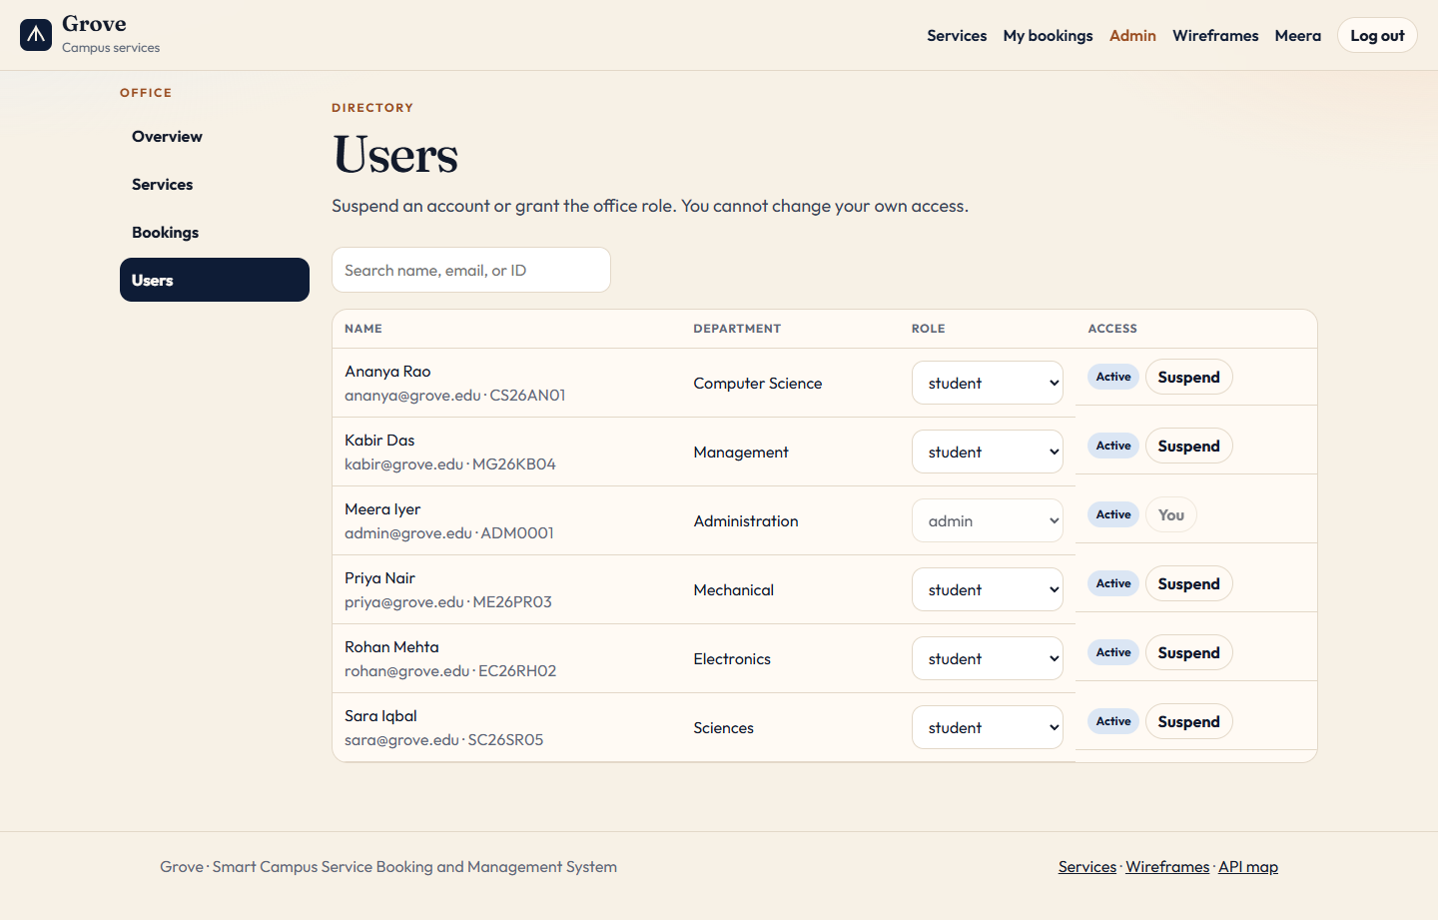

Figure 17.9 — Mobile layout.
Captured from the running Grove application.
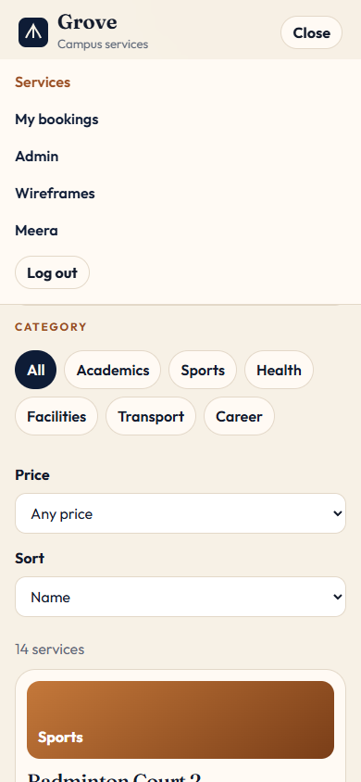

18. Challenges Faced and Solutions Implemented

Running without a database server
A separate database would have made the first run depend on another installation. The documents were still designed as MongoDB collections, and the application needed to start from npm install and npm run dev. The working solution is db.js: one JSON document with the five arrays, a process cache, and a full rewrite on each save. Seed runs only when users is empty, so a restart keeps real bookings. The cost, which the code makes obvious, is that a second process can rewrite the file without the running API noticing. Reset is therefore done with the API stopped. Tests avoid the problem by setting DB_PATH to a private temporary file.

Capacity, history, and clock
Two students can submit the last seat together. In this single Node process the booking handler checks the count and pushes the new booking before it returns, and save() is synchronous, so the second request on that process sees the first hold and returns 409. That is the behaviour the capacity test locks in. It is not a multi-server lock. Retiring a service raised the opposite problem: a hard delete would leave bookings pointing at a missing service. DELETE now removes the document only when no booking references it, and otherwise sets status inactive and returns deactivated true. “Today” was another source of wrong refusals if the server clock was not in India. campusToday() formats the current instant in Asia/Kolkata, and both availability and booking use it. Card expiry still uses the server’s local calendar month, which is a separate check inside the sandbox and is not the campus-day helper.

Cards, login errors, and self-lockout
A receipt has to identify a payment without becoming a copy of the card. charge() keeps brand, last4, and a generated transaction id, and the payment route never assigns the PAN, expiry, or CVV onto the stored object. The test serializes the database and fails if the full success number or those keys appear. Login had a related disclosure problem: a different error for an unknown email would tell an attacker which addresses are registered. The route uses one 401 message and compares against a placeholder hash when the user is missing. Registration ignores a client-supplied role so the same endpoint cannot be used to create an administrator. The office user update refuses the caller’s own id with 409, because a status select on that row could otherwise suspend the only administrator in the room.

Markup in notes, fonts, and tests versus the limiter
cleanText strips tags before a note is stored. The clinic test books “<b>Bring</b> the health card” and expects the plain sentence. The content-security policy allows the Google font hosts used by Fraunces and Outfit, while connect-src stays 'self' because production and the Vite proxy are same-origin to the browser. authLimiter skips itself when NODE_ENV is test, which the suite sets before importing the app, so repeated logins do not trip the 30-request window.

19. Future Enhancements
The items below are not in the repository. They are sensible next steps that keep the current behaviour, not a description of hidden features.
• Replace the JSON file with MongoDB collections that use the field names, string ids, and indexes in section 8. Keep writing the same documents so the routes and the tests change only at the load and save boundary. Add a connection setting in the environment at that time. There is no such setting to document today.
• Put a real payment provider behind the same POST /api/payments contract, still storing only brand, last four, amount, status, and a provider reference. Keep the decline and success numbers as a test mode. Do not begin storing the PAN or CVV.
• Notify the student when an administrator moves a booking to in_progress, completed, or cancelled. The product currently shows that change only when the student next opens the booking.
• Offer a waitlist when remaining seats are zero, instead of only the 409 message. Capacity would then need a defined promotion rule when a hold is cancelled.
• Add a forgotten-password path. The current password route works only for someone who can already sign in and still knows the current password.
• Page the catalog in the client once a campus has more than the default limit of 50 services. The API already accepts offset and limit.
• Add browser tests for the filters, the protected admin route, and the payment form, beside the existing API suite. Record an audit line when an administrator changes a role, a suspension, or a booking status.
None of these require a different product. The booking statuses, the refund rule, the student and administrator roles, and the five document types can stay. A future MongoDB installation should load the documents Grove already writes, rather than a second, incompatible schema.

20. Conclusion and References

Conclusion
Grove is a working campus booking system. Students search a catalog of rooms, labs, courts, care, facilities, transport, and career slots. They reserve a seat only when the slot is still open, pay in a sandbox when there is a charge, and follow the booking until the office completes it or someone cancels it. Free services confirm with payment status not_required. A paid cancellation is stored as refunded. Administrators maintain services, statuses, and accounts, and they read totals that are computed from those same documents. Access is a JWT and a role check on the server, with passwords stored as bcrypt hashes.
The implementation is a React and Vite client and an Express API, with data in server/data/db.json shaped as the five collections designed for MongoDB. The report has kept that distinction explicit: the schema is the integration design, and this build does not connect to a MongoDB server. The automated suite covers registration, roles, search, capacity, card handling, refunds, reviews, and suspension, using a temporary file. Docker runs the built client and the API as one process on port 4000, with the data file on a volume. Screenshot pages were left blank so the printed interface can be pasted into the demonstration without pretending that a description is a picture.

References
The works below are the public specifications and project documents that correspond to the technologies this system uses. Access dates are not claimed beyond the date of this report, 14 October 2026. No journal article has been added unless it is a real, identifiable paper.
[1] React documentation. Meta Open Source. https://react.dev/
[2] React Router documentation. https://reactrouter.com/
[3] Vite guide. https://vite.dev/guide/
[4] Express 4 API reference. OpenJS Foundation. https://expressjs.com/en/4x/api.html
[5] Node.js documentation. OpenJS Foundation. https://nodejs.org/docs/latest/api/
[6] MongoDB Manual, “Documents.” https://www.mongodb.com/docs/manual/core/document/
[7] MongoDB Manual, “Indexes.” https://www.mongodb.com/docs/manual/indexes/
[8] Jones, M., Bradley, J., and Sakimura, N. JSON Web Token (JWT). RFC 7519. IETF, May 2015. https://www.rfc-editor.org/rfc/rfc7519
[9] Bray, T., editor. The JavaScript Object Notation (JSON) Data Interchange Format. RFC 8259. IETF, December 2017. https://www.rfc-editor.org/rfc/rfc8259
[10] Fielding, R., Nottingham, M., and Reschke, J., editors. HTTP Semantics. RFC 9110. IETF, June 2022. https://www.rfc-editor.org/rfc/rfc9110
[11] Fielding, R. T. Architectural Styles and the Design of Network-based Software Architectures. Doctoral dissertation, University of California, Irvine, 2000. https://www.ics.uci.edu/~fielding/pubs/dissertation/top.htm
[12] Provos, N., and Mazières, D. “A Future-Adaptable Password Scheme.” Proceedings of the USENIX Annual Technical Conference, 1999. https://www.usenix.org/legacy/events/usenix99/provos.html
[13] bcrypt.js. https://github.com/dcodeIO/bcrypt.js
[14] OWASP Foundation. OWASP Top Ten. https://owasp.org/www-project-top-ten/
[15] OWASP Foundation. Authentication Cheat Sheet. https://cheatsheetseries.owasp.org/cheatsheets/Authentication_Cheat_Sheet.html
[16] OWASP Foundation. Password Storage Cheat Sheet. https://cheatsheetseries.owasp.org/cheatsheets/Password_Storage_Cheat_Sheet.html
[17] Helmet. https://helmetjs.github.io/
[18] express-rate-limit. https://github.com/express-rate-limit/express-rate-limit
[19] Docker documentation, multi-stage builds. https://docs.docker.com/build/building/multi-stage/
[20] MDN Web Docs. Fetch API. https://developer.mozilla.org/en-US/docs/Web/API/Fetch_API
[21] ISO/IEC 7812-1. Identification cards — Identification of issuers. The Luhn check digit used by the sandbox card test is the check specified for these numbers.

