Firearm Mortality and Gun Control Law Analysis
Introduction
This analysis investigates the relationship between firearm mortality rates across U.S. states and the strictness of firearm control laws. The data is sourced from the CDC, Everytown for Gun Safety, and U.S. Census Bureau projections. By combining firearm mortality rates, gun control law strictness (on a Likert scale), and population data, we aim to evaluate how stricter laws impact firearm-related deaths.
Data Sources
- CDC Firearm Mortality Data: Contains state-specific firearm mortality rates.
- Everytown Gun Control Law Ratings: Each state is assigned a score based on gun control laws, converted to a 5-point Likert scale (1 = Very Lax, 5 = Very Strict).
- U.S. Population Data: Population projections for each state to compute weighted averages.
Objectives
- Compare firearm mortality rates across states with varying levels of gun control strictness.
- Investigate the correlation between gun control law strictness and firearm mortality rates.
- Visualize these relationships using bar plots and heatmaps.

2. Methodology
Data Wrangling
- We filtered the CDC data for firearm-related injuries.
- Each state’s name was converted to its official abbreviation.
- Gun control law ratings were adjusted to a 5-point Likert scale, from "Very Lax" to "Very Strict."
- The population data for 2023 was cleaned and merged with the mortality data to calculate population-weighted rates.
Merging Data
We merged the CDC firearm mortality rates, gun law strictness ratings, and state population data to create a comprehensive dataset. This dataset enabled us to calculate the weighted average mortality rates for different levels of gun control law strictness.

3. Analysis
3.1. Heatmap of State-Level Firearm Death Rates
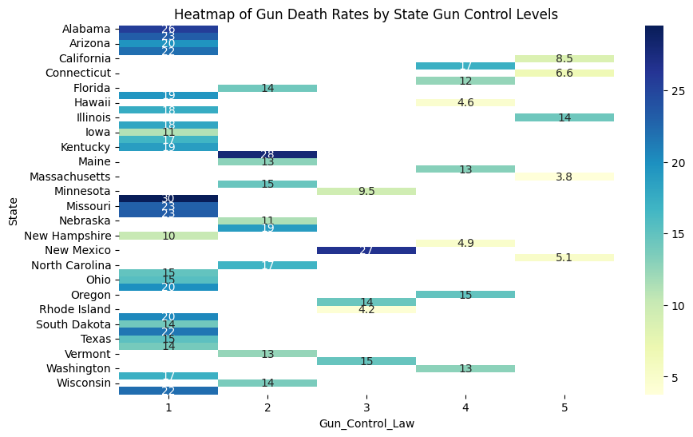
First, we created a heatmap showing the relationship between state-specific firearm mortality rates and gun law strictness. The heatmap highlighted states with both high and low gun-related deaths across different levels of gun law strictness, helping to identify any outliers. It shows an overall trend of a larger concentration of darker blues in the lower bins and more yellow hues in the higher bins. This indicates that there is a serious relationship between stricter gun laws and fewer gun related deaths.

3.2. Correlation Analysis
Correlation Between Gun Control Law and Firearm Mortality Rates
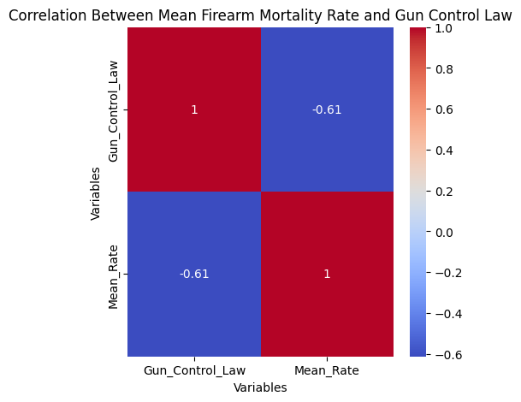
We computed the correlation between the strictness of gun control laws and firearm mortality rates. The results showed a highly significant negative correlation of -0.61 between gun control law strictness and firearm mortality rates. In other words, stricter gun laws are associated with lower firearm mortality.
3.3 Bar Plots
Weighted Mortality Rate by Gun Control Law Strictness
To understand the relationship between gun control laws and firearm deaths, we calculated the population-weighted average firearm mortality rate for each strictness level on the Likert scale.
The results were visualized in a bar plot that clearly shows a decreasing trend in firearm mortality rates as gun control law strictness increases. States with stricter laws (4-5 on the Likert scale) tend to have significantly lower firearm mortality rates.
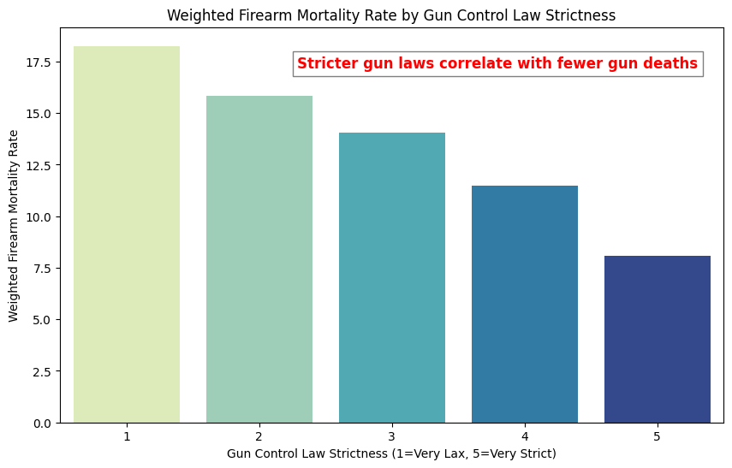
Findings:
- Very Lax (Likert 1): Higher firearm mortality rates.
- Very Strict (Likert 5): Lower firearm mortality rates.

5. Conclusion
Key Insights:
- Stricter Gun Control Laws: States with more stringent gun control laws (Likert 4-5) tend to have significantly lower firearm mortality rates compared to states with lax laws (Likert 1-2).
- Correlation: There is a clear negative correlation between the level of gun control and firearm deaths. This suggests that implementing stricter gun laws could be an effective strategy to reduce gun-related fatalities.
- Visual Representation: The bar plot and heatmap both visually confirm the trend that states with stronger gun control laws experience fewer firearm deaths.
These findings indicate a potential benefit of stricter gun control measures in reducing firearm mortality. Further research could examine additional variables, such as urbanization, socioeconomic factors, and mental health support, to explore how these factors interact with gun laws and firearm deaths.

