NAME: SHAYAN SAEED  
ROLL NO: 2021F-BSE-198  
SECTION: E  
  
  
***Question # 1***  
  
**Output**  
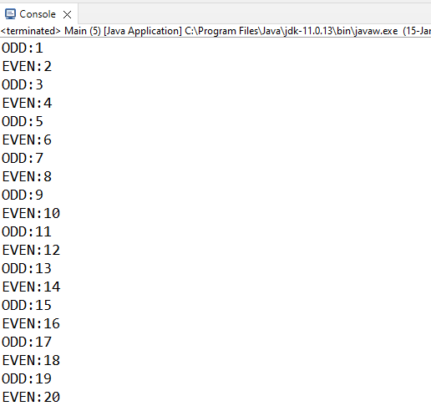   
  
 ***Question # 2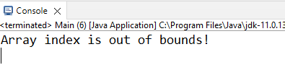 Question # 3***Discuss the benefits of using pull requests in a collaborative software development environment. Explain the steps involved in creating and merging a pull request on Github.