**Description:** Our game for the Zork project is called Dracula’s Mansion. It fits in the RPG genre of text-based video games and uses rooms, enemies, and weapons/combat to work as this type of game. The player finds themselves waking up in a random mansion, not remembering anything and later discovering that they are in a vampire mansion and need to get out. They need to navigate through 25 rooms while finding a weapon and getting through enemies such as stone guards (4 in the whole game), which they can interact with and talk to, and also vampires which they fight with in all cases.

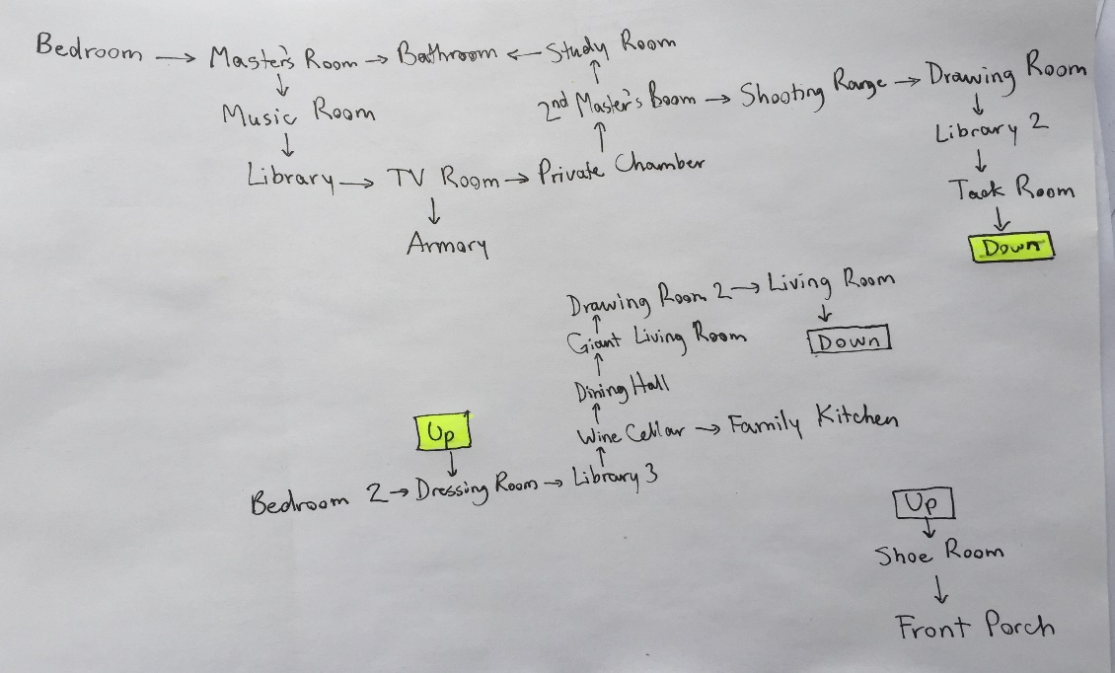

Map (Start at Bedroom, end at Front Porch

**What I learned (Shayan):** From doing this project, I learned how much contribution and revision it actually takes to make such a game like Zork. As a group, theres more work needed than I thought to make it work, and code needs to be organized appropriately in order for everything to function as intended. I got to put the material I learned throughout the year and use it in the game, and making a player be able to do stuff such as walk and pick up and drop gave me new ideas of how a potential game in the future could be.

**What I learned (Batjon):** The group project of Zork was an experience to say the least as it was interesting building up a text adventure game. I learned to be creative when creating games such as these, which is why it was my choice to add in the fighting and dialogue options in order to add some creativity to the new version of the game. Working on Zork also taught me that I need to be prepared when it comes to group coding projects and that it is much better and more efficient to work when you are physically with your group members rather than from distance where you can’t communicate with them as effectively.

**Known problems: In our code**, a big problem is that, when a guard or vampire is present in the room, the fighting isn’t initiated properly. When dialogue happens for guards and the player chooses a response, a battle should either start or not start, but what it does is that it moves to a second guard and a third, etc. without considering if a battle should start or not. This takes part of the game away, as the player can walk through all the rooms, pick up items such as Swords and/or a key, and can drop them in other locations, but combat doesn’t completely work.