|  |  |
| --- | --- |
| SQL | NO-SQL |
| Structured query language | Non-Structured query language |
| Relational database management system | Non-Relational database management system |
| Managed structured data with predefined schema | Managed Non-structured and semi-structured data. |
| Managed records in the forms of table. | Managed records in the forms of documents and collections. |
| Used ACID properties (Atomicity, consistency, isolation, durability) for transaction management. | Don’t use ACID properties. |
| Use complex queries as well as JOIN operations | Don’t use JOIN and complex queries |
| It can scaling it’s data in vertical order. | It can scale it’s data horizontally. |
| It can used for managing multi row transaction. | It can be used to managed documents or collection |
| e.g SQL, MYSQL, POSTGRE SQL | e.g MONGO DB |

I had done with the key differences between the relational & Non-relational database.

I had installed POSTGRE SQL.

Day 2:

Task:

DB Design

* Company (id, company name, company logo, company description)
* Company have departments like Admin, Marketing, Production, etc
* Each department can have a team of employees.

Findings:

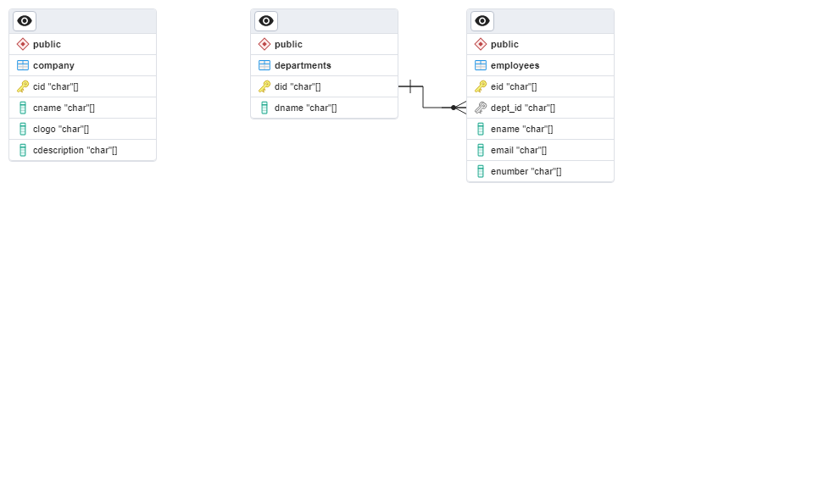

BEGIN;

CREATE TABLE IF NOT EXISTS public.company

(

cid "char"[] NOT NULL,

cname "char"[] NOT NULL,

clogo "char"[] NOT NULL,

cdescription "char"[] NOT NULL,

PRIMARY KEY (cid)

);

COMMENT ON TABLE public.company

IS 'It Based Company';

CREATE TABLE IF NOT EXISTS public.departments

(

did "char"[] NOT NULL,

dname "char"[] NOT NULL,

PRIMARY KEY (did)

);

COMMENT ON TABLE public.departments

IS 'It Departments (Hr, IT,

Marketing......).';

CREATE TABLE IF NOT EXISTS public.employees

(

eid "char"[] NOT NULL,

dept_id "char"[] NOT NULL,

ename "char"[] NOT NULL,

email "char"[] NOT NULL,

enumber "char"[] NOT NULL,

PRIMARY KEY (eid)

);

COMMENT ON TABLE public.employees

IS 'Company Employee Bio';

ALTER TABLE IF EXISTS public.employees

ADD FOREIGN KEY (dept_id)

REFERENCES public.departments (did) MATCH SIMPLE

ON UPDATE NO ACTION

ON DELETE NO ACTION

NOT VALID;

END;