**LAB # 03**

**RECURSION**

**OBJECTIVE:** To understand the complexities of the recursive functions and a way to reduce these complexities.

**LAB TASK**

1. Write a program which takes an integer value (k) as input and prints the sequence of numbers from k to 0 in descending order.

**Code:**

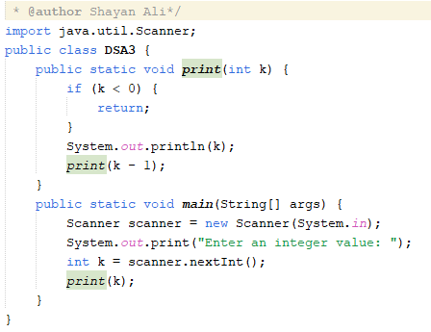

**Output:**

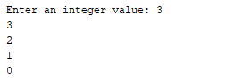

1. Write a program to reverse your full name using Recursion.

**Code:**

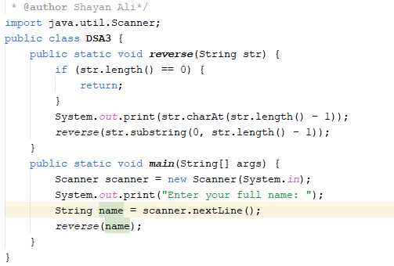

**Output:**



1. Write a program to calculate the sum of numbers from 1 to N using recursion. N should be user input

**Code:**

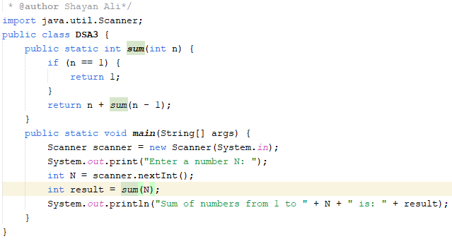

**Output:**



1. Write a recursive program to calculate the sum of elements in an array.

**Code:**

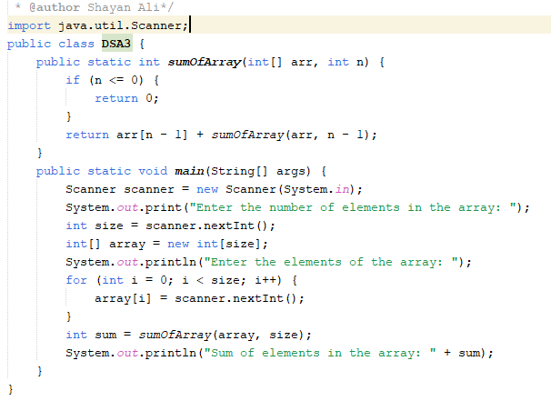

**Output:**

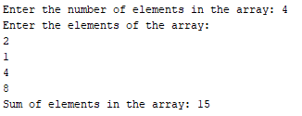

1. Write a recursive program to calculate the factorial of a given integer n

**Code:**

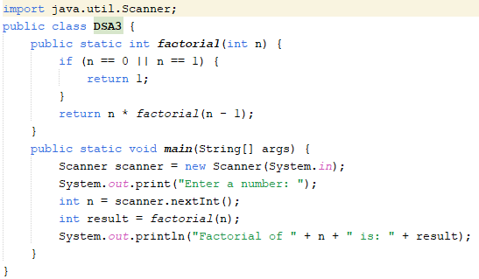

**Output:**



6. Write a program to count the digits of a given number using recursion.

**Code:**

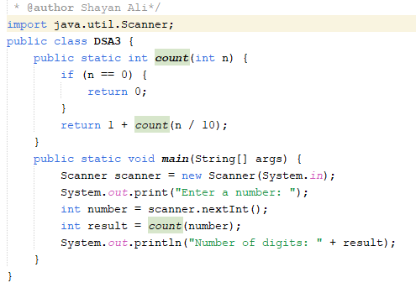

**Output:**



**HOME TASK**

1. Write a java program to find the N-th term in the Fibonacci series using Memoization.

**Code:**

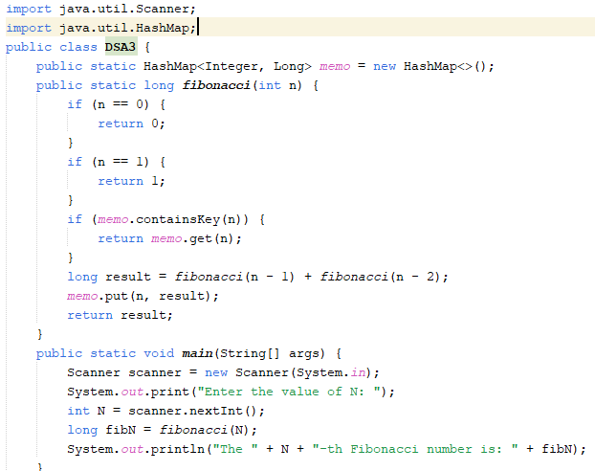

**Output:**



2. Write a program to count the digits of a given number using recursion.

**Code:**



**Output:**



3. Write a java program to check whether a given string is a palindrome or not. A palindrome is a string that reads the same forwards and backwards.Print "YES" if the string is a palindrome, otherwise print "NO".

**Code:**

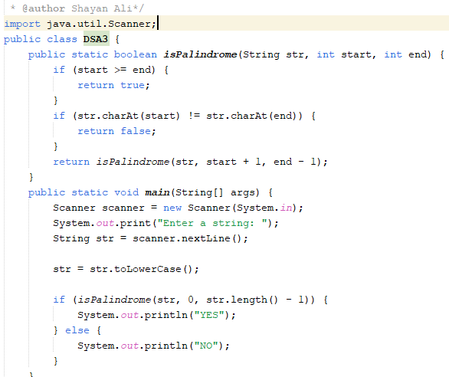

**Output:**



4. Write a recursive program to find the greatest common divisor (GCD) of two numbers using Euclid's algorithm

**Code:**

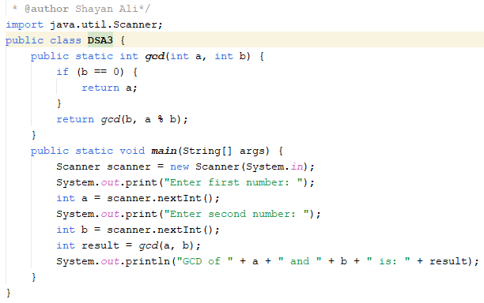

**Output:**

