**LAB # 06**

**Searching in a Linear Array**

**OBJECTIVE:** To find an element in linear array using Linear Search and Binary Search.

**Lab Task**

1. Declare an array of size 10 to store account balances. Initialize with values 0 to 1000000. Check all array if any value is less than 10000. Show message:

Account No. Low Balance

Account No. Low Balance

**Code:**

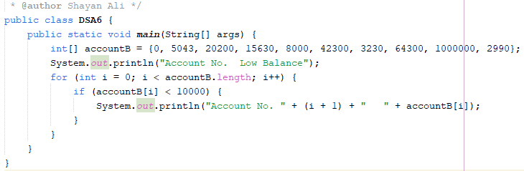

**Output:**

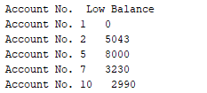

1. Write a program to search in array using Array built-in class

**Code:**

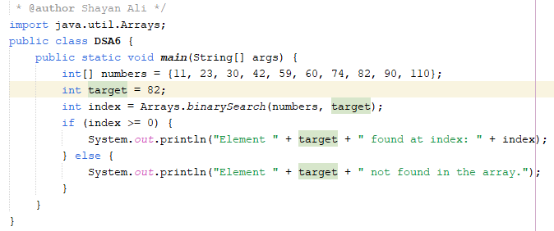

**Output:**



1. Given an unsorted array arr of integers, find the smallest positive integer that is **missing** from the array. You need to implement this using **binary search**. The array can contain both negative numbers and positive numbers, and you can assume that the array does not have duplicates.

**Code:**

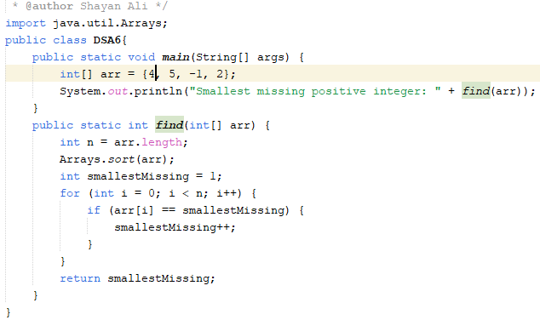

**Output:**



1. You are given a sorted array arr[] and a target element target. Your task is to find the **first occurrence** of the target in the array using binary search. If the target is not found, return -1. You are given a sorted array arr[] and a target element target. Your task is to find the **first occurrence** of the target in the array using binary search. If the target is not found, return -1.

**Code:**

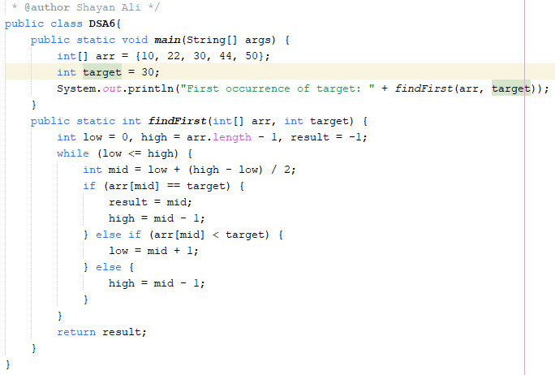

**Output:**



**Home Task**

1. Write a program initializing array of size 20 and search an element using binary search.

**Code:**

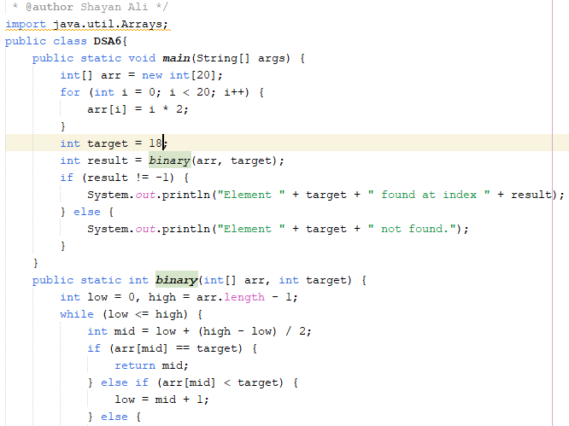

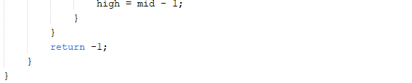

**Output:**



1. Write a function called occurrences that, given an array of numbers A, prints all the distinct values in A each followed by its number of occurrences.

For example, if A = (28, 1, 0, 1, 0, 3, 4, 0, 0, 3), the function should output the following five lines (here separated by a semicolon) “28 1; 1 2; 0 4; 3 2; 4 1”.

**Code:**

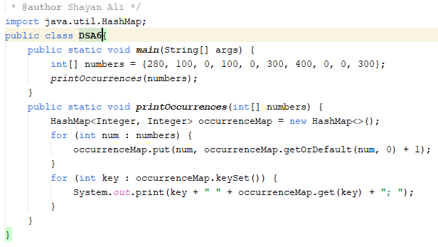

**Output:**



1. Assume a bank's system needs to identify accounts with critically low balances and alert the user. Test the function with various balance values to ensure it correctly identifies all accounts below the threshold.

**Code:**

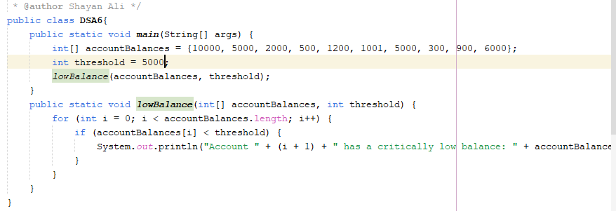

**Output:**

