Architecture Document

ExpenseMate — Personal Expense Manager
Phase 2 Deliverable — Architecture & Construction Planning

1. Architectural Style
ExpenseMate uses a Layered (N-tier) architecture running inside a local Client-Server topology, as prescribed by the assignment. The three layers are:
- Presentation Layer (ui.py) — Tkinter GUI with five tabs: Add Transaction, Transactions, Budgets & Alerts, Analytics, Import/Export.
- Business Logic Layer (logic.py) — the ExpenseManager class: validation rules, budget-alert computation, category analytics, CSV import/export.
- Data Access Layer (db.py) — the Database class: SQLite schema and CRUD operations only, no business rules.
Rationale: a layered style keeps coupling low between the GUI and business rules (the UI never touches SQL directly), matching the 'low coupling' design goal, and allows the GUI to be replaced later (e.g. with a web front-end) without touching logic.py or db.py.

2. Logical View
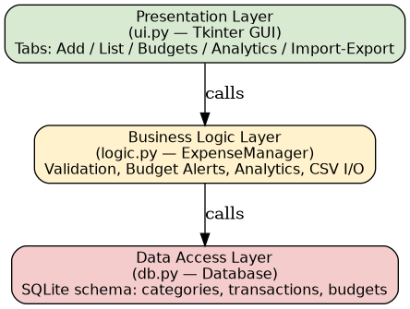
The Logical view shows the three layers and their call direction: UI calls Logic, Logic calls DB. No layer is skipped (UI never calls db.py directly), which is enforced by convention in code review.

3. Process View
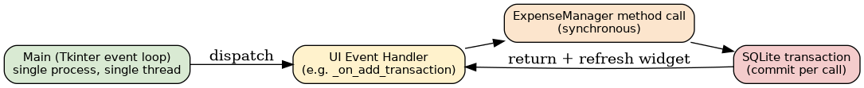
ExpenseMate runs as a single OS process with a single thread — the Tkinter main event loop. UI events call into ExpenseManager methods synchronously; each logic call issues one or more SQLite statements and commits before returning control to the UI, which then refreshes the relevant widget (table, chart, or alert box).

4. Physical / Deployment View
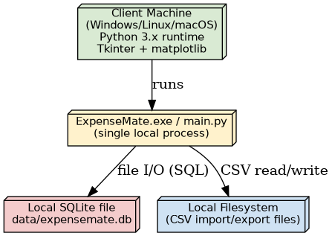
Deployment is a single node: the user's own machine. The Python process, the SQLite database file, and any imported/exported CSV files all reside on the same local filesystem — there is no network tier in this release, consistent with the 'Client-Server (local)' architecture named in the brief.

5. Coding Standards
- PEP 8 naming and formatting for all Python source.
- Every public method carries a docstring stating its layer responsibility.
- Business-rule violations raise a dedicated ValidationError rather than bare exceptions, so the UI layer can catch one exception type.
- No SQL string formatting with untrusted input — all queries use parameterised placeholders (?) to avoid injection.
- Unit tests live under tests/ and import from src/ directly; every new Logic method ships with at least one positive and one negative test.

6. Tools
Category | Tool
Language / Runtime | Python 3.9+
Persistence | SQLite (built-in sqlite3 module)
GUI | Tkinter (standard library) + matplotlib (embedded charts)
Testing | unittest, coverage.py
Static analysis | radon (cyclomatic complexity & maintainability index)
Version control | Git (local repository, one commit per construction/maintenance phase)

7. Project Timeline (Gantt Chart)
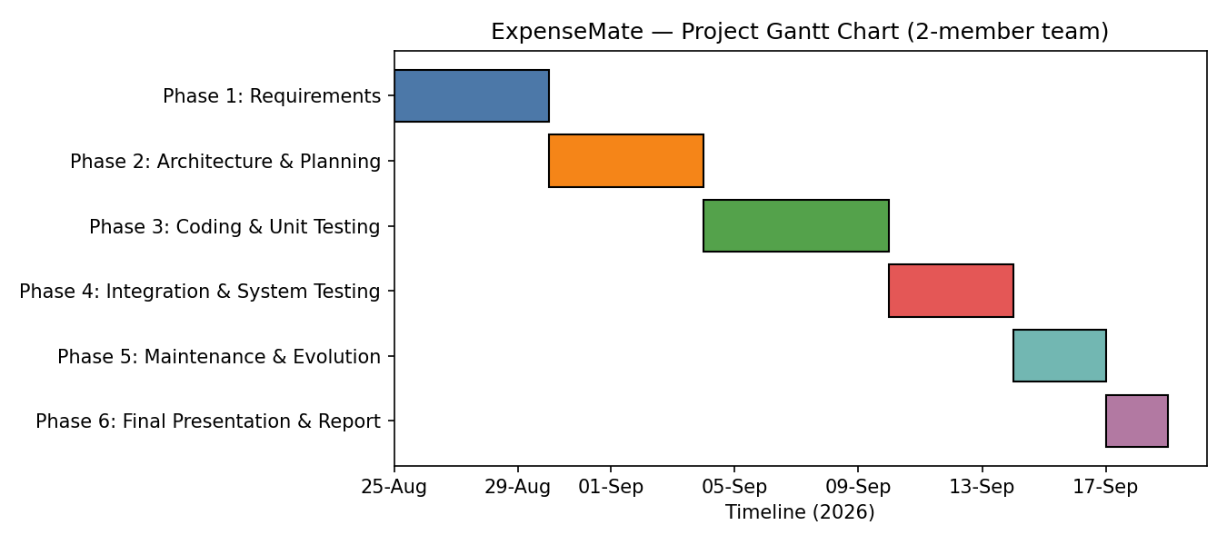
Both team members work in parallel on Phases 1, 2, 4, 5 and 6; Phase 3 splits by module ownership (Member A: backend/db+logic, Member B: frontend/UI) as assigned in the brief.

