Final Report

ExpenseMate — Personal Expense Manager
Phase 6 Deliverable — Software Construction Assignment 01

1. Project Summary
ExpenseMate is a personal expense manager built to apply the full Software Construction lifecycle — Requirements, Design, Construction, Testing, and Maintenance — to a small but complete system. It lets a single user record income and expense transactions, set monthly per-category budgets, receive alerts as spending approaches or exceeds those budgets, import/export transactions as CSV, and view category-wise spending as a chart. The system follows a Client-Server (local) topology with a Layered internal architecture (Presentation / Business Logic / Data Access), built in Python with a Tkinter GUI and a SQLite datastore.

2. What Was Built
- Backend (Member A): db.py (SQLite schema — categories, transactions, budgets tables with foreign-key and CHECK constraints) and the core of logic.py (validation rules, CSV import/export, recurring-transaction generation).
- Frontend (Member B): ui.py — a 5-tab Tkinter application (Add Transaction, Transactions, Budgets & Alerts, Analytics, Import/Export) with an embedded matplotlib pie chart for category analytics.
- Both members: budget-alert logic (check_budget_alerts, the 'challenging part' shared across both layers), module division, and the Phase 5 adaptive feature (recurring transactions) and Lehman's Laws analysis.

3. Requirements Coverage
ID | Requirement | Status
FR-1..FR-3 | Record transactions, validate input, set budgets | Implemented & tested
FR-4 | Budget alerts (warning / exceeded) | Implemented & tested
FR-5 | Category-wise analytics chart | Implemented & tested
FR-6, FR-7 | CSV export / import with row-level error reporting | Implemented & tested
FR-8 | View / filter / delete transactions | Implemented & tested
FR-9 | Recurring transactions (added Phase 5) | Implemented & tested
Optional | Multi-currency, cloud backup | Out of scope — proposed next increment

4. Quality Results
- 20 / 20 automated unit tests passing (unittest); 97% statement coverage on the Data and Logic layers (coverage.py).
- Average cyclomatic complexity: grade A (2.39) across all 38 analysed functions/methods; highest single-function complexity is 7 (import_csv), still within radon's low-risk band.
- 2 real faults found via testing (BUG-01, BUG-02) and fixed with a 100% fix rate before final submission — full details in the Maintenance & Refactoring Report.
- 12 system test cases executed end-to-end against a real sample dataset (data/sample_import.csv) — all passing, including a genuine budget-exceeded alert and a rendered analytics chart (see Test Cases & Metrics report, Section 3).

5. Demo Walkthrough
- 1. Launch: python src/main.py opens the 5-tab Tkinter window.
- 2. Add Transaction tab: enter type/amount/category/date/description and click Add — the Transactions tab updates immediately.
- 3. Budgets & Alerts tab: set a category limit for the current month, then click 'Check Alerts' to see a colour-coded ok / warning / exceeded status per category.
- 4. Analytics tab: a live matplotlib pie chart breaks down the current month's expenses by category.
- 5. Import/Export tab: export the current month to CSV, or bulk-import a CSV (e.g. data/sample_import.csv) — bad rows are skipped and reported individually rather than aborting the whole import.
A scripted, non-interactive run of this exact flow (import -> set budgets -> check alerts -> render chart) was used to produce the evidence below, since it doesn't depend on a live display. Sample dataset: 8 transactions (data/sample_import.csv), September 2026, income 50,000 / expense 30,200 / net 19,800.
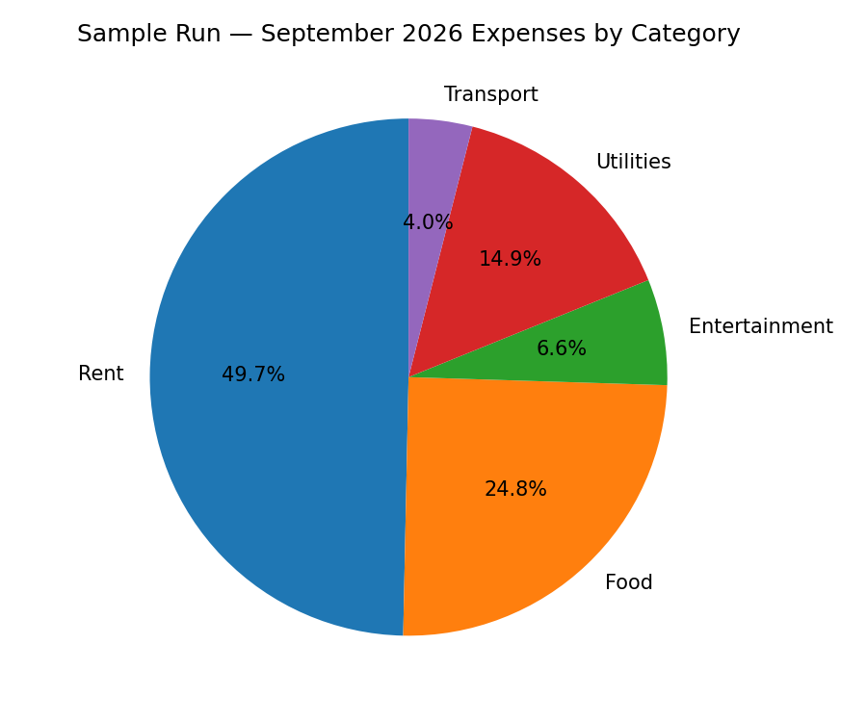

6. Lessons Learned
- Keeping the Presentation layer thin and pushing every rule into ExpenseManager made unit testing straightforward — 97% of the coverage lives entirely outside the GUI.
- Both bugs found in Phase 4 were single-token logic inversions (== vs >=, 'income' vs 'expense') — a reminder that this class of bug is easy to introduce and easy to miss by eye, but cheap to catch with even a small automated test suite.
- Designing category_breakdown() and check_budget_alerts() as pure functions over already-fetched rows (rather than re-querying SQLite mid-calculation) kept their cyclomatic complexity low and made them trivial to unit-test without a live database in every case.

7. Future Work (Maintenance Scope)
- Multi-currency support: store an ISO currency code per transaction and convert at display time using a pluggable exchange-rate provider.
- Cloud backup: periodic export of the SQLite file (or a sync table) to a user-configured remote store, kept optional to preserve the current fully-offline, single-file deployment model.

8. Final Submission Bundle
- SRS_ExpenseMate.docx
- Architecture_Document.docx (includes Gantt chart)
- ExpenseMate_SourceCode.zip (src/, tests/, data/, README.md, git history)
- Test_Cases_Bug_Report_Metrics.docx
- Maintenance_Refactoring_Report.docx
- Final_Report.docx (this document)

9. Team Contribution Summary
Member | Primary Contributions
Member A | Functional/non-functional requirements (SRS §1-2), Logical/Process/Physical views, db.py, backend half of logic.py, integration testing, cyclomatic-complexity measurement, 2 bug fixes (corrective maintenance).
Member B | Use case diagram, coding standards & tool selection, Gantt chart, ui.py (all 5 tabs), system testing, fault-find/fault-fix tracking, perfective maintenance pass, this Final Report.
Both | Module split (UI / Logic / DB), budget-alert logic, the Phase 5 adaptive feature (recurring transactions), and the Lehman's Laws analysis.

10. Risks & Challenges Encountered
- Budget-alert thresholds (ok / warning / exceeded) needed an exact, testable boundary definition before coding could start cleanly — resolved by fixing the warning threshold at 80% and writing the three-state test (TC-05..TC-07) before the corrective bugs were even found, which is what let those bugs surface immediately as test failures rather than as silent GUI mis-behaviour.
- CSV import needed to tolerate partially-bad files (a real user's export from another app) without discarding the good rows — solved by validating and inserting row-by-row inside a try/except per row, with a summary of skipped rows and reasons returned to the caller instead of raising on the first bad row.
- Recurring-transaction date generation had to handle month-end edge cases (e.g. day 31 landing in a 28/29/30-day month) correctly on the first attempt in Phase 5, since the feature came with a hard deadline pressure late in the schedule (see Gantt chart, Phase 5 is only 3 days) — mitigated by writing the February-clamping unit test alongside the implementation rather than after it.

11. Conclusion
ExpenseMate meets all functional requirements defined in the SRS (FR-1 through FR-9), passes its full automated test suite, and stayed within a low cyclomatic-complexity band throughout construction and one full maintenance cycle. The Requirements -> Design -> Construction -> Testing -> Maintenance lifecycle prescribed by the assignment was followed end-to-end, including a genuine (not simulated) corrective-maintenance cycle: two real bugs were introduced, caught by regression tests, root-caused, and fixed with an accompanying diff, giving the team direct, first-hand evidence for the Lehman's Laws discussion in Section 5 of the Maintenance & Refactoring Report.

