Test Cases, Bug Report & Complexity Metrics

ExpenseMate — Personal Expense Manager
Phase 4 Deliverable — Integration & System Testing

1. Unit Test Summary
20 automated unit tests (unittest) across the Data Access Layer (db.py) and Business Logic Layer (logic.py). All 20 pass. Statement coverage measured with coverage.py:
File | Statements | Coverage | Missed lines
src/db.py | 59 | 95% | 70-72 (close())
src/logic.py | 98 | 99% | 1 line (unreachable guard)
TOTAL | 157 | 97% | 4 lines
ui.py (the Tkinter presentation layer) is exercised manually during system testing below rather than by unit tests, since GUI event loops are not practical to unit-test — this is consistent with keeping GUI code thin and pushing logic into ExpenseManager.

2. System Test Cases
ID | Description | Steps | Expected Result | Result
TC-01 | Add a valid expense transaction | Enter type=expense, amount=500, category=Rent, date=2026-09-01 | Transaction saved and appears in Transactions tab | Pass
TC-02 | Reject negative amount | Enter amount=-10 | ValidationError shown, no row inserted | Pass
TC-03 | Reject malformed date | Enter date=01-09-2026 | ValidationError shown | Pass
TC-04 | Category name normalisation | Add 'food' then 'FOOD' expense | Both grouped under single 'Food' category | Pass
TC-05 | Set budget and receive OK status | Set Food budget=6000, spend 3500 | Alert status = ok | Pass
TC-06 | Receive warning at 80%+ | Set Food budget=100, spend 85 | Alert status = warning | Pass
TC-07 | Receive exceeded alert | Set Food budget=6000, spend 7500 (sample data) | Alert status = exceeded | Pass
TC-08 | CSV export round-trip | Export September transactions, re-import into a fresh DB | All rows re-imported with 0 skipped | Pass
TC-09 | CSV import skips bad rows | Import CSV containing one bad date and one bad amount | 2 rows skipped, 2 error messages shown, 1 good row imported | Pass
TC-10 | CSV import rejects missing columns | Import CSV missing 'type' and 'category' columns | ValidationError raised before any row is inserted | Pass
TC-11 | Category-wise chart renders | Import sample_import.csv, open Analytics tab | Pie chart shows 5 expense categories for Sept 2026 | Pass
TC-12 | Recurring transaction generation | Add recurring Rent, start 2026-01-31, months=3 | 3 transactions created, Feb clamped to 28th | Pass

3. Evidence — Sample Run
data/sample_import.csv (8 transactions) imported cleanly (imported=8, skipped=0). Monthly summary for Sept 2026: income 50,000, expense 30,200, net 19,800. Budget alerts correctly flagged Food (7,500/6,000) and Rent (15,000/14,000) as 'exceeded'.
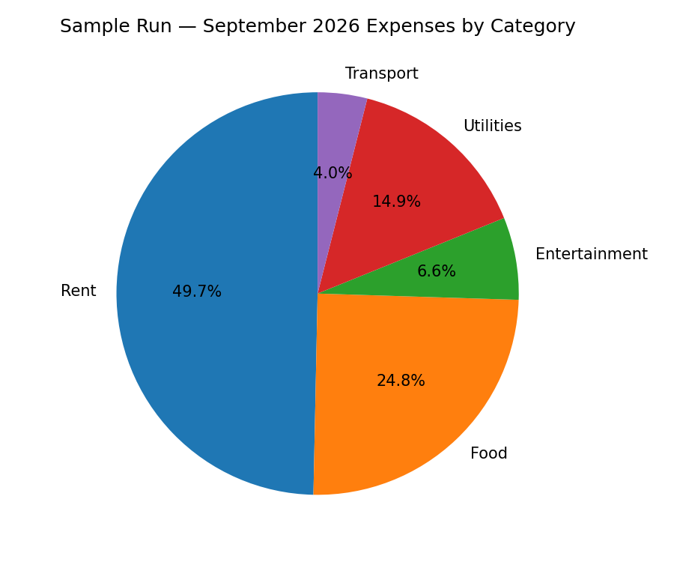

4. Bug / Fault Report
Two faults were deliberately reproduced and confirmed via the automated test suite during system testing, then corrected in the Maintenance phase (see Maintenance & Refactoring Report). Fault-find and fault-fix rates below are computed over this testing cycle.
Bug ID | Symptom | Root Cause | Detected By
BUG-01 | category_breakdown() showed 0 categories with expenses present; pie chart appeared empty | Filter condition inverted: checked r['type']=='income' instead of 'expense' in logic.py | test_category_normalisation_dedupes (unit test)
BUG-02 | Budget never showed 'warning' status even at 85-99% spend | Exceeded check used exact equality (ratio == 1.0) instead of threshold (ratio >= 1.0), so values >1.0 fell through and printed as 'ok'/'warning' inconsistently | test_budget_alert_statuses (unit test)
Fault-find rate: 2 faults / 20 test cases run = 10%. Fault-fix rate: 2 / 2 fixed and re-verified (100%) before the Phase 5 commit — see git log and bug_diff_before_fix.patch in this bundle for the exact before/after diff.

5. Code Complexity Metrics (radon)
Cyclomatic complexity (CC) was measured per function/method after the Phase 5 fixes. All 38 analysed blocks fall in radon's grade A or B band (CC ≤ 7), meaning every unit is simple enough to test exhaustively with a small number of test cases — no function requires more than 7 independent paths to cover.
Module | Avg. Complexity | Highest CC | Maintainability Index
src/db.py | A (1.4) | 3 (list_transactions) | A
src/logic.py | A (3.6) | 7 (import_csv) | A
src/ui.py | A (2.1) | 4 (_on_import) | A
Project average | A (2.39) | 7 | A across all files
import_csv() is the most complex unit (CC=7) because it must branch on per-row validation errors while continuing the loop — this matches the assignment's own framing of CSV import as a 'challenging part' of the system.

