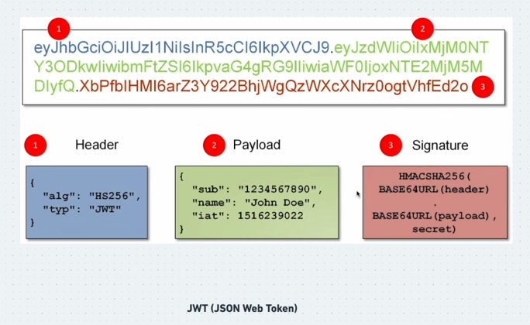

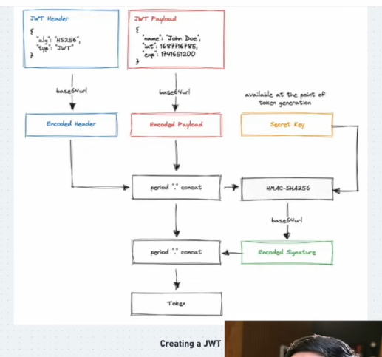

Header
Payload
Signature
Header.Payload.signature
Secret key makes signature
Header + payload + secret key = singature

