1. Go to **Add sale invoice.** Add fields of (Name, Father’s name, Address, License No., Date issued, Issued By). 2 more fields with checkbox if yes, Fields are (Purchasing Period Up To & Granted by) if not then don’t show in the invoice.
2. Also add fields in the sale invoice if check box yes then fields are (Permit no, Permit Issued Date, Permit Issued By) checkbox not then don’t add in the invoice
3. Customize Sale invoice PDF FILE as below for example the main data which my invoice should have. 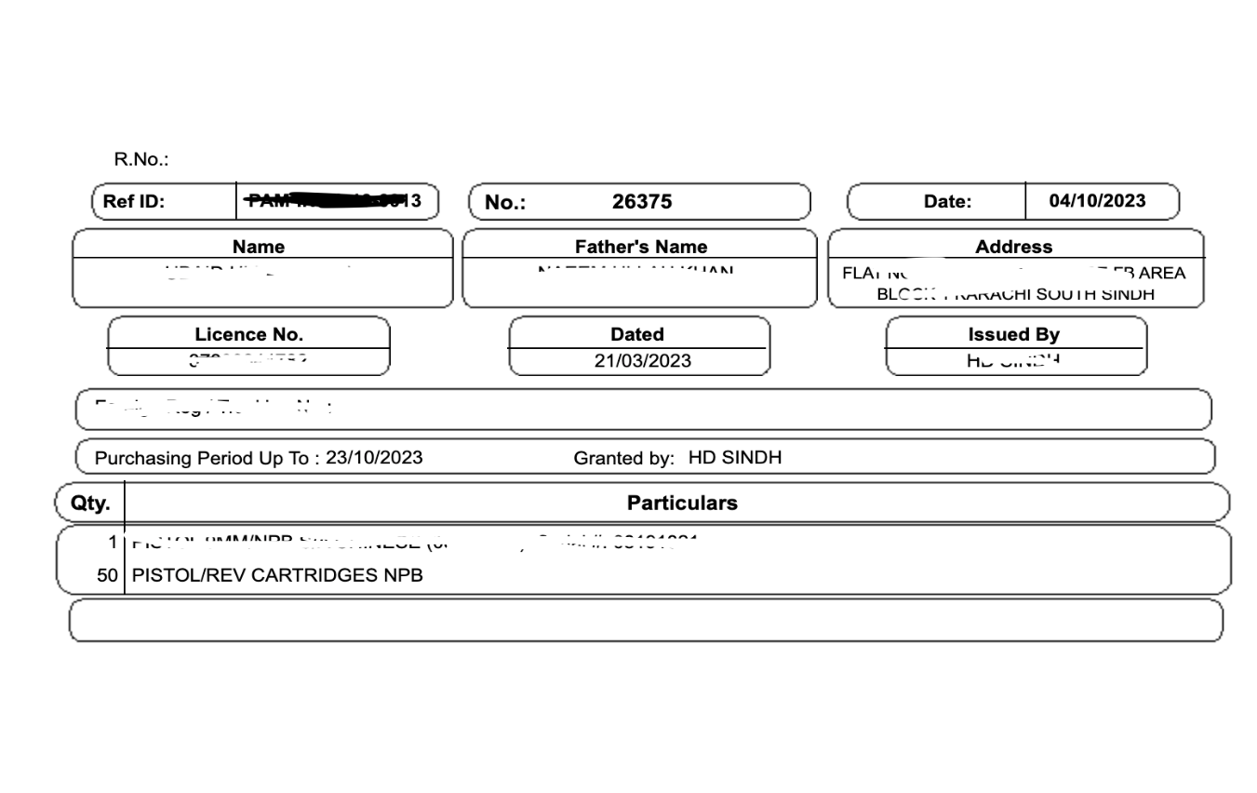
4. In Supplier add fields (License No., NTN No.)
5. Go to **ADD NEW PRODUCT** – add fields (Model Made, Caliber) also add them in the reports too. Filter for example I want to check what type of caliber were sold etc.
6. I want to track my inventory by serial numbers. In purchase order there should be column of serial numbers of add serial numbers.
7. Search product by serial number when adding product in the invoice it also should show in the print of invoice.
8. Search product by serial numbers in inventory section.
9. Search product by serial number to find which location product is in.
10. In Stock transfer stock movement should be done by serial numbers and also remove the price area or put as an option whether I want to show total price in the pdf or not. Also add time in the stock transfer.

**New Points**

1. Multiple serial number will be saved/edit and search by any of the serial number in quick add product in multiple places like purchase and stock transfer.
2. Muliple serial number option will be added in both quick add product and add product page.
3. While creating a quick add product you have to add a quantity to the main table of quick add product in purchcase and stock.
4. While creating a sale invoice specific serial number can be added and it will show in invoice.
5. Serial number can be added or removed when we add product from quick add product in purchase and quantity will change according to the number of serial numbers
6. When we search the product in add sale serial number can be selected in quick add product section and product quantity will be update according to the number of serial number selected.
7. Add that selected serial number in invoice created.

Reports

1. Stock in information with serial number
2. Stock out information with serial number
3. Current stock with serial number
4. Sales report with serial numbers
5. Purchase report with serial numbers

Note: date range should be the same it is in the current system