

Prepared by Shayan Siddiqui



DAY 6 - DEPLOYMENT

PREPARATION AND STAGING

ENVIRONMENT SETUP

## Day 5 Recap:

Day 5 focused on testing to ensure all marketplace components were functioning as intended. I conducted:

1. Functional testing to verify workflows, such as product listings, cart operations, and API interactions.
2. Performance testing using tools like Lighthouse to analyze speed, responsiveness, and load times.
3. Security testing to validate input fields, secure API keys, and ensure HTTPS implementation.
4. Comprehensive reporting to identify pending issues for future resolution.

# Day 6 - Deployment Preparation and Staging Environment Setup

## Today’s Objective:

### 1. Deployment Strategy Planning

* I chose a hosting platform called Vercel. Below is the link to my website

<https://fame-store.vercel.app>

* Finalize the application’s interaction with backend services such as Sanity CMS and third-party APIs.

### 2. Environment Variable Configuration

* Secured API keys, database credentials, and sensitive data using .env files.
* Configure environment variables in the hosting platform for secure deployment.

### 3. Staging Environment Setup

* Deploy the application to a staging environment to test it in a production-like setting.
* Validate that deployment builds successfully and the site loads correctly.

### 

### 4. Staging Environment Testing

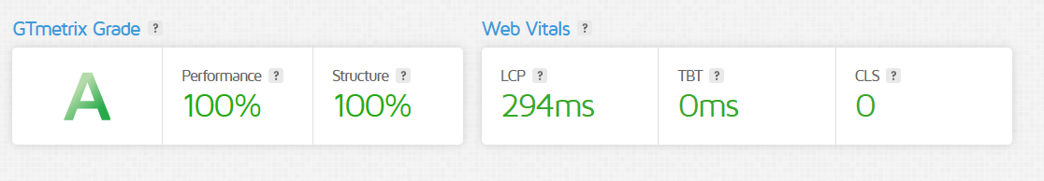

For further testing use pagespeed Insights

For desktop:

<https://pagespeed.web.dev/analysis/https-fame-store-vercel-app/jy7ecfrcpn?form_factor=desktop>

For Mobile:

<https://pagespeed.web.dev/analysis/https-fame-store-vercel-app/jy7ecfrcpn?form_factor=mobile>