I190749

Digital Image processing

Project Report

# CavityScope

## Introduction

CavityScope is a smart dentist that detects cavity present in teeth and also suggests braces for mal-positioned teeth. The detection of cavity alongside the detection of mal-positioned teeth are the main features of the app. The application is built on the web.

## Technology stack used

The application is built in Flask. For image processing tasks, Python and OpenCV is used. The frontend of the application is built using HTML, CSS and JavaScript. The backend is built using flask/python.

## Inputs

The app takes as input, the image that would be used for analysis run.

## OUtputs

The output is another image that identifies areas of damage and a report that provides details regarding the extent of damage.

## screens

### LOGIN page

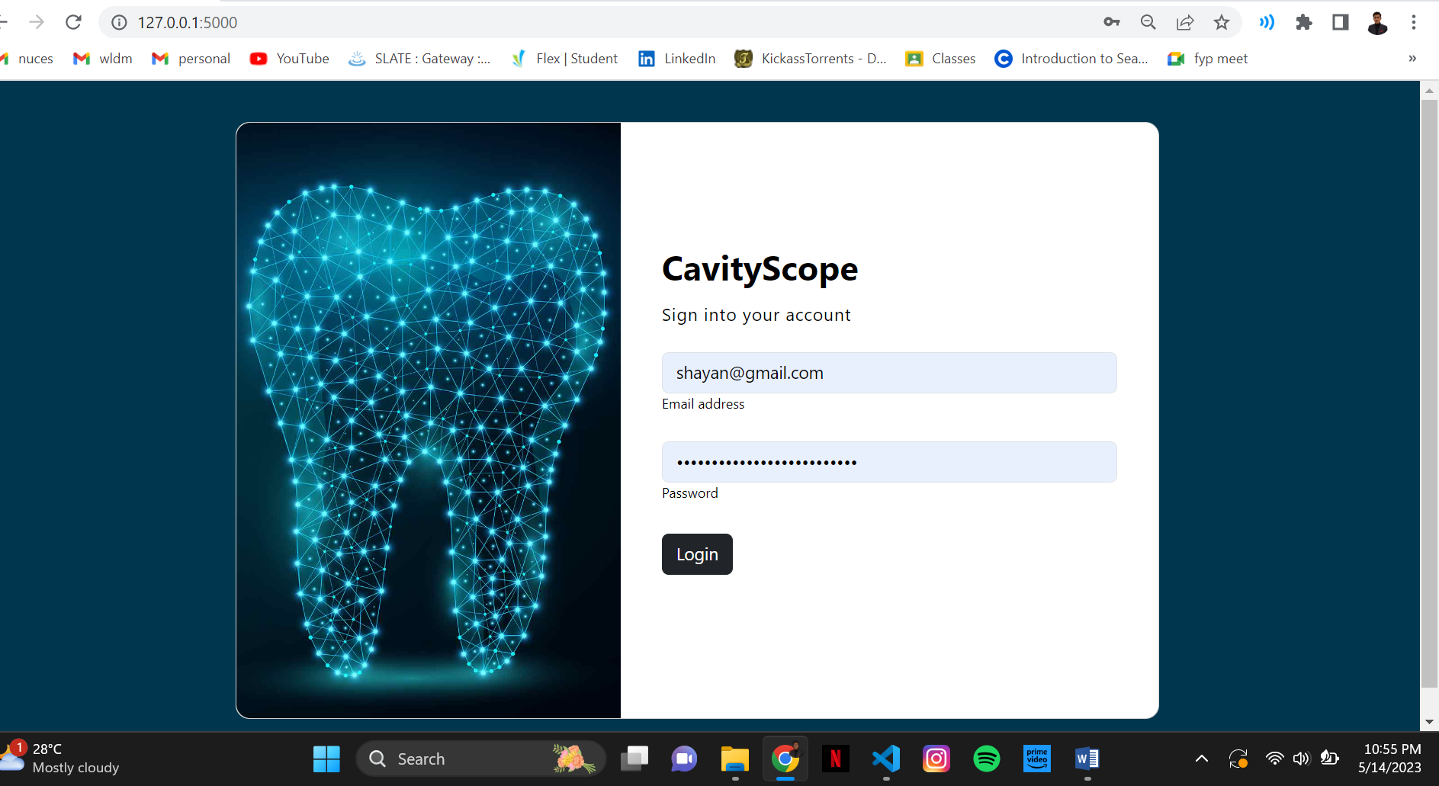

### Input image page

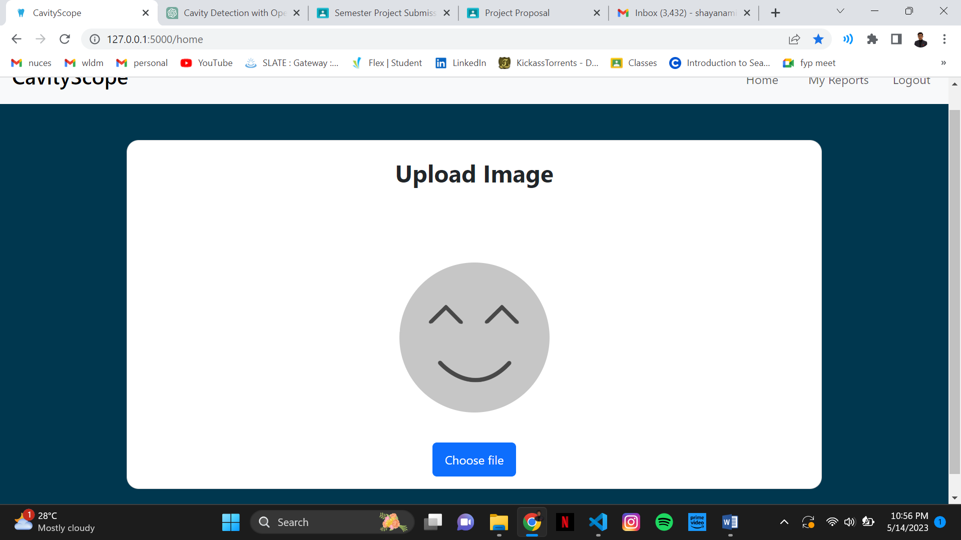

### OUPUT IMAGE PAGE

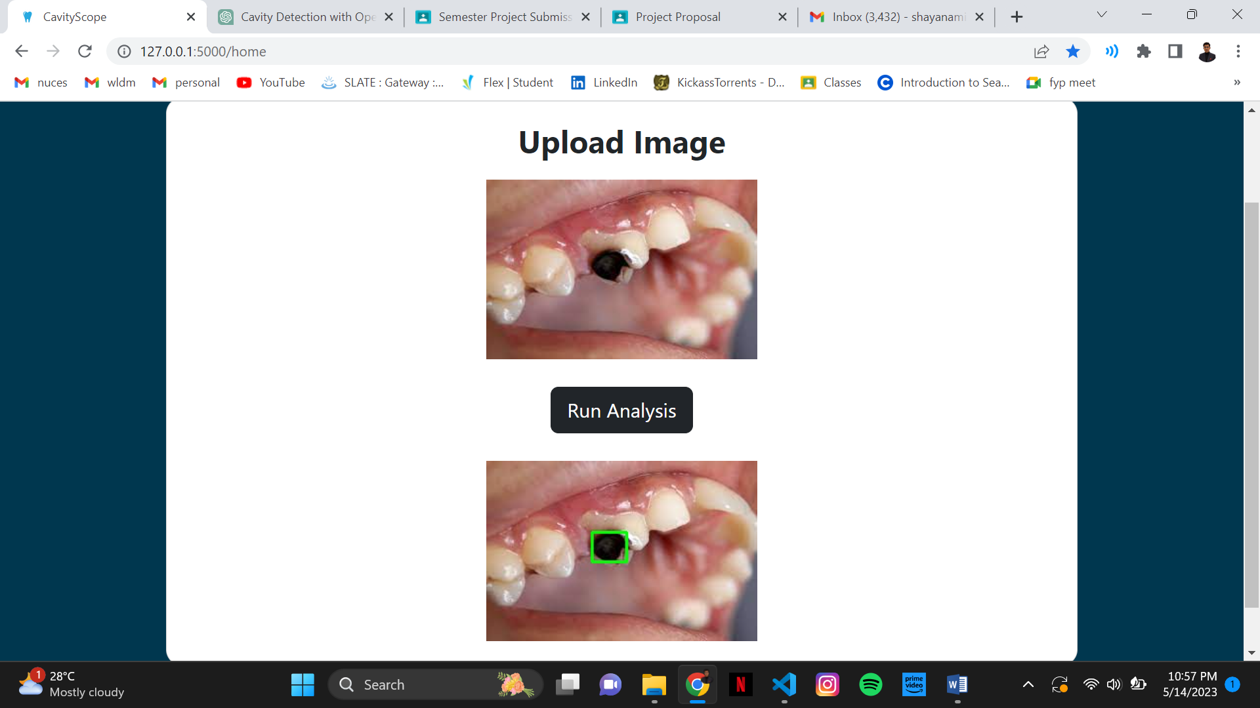

As we can see, the cavity in the teeth has been detected by the tool. Here are some code snapshots that are used to achieve the task.

### Getting the image from the frontend using post request

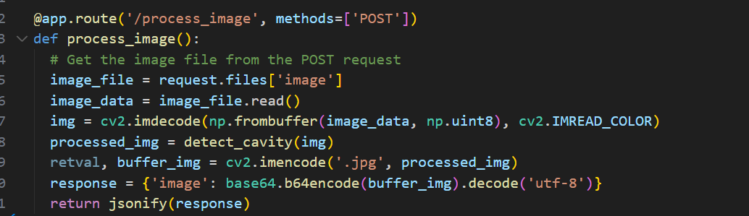

### Performing image processing operations

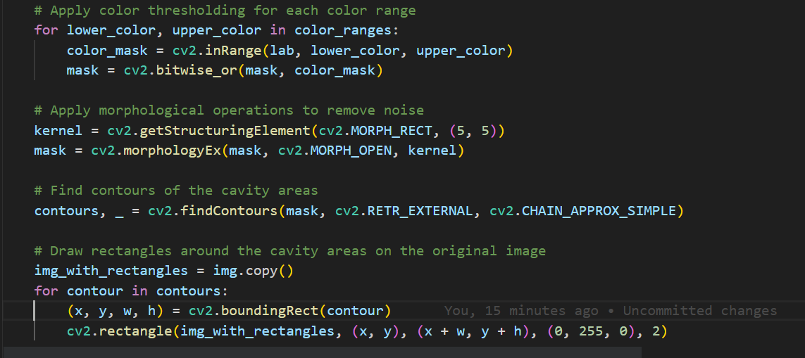

## improvements

Overall, there are many improvements that shall be considered for the app. The GUI can be improved and the performance of image processing techniques can be improves to increase accuracy.