B.Sc. (Hons) in Software Development

Applied Project & Minor Dissertation

Project Proposal

Each student must complete the following form and submit it to their supervisor for consideration. Once your supervisor has signed-off on the proposal, you must submit the document for consideration using Moodle.
Shayanny
- Student Name:
- Supervisor Name:
Daniel Cregg
- Project Name:
CoWrite – Cooperative Concurrent Writing Application

- Project Context
Describe the context of the problem domain here. Explain what you are proposing to do and your rationale for doing it. Explain why the problem domain is of interest.
Real-time collaborative editing has become essential in modern digital workflows, enabling teams to work together seamlessly regardless of physical location. My project idea, CoWrite is a web-based collaborative document editor that addresses the challenge of maintaining document consistency across multiple concurrent users. Google Docs demonstrate the value of this approach quite well and inspired this idea.

CoWrite is intended for collaborative scenarios like group projects between students or even real-time document review sessions between teachers and students online or any situation where multiple users need to work on the same document concurrently.

It allows people to create an account where they can create and edit documents with other users at the same time by generating a QR code as a secure temporary invitation token. Users can also communicate in an integrated discussion box without leaving the editing interface .

The reason I have an interest in this problem domain is that I’ve never worked with concurrency or anything “multiplayer”, I know it’s one of the harder things to implement as a developer and see it as a great learning opportunity. As for the document editor aspect, I find it a useful tool I could use myself and I have previously worked with implementing a canvas , different brush styles and saves in a project so I figured this would be the next logical step up.

The main technical challenge I want to tackle in this project is solving real-time synchronization problems that arise when multiple users edit the same document simultaneously. For example, what happens when one user deletes text that another user is currently typing? How do I handle overlapping edits without creating conflicts or losing data? How do I deal with the network latency while maintain document integrity and providing immediate visual feedback for all currently connected users?

This problem domain offers valuable learning opportunities in WebSocket communication, state management, conflict resolution strategies, and distributed systems design , all of which are fundamental skills in modern software development.

- Project Objectives
Write out the key objectives of the project as bullet points. Each objective should be clear, realisable and measurable / testable, i.e. the success of your project is determined by the degree to which these are realised.

Primary (Must Have):
- User set up and authentication
- Document CRUD ( Create , Read , Update , Delete)
- Real-time Collaborative editing ( at least 4 simultaneous users)
- Unique URL invitations
- Discussion box
- < 300ms edit latency

Secondary (Should Have):
- User presence indicators (online status or cursors)
- QR Code invitations
- Basic permissions (owner/editor/viewer)
- Document Version history

Stretch Goals (If Time Permits):
- PDF Export
- Offline Syncing

- Technologies & System Architecture
Explain the technologies you are going to use and why you selected them. These include the programming languages, operating systems, presentation and storage technologies and any cloud / 3rd party libraries / services that you intend to use.
Frontend Technologies:
React with Typescript
- I'm already comfortable with React from previous coursework, so it makes sense to build on that foundation rather than learning a new frontend framework. TypeScript will help catch errors early, especially important when dealing with real-time WebSocket communication where bugs can be tricky to debug.
Vite
- Modern build tool for React that provides fast development with instant hot reload. I chose it over older tools like Create React App because of its speed and performance.
Quill.js
- I chose Quill because I want to focus my time on solving the concurrency challenges, not building a text editor from scratch. I have previous experience working with canvas elements and drawing tools, so working with a rich text editor feels like a natural next step. Quill's Delta format also structures changes in a way that makes synchronization easier to implement.
Native WebSocket API
- It’s built into browsers, so no extra dependencies needed. Keeps things simple while still providing the real-time communication I need for collaborative editing.
Backend Technologies:
Go (Golang)
- This is my first time using Go, which is part of why I chose it - I want to learn something new and challenging. Go's reputation for excellent concurrency support with goroutines makes it ideal for handling multiple simultaneous WebSocket connections.
Gorilla WebSocket
- Since I've never worked with WebSockets before, I figured I’d use the standard WebSocket library for Go with good documentation and examples.
PostgreSQL
- I've used SQL databases before (and also MongoDB and Firebase), so PostgreSQL feels like a logical choice. It's reliable for storing users, documents, and permissions with proper relational structure.
Redis
- This is new to me, but I need it for fast session management and real-time features. Redis's speed (sub-millisecond) is crucial for hitting my 300ms synchronization target. I’ll keep temporary data (online users) and permanent (accounts , documents) separate using this.
JWT (JSON Web Tokens)
- I've only used Firebase Auth before, so implementing authentication myself will be a valuable learning experience. JWT is industry standard and works well with Go and React. Building this from scratch will help me understand how authentication actually works.
Synchronization & Concurrency:
Google Diff-Match-Patch
- Diff-Match-Patch is my chosen concurrency strategy because it allows me to focus on building a complete system while still tackling real synchronization challenges like handling overlapping edits and simultaneous deletions. Using Google's Diff-Match-Patch library as a foundation is achievable while still letting me build custom conflict resolution logic on top to manage these scenarios.
Infrastructure:
Docker
- I'm new to Docker, but it's essential for modern development. It ensures my entire stack (React, Go, PostgreSQL, Redis) runs consistently across different environments and makes deployment simpler.

- Schedule of Work
Using a Gantt chart or tabular format, outline your schedule of work for all the key project activities, deliverables and dates.
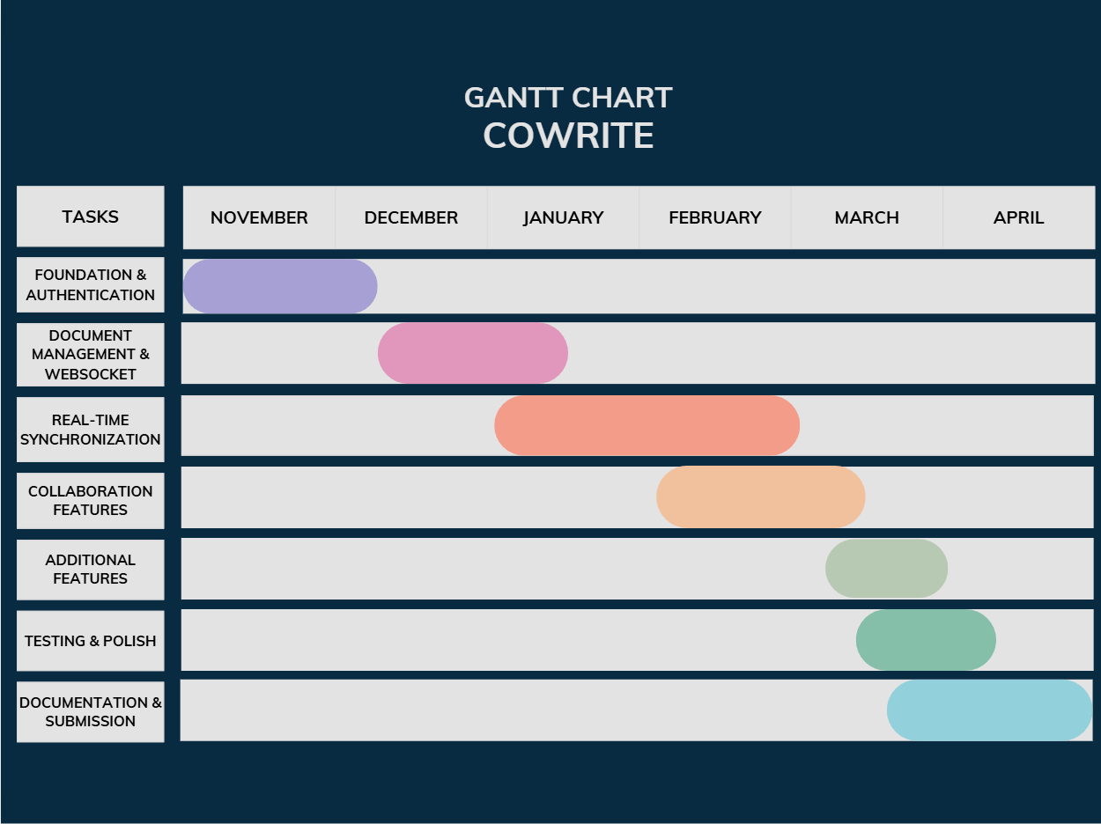

Task Breakdown:
Foundation & Authentication (November) - User registration/login with JWT, PostgreSQL setup, authentication middleware
Document Management & WebSocket (December - Early January) - Document CRUD operations, Quill.js integration, WebSocket connection establishment. Christmas Seminar: Working prototype delivered.
Real-Time Synchronization (January - February) - Diff-Match-Patch implementation , conflict resolution logic, multi-user testing.
Collaboration Features (February - March) - User presence indicators, discussion box, performance optimization
Additional Features (March) - QR codes, permissions system
Testing & Polish (March - April) - Comprehensive testing, bug fixes, code cleanup
Documentation & Submission (April) - Dissertation writing (10,000-15,000 words), A0 poster, demonstration video, final submission
Key Milestones:
- December 20: Semester 1 Review
- April 25: Final Submission
- May: Viva Voce

