COMP3133 Assignment 1 Submission Screenshots
Employee Management System (NodeJS + Express + GraphQL + MongoDB)

Student ID: 101474651
GitHub Repo: COMP3133_101474651_Assignment1

1) MongoDB Console Screenshots
- Screenshot of MongoDB database showing the database name and collections (users, employees).
- Optional: screenshot of a sample document in each collection.
Paste screenshots below (label each image with a caption).
MongoDB - Database & Collections
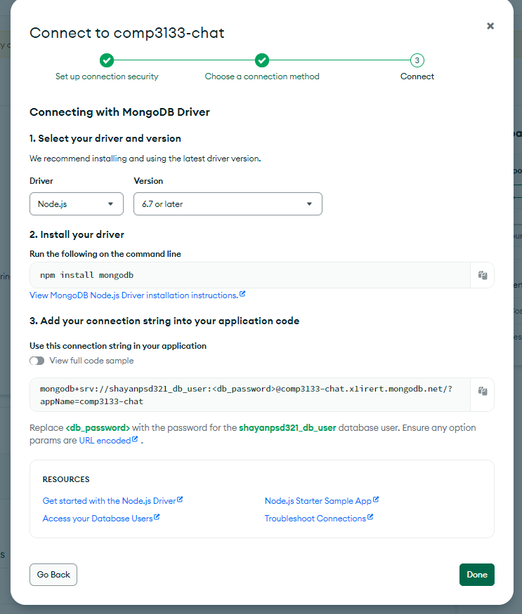
2) GraphQL API Testing Screenshots (Postman or GraphiQL)

API 0- loading
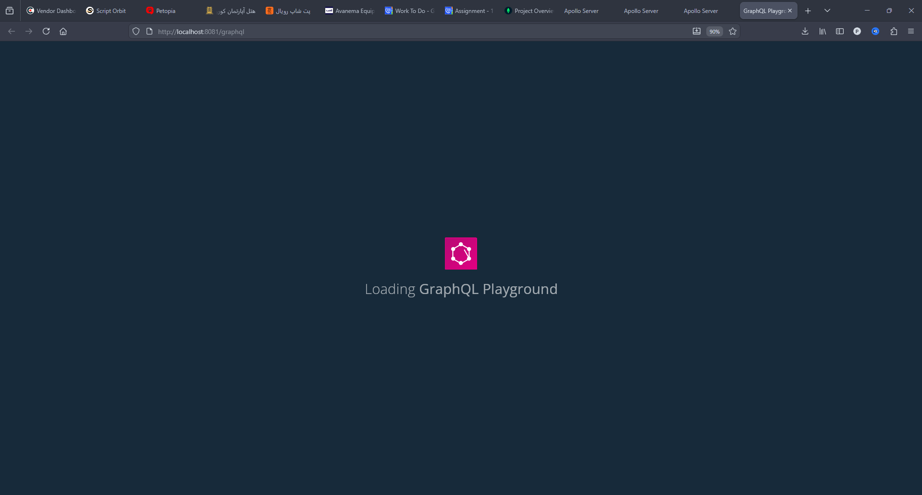
API 1 - Signup
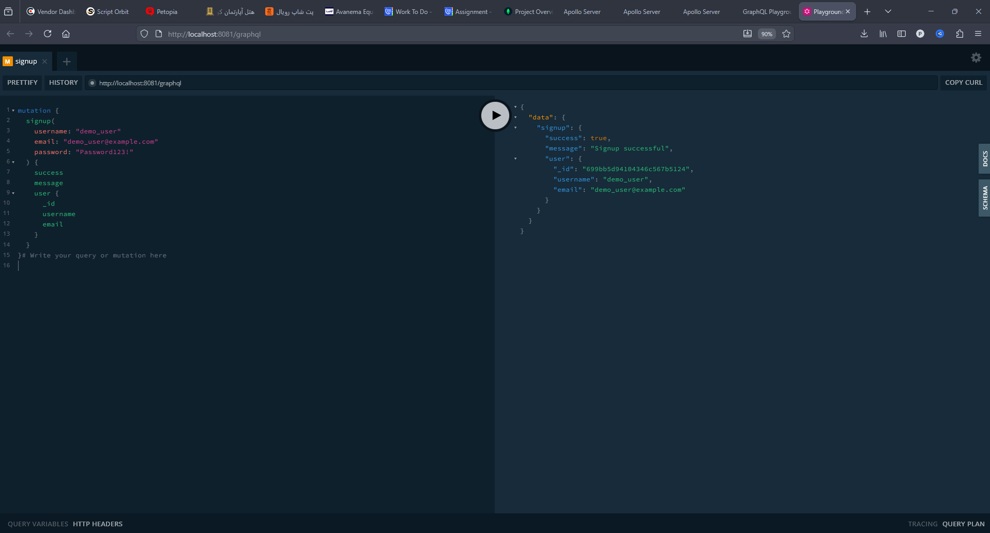

API 2 - Login
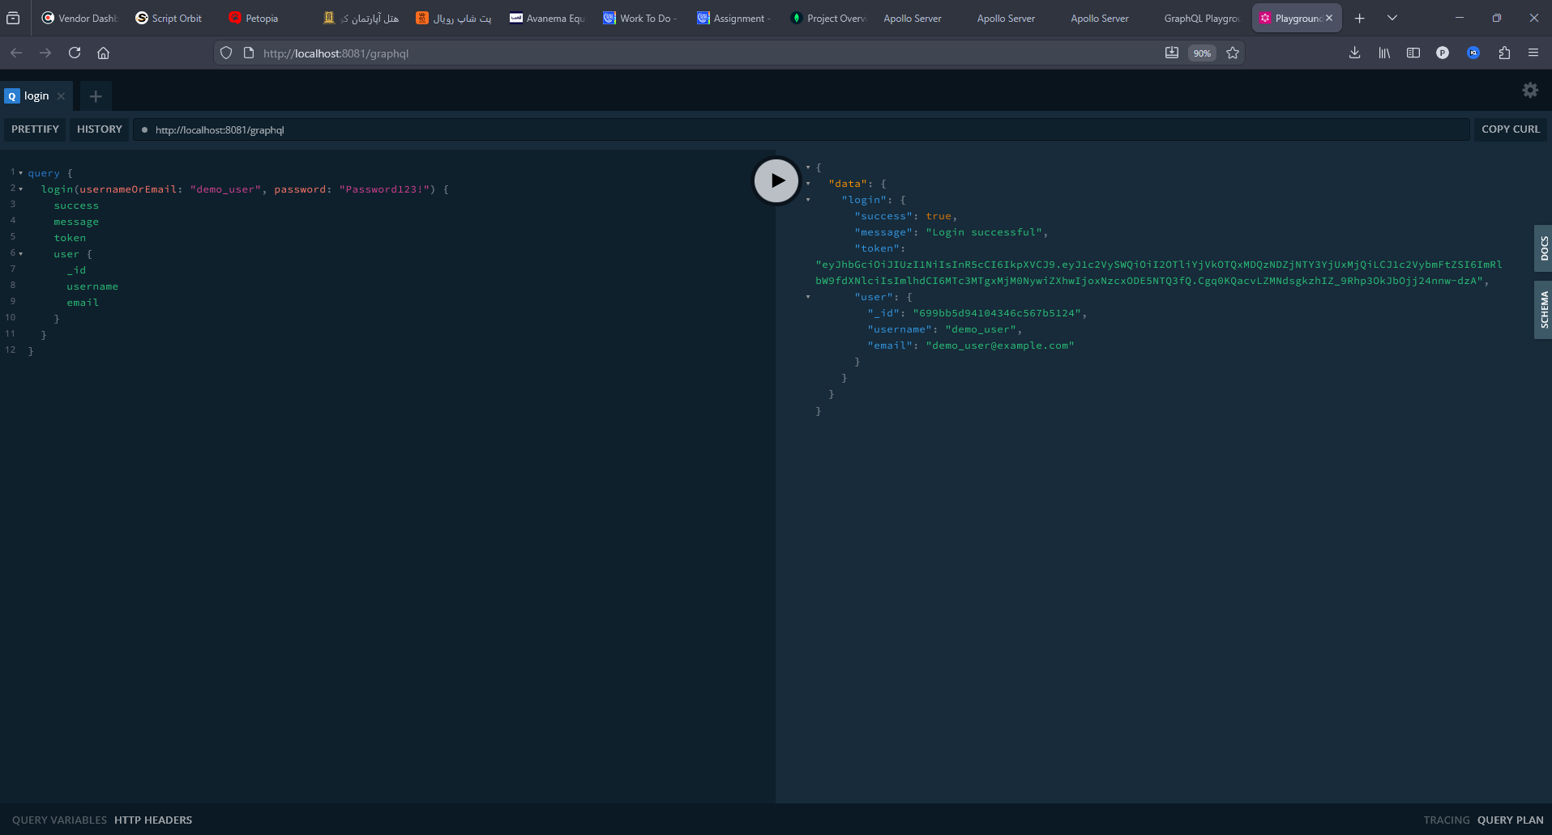
API 3 - Get all employees
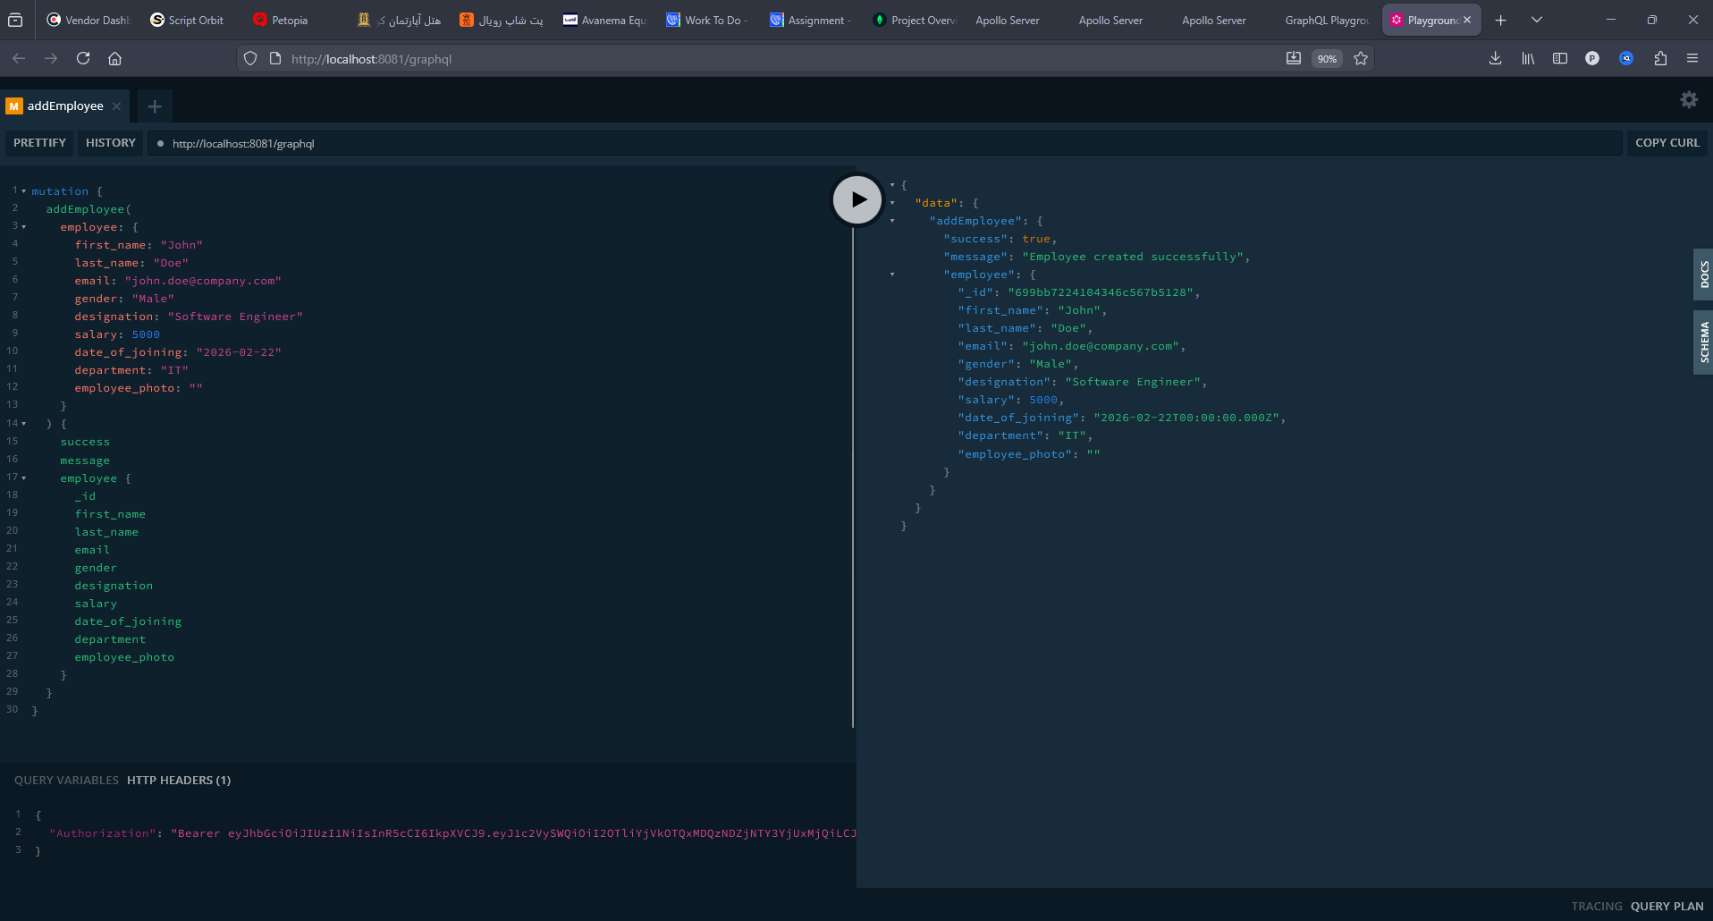

API 4 - Add new employee
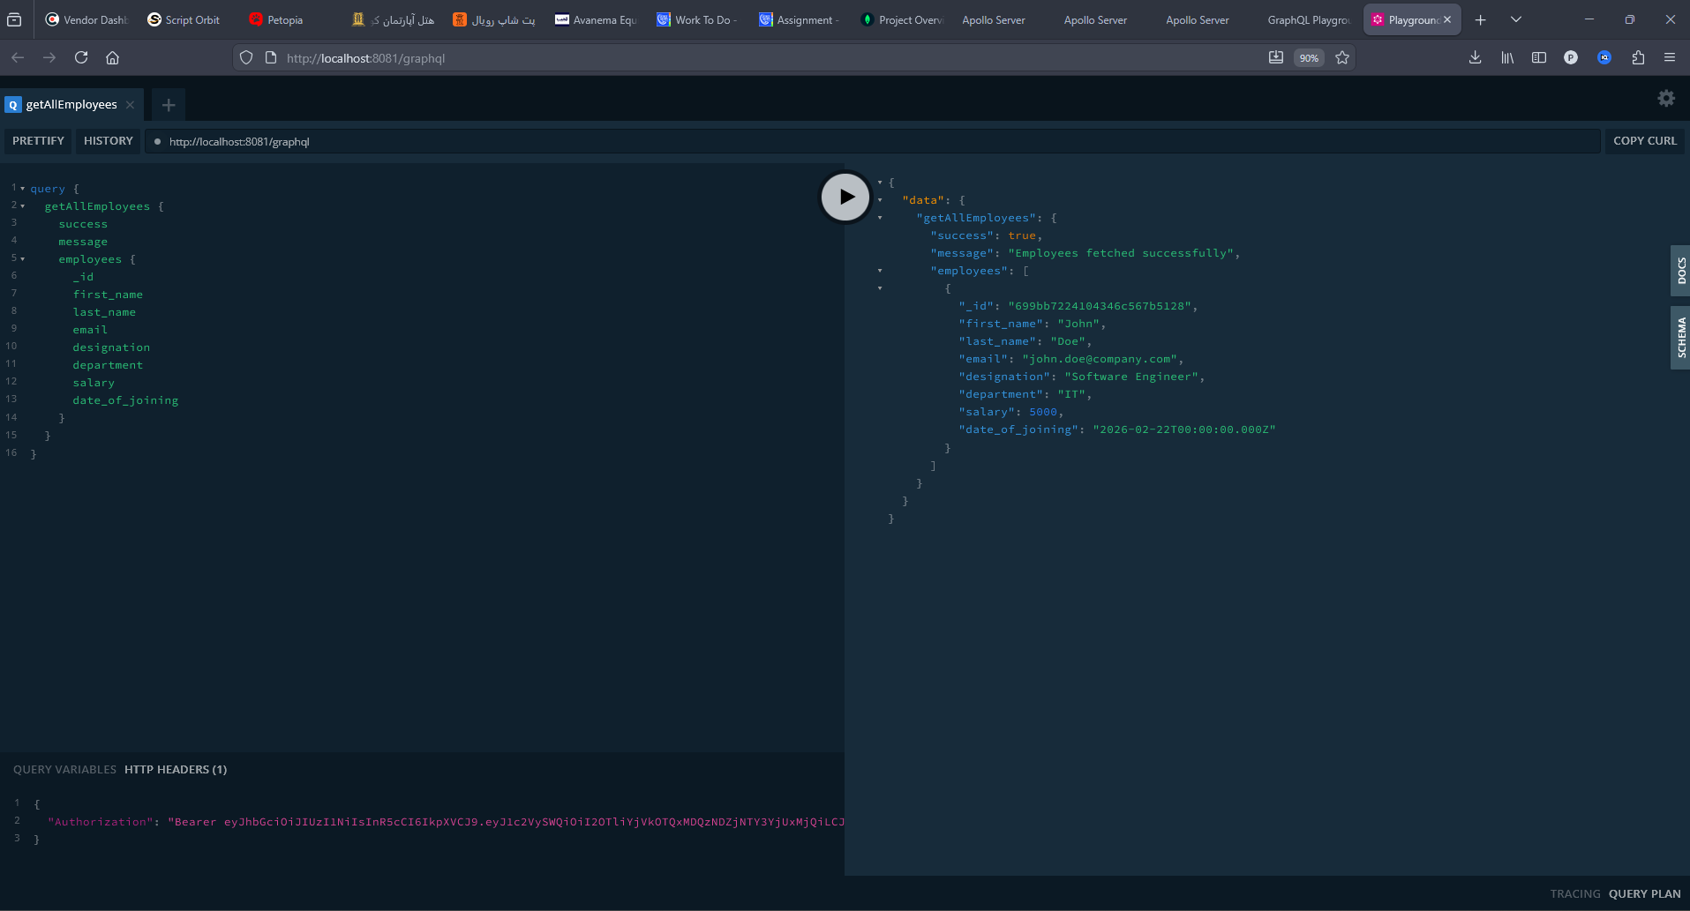
API 5 - Search employee by EID
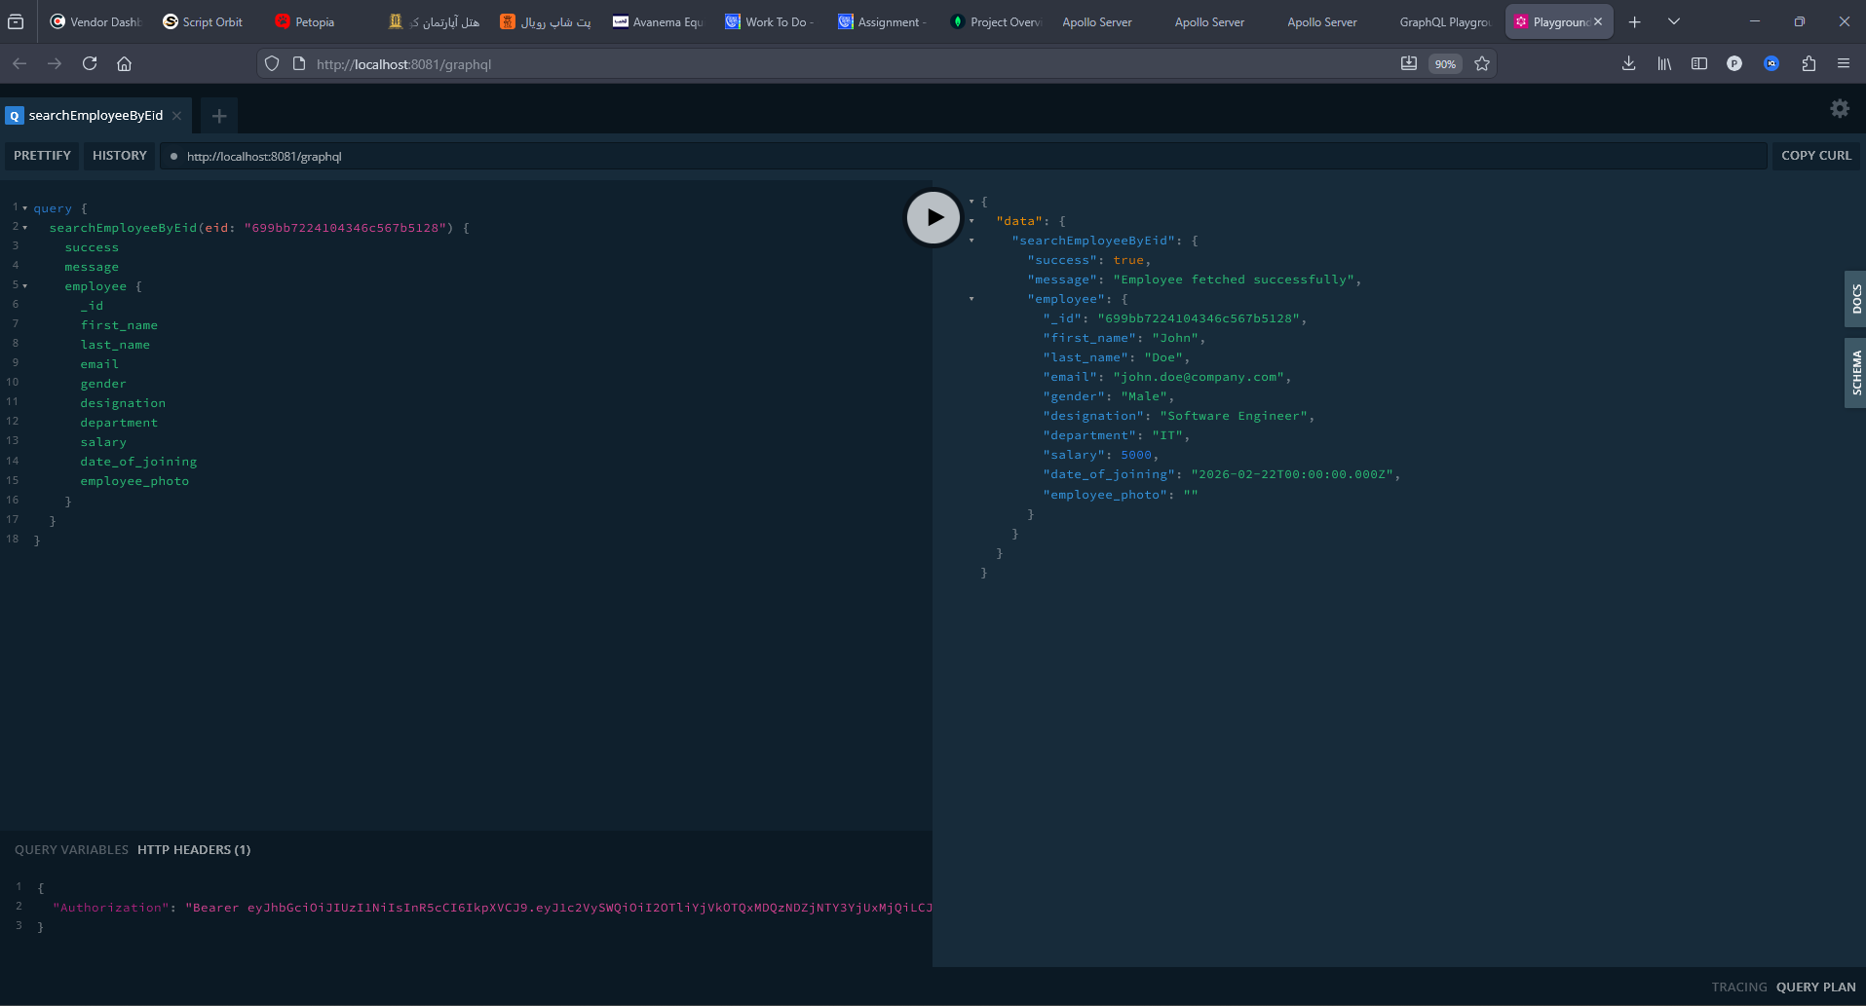

API 6 - Update employee by EID
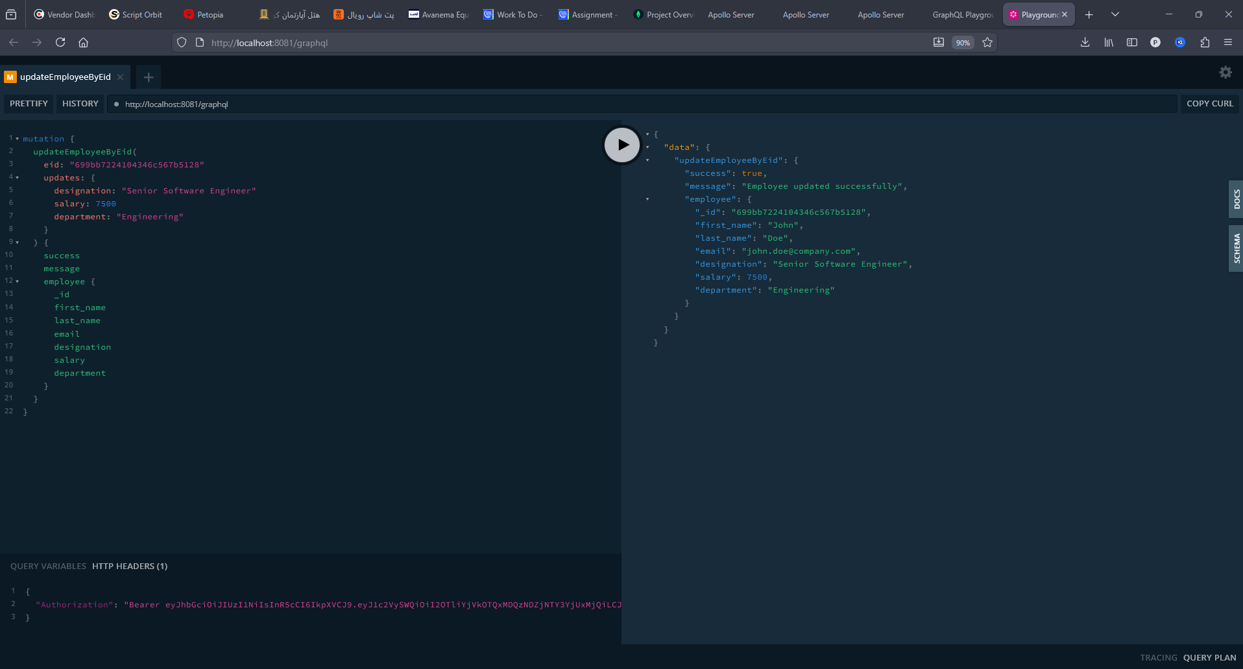
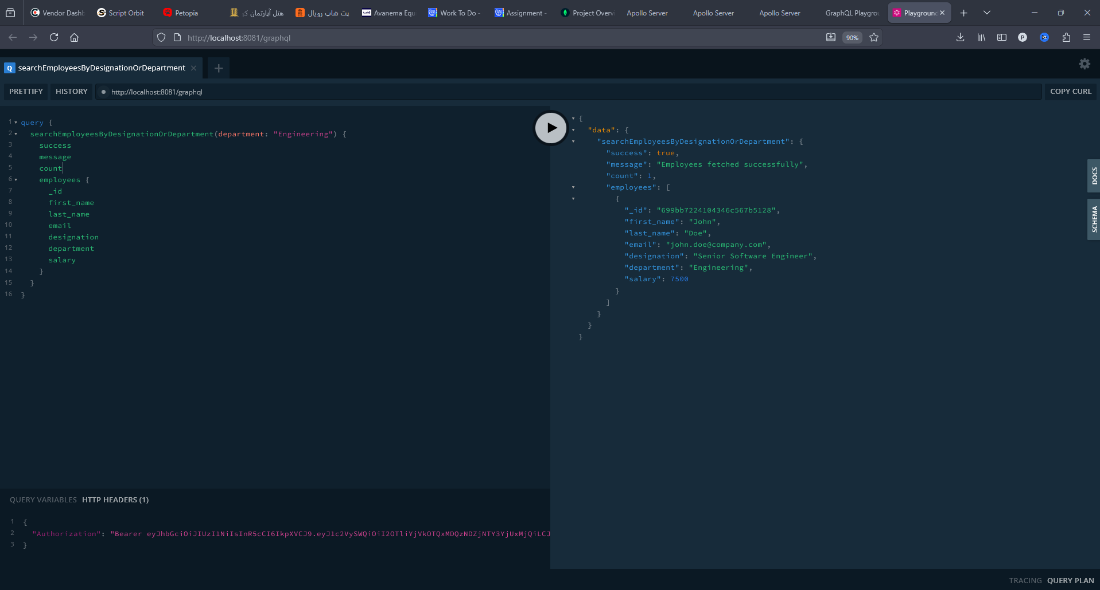
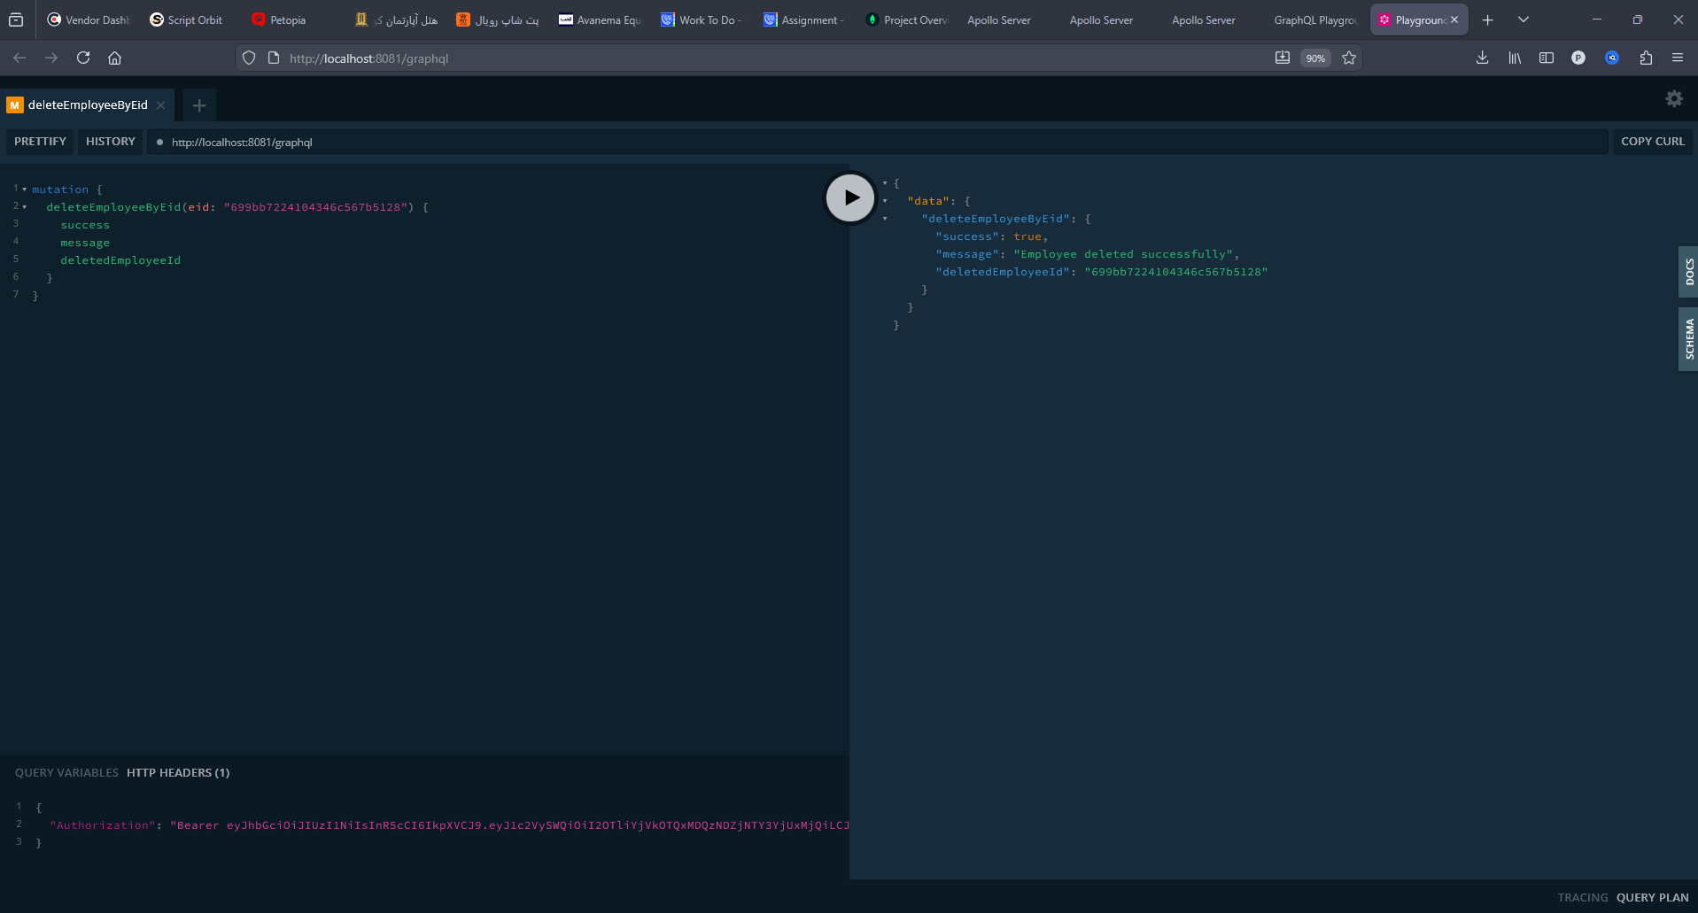

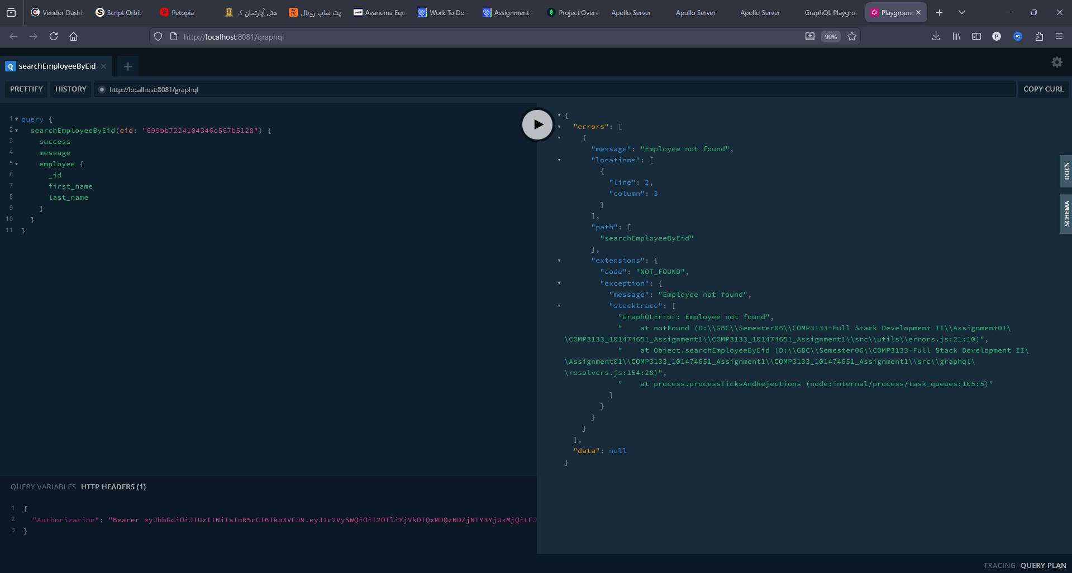

3) Postman Collection Export
