DS Assignment REPORT



**Muhammad Idrees Khan , Muhammad Nameer Khan**

CY-B-22i-1747-22i-1695

# INTRODUCTION

Overview

The Cloud Manager is a C++ program designed to simulate the management of cloud machines, job prioritization, and fault tolerance in a cloud computing environment. The system consists of several classes representing key components such as jobs, virtual machines (VMs), a priority queue for job prioritization, and a cloud resource manager.

# 2. Key Features

# 2.1 Job Class

- Represents a job with attributes such as JobID, Priority, Ram, Processor, RTC, and execution timings.

- Supports methods for setting job details, displaying job information, and tracking execution start and end times.

#### 2.2 Priority Queue Class

- Implements a priority queue data structure for job prioritization based on job priority.

- Uses heap operations (heapify up and heapify down) to maintain the priority order.

- Allows enqueueing and dequeuing jobs with the highest priority.

# 2.3 VM Class

- Represents a virtual machine with attributes such as available RAM, processor, real-time clock (RTC), and a list of currently running jobs.

- Supports methods for displaying VM resource information, sending job requests to the VM, and managing job capacity.

# 2.4 CloudResourceManager Class

- Manages cloud resources, including virtual machines.

- Handles the addition of jobs to VMs, monitors resource capacity, and requests a new VM if needed.

# 2.5 Controller Class

- Coordinates the overall functionality of the system.

- Reads job information from a file, prioritizes jobs using a priority queue, and sends jobs to VMs.

- Implements fault tolerance mechanisms for handling jobs that exceed specified limits.

- Logs job execution timings to a logfile.

# 2.6 Main Functionality

- The system provides a menu-driven interface allowing users to:

- Run Cloud Machines: Prioritize and send jobs to VMs.

- View Logfile Data: Display details of job execution timings from the logfile.

- Exit: Terminate the program.

### 3. Additional Information

# 3.1 File Input

- The system reads job information from a file named "jobs.txt."

- Each line in the file represents a job, including JobID, Priority, Ram, Processor, and RTC, separated by commas.

# 3.2 Color-Coded Output

- The console output is color-coded for better visibility.

- Green: Informational messages.

- Red: Fault tolerance messages.

- Purple: Execution time details.

# 3.3 Logging

- The system logs job execution timings, including start time, end time, and execution duration, to a file named "logfile.txt."

# 3.4 Fault Tolerance

- The system applies fault tolerance by skipping jobs with specific conditions, such as exceeding RAM, processor, or RTC limits.

- The skipped job details are displayed in red.

# 4. Usage Instructions

1. Compile the code using a C++ compiler.

2. Run the executable.

3. Choose options from the menu to simulate the cloud management system.

# Sample Input

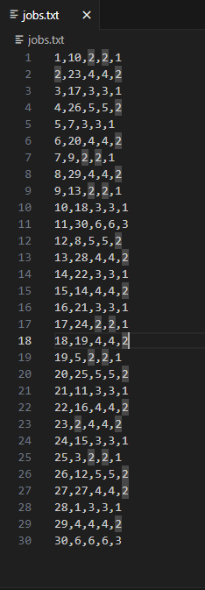

# Sample Output

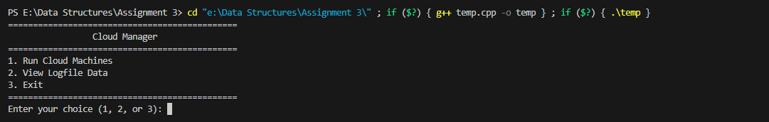

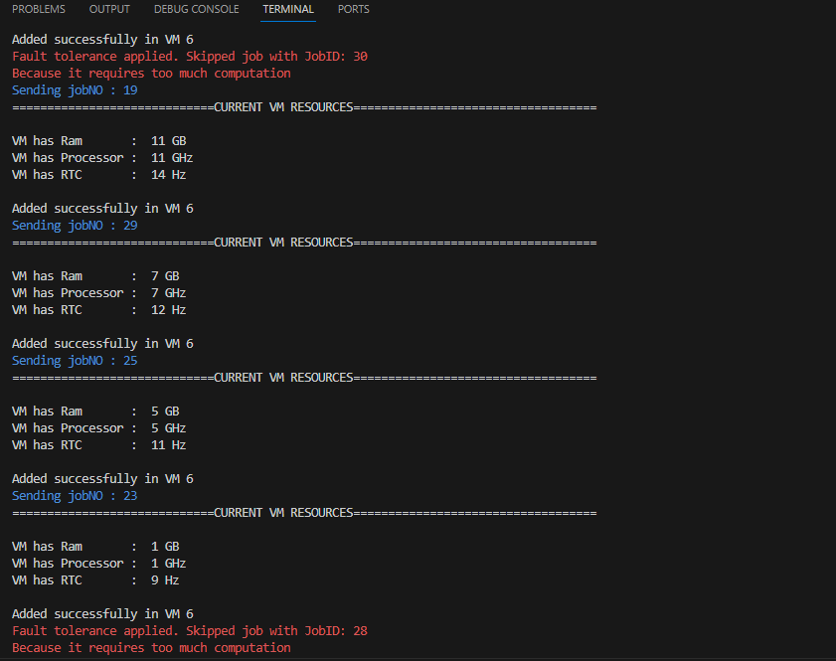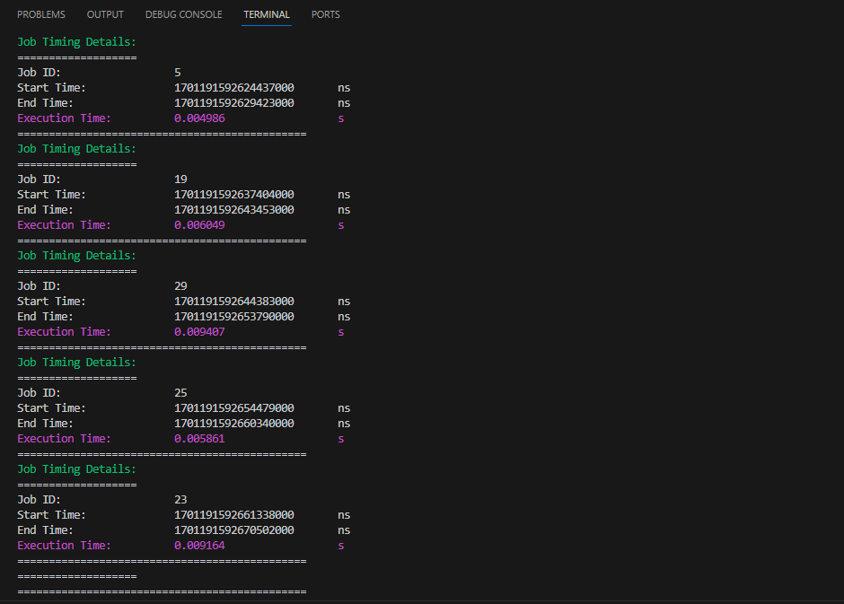

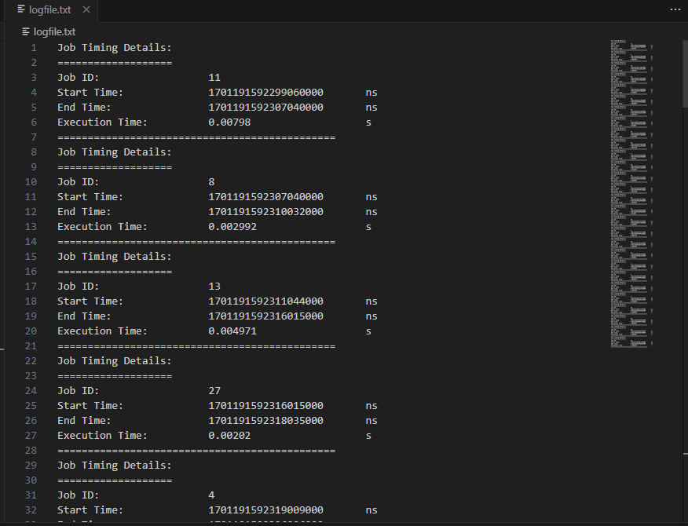

# CONCLUSION

The Cloud Manager provides a simulation of cloud resource management, job prioritization, and fault tolerance. It offers a user-friendly interface for interacting with the system and viewing relevant information. The color-coded output enhances the readability of the console messages. The system's modular design allows for easy expansion and modification to suit specific requirements.