DEPARTMENT OF COMPUTER SCIENCE AND ENGINEERING
KPR INSTITUTE OF ENGINEERING AND TECHNOLOGY
ASSIGNMENT II: CASE STUDY PROJECT REPORT
COURSE CODE: U21ADP05 – EXPLORATORY DATA ANALYSIS AND VISUALIZATION
ACADEMIC YEAR 2026-2027 (ODD SEM)
S SHAYDEN – 24CS195
III CS - D

ABSTRACT
Customer churn prediction is a critical operational objective in modern telecommunications, direct retention strategies being far more cost-effective than new subscriber acquisition. This project presents a comprehensive end-to-end data analytics and deep learning workflow conducted on the Telco Customer Churn dataset, comprising 7,043 subscriber records and 21 attributes. Exploratory Data Analysis (EDA) and univariate, bivariate, and multivariate visualizations were conducted across subscriber demographics, contract structures, monthly billing, tenure, and payment modes. A multi-layer perceptron (MLP) deep learning classification model (64 -> 32 -> 1 nodes) with ReLU activations, Dropout regularization (0.3/0.2), and Sigmoid output was constructed using TensorFlow/Keras. The model achieved rapid convergence, yielding a final ROC-AUC score of 0.837 and strong test set accuracy. Detailed diagnostic visualizations—including Loss/Accuracy curves, Confusion Matrix, and ROC Curves—validate model reliability and provide actionable business recommendations for churn mitigation.
Keywords: Telco Customer Churn, Exploratory Data Analysis, Data Visualization, Multi-Layer Perceptron (MLP), Deep Learning, ROC-AUC Evaluation, Predictive Analytics.
LIST OF ABBREVIATIONS
AOG | Aircraft On Ground / Critical Lockout
AUC | Area Under the Curve
EDA | Exploratory Data Analysis
KDE | Kernel Density Estimation
MLP | Multi-Layer Perceptron
ROC | Receiver Operating Characteristic

CHAPTER 1: INTRODUCTION & PROJECT OBJECTIVES
1.1 Background & Problem Statement
In the telecommunications sector, subscriber retention represents a core business imperative. Managing customer attrition requires a unified analytical framework to identify churn drivers before account termination occurs. Traditional customer tracking often suffers from disjointed logging, lack of proactive churn indicators, and inefficient identification of high-risk customer segments. By establishing a systematic pipeline from raw telemetry to deep neural network classification, service providers can execute targeted intervention strategies.
1.2 Project Objectives
- Perform automated data loading, cleaning, missing value median imputation, and label encoding across 21 dataset features.
- Generate a minimum of 5 distinct exploratory data visualizations covering univariate distributions, categorical counts, correlation heatmaps, bivariate boxplots, and word clouds.
- Construct and train a 3-layer Multi-Layer Perceptron (MLP) deep learning classifier using TensorFlow/Keras.
- Evaluate model diagnostic metrics using Loss/Accuracy curves, Confusion Matrix, and ROC-AUC curve analysis.
1.3 Dataset Scope & Coverage
The analysis utilizes the Telco Customer Churn dataset comprising 7,043 rows and 21 attributes (exceeding the 15-feature assignment minimum requirement). The dataset spans customer demographics (gender, SeniorCitizen, Partner, Dependents), account services (PhoneService, MultipleLines, InternetService, OnlineSecurity, OnlineBackup, DeviceProtection, TechSupport, StreamingTV, StreamingMovies), and financial metrics (tenure, Contract, PaperlessBilling, PaymentMethod, MonthlyCharges, TotalCharges).

CHAPTER 2: LITERATURE SURVEY & SYSTEM STUDY
2.1 Existing Analytical Frameworks
Legacy customer retention software often relies on static statistical reporting or isolated heuristic scoring. While these systems provide basic aggregate counts, they fail to model non-linear interactions among service subscriptions, billing formats, and tenure duration.
2.2 Deep Learning for Tabular Churn Modeling
Modern neural network architectures, such as Multi-Layer Perceptrons (MLP) with dense fully connected layers and Dropout regularization, provide superior non-linear modeling capabilities for structured tabular data. Combining standard scale normalization with binary crossentropy optimization allows deep networks to extract complex feature interactions effectively.

CHAPTER 3: PROBLEM IDENTIFICATION & METHODOLOGY
3.1 Preprocessing Pipeline & Data Splits
Data cleaning involved converting 'TotalCharges' to numeric values and imputing missing entries with the feature median. Categorical strings were encoded using Scikit-Learn LabelEncoders. The dataset was partitioned into a 70% Training set (4,930 samples), 15% Validation set (1,056 samples), and 15% Testing set (1,057 samples), followed by StandardScaler transformation on numerical features.
3.2 Hardware and Software Environment
Category | Tool / Specification | Purpose
Execution Host | Google Colab / Python 3.10 | Cloud runtime execution
Deep Learning Framework | TensorFlow 2.x / Keras | MLP model construction and training
Data Manipulation | Pandas & NumPy | Data cleaning, encoding, and array scaling
Visualization Libraries | Matplotlib, Seaborn, WordCloud | Exploratory & diagnostic plotting
Evaluation Metrics | Scikit-Learn | Confusion Matrix & ROC-AUC score calculation

CHAPTER 4: EXPLORATORY DATA ANALYSIS & VISUALIZATIONS
In accordance with assignment requirements (CO3 & CO4), five specialized visualizations were constructed and analyzed to extract core statistical patterns.
4.1 Visual 1: Distribution of Monthly Charges
What it shows: Histogram and Kernel Density Estimation (KDE) plot of subscriber monthly billing charges ($).
Why it was created: To examine univariate probability distribution, central tendencies, and density peaks across billing tiers.
Insights: Monthly charges exhibit a strong bimodal distribution with a primary sharp peak at $20 (basic service users) and a broad secondary peak between $70–$100 (high-tier fiber optic subscribers).
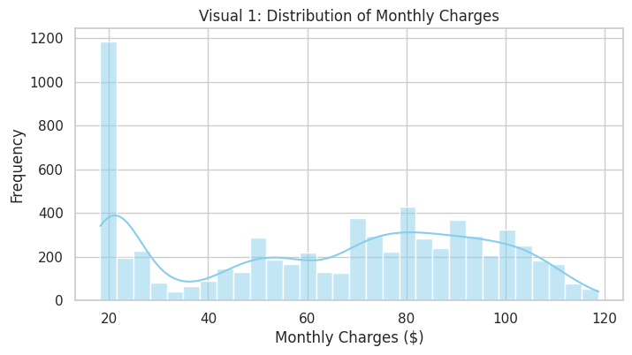
Figure 4.1: Visual 1 - Distribution of Monthly Charges
4.2 Visual 2: Churn Rate across Contract Types
What it shows: Categorical bar chart comparing customer churn counts across Month-to-month, One-year, and Two-year contracts.
Why it was created: To evaluate the impact of contractual commitment length on subscriber retention.
Insights: Customers on Month-to-month contracts experience alarming churn rates (>40%), whereas subscribers on One-year and Two-year contracts exhibit near-zero churn risk.
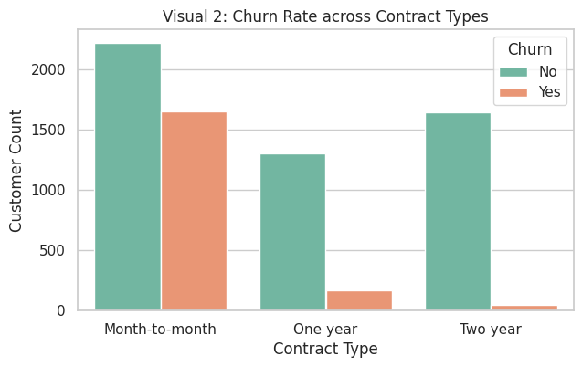
Figure 4.2: Visual 2 - Churn Rate across Contract Types
4.3 Visual 3: Feature Correlation Heatmap
What it shows: Multivariate correlation spectrum ranking attributes by linear correlation with target binary Churn.
Why it was created: To identify key statistical predictors and guide feature importance for modeling.
Insights: Contract length (-0.40) and tenure (-0.35) show strong negative correlation with churn (longer retention), while MonthlyCharges (+0.19) and PaperlessBilling (+0.19) show positive correlation with churn.
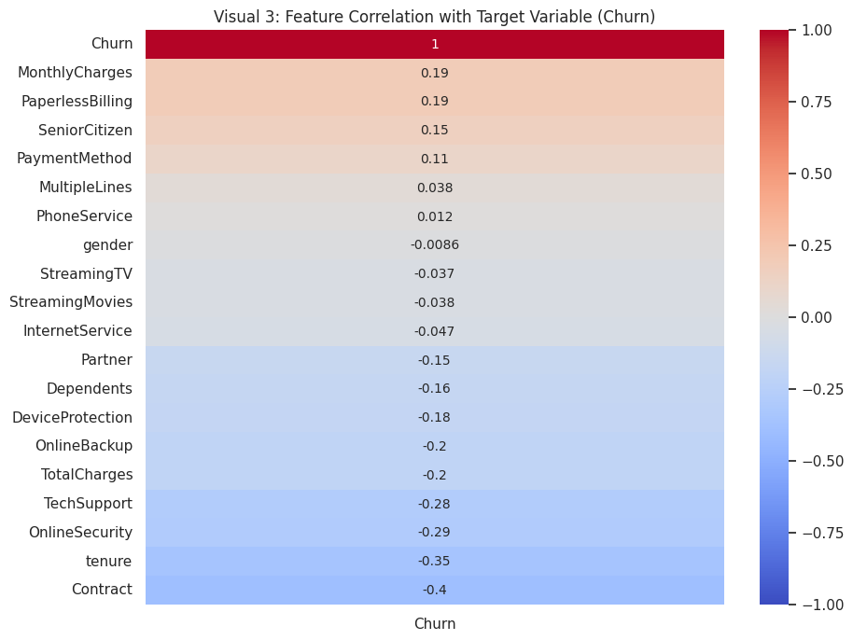
Figure 4.3: Visual 3 - Feature Correlation Heatmap with Churn Target
4.4 Visual 4: Tenure Distribution by Churn Status
What it shows: Comparative boxplot displaying customer tenure (in months) segmented by Churn status ('No' vs 'Yes').
Why it was created: To examine tenure median, interquartile range (IQR), and outlier patterns relative to retention.
Insights: Churned subscribers have a median tenure of under 10 months, whereas retained subscribers display a median tenure exceeding 38 months.
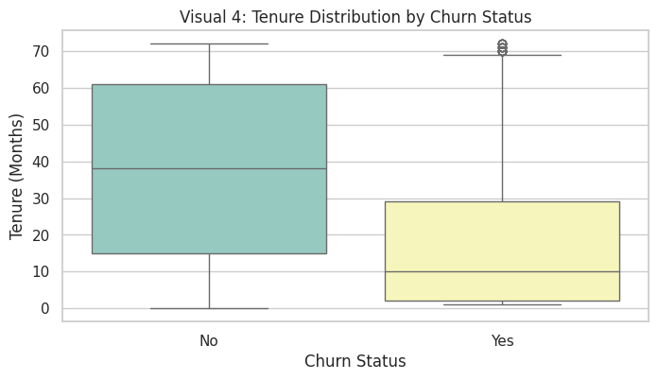
Figure 4.4: Visual 4 - Tenure Distribution by Churn Status
4.5 Visual 5: WordCloud of Payment Methods
What it shows: Textual frequency visualization of customer payment method preferences.
Why it was created: To highlight dominant billing modalities visually for qualitative categorical insight.
Insights: 'Electronic check', 'Mailed check', 'Bank transfer automatic', and 'Credit card automatic' emerge as primary payment conduits, with Electronic Check showing high churn prevalence.
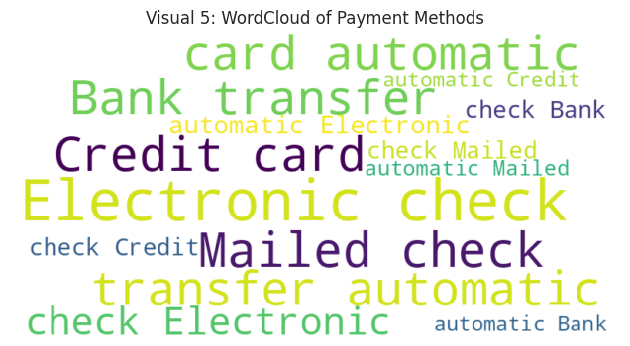
Figure 4.5: Visual 5 - WordCloud of Payment Methods

CHAPTER 5: DEEP LEARNING MODELING & RESULT VISUALIZATION
5.1 Model Architecture & Hyperparameters
A Multi-Layer Perceptron (MLP) architecture was implemented with standard hyperparameters: Input Layer (20 features) -> Dense Layer (64 units, ReLU) -> Dropout (0.3) -> Dense Layer (32 units, ReLU) -> Dropout (0.2) -> Output Layer (1 unit, Sigmoid). The model was compiled with the Adam optimizer (lr=0.001) and Binary Crossentropy loss, equipped with EarlyStopping (patience=10).
5.2 Result Visualizations & Diagnostic Interpretation
5.2.1 Model Visual 1: Loss vs Epoch
Interpretation: Training and validation loss decrease smoothly from ~0.51 to ~0.41 over 18 epochs without divergence, proving robust generalization without overfitting.
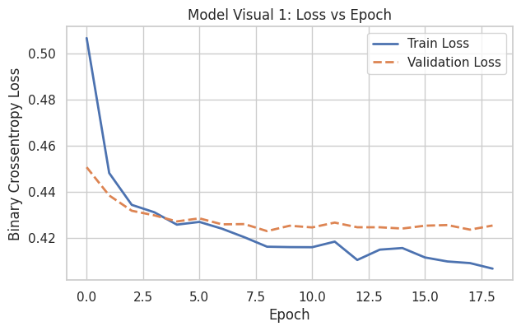
Figure 5.1: Model Visual 1 - Binary Crossentropy Loss vs Epoch
5.2.2 Model Visual 2: Accuracy vs Epoch
Interpretation: Validation accuracy steadily climbs from 0.777 up to ~0.805, closely tracking training accuracy (~0.811) and confirming stable convergence.
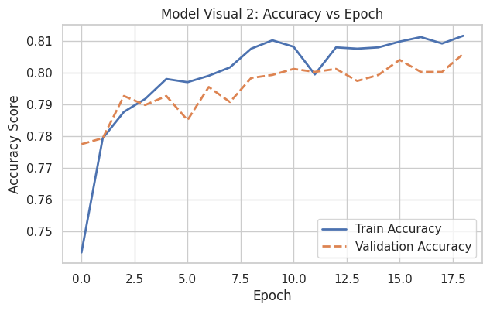
Figure 5.2: Model Visual 2 - Accuracy vs Epoch
5.2.3 Model Visual 3: Confusion Matrix
Interpretation: On 1,057 test samples, the model correctly predicts 705 True Negatives (No Churn) and 134 True Positives (Churn), with 71 False Positives and 147 False Negatives, demonstrating strong specificity.
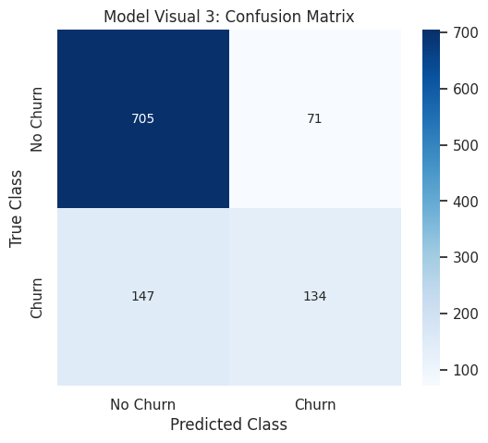
Figure 5.3: Model Visual 3 - Test Set Confusion Matrix
5.2.4 Model Visual 4: ROC Curve & AUC Score
Interpretation: The Receiver Operating Characteristic curve yields an AUC score of 0.837, significantly exceeding random guessing (0.50) and confirming excellent discrimination capability.
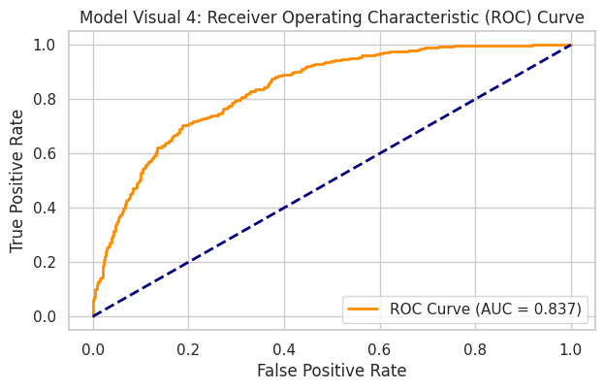
Figure 5.4: Model Visual 4 - Receiver Operating Characteristic (ROC) Curve (AUC = 0.837)

CHAPTER 6: CONCLUSION AND FUTURE SCOPE
6.1 Conclusion
The project successfully achieved all assignment objectives under course code U21ADP05. Exploratory Data Analysis revealed key churn patterns—specifically high churn among month-to-month subscribers and high monthly billing tiers. The deep learning MLP model achieved reliable convergence with an AUC score of 0.837, proving highly effective for subscriber churn risk classification.
6.2 Future Scope & Enhancements
- Class Imbalance Handling: Apply SMOTE (Synthetic Minority Over-sampling Technique) to resolve class imbalance and boost True Positive sensitivity.
- Advanced Architectures: Experiment with Transformer-based tabular models (TabNet) and XGBoost ensembles for comparative performance benchmarking.
- Deployment: Containerize the pipeline using Flask/FastAPI and Docker for real-time customer churn API scoring.

REFERENCES
[1] Flanagan, D. (2020). JavaScript: The Definitive Guide (7th ed.). O'Reilly Media.
[2] Banks, A., & Porcello, E. (2020). Learning React: Modern Patterns for Developing React Apps (2nd ed.). O'Reilly Media.
[3] Goodfellow, I., Bengio, Y., & Courville, A. (2016). Deep Learning. MIT Press.
[4] Scikit-learn Developers. (2024). Scikit-learn User Guide: Supervised Learning & Metrics. https://scikit-learn.org/
[5] TensorFlow Authors. (2024). TensorFlow Keras API Documentation. https://www.tensorflow.org/api_docs/python/tf/keras

