**Question 1**

|  |  |
| --- | --- |
| Human hand and robot hand nearly touching  ITPP5112  Assignment 2 | Shayla Valentyn  DISD0601 |

**Ethical implications**

Over the years AI has evolved immensely and will continue to do so. It will continue to improve as more humans use it and see what various things they wish to change or alter. AI and robotics have evolved so much that they have multiple versions or applications of certain inventions. Through the evolution of this, there has been a debate on whether it is acceptable for humans to include their values in the creation of AI and humanoid robots. Hence, this essay will be discussing for the insertion of human being values for these systems.

There are several ethical implications that come with inventors passing their human views and morals onto AI and humanoid robots.

Creators may be biased without knowing that they hold certain biases. These biases can most likely affect the robots or any AI model outcome. An example of how creators bias can cause a problem in AI can be traced back to 1988, when a medical school was found guilty of discrimination. The reason being that a computer program that determined who would be invited for interviews had been proven to be biased against women and people with non-European names. This computer program was also developed to fall in line with human admissions and did just that with up to 95 percent accuracy.

(James Manyika, 2019)

To end Bias in AI, data scientists have been doing research on how to address the problem. One of there solutions are to increase transparency in the making of AI. This includes explaining AI in a simple way. This can be difficult as ‘explainable AI’ to someone that does not work or study in that field can be tricky. But data scientists say that even just saying how data is being trained and these creators explaining how and why they are using different algorithms is enough. Transparency is very important particularly when AI programs are being used from third-party vendors. This would not necessarily prevent bias but it’s a step toward it.

(Apte, 2022)

In addition to bias in AI, we should also take into account the value conflicts. It’s important to accommodate everyone.

Another ethical implication can be moral responsibility. We can use the concept given in the scenario given above. A seven-year-old boys’ finger was broken and now he is left injured by the robot during chess. Who would need to take moral responsibility for this? The creator or the robot? The human values being passed on to this robot causes conflict as now the creator will be blamed. It is important to understand that robots cannot be morally responsible for the harm they inflict as they do not have moral agency like humans do. They lack consciousness and empathy so it would be useless to even punish them for this by letting them take some sort of responsibility for it. But when these human values are passed onto the robot, how would we defend an issue like this.

(Gogoshin, 2021)

Human values being passed onto Ai and humanoid robots, can benefit us in a lot of ways. Some major examples of humanoid robots and AI helping people in the health and medical field are the Next-generation robots that work with autistic children. They effectively bond the communication between parent and their children. There is also a social robot used in the MIT media lab which teaches languages and reading skills to children. This provides a fun and more memorable way for children to learn and read.

(Anon., 2015)

There are also weight loss robots which help people meet their weight loss goals. There are even Paro seal robots that is used in elderly homes and with dementia patients as well. They provide something they lack when they are alone, and away from family and friends.

(Mail, n.d.)

These are all engaging for children and elderly. They ultimately give these people a sense of nurturing they might need in certain ways.

(2015, 2015)

We can now conclude that human values in AI is necessary even if it may cause some conflict. There is without a doubt risks but ultimately AI and humanoid robots having human values can benefit us in a range of ways. The ethical implications should not scare us but motivate us to improve and be open to what it is becoming and what it already is. This would be the only way we as humans can live and accept the AI.

**Code of conducts**

To include human values, we would also need to use a code of conduct. This code of conduct will help creators of these systems, AI and humanoid robots stick to a guideline.

The first code of conduct is for creators to be transparent (as mentioned in above aw well). With any data driven object, AI counts on the quality of data to direct their AI model. This is why they are affected by bias or have a risk when they are used. Transparency in AI is all about having a clear explanation behind each thing being put out and making your reasoning or decision-making process accessible to users of your model. (Lawton, 2023)

Another code of conduct, which will fall hand in hand with the earlier discussion on AI and Bias is to have Ethical decision-making. Creators should try their best to not be biased in the making of their AI system or model. They should have diverse opinions around them to help with this. AI is only as good as its data and the creators have full control over that. Ethics are taught by humans and would only be as ethical as it was taught to be. (Catlin, 2017)

Just as humans that work in a specific field need to continuously learn to become better at the jobs, the same should be for AI. AI should continuously be learning. We can already see this in AI search engines like ChatGPT. The reason for its speed is because of this. AI should be able to learn and adapt their values over time. This could make place for fresh information and will also correct the bias and dated values it has learnt. (Caruana, 2023)

Humans overseeing AI can play a big role in accountability (moral accountability) This is necessary in ensuring that AI and their outputs are justifiable or clear. AI being clear and humans understanding them, can build trust between the two. So, creators should make clear and concise AI. (Anon., n.d.)

All AI should respect the diverse values of humans. This would once again aid in helping with bias. This would ensure all humans are respected. However, this would require a lot of research in the development process. This would prevent instances like the discrimination in the medical school (as mentioned above). (Anon., 2023)

The benefits of an AI code of conduct includes ethical integrity. This would ensure that there is responsible use of AI. A code of conduct will also provide consistency, this lowers the chances of unethical practices. Another benefit would be an improvement in the decision-making process of AI. This is because the people can now trust the data given through AI and humanoid robots.

(Grieco, 2023)

In conclusion, a code of conduct is necessary for AI and humanoid robots. It is a way to address the ethical concerns around the world of AI and robots. It will benefit us in a range of ways and provide a more trustworthy opinion around the creation of them.

Section 1

1. **Azure board link:** <https://dev.azure.com/ST10269117/ITTP5112A2/_boards/board/t/ITTP5112A2%20Team/Issues>

Screenshots:

To do:

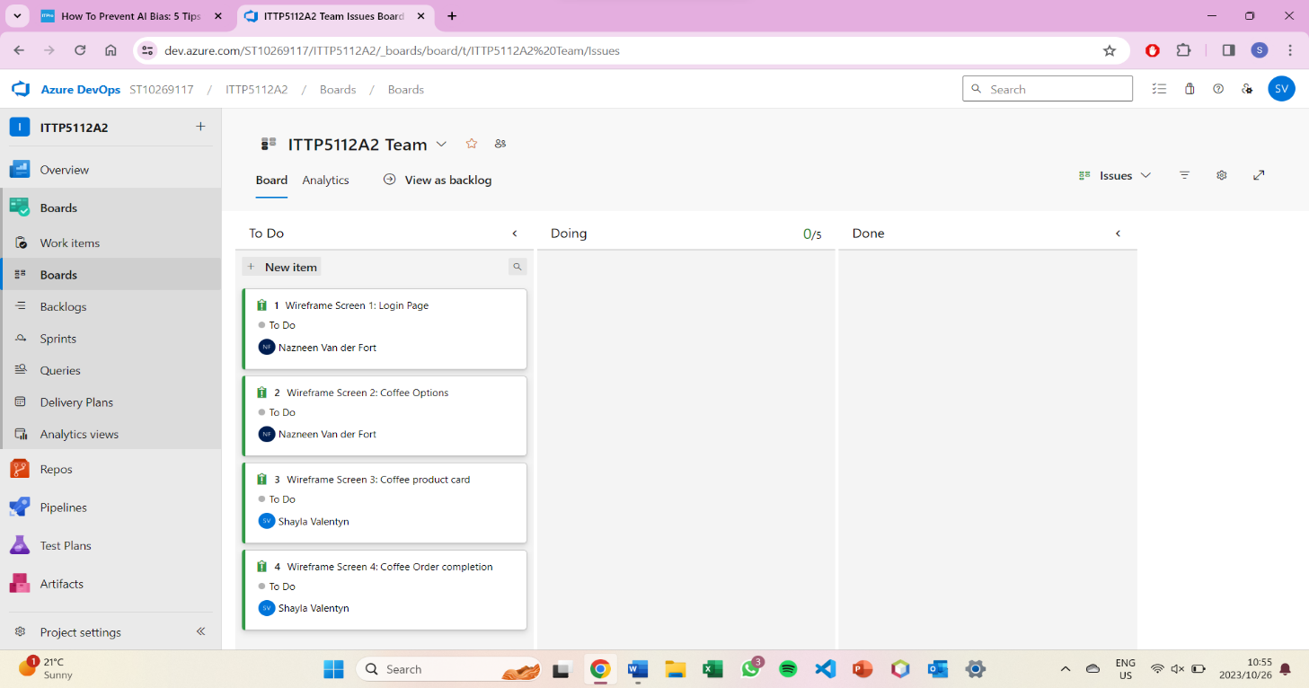

Doing:



Final:

**2. Figma Wireframe**

(Created Screen 3 and 4)

Screen 3: Displays delivery address, date, payment gateway.

Screen 4: Order Completion Page

**Figma Prototype:** <https://www.figma.com/proto/x5evO2HFW6nkpFPZLlI5lX/ITPP5112A2_DREAM-BEAN?type=design&node-id=9-15&t=4hKqbDnYTTUM95w2-1&scaling=scale-down&page-id=0%3A1&mode=design>

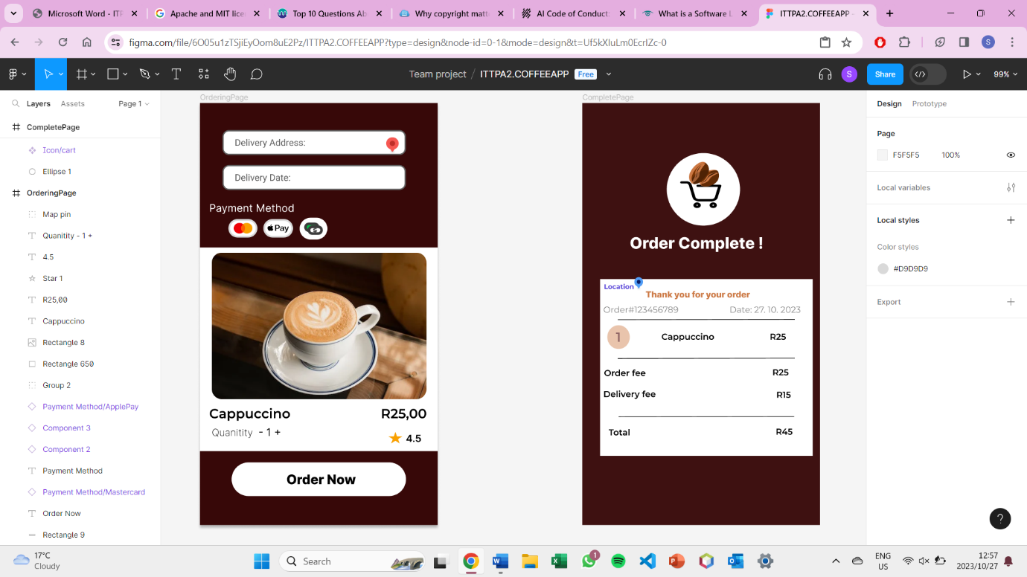

**3.Report**

**Done by Team:**

**ST10269117**

**ST10338973**

Intellectual property

Intellectual property is the right that qualifies a person or business to prevent others from control which would give them a one-sided trade advantage. It is property created by someone which can be literacy, an invention or any other artistic work done. It is now becoming even more necessary to identify what exactly intellectual property. IP is divided into a range of unique categories. One of which is copyright. Other examples include trademarks, domain names, patents and more.

The way intellectual property works is different depending on the product or design. A single product can even be the subject of various forms of protection. For example, a computer can have these features protected as Intellectual property, patents for hardware, copyright for software and its registered designs for casing of shapes. (Giles, 2013)

Copyright

Copyright is a type of Intellectual Property that gives credit and allows legal protection to the owner of the piece. In our case the copyright will be for the prototype. This consist of the design and graphics used.

There are specific requirements that need to be had to request for a copyright license. The license permits you to take legal action versus anyone that utilizes your work without providing credit. An example would be, to use Figma’s Attribution 4.0 International

(CC BY 4.0) license. This license permits files to be shared and changed according to a companys need.

(Figma Learn, n.d.)

There are certain influences that have to be kept in mind when choosing your preferred software license. These include openness, possible restrictions and upcoming partnerships that can be spent for commercial use. We have opted to go with the Apache licensing for our prototype as ‘;/it can be tailored and adjusted to our needs. ​ (Auora, 2022)

**Question 3**

Youtube video: https://youtu.be/oV9ZtHtwqbc?si=Oh3lsYIc2BSx8Ne8

# Bibliography

2015, T. C., 2015. *Youtube [video].* [Online]   
Available at: https://youtu.be/m3gp4LFgPX0?si=x3cCGGJVcF4FCSgp

Anon., 2015. *MIT media.* [Online]   
Available at: https://www.media.mit.edu/projects/robot-vocal-expressiveness/overview/

Anon., 2023. *DIVERSIO.* [Online]   
Available at: https://diversio.com/the-role-of-ai-in-diversity-equity-and-inclusion/#:~:text=Education%20and%20Awareness%3A,cultural%20sensitivity%2C%20and%20inclusive%20practices.

Anon., n.d. [Online]   
Available at: https://link.springer.com/article/10.1007/s00146-023-01777-z#:~:text=Humans%20in%20charge%20of%20oversight,%2C%20and%20%E2%80%9Cinterrupt%E2%80%9D%20the%20system's

Apte, P., 2022. *ITProToday.* [Online]   
Available at: https://www.itprotoday.com/artificial-intelligence/5-ways-prevent-ai-bias  
[Accessed 10 2023].

Auora, 2022. *planetcrust.* [Online]   
Available at: https://www.planetcrust.com/what-is-an-apache-2-0-license-and-why-does-it-matter-to-your-business

Caruana, V., 2023. *algolia.* [Online]   
Available at: https://www.algolia.com/blog/ai/how-continuous-learning-lets-machine-learning-provide-increasingly-accurate-predictions-and-recommendations/  
[Accessed 2023].

Catlin, J., 2017. *Forbes.* [Online]   
Available at: https://www.forbes.com/sites/forbestechcouncil/2017/12/21/the-role-of-artificial-intelligence-in-ethical-decision-making/?sh=5355089621dc

Figma Learn, n.d. *Figma Learn.* [Online]   
Available at: https://help.figma.com/hc/en-us/articles/360042296374-Figma-Community-copyright-and-licensing

Giles, J., 2013. *michalsons.* [Online]   
Available at: https://www.michalsons.com/blog/what-makes-up-intellectual-property/1170  
[Accessed 2023].

Gogoshin, D. L., 2021. *PMC.* [Online]   
Available at: https://www.ncbi.nlm.nih.gov/pmc/articles/PMC8646153/#:~:text=It%20is%20almost%20a%20foregone,senselessness%20of%20holding%20them%20accountable.  
[Accessed 10 2023].

Grieco, J., 2023. *MineOS.* [Online]   
Available at: https://www.mineos.ai/articles/ai-code-of-conduct-how-to-make-it-work#:~:text=The%20Need%20for%20an%20AI%20Code%20of%20Conduct&text=The%20extensive%20adoption%20of%20AI,purposes%20if%20not%20used%20ethically.  
[Accessed 2023].

James Manyika, J. S. a. B. P., 2019. *Harvard Business Review.* [Online]   
Available at: https://hbr.org/2019/10/what-do-we-do-about-the-biases-in-ai  
[Accessed 10 2023].

*Kate Darling – Ethical issues in human-robot interaction.* 2015. [Film] s.l.: The Conference .

Lawton, G., 2023. *TechTarget.* [Online]   
Available at: https://www.techtarget.com/searchcio/tip/AI-transparency-What-is-it-and-why-do-we-need-it#:~:text=Like%20any%20data-driven%20tool,those%20influenced%20by%20the%20decision.

Mail, D., n.d. *Youtube [video}.* [Online]   
Available at: https://youtu.be/g9wj5v22KsA?si=g3t9ayhJ4uIm7PLR

*Robot baby seal 'Paro' helps elderly dementia patients in Hong Kong.* 2018. [Film] Hong Kong: Daily Mail.