**PDYSHA009 – Shaylin Padayachee**

**Networks Assignment 2 – CSC3002F**

8b) The minimum amount of buffer space (receiver window) advertised at gaia.cs.umass.edu for the entire trace is 5840 bytes, which shows in the first acknowledgement from the server. This receiver window grows steadily until a maximum receiver buffer size of 62780 bytes. The sender is never throttled due to lacking of receiver buffer space by inspecting this trace.

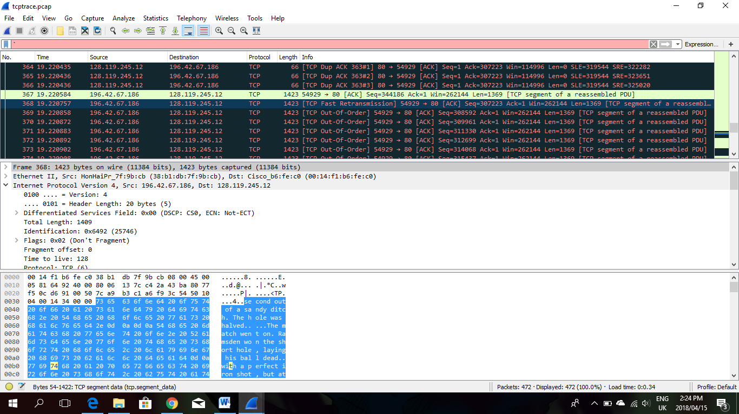9) There was an occurrence of a retransmitted segment on frame 368 of the tcptrace you can see there is a TCP Fast Retransmission (indication that a confirmation of not receiving the file was received). This also shows in the Stevens graph below in the section around sequence number 307223 the sequence number of the retransmitted segment is smaller than its neighbouring segments while time is increasing.

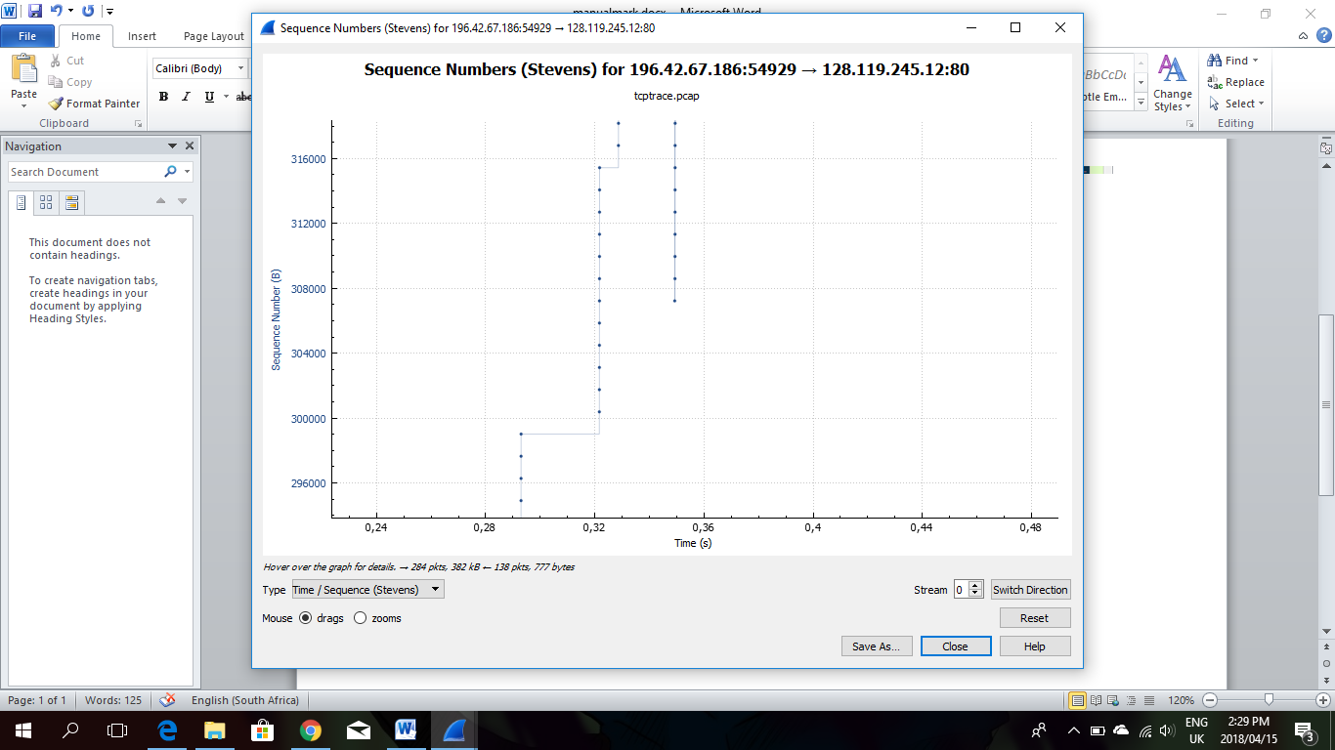

12) No

13) Wireshark shows fragmented sections and in the “Fragment offset:” field the value is 0 indicating that it is not fragmented.(figure 1)

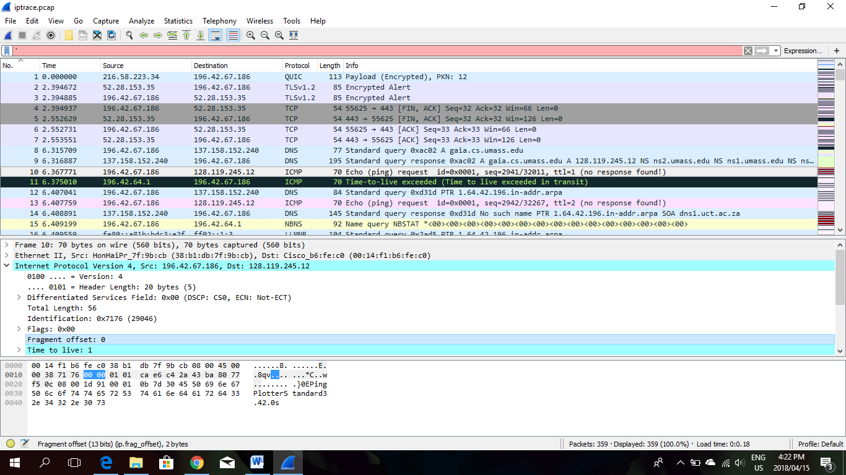

Figure

14) The IP header is 20 bytes  
 The payload is 36 because the total length is 56 and 56 – 20 = 36 (figure 2)

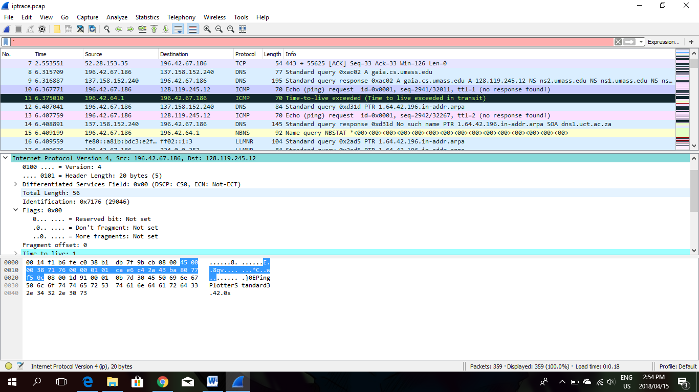

Figure

15) Frame, time to live and identification.

16)   
**The fields that stay constant across the IP datagrams are:** -Version/protocol (since we are using IPv4 for all packets)  
 -header length (since these are ICMP packets)  
 -source IP (since we are sending from the same source)   
 -destination IP (since we are sending to the same dest)  
 -Differentiated Services (since all packets are ICMP they use the same Type of Service class)  
 -Upper Layer Protocol (since these are ICMP packets)

**The fields that must stay constant are:**-Version/protocol (since we are using IPv4 for all packets)  
-header length (since these are ICMP packets)  
-source IP (since we are sending from the same source)  
-destination IP (since we are sending to the same dest)  
-Differentiated Services (since all packets are ICMP they use the same Type of Service class)  
-Upper Layer Protocol (since these are ICMP packets)

**The fields that must change are:**-Identification(IP packets must have different ids)  
-Time to live (traceroute increments each subsequent packet)  
-Header checksum (since header changes, so must checksum)

17) The identification goes up by one (and time to live goes up by one).

17) (There are two question 17 in the question document, just keeping true)  
  
Referring to the image below the information was obtained.  
To find the nearest router I searched for the lowest TTL in the “Time to live exceeded” section  
(figure 3).

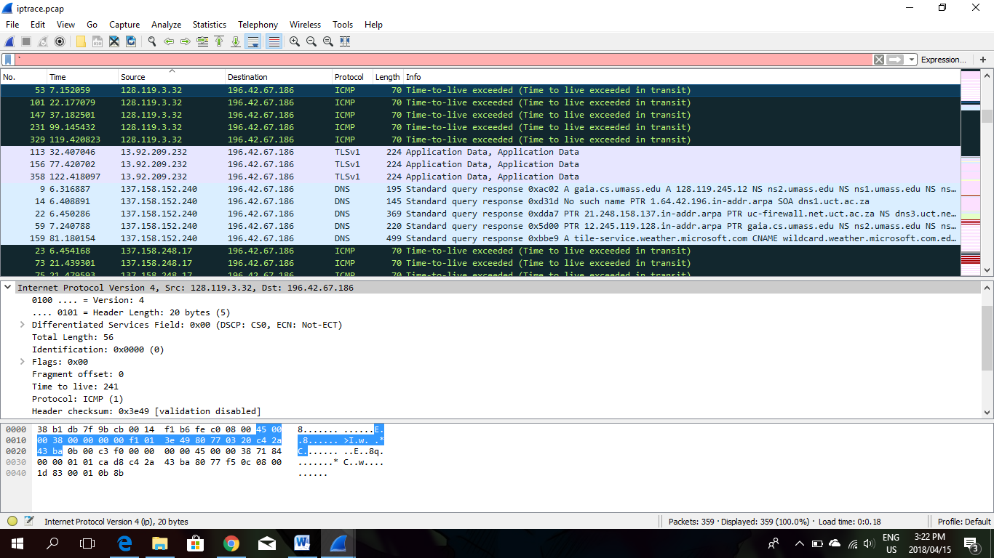TTL: 241  
Identification: 0X0000 (0)

Figure

18) No, they don’t remain the same. The TTL remains the same because it’s coming from the same source/router however the Identification changes as these are unique values.