**A* Search:**

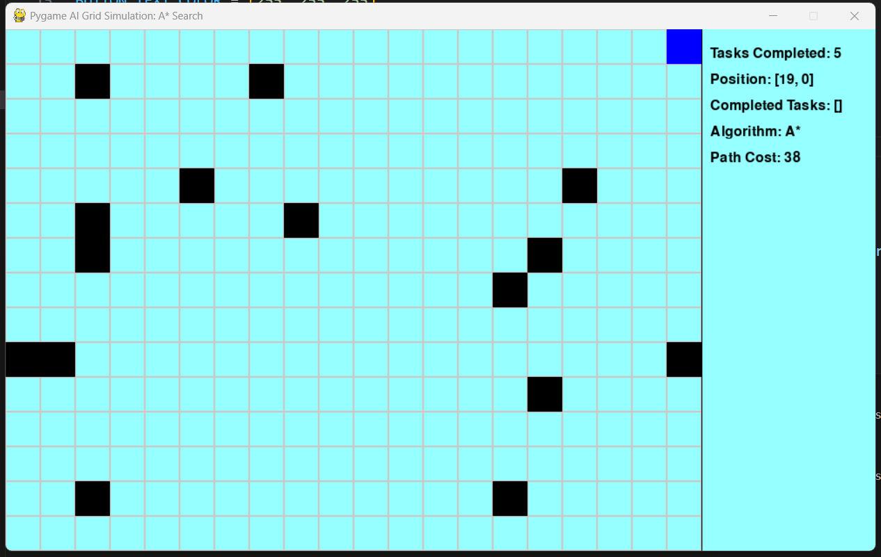

A* search algorithm searches with cost function f(n) = g(n) + h(n), and uses a priority queue (typically a min-heap). Generally faster because it explores fewer unnecessary nodes. It guarantees an optimal path if heuristic is admissible. Moves efficiently in one go to the nearest task.

**IDA* Search:**

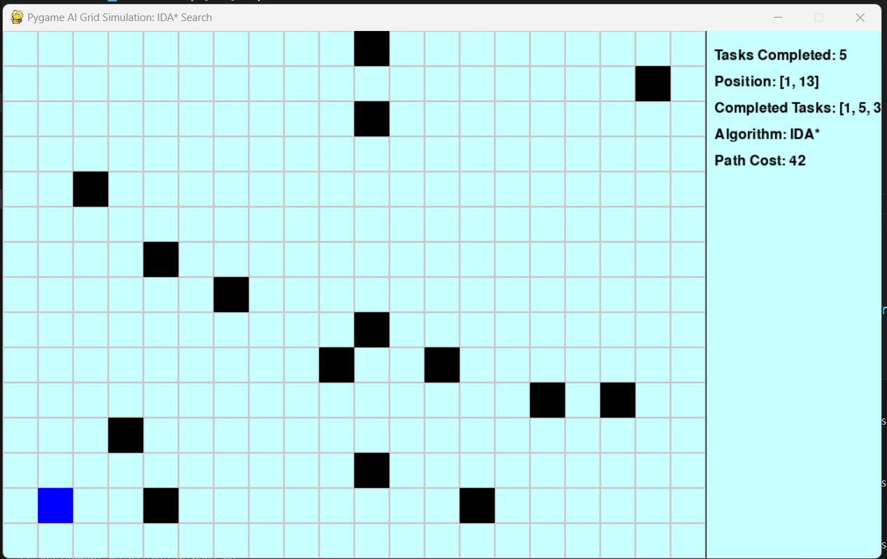

IDA* search algorithm searches iterative Deepening with Depth-First Search and heuristic cutoff. Uses iterative deepening with recursive DFS. Can be slower in large grids due to re-expanding nodes. It is also optimal, but takes longer in complex cases. May seem slower due to iterative deepening recalculations.

**Challenges & Solution:**

In both cases the whole traversed path could not be drawn. Another challenge was, after the task completion the agent stops when there are no more paths. There could have been two solutions. One, asking for a restart or automatic restart, two, traverse ending message.