Product search code implementation:-

Implementation of product class and sorting algorithms.

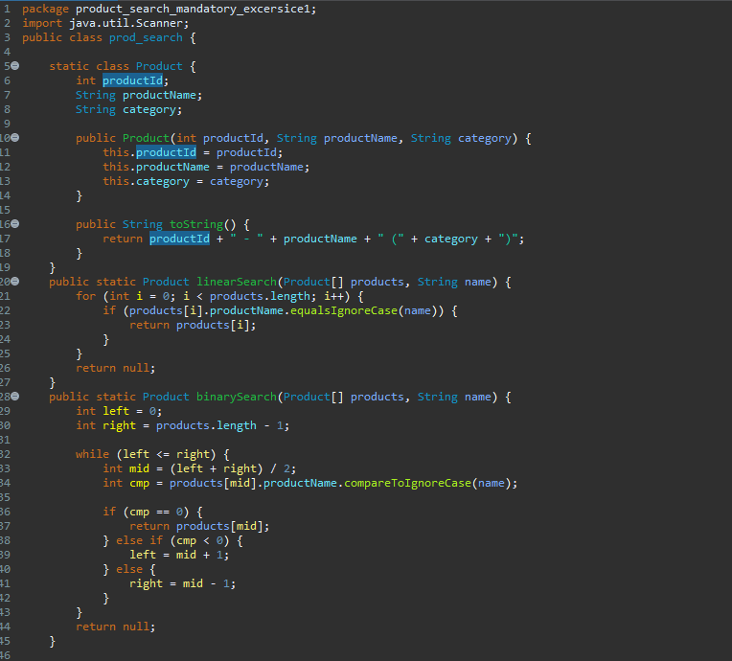

Implementation of sorting to make data ready for binary sort.

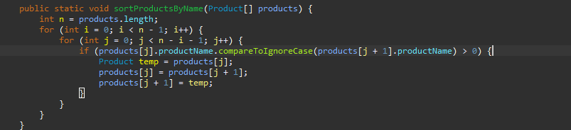

Main class for function calling and user input.

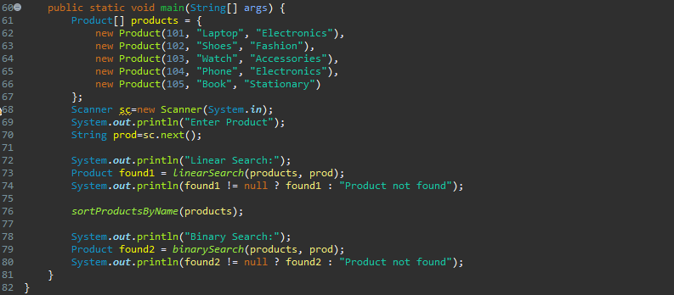

Final output demonstrating the output received when both algorithms are used.

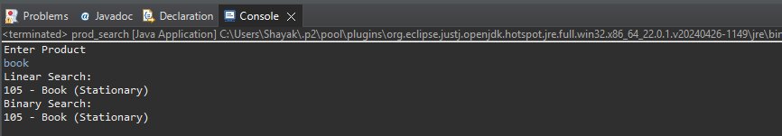

Q1) What is Big O notation?

Ans) These are asymptomatic notations used to describe the efficiency of a program and denote hoe the runtime of a program increases as the size of input increases.

Linear Search:-

Time Complexity= O(n)

Can be used when data set is small and unsorted.

Binary Search:-

Time Complexity= O(log n)

Best used when data is sorted and larger data size are involved.