Code Implementation:-

Recursive Financial Forecast Implementation.

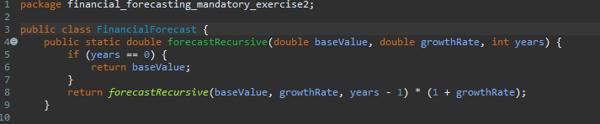

Recursion using memorization technique which stores the redundant calculation in an array for to prevent recalculation.

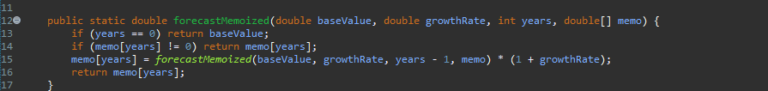

Main method to print result from both values.

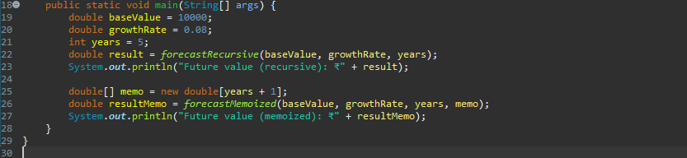

Final Output.

