Notification system methods:-

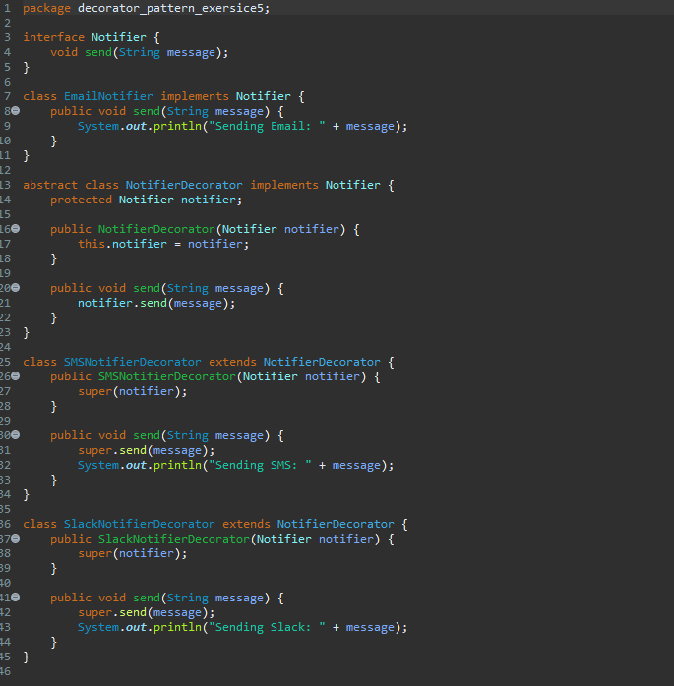

Main Method code:-

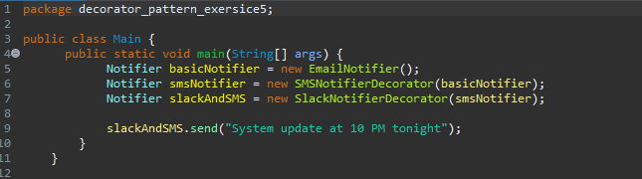

Output:-

