Customer System methods:-

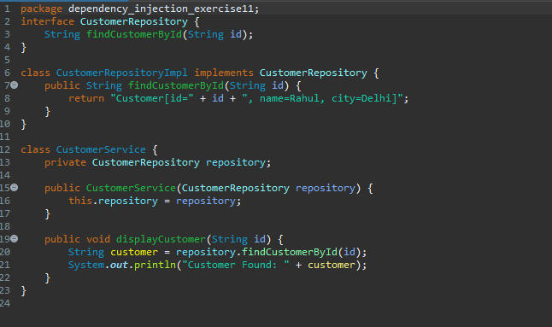

Main method:-

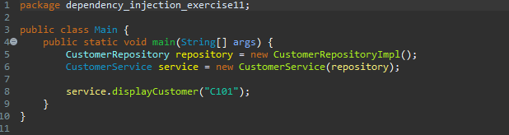

Output:-

