Logger Class to generate instances and ensure proper implementation of singleton principle

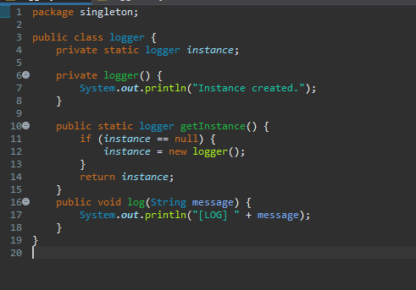

Logger test class to test singleton pattern implementation

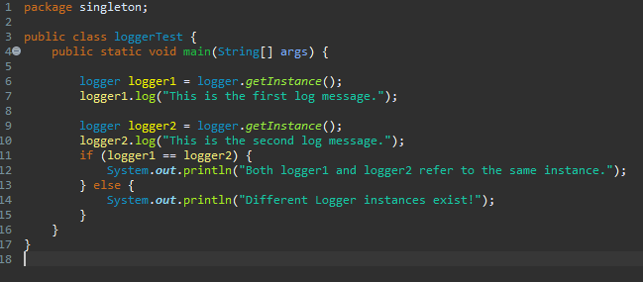

Output showing that both instance created utilize the same object hence ensuring singleton implementation.

