Document interface and concrete classes

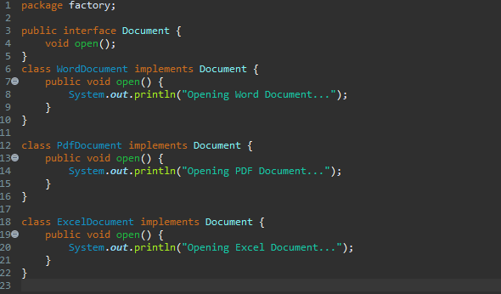

Document factory abstract class and abstract class implementation

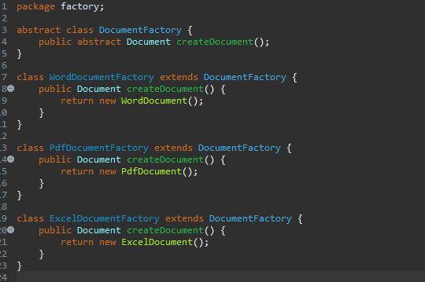

Factory test class to check factory creation and file opening

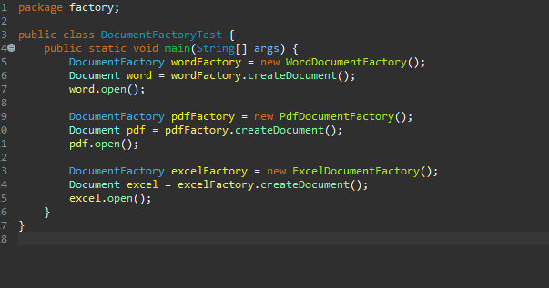

Factory test class to ensure factory creation and object response

