Payment System methods:-

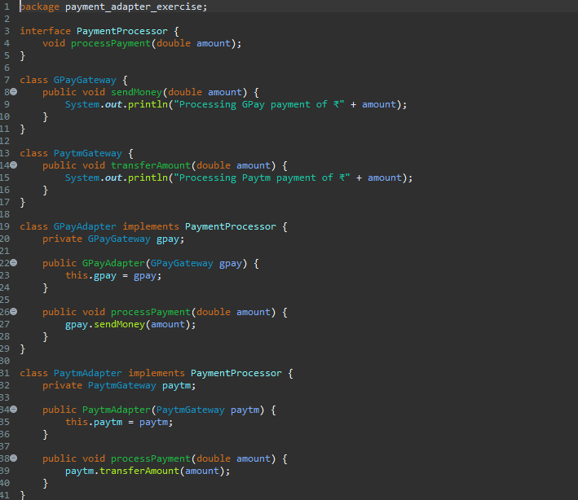

Main Function code:-

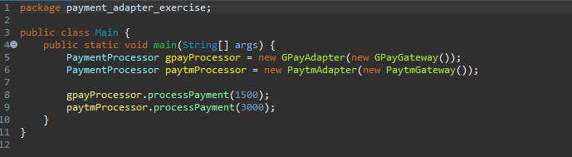

Output :_

