Image system methods:-

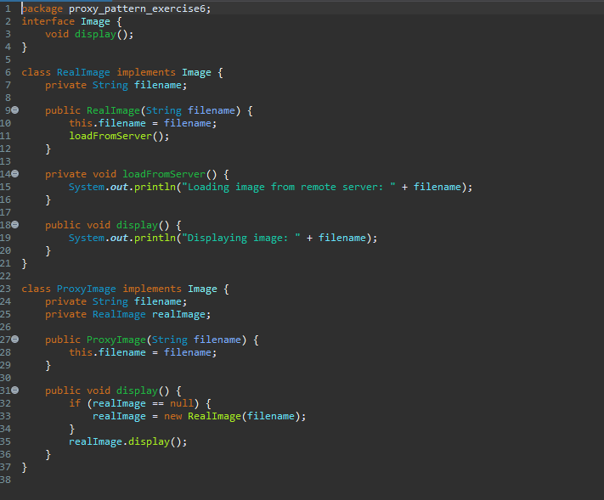

Main File Java:-

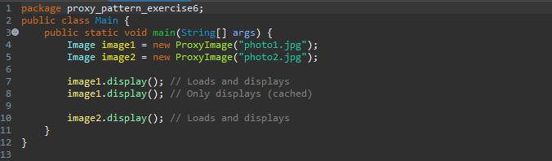

Output :-

