Payment Strategy interface and methods:-

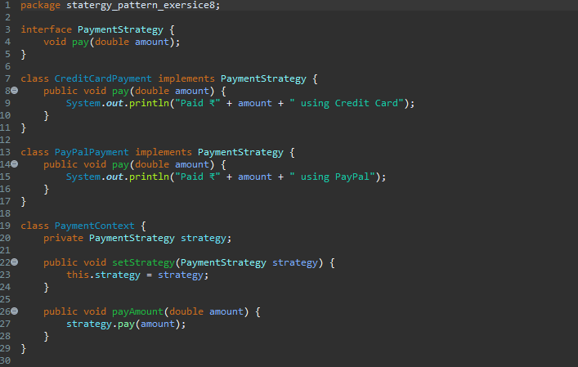

Main Java file:-

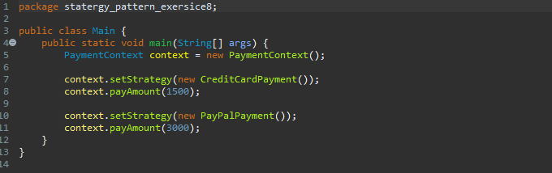

Output:-

