Scenario specific insert values to View output for the Stored Procedures.

INSERT INTO Customers (Name, DOB, Balance)

VALUES

('Elder John', '1950-01-01', 9500.00), -- Age 74, will get 1% discount (Scenario 1)

('Wealthy Alice', '1985-07-15', 15000.00), -- Not over 60, but VIP eligible (Scenario 2)

('Soon Due Bob', '1960-08-20', 10500.00); -- Age ~63, loan ends soon (Scenario 3)

INSERT INTO Accounts (CustomerID, AccountType, Balance)

VALUES

(1, 'Savings', 9500.00), -- Elder John

(2, 'Current', 15000.00), -- Wealthy Alice

(3, 'Savings', 10500.00); -- Soon Due Bob

INSERT INTO Loans (CustomerID, LoanAmount, InterestRate, StartDate, EndDate)

VALUES

(1, 5000.00, 6.5, '2023-01-01', '2028-01-01'), -- John: Age > 60 → interest will be reduced

(2, 8000.00, 5.9, '2023-03-01', '2027-03-01'), -- Alice: no change, just for completeness

(3, 6000.00, 6.8, '2024-01-01', CURDATE() + INTERVAL 15 DAY); -- Bob: loan due in 15 days

INSERT INTO Transactions (AccountID, TransactionDate, Amount, TransactionType)

VALUES

(1, CURDATE() - INTERVAL 2 DAY, 500.00, 'Credit'), -- John

(2, CURDATE() - INTERVAL 5 DAY, 1000.00, 'Credit'), -- Alice

(3, CURDATE() - INTERVAL 1 DAY, 200.00, 'Debit'); -- Bob

INSERT INTO Employees (Name, Position, Salary, Department)

VALUES

('Martin King', 'Clerk', 35000.00, 'Loans'),

('Nina Rivera', 'Advisor', 60000.00, 'Customer Service'),

('Leo Grant', 'IT Lead', 70000.00, 'Technology');

Code block used:-

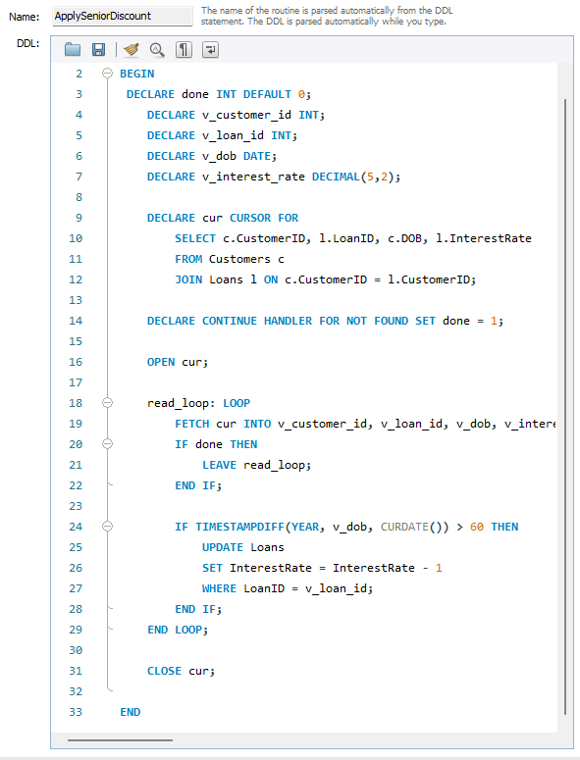

Output Obtained:-

Reduced Interest Rate for Elderly Customer:-

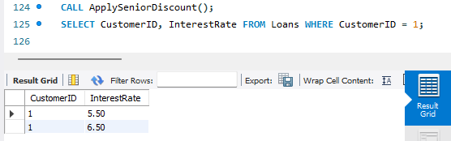

Code Block For Scenario2:-

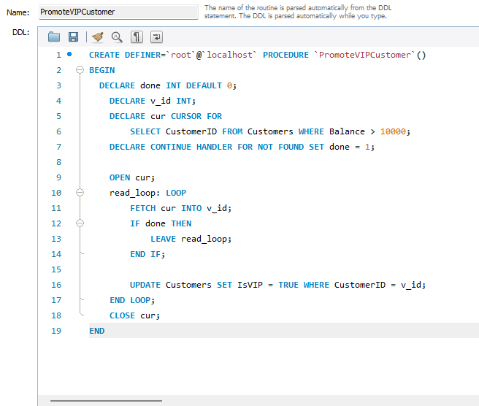

Output Block Showing the change And command used:-

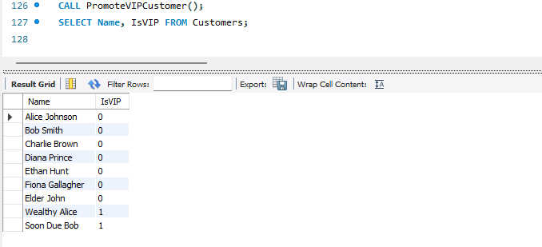

Code block for Scenario3:

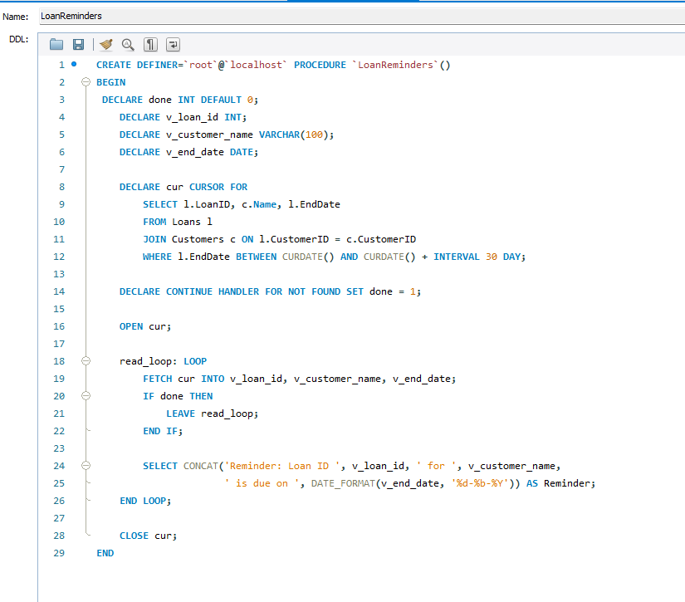

Output Showing Reminder along function call:-

