**Commands to create tables on MYsql Workbench.**

CREATE TABLE Customers (

CustomerID INT AUTO_INCREMENT PRIMARY KEY,

Name VARCHAR(100) NOT NULL,

DOB DATE,

Balance DECIMAL(15,2),

LastModified TIMESTAMP DEFAULT CURRENT_TIMESTAMP ON UPDATE CURRENT_TIMESTAMP

);

CREATE TABLE Accounts (

AccountID INT AUTO_INCREMENT PRIMARY KEY,

CustomerID INT NOT NULL,

AccountType VARCHAR(20),

Balance DECIMAL(15,2),

LastModified TIMESTAMP DEFAULT CURRENT_TIMESTAMP ON UPDATE CURRENT_TIMESTAMP,

FOREIGN KEY (CustomerID) REFERENCES Customers(CustomerID)

ON DELETE CASCADE

ON UPDATE CASCADE

);

CREATE TABLE Transactions (

TransactionID INT AUTO_INCREMENT PRIMARY KEY,

AccountID INT NOT NULL,

TransactionDate TIMESTAMP DEFAULT CURRENT_TIMESTAMP,

Amount DECIMAL(15,2),

TransactionType VARCHAR(10),

FOREIGN KEY (AccountID) REFERENCES Accounts(AccountID)

ON DELETE CASCADE

ON UPDATE CASCADE

);

CREATE TABLE Loans (

LoanID INT AUTO_INCREMENT PRIMARY KEY,

CustomerID INT NOT NULL,

LoanAmount DECIMAL(15,2),

InterestRate DECIMAL(5,2),

StartDate DATE,

EndDate DATE,

FOREIGN KEY (CustomerID) REFERENCES Customers(CustomerID)

ON DELETE CASCADE

ON UPDATE CASCADE

);

CREATE TABLE Employees (

EmployeeID INT AUTO_INCREMENT PRIMARY KEY,

Name VARCHAR(100) NOT NULL,

Position VARCHAR(50),

Salary DECIMAL(15,2),

Department VARCHAR(50),

HireDate TIMESTAMP DEFAULT CURRENT_TIMESTAMP

);

**Commands to insert dummy data into the tables.**

INSERT INTO Customers (Name, DOB, Balance)

VALUES

('Alice Johnson', '1985-06-12', 1200.50),

('Bob Smith', '1990-09-25', 2450.75),

('Charlie Brown', '1978-01-15', 980.00),

('Diana Prince', '1992-03-18', 3100.00),

('Ethan Hunt', '1980-12-01', 1500.25),

('Fiona Gallagher', '1988-07-30', 2045.60);

INSERT INTO Accounts (CustomerID, AccountType, Balance)

VALUES

(1, 'Savings', 1200.50),

(2, 'Current', 2450.75),

(3, 'Savings', 980.00),

(4, 'Savings', 3100.00),

(5, 'Current', 1500.25),

(6, 'Savings', 2045.60);

INSERT INTO Transactions (AccountID, TransactionDate, Amount, TransactionType)

VALUES

(1, '2024-06-01', 200.00, 'Credit'),

(2, '2024-06-02', 500.00, 'Debit'),

(3, '2024-06-03', 150.00, 'Credit'),

(4, '2024-06-04', 1000.00, 'Debit'),

(5, '2024-06-05', 300.00, 'Credit'),

(6, '2024-06-06', 400.00, 'Debit');

INSERT INTO Loans (CustomerID, LoanAmount, InterestRate, StartDate, EndDate)

VALUES

(1, 5000.00, 5.5, '2023-01-01', '2026-01-01'),

(2, 10000.00, 6.0, '2022-05-15', '2027-05-15'),

(3, 7500.00, 4.8, '2024-03-10', '2029-03-10'),

(4, 12000.00, 5.0, '2023-09-01', '2028-09-01'),

(5, 3000.00, 6.2, '2024-01-20', '2027-01-20'),

(6, 9500.00, 5.7, '2023-11-25', '2028-11-25');

INSERT INTO Employees (Name, Position, Salary, Department)

VALUES

('James Miller', 'Manager', 75000.00, 'Finance'),

('Karen Davis', 'Clerk', 35000.00, 'Accounts'),

('Liam Wilson', 'Analyst', 55000.00, 'IT'),

('Mia Taylor', 'Assistant', 32000.00, 'Loans'),

('Noah Thomas', 'Supervisor', 60000.00, 'Operations'),

('Olivia Moore', 'Executive', 58000.00, 'HR');

**Output Tables Created on MYSql Workbench.**

**Accounts Table:-**

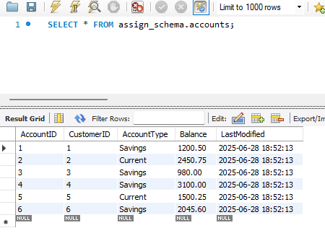

**Customer Table:-**

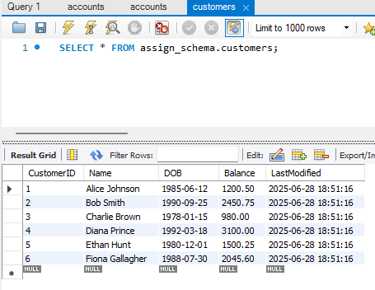

**Employees Table:-**

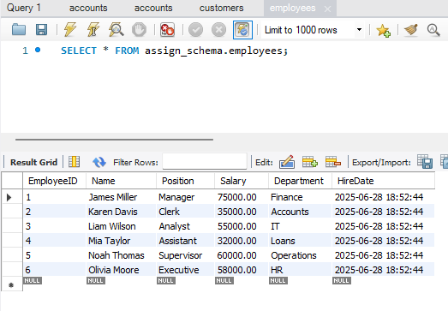

**Loans Tables:-**

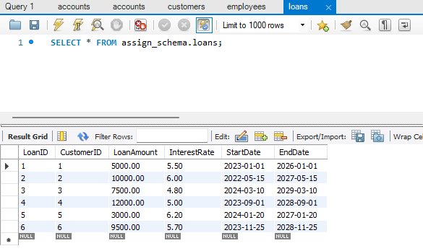

**Transaction Table:-**

