Pom File:_

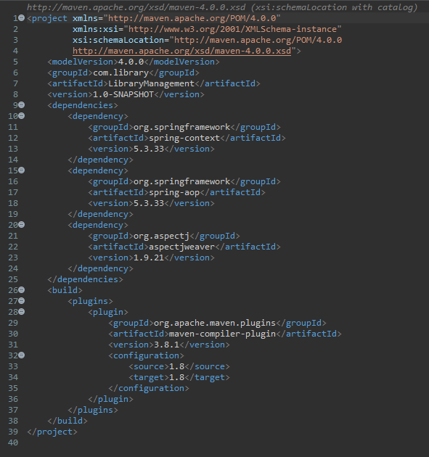

Application content XML file:-

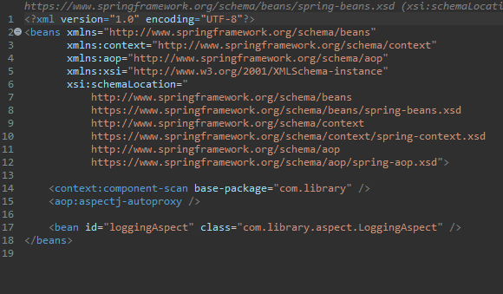

Logging aspect file:-

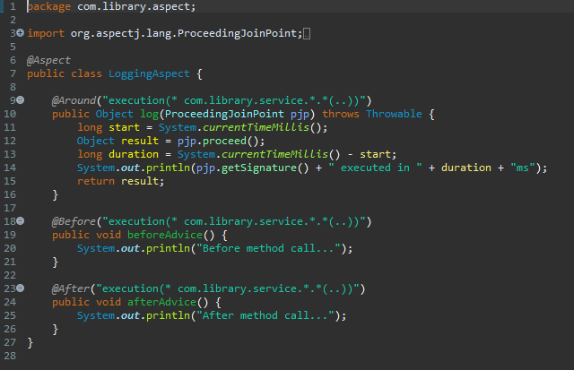

Book repository File:-

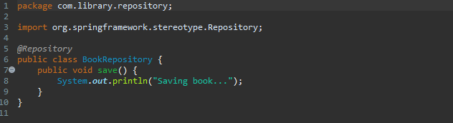

Book Service file:-

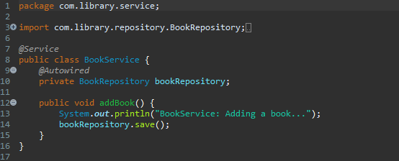

Library Management Application file:-

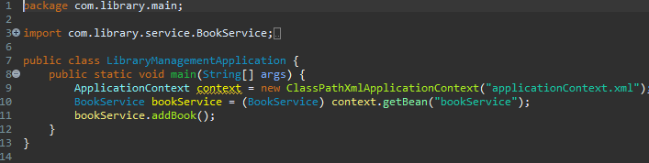

Output when LibraryManagement.java if executed:-

