Pom.xml file

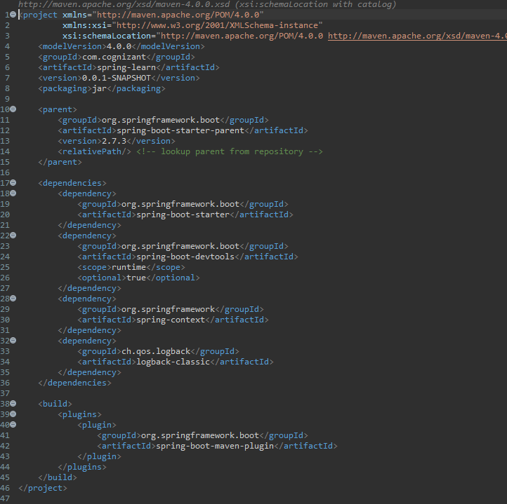

Country.java code file

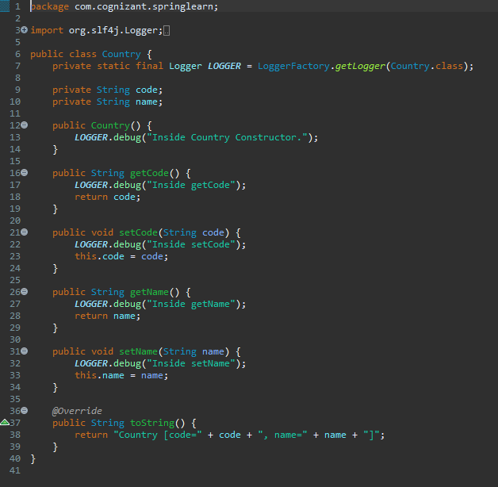

Country xml file:-

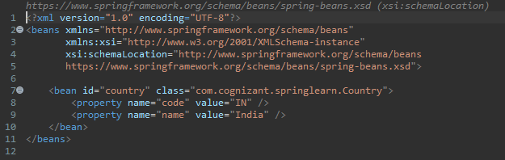

Date_Format.xml:-

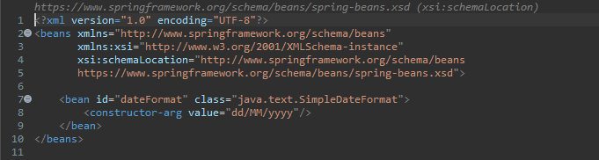

SpringLearnApplication:-

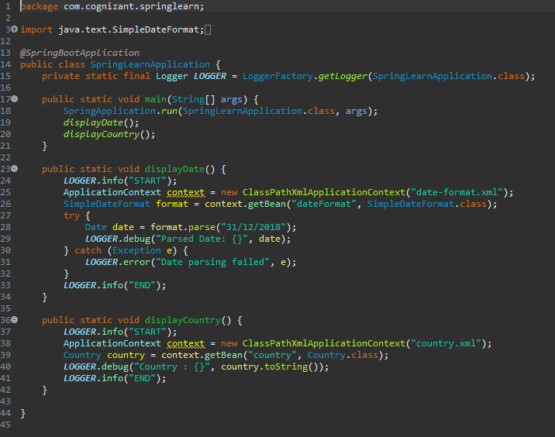

Output File:-

