Pom .xml file:_

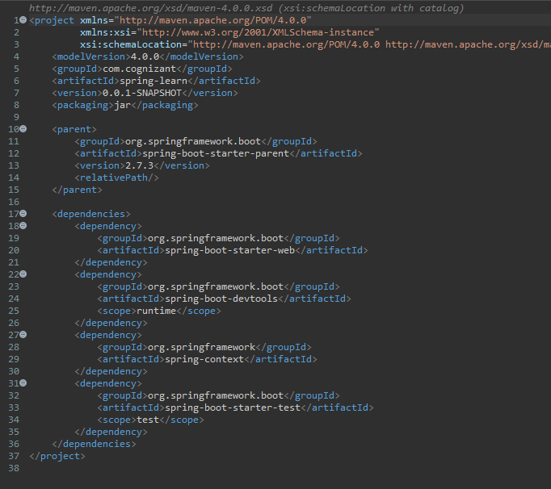

Country.java file:-

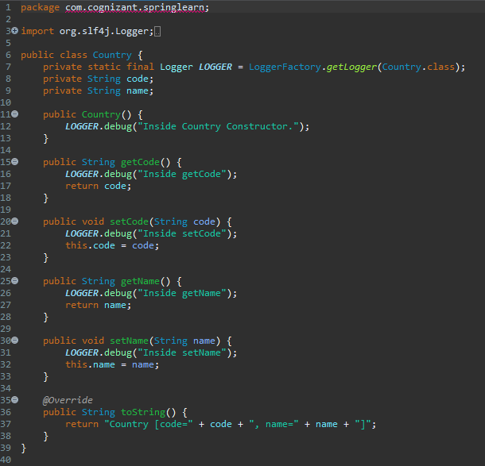

Country Controller:-

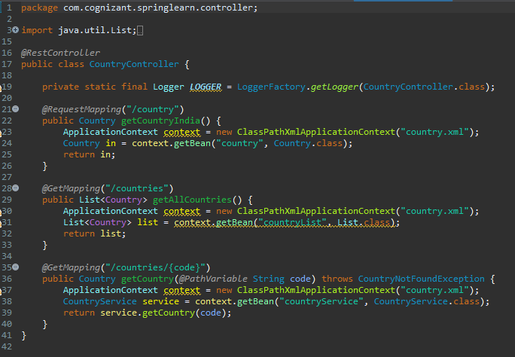

HelloControler.java

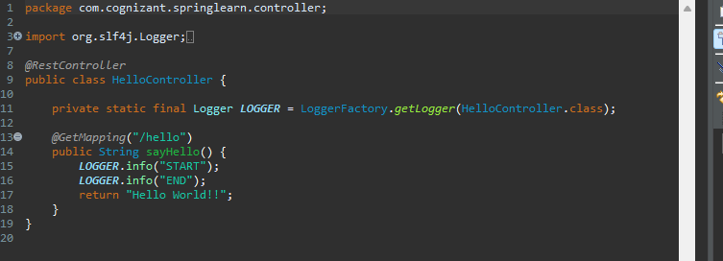

CountryService.java

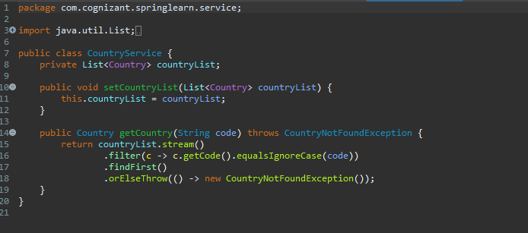

CountryNotFound.java:-

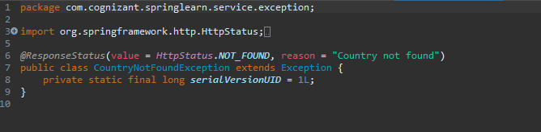

SpringLearnApplication program:-

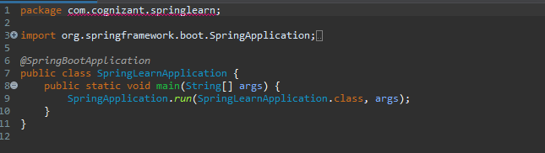

URL use for API testing:-

<http://localhost:8083/hello>

<http://localhost:8083/country>

<http://localhost:8083/countries>

<http://localhost:8083/countries/US>

<http://localhost:8083/countries/XX>

Output received:

