Git Commit and set origin:

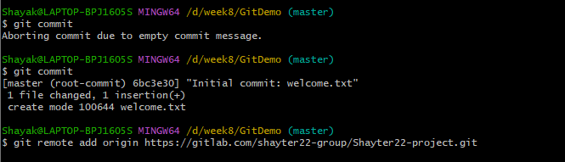

Git Pull and push:

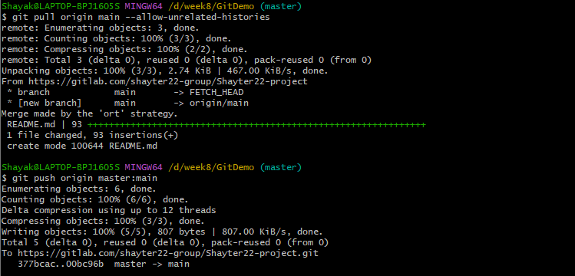

Notepad++ integration and welcome.txt creation:

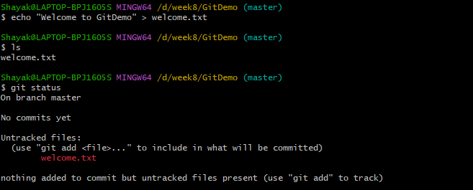

Pushed to git lab:

