Creating log.txt and log dir:

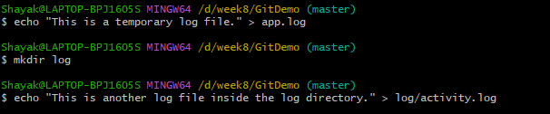

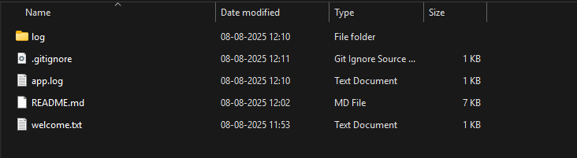

Creating .Gitignore to ignore both:

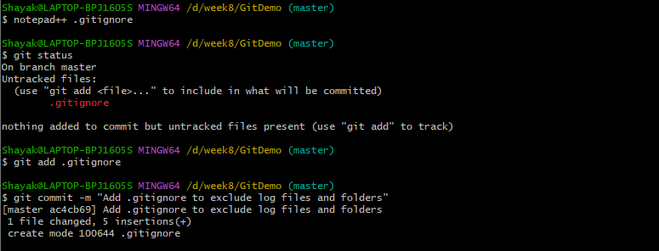

Final Commit:

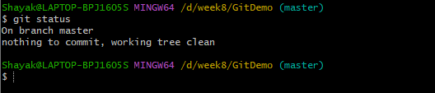



Therefore no changes reflected.