Creating New Branch and Conflcting files and merging them using mergetool:

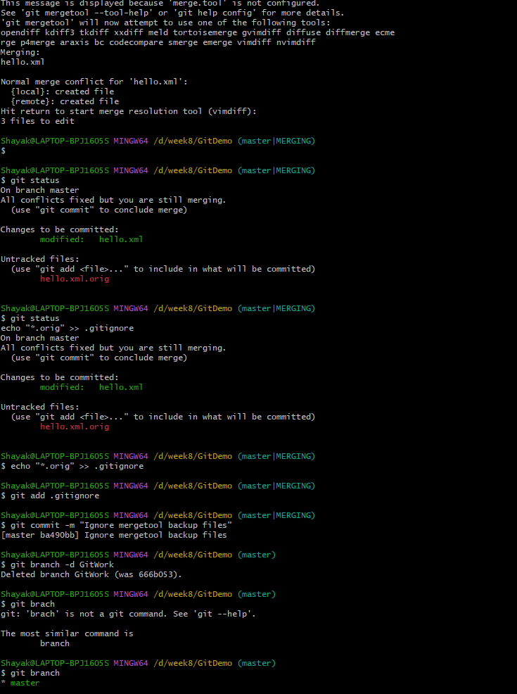

Finally Verifying the logs:

