Commit welcome and hello.xml files:

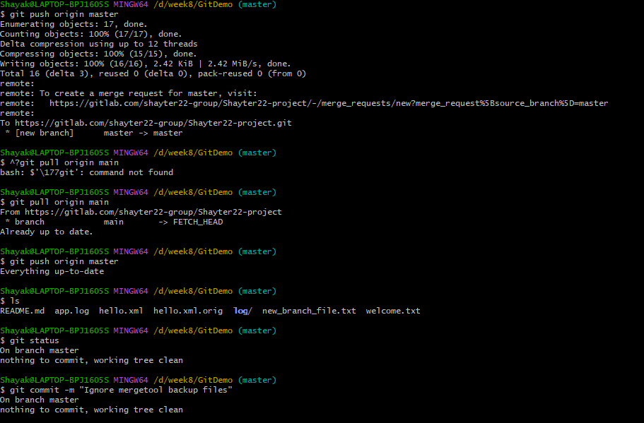

Checking on gitlab to see if commited:

