EDA Reference Guide
Enhanced version of the original markdown notes with improved visualizations for Exploratory Data Analysis (EDA), distributions, probability concepts, and statistical interpretation.

Introduction
Exploratory Data Analysis (EDA) is the process of understanding, summarizing, and visualizing datasets before applying machine learning models. EDA helps identify patterns, anomalies, missing values, and relationships between variables.

Understanding Data
Initial inspection is performed using methods such as info(), nunique(), and descriptive statistics. This phase focuses on understanding structure, datatypes, null values, and cardinality.
# Get dataset overview
data.info()
# Check unique values
data.nunique()
# Drop unnecessary columns
data = data.drop(columns=['ID'])

Feature Engineering
Feature engineering involves cleaning, transforming, and creating features that improve downstream model performance.
Common techniques include:
- Regex-based text cleaning
- Exact mapping for categorical normalization
- Fuzzy matching
- Feature type identification

Distribution Concepts
Distributions describe how data values are spread across a range. The normal distribution is symmetric, while skewed distributions contain longer tails on one side.
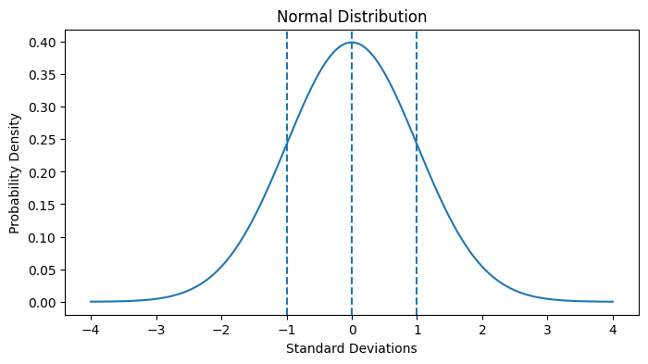
Figure: Standard normal distribution showing symmetry around the mean.
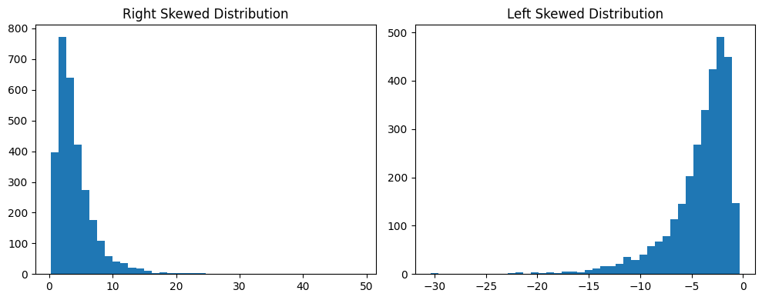
Figure: Comparison of right-skewed and left-skewed distributions.

Understanding Distribution Curves
In probability distributions, the X-axis represents data values and the Y-axis represents density or relative frequency. The area under the curve equals 1.

Standard Deviation and Empirical Rule
Standard deviation measures how far observations spread from the mean. For normal distributions, the Empirical Rule states:
• 68% within ±1σ
• 95% within ±2σ
• 99.7% within ±3σ
Mean: μ = Σx / n
Variance: σ² = Σ(x - μ)² / n
Standard Deviation: σ = √Variance

Z-Score and Standardization
A z-score measures how many standard deviations a value lies from the mean.
Z = (X - μ) / σ
Positive z-scores indicate values above the mean, while negative z-scores indicate values below the mean.

Histogram, KDE, and Boxplots
Histograms display frequency distribution, KDE curves provide smooth density estimation, and boxplots help detect outliers and spread.
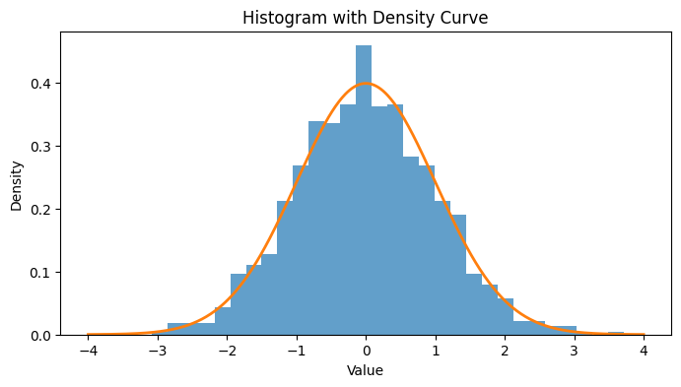
Figure: Histogram with smooth density curve.
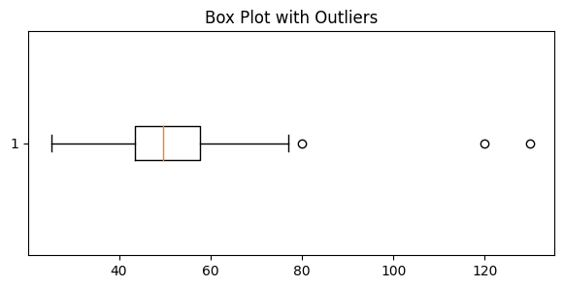
Figure: Boxplot highlighting outliers and quartiles.

Log Transformation
Log transformation is commonly applied to right-skewed data to make the distribution more symmetric and stabilize variance.
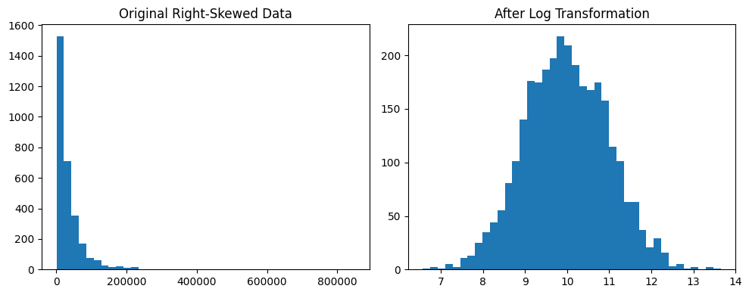
Figure: Original right-skewed data compared with log-transformed data.
# Apply log transformation
df['log_value'] = np.log1p(df['value'])

Probability Density Function (PDF)
A Probability Density Function (PDF) defines the mathematical shape of a distribution curve. The probability between two values is calculated as the area under the curve.

Summary
- EDA is essential before machine learning modeling.
- Understand distributions before applying transformations.
- Use multiple visualizations instead of relying on a single chart.
- Standard deviation and z-scores are foundational statistical tools.
- Log transformation is useful for handling right-skewed data.
- Boxplots and KDE plots help detect outliers and distribution patterns.

