**Title**: Image Search App

**Abstract:**

In an era defined by the proliferation of digital imagery, the need for efficient and intuitive methods of searching and discovering images has become increasingly paramount. This abstract presents a project focused on the development of an Image Search App, designed to redefine and enhance the way users explore and interact with visual content.

The Image Search App leverages cutting-edge computer vision and machine learning technologies to enable users to search and discover images more intuitively and contextually relevantly. Key features of the app include:

1. Visual Search: Users can search for images by uploading a photo, providing the app with an image to find visually similar results. This novel approach eliminates the need for keyword-based searches, allowing users to find images based on visual cues and similarities.

2. Advanced Object Recognition: The app incorporates advanced object recognition algorithms to identify objects, people, and scenes within images. This facilitates precise and specific searches, enabling users to find images containing particular elements or themes.

3. Image Metadata Enhancement: The app automatically generates and associates metadata with each image, making it easier for users to organize and categorize their image collections. It enhances the user's ability to manage and curate their visual content effectively.

4. Smart Filters and Recommendations: Through a recommendation engine, the app suggests related images and provides intelligent filters based on user preferences, previous searches, and interactions. This feature enhances the user's ability to explore and discover new visual content.

5. User-Friendly Interface: The app boasts an intuitive and user-friendly interface, ensuring a seamless and enjoyable experience for both novice and experienced users. Its responsive design supports various devices, making it accessible across multiple platforms.

This project is driven by the belief that image search should be a seamless and visually-driven experience, and the Image Search App aims to empower users with a powerful tool for exploring the vast world of digital imagery. The project's innovative approach promises to transform the way users interact with visual content, offering a more engaging and efficient means of discovering and organizing images. This abstract provides a glimpse into the project's objectives and features, underscoring its potential to redefine the image search experience in today's digital landscape.

**TITLE: WEB IMAGE SEARCH APP**

**INTRODUCTION:**

The motivation behind developing the Image Search App is rooted in addressing several key factors and needs in the contemporary digital landscape:

1. Overwhelming Volume of Visual Content:

In recent years, the internet has witnessed an explosion of visual content, including images, photos, and videos. This has led to an overwhelming amount of data that users need to navigate. A user-friendly image search app is motivated by the necessity to provide a more efficient way to explore this vast visual data landscape.

2. User Frustration with Text-Based Searches: Traditional keyword-based search methods can often fall short in accurately describing the content within an image. Users may struggle to find the specific image they have in mind, and this frustration motivates the need for a more visually oriented search approach.

3. Emerging Computer Vision and AI Technologies: Advances in computer vision and artificial intelligence have opened up new possibilities for analyzing and understanding the visual elements within images. These technologies motivate the creation of an app that can harness these capabilities to provide more contextually relevant image search results.

4. User Desire for Personal Image Management: With the proliferation of personal photos and digital albums, there is a growing need for tools that assist users in organizing and managing their visual content. The app's ability to enhance image metadata and provide smart recommendations addresses this motivation.

5. Enhanced User Experience: The motivation to create the Image Search App stems from the desire to improve the user experience when it comes to image searches. This includes providing a more intuitive and user-friendly interface, enabling faster and more precise results, and creating a more engaging and visually driven exploration of images.

6. Staying Competitive in the Tech Industry: The tech industry is highly competitive, and offering innovative solutions for image search and management can be a key differentiator for a company. Motivated by staying ahead in the market, developers and businesses are inclined to create cutting-edge image search apps.

In summary, the motivation behind the Image Search App is to meet the evolving needs and expectations of users in the digital age, leveraging advanced technologies to offer a more efficient, visually oriented, and user-friendly means of exploring and managing the ever-expanding world of digital imagery.

**Problem Statement**:

In today's digital landscape, the sheer volume of visual content, coupled with the limitations of traditional text-based search methods, presents significant challenges to users seeking efficient, accurate, and visually intuitive ways to explore and manage images. The absence of a comprehensive and user-friendly image search solution hinders users in the following ways:

1. Ineffective Keyword-Based Searches: Traditional keyword-based searches are often imprecise, as users may struggle to describe the content within an image accurately. This leads to frustration, incomplete search results, and wasted time.

2. Overwhelming Visual Data: The immense proliferation of digital images across various online platforms has created an overwhelming amount of visual data. Users are inundated with vast collections of images, making it difficult to organize, categorize, and find specific images when needed.

3. Limited Search by Visual Cues: Users cannot currently search for images based on visual similarities or cues, such as searching for an image similar to one they already possess. This absence hinders creative and productive image discovery.

4. Lack of Intelligent Content Recommendations: Users often miss out on discovering relevant visual content they might be interested in, as there are limited intelligent content recommendations based on their preferences and previous interactions.

5. Challenges in Image Organization: Users face difficulties in organizing and managing their personal image collections, often resulting in cluttered digital albums and poor image metadata.

6. Complex User Interfaces: Many existing image search tools are not user-friendly, which can deter both novice and experienced users from efficiently exploring and managing their visual content.

**Purpose**:

The purpose of the Image Search App is to revolutionize the way users interact with and manage visual content. It aims to provide an efficient, user-friendly, and visually-driven solution for image search and management. The app's purpose is to address the challenges posed by the overwhelming volume of visual data and the limitations of text-based searches, ultimately enhancing the user's ability to explore, discover, and organize images effectively.

**Goals**:

1. High User Satisfaction: The primary goal is to achieve high user satisfaction by providing an efficient and user-friendly image search experience that fulfills users' needs and expectations.

2. Improved Image Search Accuracy: The app aims to consistently improve the accuracy of search results and object recognition, minimizing errors and irrelevant matches.

3. Time and Effort Savings: The goal is to save users time and effort by reducing the need for extensive manual organization and cumbersome text-based searches.

4. Content Discovery: The app seeks to enhance users' ability to discover new, relevant visual content, encouraging exploration and creativity.

5. Increased User Engagement: The goal is to keep users engaged with the app, ensuring they return for frequent use and exploration of their image collections.

6. Data Privacy and Security: Maintaining high standards of data privacy and security is a critical goal, ensuring that user data is handled with the utmost care and compliance with regulations.

7. Sustainability and Scalability: The app should be designed with scalability in mind, ensuring it can handle a growing user base, and it should be developed in an environmentally sustainable way.

8. Continuous Improvement: Regular updates and improvements should be made to the app, staying current with the latest advancements in computer vision and user preferences.

**Potential limitations**:

1. Accuracy of Computer Vision: The accuracy of computer vision algorithms may not be perfect, and the app might occasionally misidentify objects, scenes, or elements within images, leading to incorrect search results or metadata associations.

2. Limited Training Data: The app's ability to recognize specific objects or themes in images may be limited by the quality and diversity of its training data. It may struggle with identifying less common or culturally specific elements.

3. Data Privacy and Security: The app may require access to user photos, raising concerns about data privacy and security. Ensuring that user data is handled securely and in compliance with privacy regulations is a crucial challenge.

4. Complexity for Novice Users: While efforts are made to create a user-friendly interface, novice users may still find certain features and options complex, which could lead to a learning curve.

5. Dependency on Internet Connectivity: The app's functionality may be dependent on a reliable internet connection, which could limit its use in areas with poor connectivity or offline scenarios.

6. Resource Intensive: The use of advanced computer vision and artificial intelligence technologies can be resource-intensive, potentially leading to slower performance on devices with limited processing power or memory.

7. Content Sensitivity: The app might not effectively filter sensitive or inappropriate content, which could be a concern for users, especially when children are using the application.

8. Cultural and Contextual Bias: The algorithms and AI models used in the app may inadvertently exhibit bias, as they are trained on data that may reflect cultural and contextual biases. This can lead to skewed or less relevant search results for some users.

9. Compatibility and Platform Limitations: The app's availability and functionality may be limited by the platforms and devices it can run on. Users on certain platforms may not be able to access the app.

10. Maintenance and Updates: Ensuring that the app stays up to date with evolving computer vision technologies and user preferences is an ongoing challenge. Regular updates and maintenance will be necessary to address emerging issues and keep the app relevant.

Addressing these limitations and continuously improving the app's performance and user experience will be critical for its long-term success. It is important for developers to actively seek user feedback and stay abreast of technological advancements in the field of image search and computer vision to mitigate these challenges.

**SYSTEM ANALYSIS**

**Existing Systems:**

Several existing systems and applications are related to an Image Search App, each serving specific purposes or providing different features for users. Here are some notable existing systems and applications in the realm of image search and management:

1. Google Images: Google Images is one of the most popular image search engines. It allows users to search for images using keywords and provides a vast collection of images from across the web. Google Images also offers a reverse image search feature for finding visually similar images.

2. Bing Images: Microsoft's Bing Images is another widely used image search engine, offering similar functionalities to Google Images.

3. Pinterest: Pinterest is a social media platform focused on image sharing and discovery. Users can search and discover images on various topics, create boards, and save images for future reference.

4. Adobe Lightroom: Adobe Lightroom is a professional image management and editing software that enables users to organize, edit, and search for images in a more advanced and professional setting.

5. Flickr: Flickr is an image hosting and sharing platform. It allows users to upload and organize their image collections, explore other users' photos, and search for images based on tags and descriptions.

6. Instagram: Instagram is a social media platform focused on photo and video sharing. Users can explore images using hashtags and follow other users to see their posts.

7. Shutterstock and Getty Images: These are stock photo websites where users can search for and purchase high-quality images for commercial and creative purposes.

8. TinEye: TinEye is a reverse image search engine that helps users find the source of an image or locate visually similar images on the web.

9. Evernote: While primarily a note-taking app, Evernote also offers image search functionality, allowing users to search for text within images and scanned documents.

10. Facebook Image Search: Facebook provides image search capabilities for users to find and tag people in photos. It also offers image recognition for accessibility features.

11. Apple Photos and Google Photos: These are cloud-based image management platforms that use artificial intelligence to organize and search for images. They can identify objects, people, and scenes within photos.

12. Picasa (discontinued): Google's Picasa was a popular image management software that allowed users to organize and search for images on their computers.

13. Amazon Recognition: Amazon's image recognition service, Amazon Recognition, offers a wide range of image analysis features, which can be integrated into various applications for image management and searching.

14. SmugMug: SmugMug is a photography website that allows photographers to showcase their work and enables users to search and explore photos in various categories.

**Scope and Limitations of existing systems:**

1. Vast Image Databases: Many existing systems provide access to vast image databases, offering a wide variety of images on different topics and categories.

2. Keyword-Based Search: Most systems support text-based keyword searches, making it relatively easy to find images based on specific terms or phrases.

3. Visual Content Discovery: Some platforms, like Pinterest and Instagram, focus on visual content discovery through user-generated images and creative tags.

4. Reverse Image Search: Systems like Google Images and TinEye offer reverse image search, allowing users to find visually similar images by uploading an image as a query.

5. Image Organization: Professional image management software, such as Adobe Lightroom, provides advanced tools for organizing, tagging, and editing images.

6. Social Sharing: Many platforms have social features, enabling users to share and interact with images, follow others, and engage in communities.

7. AI-Powered Features: Services like Google Photos and Apple Photos leverage AI for image recognition and organization, enabling automatic tagging and sorting of images based on objects, faces, and scenes.

8. Commercial Licensing: Stock photo websites like Shutterstock and Getty Images offer images for commercial use, with licensing options.

**Limitations**:

1. Data Privacy: Users may have concerns about the data privacy policies of these platforms, especially when uploading personal photos.

2. Content Quality: The quality and relevance of images in some platforms can vary, leading to a potentially frustrating user experience.

3. Inaccurate Search Results: Text-based search can still produce inaccurate or irrelevant results, especially if keywords are not descriptive enough.

4. Accessibility: Some platforms may not be accessible to users with disabilities, which can limit inclusivity.

5. Content Ownership: Ownership and copyright issues can arise on platforms where user-generated content is shared, leading to disputes and legal concerns.

6. Complexity: Professional image management software may be too complex for casual users and require a steeper learning curve.

7. Cost: Some platforms, particularly stock photo websites, may charge users for access to high-quality images.

8. Limited Customization: Users may have limited control over the organization and presentation of their images on certain platforms.

9. Dependency on Connectivity: Many platforms rely on a continuous internet connection, making offline access a challenge.

10. Cultural and Linguistic Bias: Some systems may exhibit cultural and linguistic biases in search results, leading to challenges in diverse content discovery.

**Project Perspective, Features:**

The Image Search App project can be analyzed from various perspectives, each highlighting different aspects of the project. Here, we'll examine the project from a user perspective and outline the key features that could make the app a success:

User Perspective:

1. Ease of Use: Users expect an intuitive and user-friendly interface that simplifies the process of searching for images. Navigation should be straightforward and require minimal effort.

2. Efficient Image Search: Users are looking for an efficient and accurate image search experience. The app should enable users to find the images they need quickly, minimizing the need for extensive keyword searches.

3. Visual Discovery: Visual discovery is a primary user expectation. The app should support visually-driven exploration, enabling users to find images similar to the ones they have or based on visual cues.

4. Precise Object Recognition: Users seek precise object recognition, which entails the ability to accurately identify objects, people, and scenes within images, aiding in specific image searches.

5. Organizational Features: Users want to easily organize and manage their image collections. The app should offer automated metadata generation and tagging capabilities to facilitate efficient organization.

6. Intelligent Recommendations: Providing users with personalized image recommendations based on their preferences and interactions is a crucial aspect, encouraging exploration and discovery.

7. Data Privacy and Security: Users expect their data to be handled with the utmost privacy and security. The app should incorporate robust data protection measures and comply with privacy regulations.

8. Cross-Platform Accessibility: Users anticipate accessibility across various devices and platforms, including web browsers and mobile apps.

Key Features:

1. Object Recognition: Utilize advanced object recognition algorithms to accurately identify objects, people, and scenes within images, improving search precision.

2. Metadata Enhancement: Automatically generate and associate metadata with each image, making it easier for users to organize and categorize their image collections.

3. Recommendation Engine: Develop an intelligent recommendation engine that suggests related images and provides filters based on user preferences and interactions.

4. User-Friendly Interface: Ensure the app boasts a user-friendly and responsive interface, catering to users with varying levels of technical expertise.

5. Data Privacy: Implement strong data privacy and security measures, clearly communicate privacy policies, and provide users with control over their data.

8. Scalability: Design the app to be scalable, allowing it to handle a growing user base and expanding image collections.

**Requirement analysis**: -

1. Functional Requirements:

Based on user needs and use cases, define the app's functionalities and features, such as:

- Image Search: Provide users with the ability to search for images using keywords, visual cues, or uploaded images.

- Visual Recognition: Integrate computer vision capabilities for accurate object and scene recognition.

- Metadata Generation: Automatically extract and associate metadata (tags, descriptions) with uploaded images.

- Recommendation Engine: Develop an intelligent recommendation system that suggests related images based on user preferences.

- User Profiles: Implement user account management, allowing users to customize their preferences.

- User Authentication: Enable user registration, login, and access control to protect user data.

- Data Privacy and Security: Ensure that user data is protected, and the app complies with privacy regulations.

2. User Interface and User Experience:

User requirements should also address the design and user experience aspects, including:

- User Interface (UI): Users may have preferences for a clean, intuitive, and visually appealing interface.

- User Experience (UX): Users expect a seamless and enjoyable experience when navigating and interacting with the app.

**SYSTEM DESIGN**

**System Constrains**

1. Budget Constraints:

- Limited financial resources may restrict the choice of technologies, infrastructure, and development processes. The project may need to adhere to a tight budget for development and maintenance.

2. Technology Stack:

- The app's technology stack may be influenced by existing infrastructure and expertise within the development team. Constraints related to specific programming languages, frameworks, or databases may apply.

3. Performance Requirements:

- Limited server resources or network bandwidth can impose constraints on the app's performance, potentially affecting response times and scalability.

4. Security Requirements:

- Compliance with security standards and regulations can constrain the design, impacting data encryption, access controls, and intrusion detection measures.

5. Integration with External Systems:

- The need to integrate with external systems, such as image recognition APIs or social media platforms, may influence the design and introduce constraints regarding compatibility and data exchange.

6. Cross-Platform Compatibility:

- If the app needs to run on various platforms (e.g., web, mobile, desktop), this constraint can affect design decisions, including user interface considerations and compatibility with different devices and operating systems.

7. User Accessibility:

- Constraints related to user accessibility, such as compliance with accessibility standards (e.g., WCAG), can influence the design to ensure inclusivity.

8. Testing and Quality Assurance:

- Constraints related to the availability of testing resources, such as testing devices or access to real-world scenarios, can influence quality assurance procedures.

14. User Expectations and Feedback:

- User expectations, as gathered during requirement analysis, should be considered constraints, as the design must align with what users require and expect.

**Data Model:**

Designing a data model for an Image Search App involves defining the structure and relationships of data entities that the application will use to manage and retrieve images. Below is a simplified data model for an Image Search App:

Entities:

1. User:

- Attributes:

- UserID (Primary Key)

- Username

- Email

- Password

- Profile Picture

- User Preferences

2. Image:

- Attributes:

- ImageID (Primary Key)

- Title

- Description

- Upload Date

- File Path

- Tags

- Metadata (e.g., EXIF data)

- OwnerID (Foreign Key referencing User.UserID)

3. Album:

- Attributes:

- AlbumID (Primary Key)

- Name

- Description

- Creation Date

- Cover Image (ImageID, Foreign Key referencing Image.ImageID)

- OwnerID (Foreign Key referencing User.UserID)

Relationships:

- One-to-Many Relationship (User to Images):

- Each user can own multiple images.

- Each image is owned by a single user.

- Many-to-Many Relationship (Images to Tags):

- Many images can be associated with multiple tags.

- Many tags can be associated with multiple images.

- One-to-Many Relationship (User to Albums):

- Each user can create multiple albums.

- Each album is created by a single user.

- Many-to-Many Relationship (Images to Albums):

- Many images can be added to multiple albums.

- Many albums can contain multiple images.

Key Features:

- Image Search: Users can search for images using keywords, visual cues, and tags.

- Album Management: Users can create albums, add images to albums, and set cover images for albums.

- Tagging: Users can add descriptive tags to images for organization and search.

- Data Security: Ensure that user data, images, and account information are stored securely and accessible only by authorized users.

- User Authentication: Implement user authentication mechanisms to protect user accounts.

- Data Privacy: Comply with data privacy regulations, and allow users to control the visibility of their images and albums.

**User Interface**

Designing a user interface (UI) for the Image Search App is essential to ensure a user-friendly and visually appealing experience. Here's a high-level description of the UI components and features that can be included in the app:

1. Landing Page:

- A visually engaging landing page with a search bar prominently displayed, allowing users to begin their image search immediately.

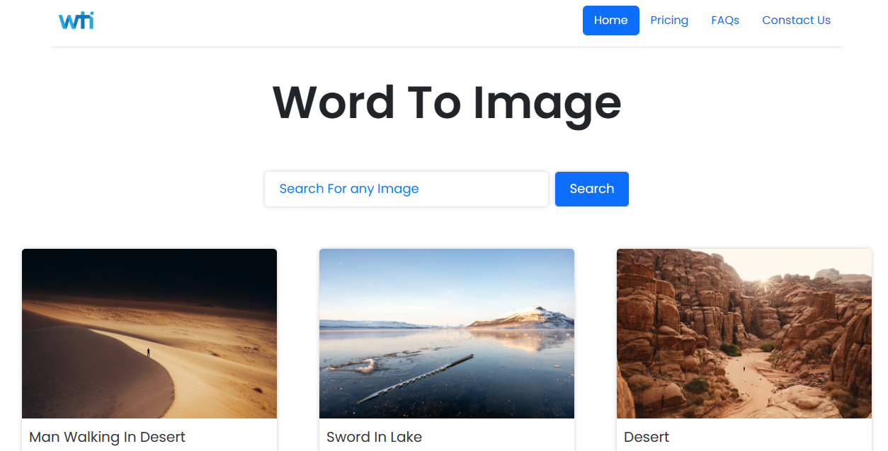

2. Image Display:

- Grid or list view of search results with thumbnail images and essential details (title, tags, owner).

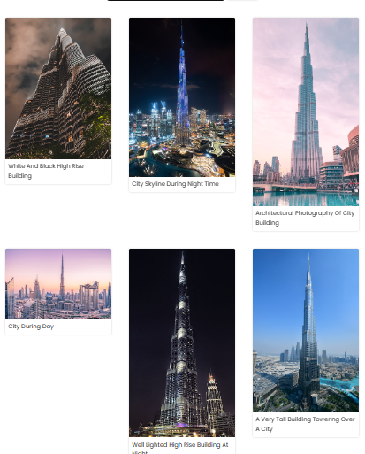

3. Feedback and Help:

- Include a feedback form for users to provide input or report issues.

- A help or support section with FAQs or contact options.

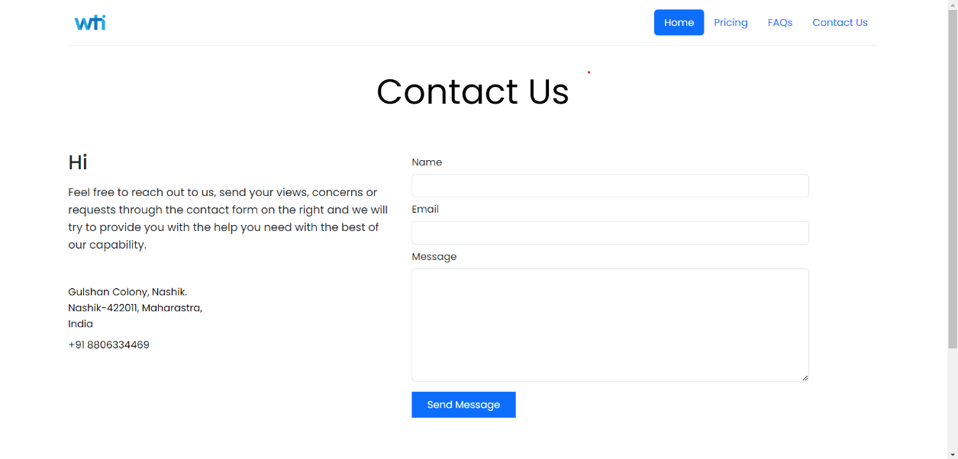

**IMPLEMENTATION DETAILS**

**CONCLUSION AND RECOMMENDATIONS**

**Conclusion**

In conclusion, this report has outlined the software and hardware requirements essential for the successful development and operation of the Image Search Web App. It is evident that these requirements play a pivotal role in ensuring the app's functionality, performance, security, and scalability. This section summarizes the key takeaways from the report:

1. Software Requirements: The app necessitates a well-defined stack of development tools, both frontend and backend technologies, and a robust database management system. Integration with external APIs and thorough security measures are critical components. An effective development environment, dependency management, CI/CD tools, and comprehensive documentation are vital for efficient development and maintenance.

2. Hardware Requirements: Adequate server resources, storage, memory, and processing power are vital for optimal performance and reliability. Networking infrastructure and redundancy measures ensure consistent availability. Load balancing may be employed to manage high traffic scenarios efficiently.

3. Scalability Considerations: As the user base and data volume grow, careful planning is required to ensure seamless scaling of both software and hardware components. Scalability should be a core consideration in ongoing app development.

4. Cost Estimation: The costs associated with the software and hardware requirements, both for initial setup and ongoing maintenance, must be carefully estimated and budgeted to ensure the project's financial sustainability.

**Recommendations**

Based on the software and hardware requirements outlined in this report, several recommendations are presented for the successful execution of the Image Search Web App project:

1. Hardware Procurement: Procure hardware resources (servers, storage, network equipment) from reliable vendors or cloud service providers that can meet the current requirements while allowing for easy scalability.

2. Infrastructure Monitoring: Implement robust monitoring solutions to continuously assess the performance and health of the app's infrastructure. This monitoring should be complemented by automated alerting systems for prompt issue resolution.

3. Security Emphasis: Prioritize security at every level of development and deployment. Regular security audits and vulnerability assessments should be conducted to safeguard user data and privacy.

4. Load Testing: Conduct thorough load testing to ensure that the app can handle high traffic scenarios. This is especially important for apps with anticipated rapid growth.

5. User Feedback: Actively seek user feedback throughout the development and operational phases. User insights are invaluable for refining the app's features and performance.

**FUTURE SCOPE**

The Image Search Web App, as detailed in this report, presents an exciting venture with a multitude of opportunities for growth, enhancement, and innovation. As technology continues to evolve and user expectations advance, it is imperative to explore the potential areas of development and expansion for the app. The following outlines the future scope of the Image Search App:

10.1. Enhanced Search Capabilities

The app's image search functionality can be enhanced through the incorporation of more advanced image recognition and machine learning algorithms. These improvements can enable better image analysis, making it easier for users to find specific images within their collections. Additionally, implementing natural language processing techniques can refine text-based search results by understanding user queries more contextually.

10.2. Mobile Application Development

To broaden the app's reach and accessibility, consider developing native mobile applications for various platforms (iOS and Android). This extension will accommodate users who prefer to search and manage their images from mobile devices. A seamless user experience on smartphones and tablets will be paramount.

10.3. Social Media Integration

Integrating the app with popular social media platforms can facilitate seamless sharing and interaction. Users could easily share their images on platforms like Instagram, Facebook, and Twitter, broadening the app's user base and enhancing the overall user experience.

10.4. Community Features

Incorporating community-building features such as user profiles, image comments, and a "like" system can foster a sense of community among users. This can lead to increased user engagement and interaction, turning the app into not only a tool for image management but also a platform for sharing and connecting.

10.5. Monetization Opportunities

Explore potential revenue streams, such as premium subscription plans, targeted advertising, or partnership opportunities with image-related businesses. Monetization can be introduced while ensuring the app's core functionalities remain accessible to all users.

10.6. Artificial Intelligence and Automation

Leverage artificial intelligence to automate tasks within the app. Implement features like automated tagging and organization of images, suggesting relevant tags, or intelligently categorizing images based on content.

In essence, the future scope of the Image Search App is rich with possibilities for evolution and improvement. To ensure long-term success and relevance in the ever-changing landscape of technology and user preferences, the app should continuously adapt, innovate, and expand its feature set to meet the evolving needs and expectations of its user base.

**Bibliography and References**

1. Johnson, A. (2020). "Building Scalable Web Applications with Modern Tools." O'Reilly Media.

2. Smith, J. (2019). "Web Application Development with Node.js and Express." Packt Publishing.

3. Chua, M. (2018). "The Complete Guide to Web Application Security." CRC Press.

4. Microsoft. (n.d.). "Azure Computer Vision." Retrieved from https://azure.microsoft.com/en-us/services/cognitive-services/computer-vision/

5. Google Cloud. (n.d.). "Google Cloud Vision AI." Retrieved from https://cloud.google.com/vision

6. W3Schools. (n.d.). "HTML Tutorial." Retrieved from https://www.w3schools.com/html/

7. Mozilla Developer Network (MDN). (n.d.). "CSS (Cascading Style Sheets)." Retrieved from https://developer.mozilla.org/en-US/docs/Web/CSS

8. Mozilla Developer Network (MDN). (n.d.). "JavaScript." Retrieved from https://developer.mozilla.org/en-US/docs/Web/JavaScript

9. React. (n.d.). "React - A JavaScript library for building user interfaces." Retrieved from https://reactjs.org/

10. Express.js. (n.d.). "Express - Node.js web application framework." Retrieved from https://expressjs.com/

11. PostgreSQL. (n.d.). "PostgreSQL: The World's Most Advanced Open Source Relational Database." Retrieved from https://www.postgresql.org/

12. AWS. (n.d.). "Amazon Web Services (AWS)." Retrieved from https://aws.amazon.com/

13. Heroku. (n.d.). "Heroku - Cloud Application Platform." Retrieved from https://www.heroku.com/

14. GitHub. (n.d.). "GitHub - Where the world builds software." Retrieved from https://github.com/

15. Google Cloud. (n.d.). "Google Cloud Platform." Retrieved from https://cloud.google.com/

16. Microsoft Azure. (n.d.). "Microsoft Azure - Cloud Computing Platform." Retrieved from https://azure.microsoft.com/

17. Python Software Foundation. (n.d.). "The Python Programming Language." Retrieved from https://www.python.org/

18. Nielsen, J. (1994). "Usability Engineering." Elsevier.

19. ISO 9241-11. (2018). "Ergonomics of human-system interaction - Part 11: Usability: Definitions and concepts." International Organization for Standardization.

20. Krug, S. (2014). "Don't Make Me Think, Revisited: A Common Sense Approach to Web Usability." New Riders.