|  |  |
| --- | --- |
| Name: Muhammad Shazain Khan Mazari | EE-272L Digital Systems Design |
| Reg. No.: 2023-EE-134 | Marks Obtained: ____________ |

**Lab Manual [ 1 ]**

|  |  |  |  |  |  |
| --- | --- | --- | --- | --- | --- |
| **DSD Lab Manual Evaluation Rubrics** | | | | | |
|  |  |  |  |  |  |
| **Assessment** | **Total Marks** | **Marks Obtained** | **0-30%** | **30-60%** | **70-100%** |
| Code Organization (CLO1) | 3 |  | No Proper Indentation and descriptive naming, no code organization.  Zero to Some understanding but not working | Proper Indentation or descriptive naming or code organization.  Mild to Complete understanding but not working | Proper Indentation and descriptive naming, code organization.  Complete understanding, and proper working |
| Simulation (CLO2) | 5 |  | Simulation not done or incorrect, without any understanding of waveforms | Working simulation with errors, don't cares's(x) and high impedance(z), partial understanding of waveforms | Working simulation without any errors, etc and complete understanding of waveforms |
| FPGA (CLO2) | 2 |  | Not implemented on FPGA and questions related to synthesis and implementation not answered. | Correctly Implemented on FPGA or questions related to synthesis and implementation answered. | Correctly Implemented on FPGA and questions related to synthesis and implementation answered. |

1. **Apply 5V at terminal A, what is the voltage at terminal B? Does the LED glow?**

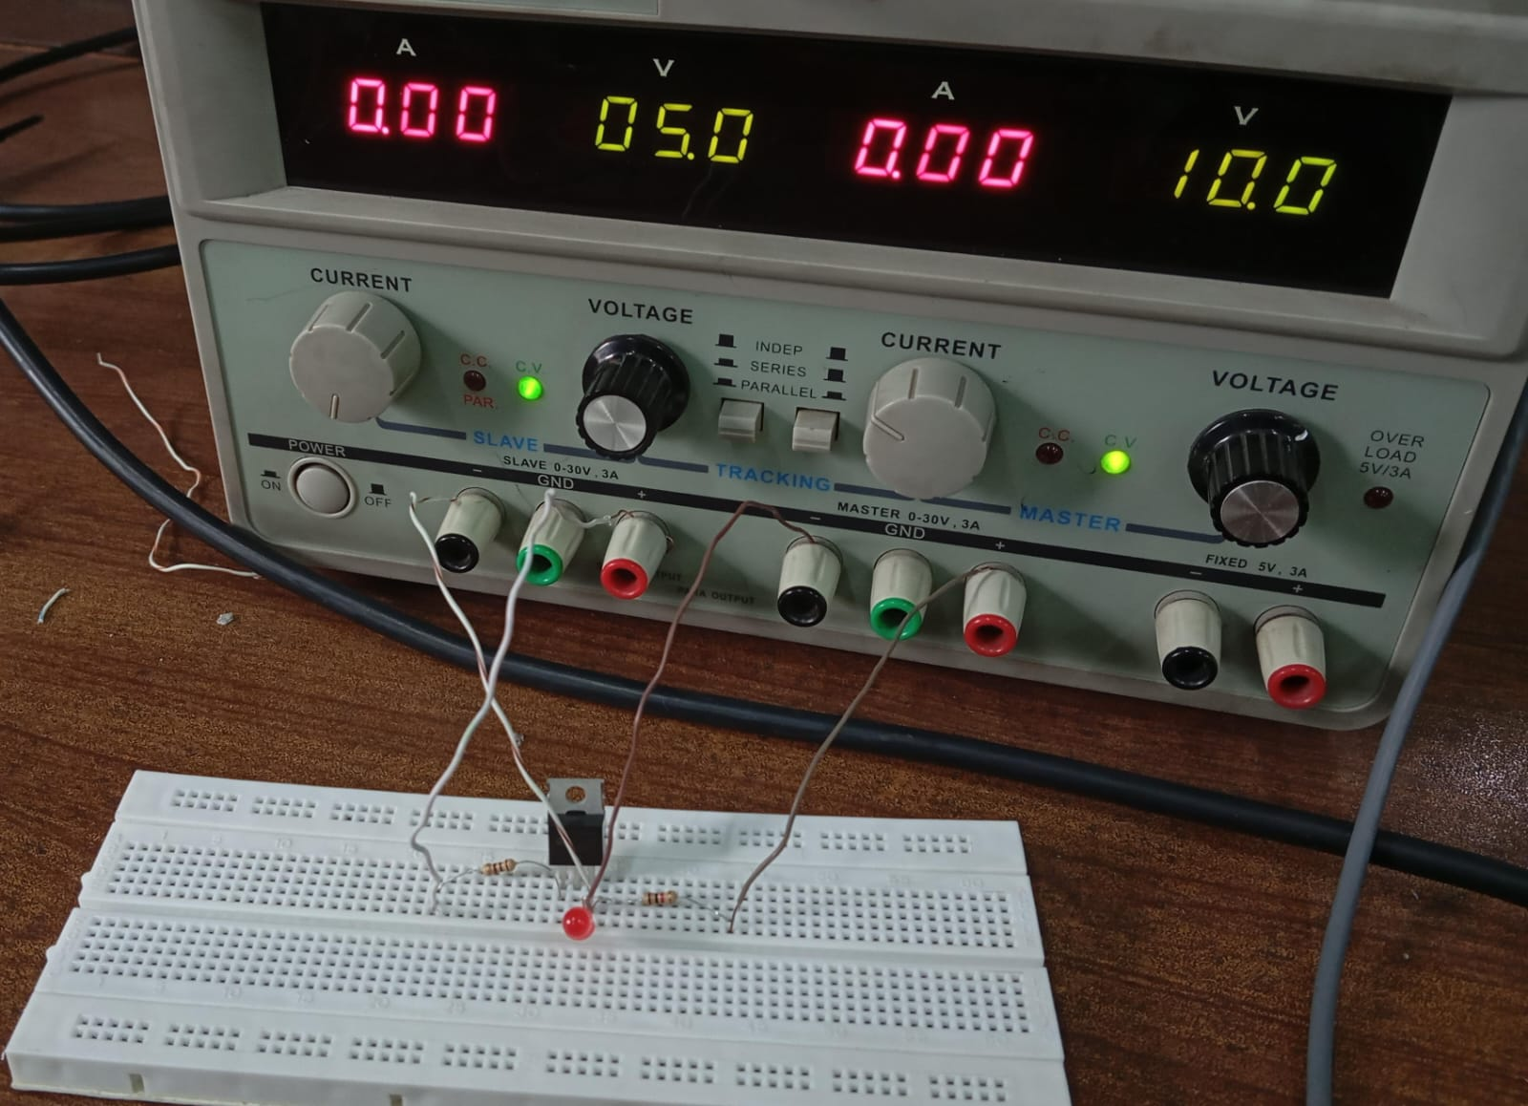After applying 5V at terminal A ,the voltage level at terminal B is zero .The LED doesn’t glow.

1. **Apply 0V at terminal A, what is the voltage at terminal B? Does the LED glow?**

After applying 0V at terminal A ,the voltage level at terminal B is 1.95V .The LED has glow.

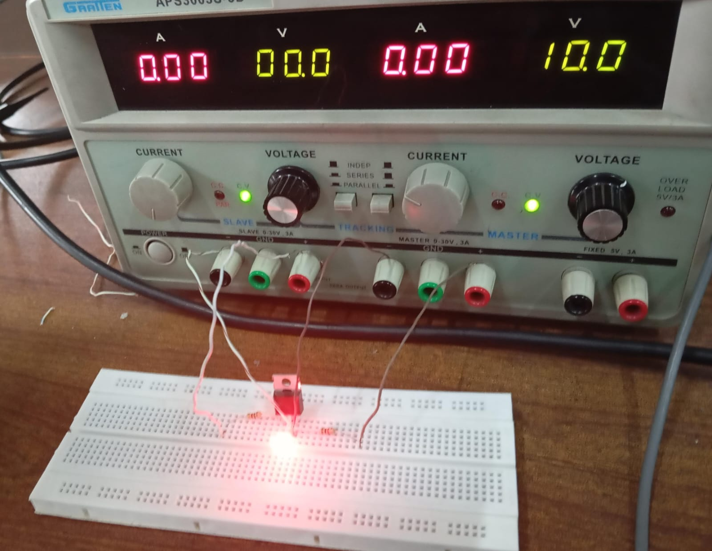

1. **Apply a 1 kHz, 5V peak voltage square wave at terminal A using the signal generator. Plot the input voltage at terminal A and the output voltage at terminal B using C.R.O. When the input goes from high voltage to low voltage, how much time does the output take to go from low voltage to high voltage (propagation delay)? Similarly, find the time the output takes to go from high to low voltage.**

Propagation delay is 1.9*10-6 sec.

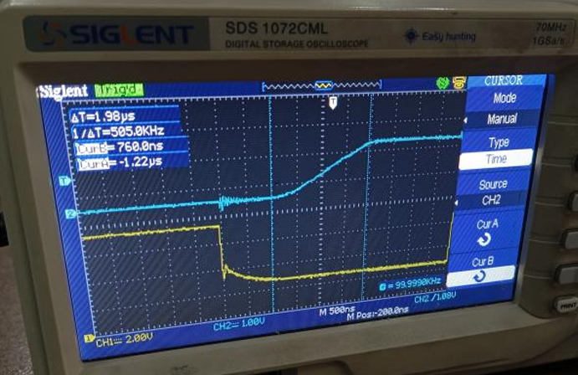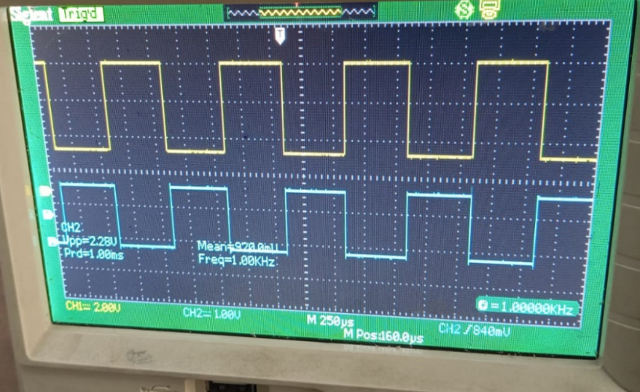

1. **Repeat the above step by applying the frequency of 100kHz at the input terminal.**

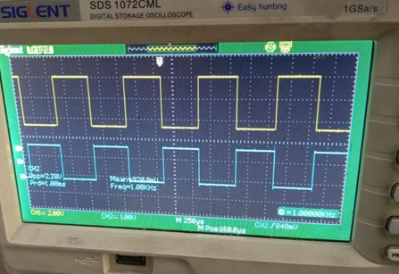

1. **How does the change of frequency affect the mode of operation of a transistor?**

Transistors have internal capacitances. As frequency increases, the capacitive reactance decreases. This can cause the transistor to behave differently.