#In_class_assignment_2_class_3

Shazman Khan

MSBA-4

1. #Use the dataset women plot a scatter plot between height and weight of women

Code:

womenscatter<-ggplot(women, aes(weight, height))

womenscatter +geom_point() +geom_smooth(method="lm", colour = "Red") +labs(x="weight", y="height")

Output:

|  |
| --- |
| womenscatter<-ggplot(women, aes(weight, height))  >  > womenscatter +geom_point() +geom_smooth(method="lm", colour = "Red") +labs(x="weight", y="height") |
|  |
| |  | | --- | | > | |

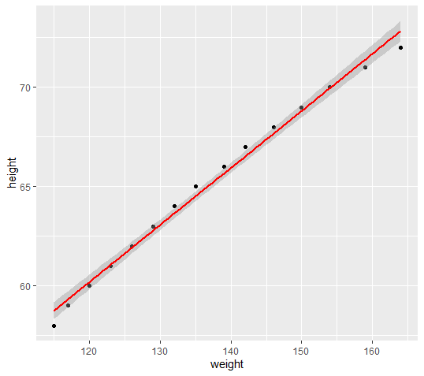

2. #Use the dataset mtcars and plot Boxplot of mpg split by number of cylinders (cyl.f)

Code:

mtcarsBoxplot<- ggplot(mtcars, aes(cyl,mpg,group=cyl))

mtcarsBoxplot + geom_boxplot() +labs(x="cyl", y="mpg")

Output:

> mtcarsBoxplot<- ggplot(mtcars, aes(cyl,mpg,group=cyl))

> mtcarsBoxplot + geom_boxplot() +labs(x="cyl", y="mpg")

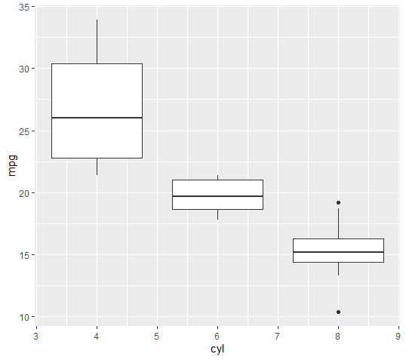

3. #Bar chart for one independent variable

Code:

SpiderLong<-read.delim("SpiderLong.dat", header =TRUE)

head(SpiderLong)

bar <- ggplot(SpiderLong, aes(Group, Anxiety))

bar + stat_summary(fun.y = mean, geom = "bar", fill = "White", colour = "Black") + stat_summary(fun.data = mean_cl_normal, geom = "pointrange") + labs(x = "Group", y = "Anxiety")

Output:

SpiderLong<-read.delim("SpiderLong.dat", header =TRUE)

> head(SpiderLong)

Group Anxiety

1 Picture 30

2 Picture 35

3 Picture 45

4 Picture 40

5 Picture 50

6 Picture 35

> bar <- ggplot(SpiderLong, aes(Group, Anxiety))

> bar + stat_summary(fun.y = mean, geom = "bar", fill = "White", colour = "Black") + stat_summary(fun.data = mean_cl_normal, geom = "pointrange") + labs(x = "Group", y = "Anxiety")

