SoleMate — Architecture & Deployment Design
Architecture & DevOps Design Document
Project: SoleMate (footwear ecommerce platform)
Document type: Architecture & DevOps design
Cloud target: Amazon Web Services (ECS Fargate + Lambda)
IaC: AWS CloudFormation (YAML) · CI/CD: GitHub Actions

Table of Contents

1. Introduction

1.1 Purpose
This document describes the architecture of the SoleMate ecommerce application and the design for deploying it to AWS using modern DevOps practices: Infrastructure as Code, containerization, a serverless event tier, and a fully automated CI/CD pipeline.

1.2 Scope
It covers the application architecture (frontend, API, data, events), the target AWS cloud architecture, the network/security design, the deployment process, and the CI/CD pipeline. Diagrams are provided at the system, container, deployment, and network levels.

1.3 Goals & non-functional requirements
Goal | How it is addressed
Scalability | Stateless API on ECS Fargate behind an ALB with auto-scaling; serverless Lambda for spiky event work
Availability | Multi-AZ deployment of ECS tasks and RDS; managed, self-healing services
Security | Private subnets for compute/data, secrets in Secrets Manager, least-privilege IAM, HTTPS everywhere
Maintainability | 100% IaC, immutable container images, one-command pipeline deploys
Observability | Centralized logs (CloudWatch), health/readiness probes, metrics & alarms
Cost-efficiency | Fargate right-sizing, serverless for bursty work, S3+CloudFront for static assets

2. Application overview
SoleMate is a classic three-tier web application.
Tier | Technology | Responsibility
Presentation | React 18 + Vite + Tailwind (SPA) | UI, cart, checkout, admin
Application | Node.js + Express REST API | Auth (JWT), products, orders, payments
Data | PostgreSQL | Users, products, orders, payments
Events | (new) AWS Lambda | Stripe webhook, image processing, email
Storage | Object storage (S3) | Product images
External | Stripe | Card payments

3. System context (C4 — Level 1)
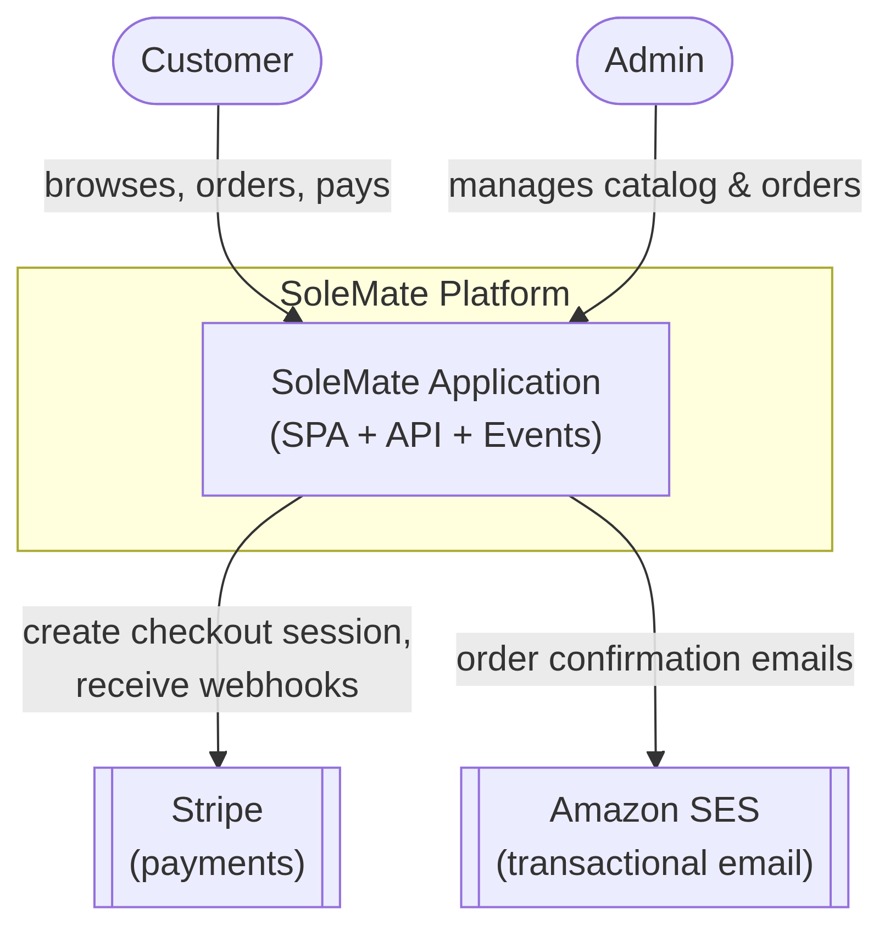
Actors
- Customer — browses products, manages a cart, places and pays for orders.
- Admin — manages the product catalog, sizes, images, and views orders.
External systems
- Stripe — hosted card checkout + webhooks for payment confirmation.
- Amazon SES — sends order-confirmation email (replaces the old EmailJS).

4. Container architecture (C4 — Level 2)
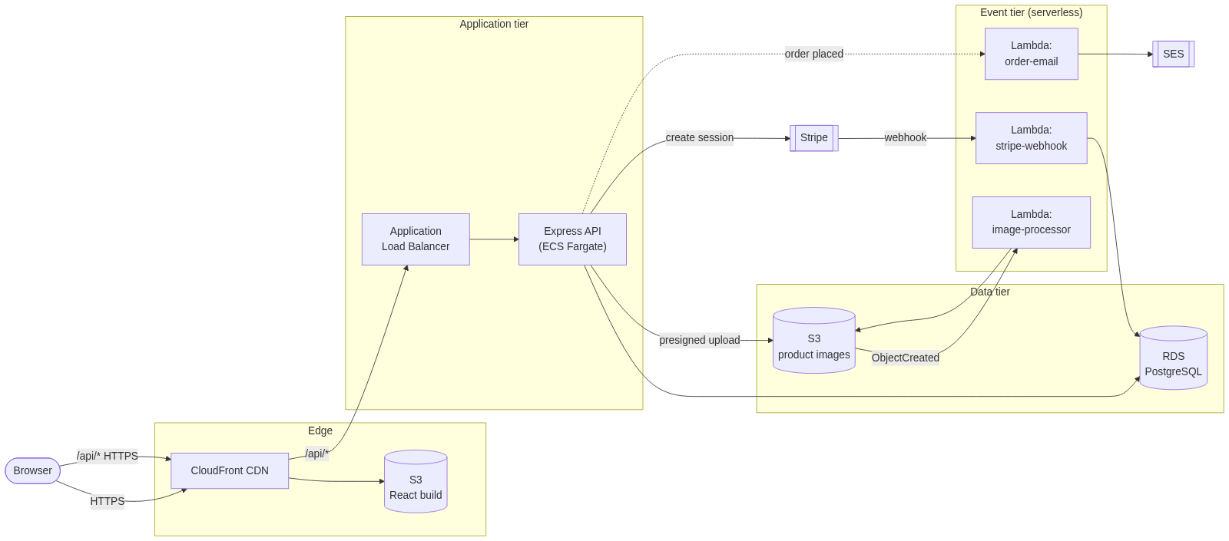
Why this split (ECS for the API, Lambda for events)?
- The Express API is a long-running request/response service with steady traffic
and shared connections (a DB pool). That fits a container on ECS Fargate.
- The webhook, image-processing, and email tasks are event-driven and bursty.
They map naturally to Lambda, which scales to zero and bills per invocation.
This is a deliberate architectural decision, not "Lambda for everything."

5. AWS deployment architecture
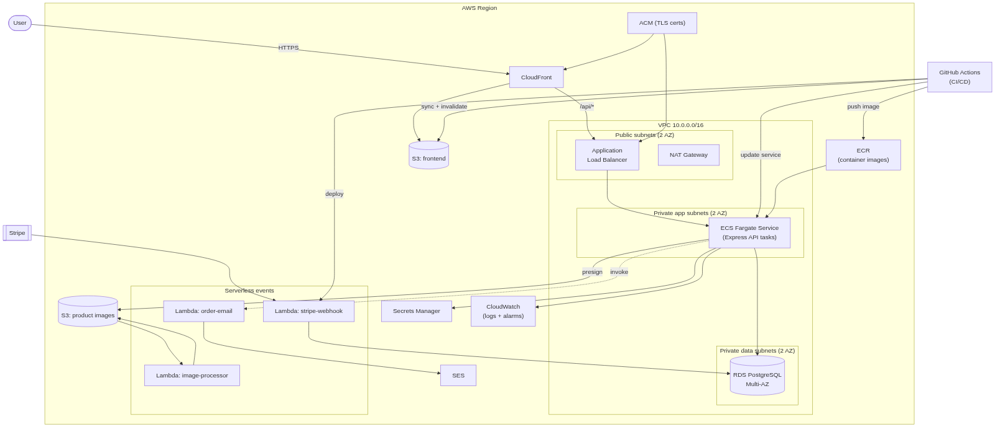

5.1 AWS service inventory
Service | Role in SoleMate
CloudFront | CDN for the SPA + TLS termination; routes /api/* to the ALB
S3 (frontend) | Hosts the static React build (private, served via CloudFront OAC)
S3 (images) | Stores product images; emits events to the image-processor Lambda
ALB | Load-balances and health-checks the ECS API tasks
ECS Fargate | Runs the Express API as containers (no servers to manage)
ECR | Stores versioned API container images
RDS (PostgreSQL) | Managed, Multi-AZ relational database
Lambda | Stripe webhook, image processing, order emails
Secrets Manager | DB credentials, JWT secret, Stripe keys
ACM | TLS certificates for CloudFront and the ALB
CloudWatch | Logs, metrics, dashboards, alarms
SES | Transactional email
IAM | Least-privilege roles for ECS tasks, Lambdas, and CI/CD

6. Network & security design
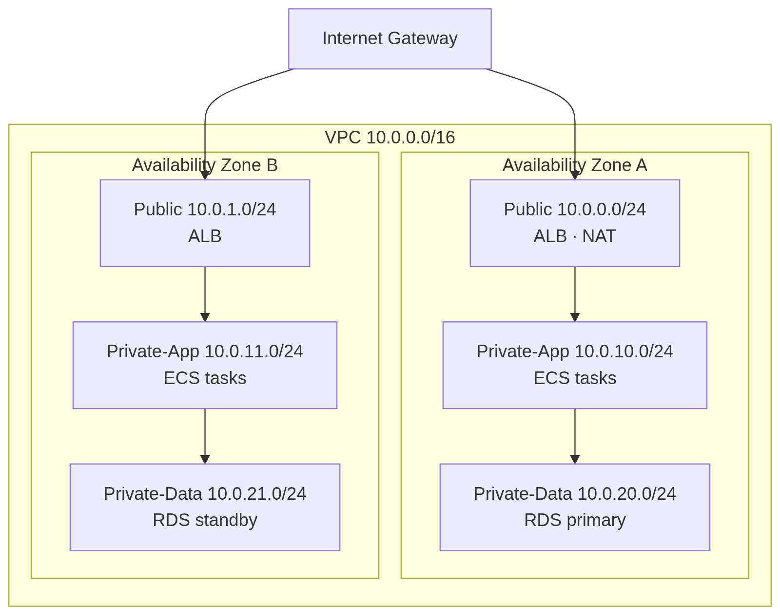

6.1 Subnet tiers
- Public subnets — only internet-facing resources (ALB, NAT Gateway).
- Private app subnets — ECS tasks; outbound internet via NAT only.
- Private data subnets — RDS; no internet route at all.

6.2 Security groups (least privilege)
SG | Inbound | From
alb-sg | 443, 80 | 0.0.0.0/0
ecs-sg | container port (5000) | alb-sg only
rds-sg | 5432 | ecs-sg and the migration runner only

6.3 Secrets & identity
- No secrets in images or env files — all pulled from Secrets Manager at task
start and injected into the container.
- IAM roles are scoped per workload (ECS task role, each Lambda's execution
role, the CI/CD deploy role) — no shared, broad credentials.
- TLS end-to-end (CloudFront → ALB → task), HSTS via helmet.

7. Data model
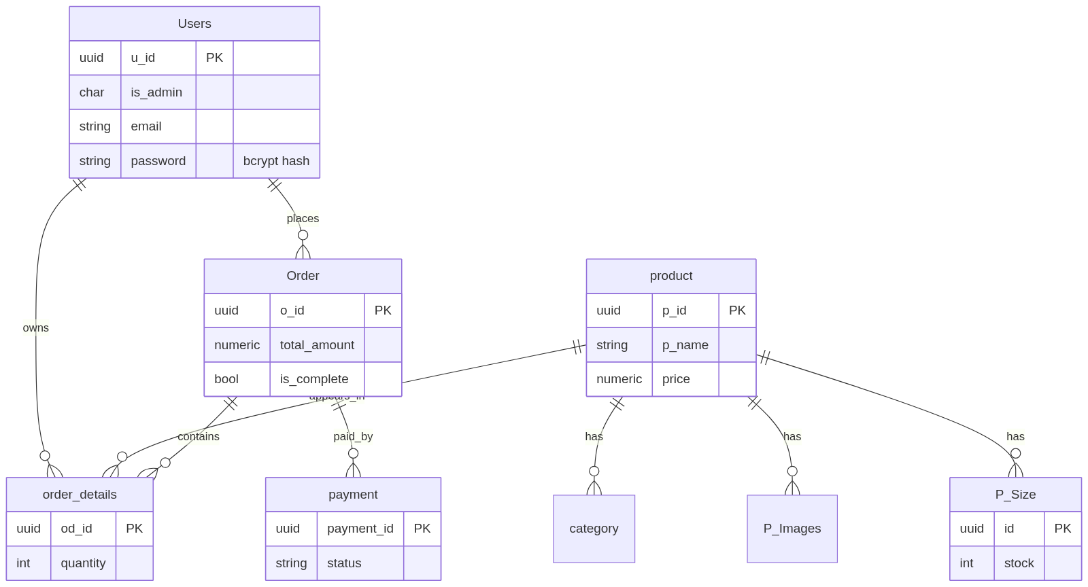
Full DDL: `backend/DB/schema.sql`. The same schema is applied to local Postgres (dev) and RDS (prod) via npm run db:migrate.

8. Key runtime flow — checkout
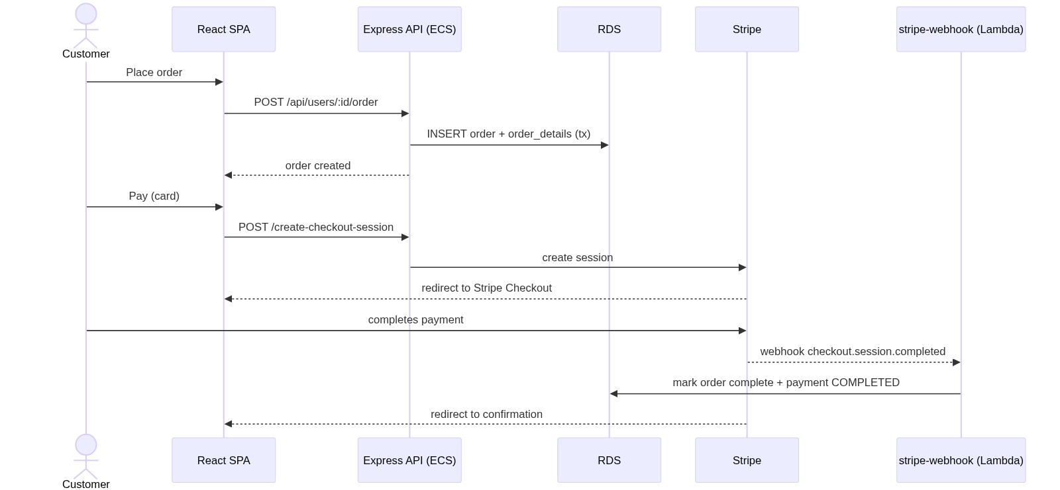
*(Non-card methods — Cash on Delivery / Bank Transfer — skip Stripe and record the payment directly via the API.)*

9. Deployment process

9.1 Environments
Environment | Frontend | API | Database
Local | Vite dev server | npm run dev | Docker Postgres
Staging | S3 + CloudFront | ECS service (1 task) | RDS (single-AZ)
Production | S3 + CloudFront | ECS service (≥2 tasks, auto-scale) | RDS Multi-AZ

9.2 Provisioning order (CloudFormation stacks)
Stacks are deliberately split so they can be updated independently:
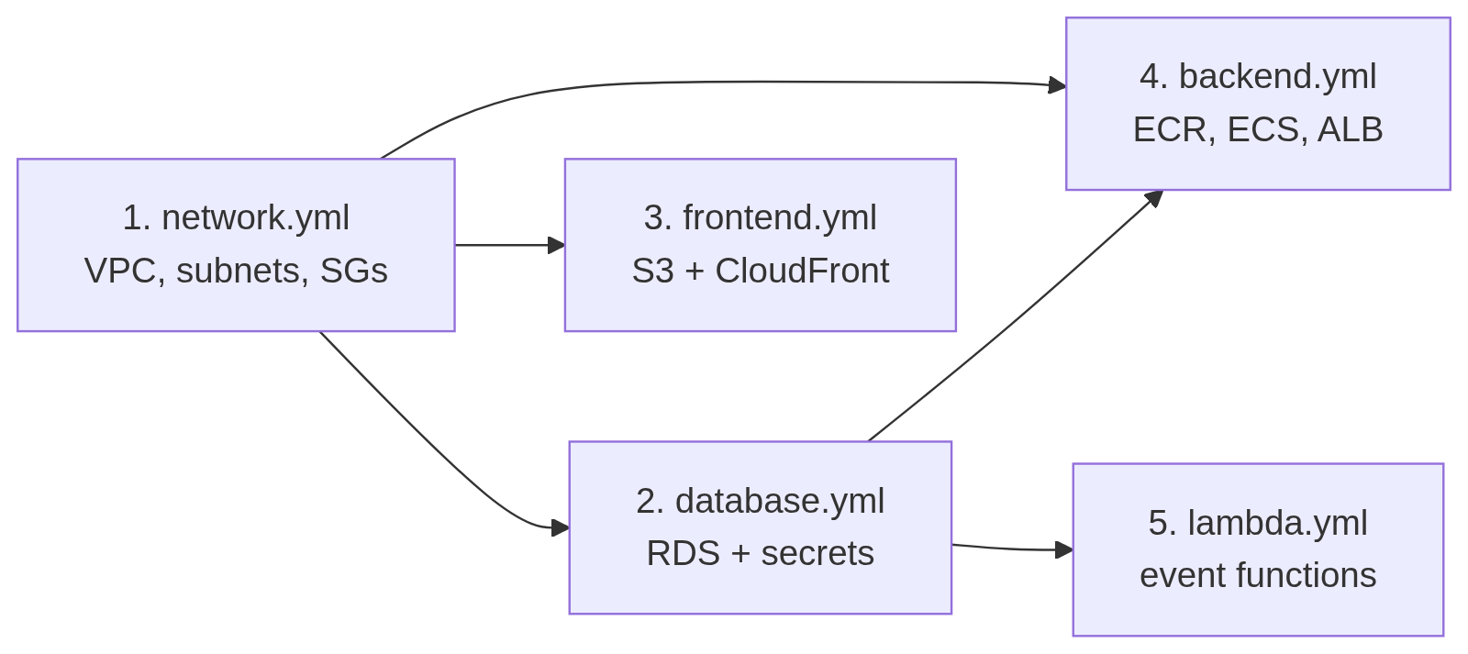

9.3 Rolling (zero-downtime) API deploy
ECS performs a rolling replacement; the ALB only sends traffic to tasks that pass the /health check, and drains old tasks gracefully (the API handles SIGTERM).
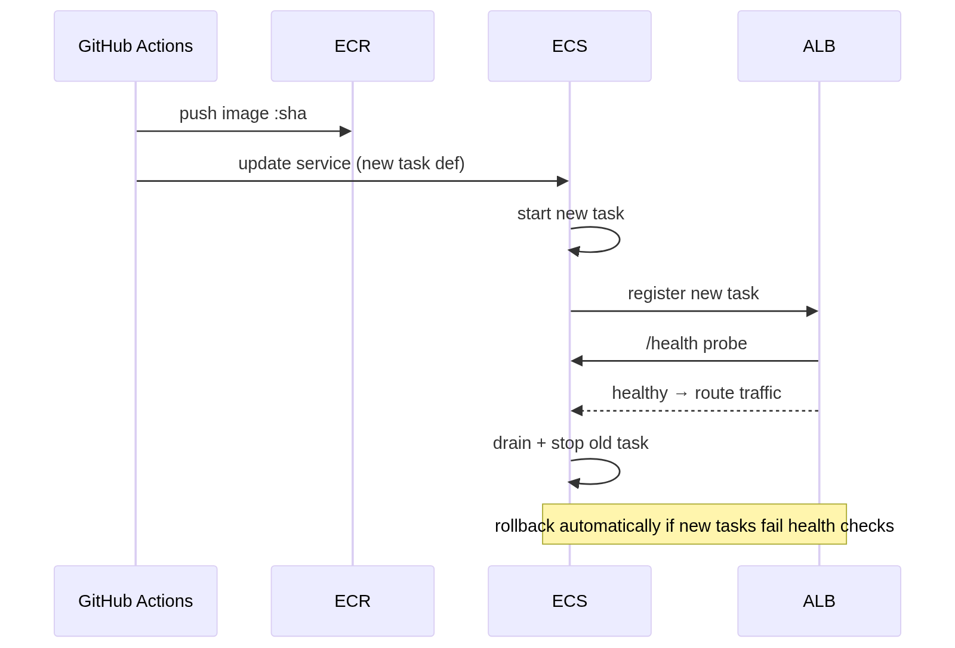

9.4 Database migrations
Migrations run as a one-off ECS task (same image, npm run db:migrate) before the service update, so schema changes land before new code serves traffic.

10. CI/CD pipeline
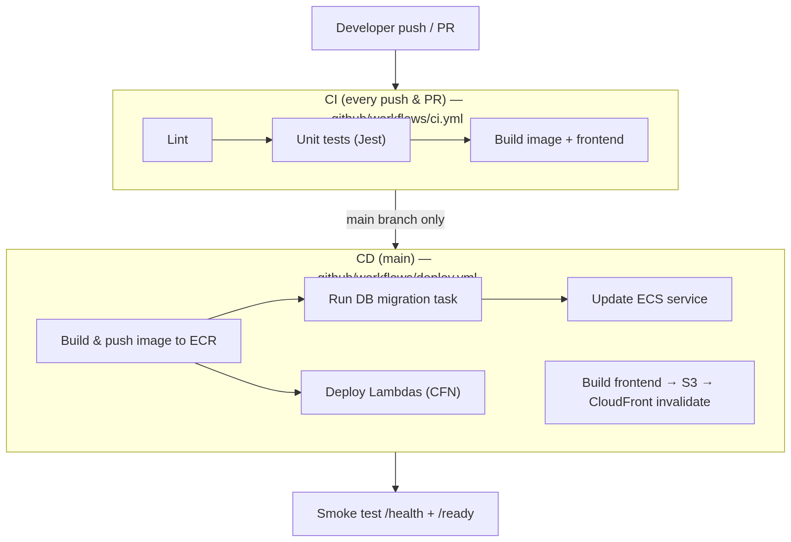

10.1 Pipeline stages
Stage | Trigger | Action
Lint & test | every push/PR | ESLint + Jest; blocks merge on failure
Build | every push/PR | Build Docker image and frontend bundle
Push image | merge to main | Tag with git SHA, push to ECR
Migrate | merge to main | Run migration as a one-off ECS task
Deploy API | merge to main | Update ECS service (rolling)
Deploy Lambdas | merge to main | aws cloudformation deploy for lambda.yml
Deploy frontend | merge to main | aws s3 sync + CloudFront invalidation
Verify | after deploy | curl /health and /ready

10.2 Pipeline security
- AWS access uses GitHub OIDC (short-lived role assumption) — no long-lived
AWS keys stored in GitHub.
- Image is tagged immutably with the commit SHA for traceability and rollback.

11. Observability & operations
- Logs: the API logs structured JSON (pino) to stdout → CloudWatch Logs.
- Health: GET /health (liveness) and GET /ready (DB reachable) back the
ALB target-group and container health checks.
- Metrics & alarms: ALB 5xx rate, ECS CPU/memory, RDS connections/CPU →
CloudWatch alarms.
- Scaling: ECS target-tracking on CPU (e.g. scale out at 70%).
- Backups: RDS automated snapshots + point-in-time recovery.

12. Cost considerations (illustrative)
Service | Driver | Lever
ECS Fargate | task count × size × time | right-size CPU/mem, scale to 1 task off-peak
RDS | instance class + Multi-AZ | single-AZ in staging, smallest viable class
NAT Gateway | hourly + data | one NAT (vs per-AZ) in non-prod
S3 + CloudFront | storage + egress | cache static assets aggressively
Lambda | invocations + duration | scales to zero when idle

13. Repository layout (DevOps artifacts)
.
├── docs/DESIGN.md ← this document
├── .github/workflows/
│ ├── ci.yml ← lint, test, build (every push/PR)
│ └── deploy.yml ← deploy to AWS (main)
├── infra/cloudformation/
│ ├── network.yml ← VPC, subnets, NAT, security groups
│ ├── database.yml ← RDS PostgreSQL + Secrets Manager
│ ├── backend.yml ← ECR, ECS cluster/service, ALB, IAM
│ ├── frontend.yml ← S3 + CloudFront for the SPA
│ └── lambda.yml ← event-driven Lambda functions
├── infra/lambdas/ ← Lambda source
├── backend/Dockerfile ← API container image
└── docker-compose.yml ← local Postgres + API

14. Summary
SoleMate is deployed as a containerized API on ECS Fargate behind an ALB, with a serverless event tier on Lambda, a managed RDS PostgreSQL database, and the React SPA served from S3 via CloudFront — all defined in CloudFormation and shipped through an automated GitHub Actions pipeline. The design prioritizes scalability, security (private subnets, managed secrets, least-privilege IAM), zero-downtime deploys, and full observability, while keeping cost in check through right-sizing and serverless-for-bursty-work.

