# DATA ANALYSIS OF XY HOTEL

# **Presented By: Shazar Khan**

# **Date: 6/21/2025**

# Project Summary

This analysis was conducted for a hotel to identify trends and causes behind customer booking cancellations. The hotel management provided real-world booking data. Our goal was to find out how many bookings are being cancelled, when they're occurring, and why, to help the business reduce revenue loss and improve customer experience.

# Business Problem

The hotel has been facing a significant number of booking cancellations, which affects occupancy rates and revenue. Management wants to understand:

* When cancellations mostly occur
* Which types of customers or booking conditions are more prone to cancel
* Whether one hotel (City or Resort) faces more cancellations
* What actions can be taken to minimize these cancellations

# Hypotheses

We formed the following assumptions before analyzing the data:

1. City Hotels face more cancellations than Resort Hotels.
2. Customers booking through online agents cancel more often.
3. Longer lead time (booking far in advance) leads to higher cancellation.
4. Peak seasons or high price rates (ADR) may influence cancellations.

# Key Analysis & Findings

1. About 37% of all bookings were cancelled.
2. City Hotels had a significantly higher cancellation rate (~41%) than Resort Hotels (~27%).
3. Summer months (June to August) had higher cancellation trends.
4. Prices (ADR) peaked during summer and were linked to higher cancellations.
5. Long lead-time bookings showed more cancellation risk.

Key Visualizations

1. Reservation Status (Total)

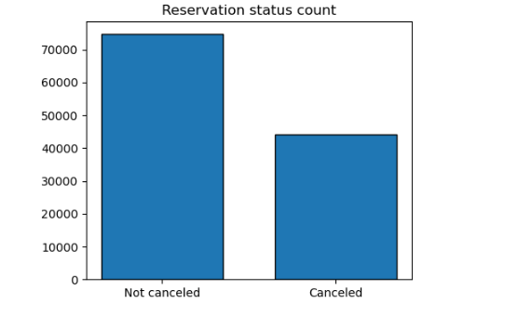

2. Reservation Status by Hotel

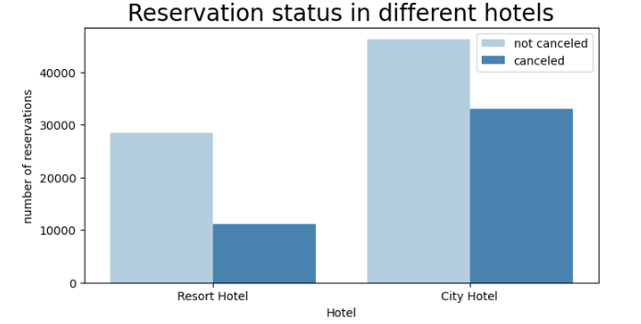

3. ADR Trend Over Time

Shows how prices for Resort and City hotels changed over the months:  
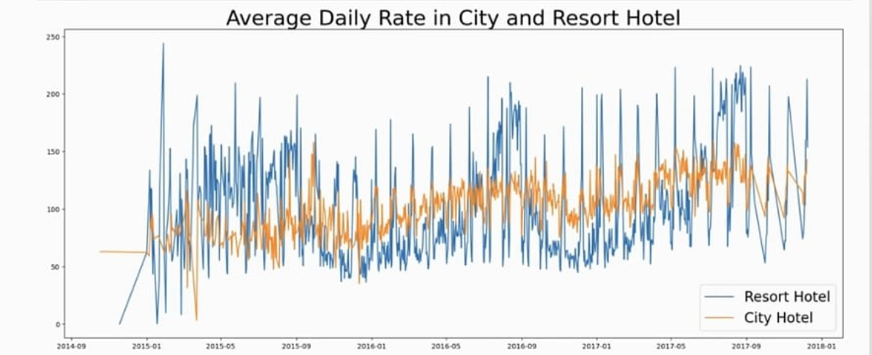

4. Cancellations by Month

Higher in mid-year months:

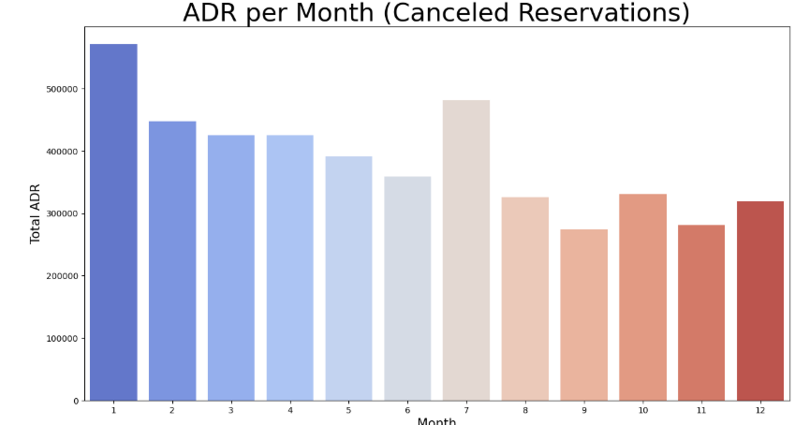

5. Top 10 Countries With Most Cancelation Rate

Portugal has high rates

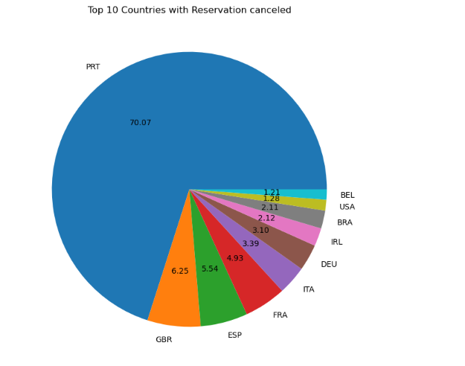

# Business Suggestions

1. Apply flexible pricing or cancellation policies during peak periods.
2. Introduce partial prepayment requirements for advance bookings.
3. Track and regulate online booking agents with high cancellation rates.
4. Launch loyalty programs to encourage follow-through.
5. Use seasonal cancellation trends to plan better overbooking strategies.

# Conclusion

The hotel can reduce cancellations by improving pricing models, booking conditions, and customer engagement strategies. This analysis offers clear steps to help boost revenue and guest reliability.