Context viewer documentation
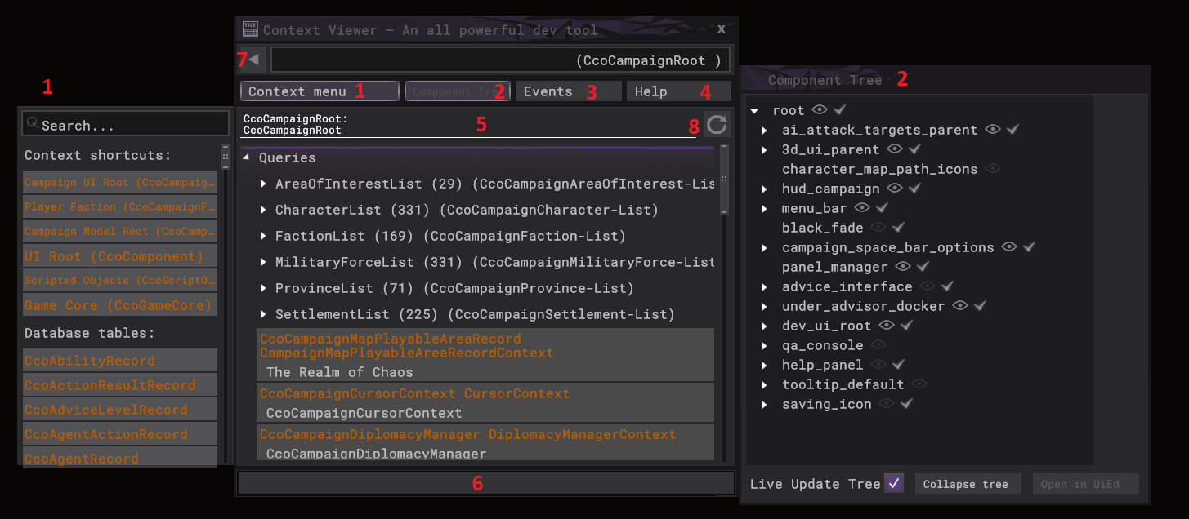

What is the context viewer?
To understand what the context viewer is, you first need to understand what we mean by a ‘context’.

What are ‘contexts’?
The TW UI (user interface) framework is primarily driven by what we call the ‘context system’. We expose game objects that we want to represent in the UI as contexts (which we refer to cco for short, you will notice the cco prefix at the start of all context type names).
So a context is basically a type of object that exists in the game. Some simple examples:
- A battle unit is exposed as a CcoBattleUnit
- A campaign character is exposed as a CcoCampaignCharacter
- A campaign settlement is exposed as a CcoCampaignSettlement
- A special ability is exposed as a CcoUnitAbility
Each context has an interface that we can call both queries on (to get information) as well as commands on (to change game state). We combine these with different behaviours in our UI system to basically build the UI.
Some examples:
- We might have a health bar hooked up to fill based on CcoBattleUnit::HealthPercent
- We might have a name label hooked up to show a CcoCampaignCharacter::Name
- We might have a button hooked up so when pressed it calls CcoCampaignSettlement::ZoomTo

Okay I know what contexts are, so what is the context viewer?
The context viewer allows you to inspect all exposed contexts in the current game model and look at their live values, as well as call any of the commands on those contexts.
In addition, it also has some other additional functionalities:
- You can easily inspect the state of the UI object tree (look at the whole UI hierarchy to easily inspect/manipulate)
- You can track the firing of UI events. These are used to refresh UI content based on changes to game state.
- You can write ‘expressions’ in the text input at the bottom to perform more complex queries/commands

Why would I use the context viewer?
- Very useful companion tool for working on UI mods
- Also useful for mods in general involving scripts, you can actually interact with the context system via script so any query/command available in the context system is available automatically for script. Therefore the context viewer gives you an idea of what information/commands are available. The following script commands can be used to interact with the context system, see the external script documentation for more information on each:
  - call_context_command
  - get_context_value
- To find out more in depth information that isn’t necessarily shown in the UI currently
- To manipulate game/UI state in ways not currently allowed by the in game UI

Are there any limitations or risks I should be aware of?
- Stability is not guaranteed, so you might experience crashes when inspecting some contexts at certain times
- The context viewer is disabled in multiplayer for obvious reasons (to prevent any form of cheating)
- Most context information is not localised

How do I use it?
- To open the context viewer, you must first enable the option in the game settings
- Once enabled, you can open the context viewer via the GRAVE (`) key (usually near the top left of keyboard).
- You can drag the context viewer around by dragging the top of it, it will remember where you placed it between sessions
- While open, you can middle mouse click on the following to inspect the context for that object immediately:
  - UI objects
  - Battle units
  - Battle buildings
  - Campaign characters
  - Campaign settlements
- You can hold alt while middle clicking on a UI object to get a list of all UI objects currently under the mouse, selecting an entry will then inspect the context for that UI object
- Here is a breakdown of the different areas on the context viewer, referring to the image at the top of the documentation:
  - You can press the context menu button to open the context menu on the left. This provides a handy list of shortcuts to get started with investigating the game state. These shortcuts are tailored to each game area. There is also a list of all exposed database contexts.
  - You can press the Component tree button to open up the component tree view on the right hand side, this shows the whole UI hierarchy which is useful for inspecting and manipulating the game UI
  - You can press the Events button to open up the events viewer on the right hand side (same space that the component tree occupies). While open you can see events appear in the list as they fire from the game.
  - You can press the help button to easily access the documentation, which includes this document as well as the documentation for all the exposed context types
  - The centre of the panel is where the information for the current inspect context is shown. Queries are shown first, followed by commands which are shown as buttons.
  - This text input is where you can write out ‘context expressions’ to perform more advanced queries/commands. You will note some command buttons are disabled and have arguments next to their names. These can only be performed by using this text input since you can type out the command and pass any relevant parameters to the command to be performed.
  - You can press the back button to easily return to the previous inspected contexts
  - You can press the refresh button to get the most up to date information for the current inspected context. Most information is updated live automatically, except for any queries returning other contexts or lists of contexts.

