Ecommerce Platform
Project Submission Report
Academic Submission Edition | Professional Format
Date: 2026-03-26

College: Mohamed Sathak College of Arts & Science
Student Name: Shalini
Roll Number: 24MCAG001
Department: MCA
Project Guide: ____________________

Certificate
This is to certify that the project report titled 'Ecommerce Platform' is an original work carried out by the candidate under approved academic supervision and is submitted in partial fulfillment of the requirements of the MCA program.

Declaration
I hereby declare that this report and the software artifacts presented in it are my original work, completed as part of the curriculum requirements under faculty guidance. All external references, frameworks, and learning resources used in this project have been duly acknowledged.

Acknowledgement
I express my sincere gratitude to my faculty guide, department members, and peers for their support, technical guidance, and continuous feedback throughout the development of this project. Their mentorship played a key role in delivering a complete and stable implementation.

Abstract
This report presents the design and implementation of a full-stack ecommerce platform composed of a customer storefront, an administrative console, and a backend API service. The solution is implemented using React, Node.js/Express, and MongoDB. The current production-ready baseline supports secure authentication, product catalog management, cart operations, Cash on Delivery (COD) checkout, and end-to-end order lifecycle tracking.

Table of Contents
- 1. Introduction
- 2. Objectives
- 3. Existing System Study
- 4. Proposed System
- 5. Architecture Design
- 6. Technology Stack
- 7. Frontend Module
- 8. Admin Module
- 9. Backend Module
- 10. Database Design
- 11. API Design
- 12. Authentication and Security
- 13. Checkout and COD Flow
- 14. Testing Strategy
- 15. Result Analysis
- 16. Deployment Guide
- 17. Viva Questions and Answers
- 18. Future Enhancements
- 19. Conclusion
- 20. References
- 21. Appendix

1. Introduction
The ecommerce platform addresses a complete online retail workflow from product discovery to fulfillment. The project is structured for maintainability, extensibility, and clarity during academic evaluation.
- Supports customer browsing and ordering.
- Includes admin controls for products and orders.
- Built with real-world full-stack architecture.

2. Objectives
Project objectives are defined for functionality, stability, and demonstration readiness.
- Build a responsive ecommerce web interface.
- Implement secure auth and role-based admin access.
- Enable COD-only order flow for operational simplicity.
- Provide clean setup documentation for evaluators.

3. Existing System Study
A review of common ecommerce starter templates identified practical limitations such as weak admin operations, incomplete documentation, and unnecessary payment-gateway complexity for initial releases.
- Lack of clean project modularization.
- Unclear deployment setup.
- Limited operational reporting structure.

4. Proposed System
The proposed system introduces a structured three-app setup with clear separation between customer-facing features and administrative operations.
- React storefront for end users.
- React admin panel for operations.
- Express backend for centralized business logic.

5. Architecture Design
Architecture follows a client-service-database model. Both frontend clients consume a common backend API, while MongoDB persists entities.
- Low coupling between UI layers.
- Reusable middleware and controllers.
- Scalable path for future modules.
Figure: High-level architecture flowchart
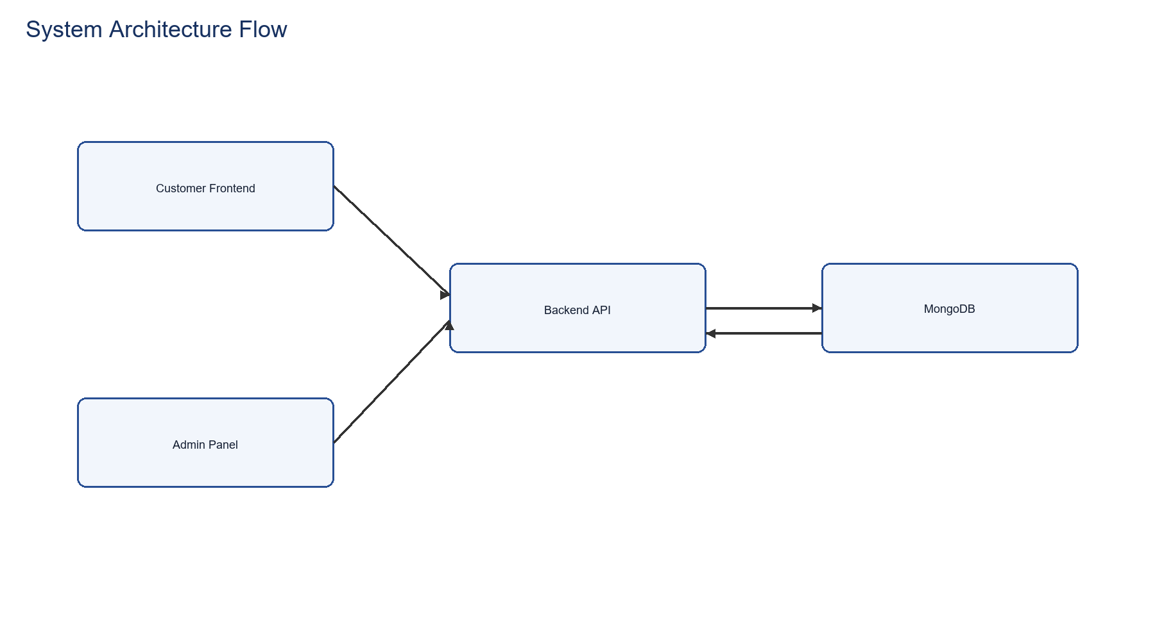

6. Technology Stack
The technology stack is selected to balance rapid implementation, maintainability, and production-readiness. The architecture separates frontend, admin, and backend concerns for independent evolution and deployment.
- Frontend Framework: React 18+ for declarative UI rendering with hooks-based state management and component reusability.
- Build Tool: Vite for fast HMR (Hot Module Replacement) dev server and optimized production bundling with ES6 module federation.
- Styling: Tailwind CSS utility-first framework for consistent design system without custom CSS files.
- HTTP Client: Axios for promise-based API requests with request/response interceptors for centralized auth and error handling.
- Routing: React Router v6 for client-side navigation with nested route features and lazy code splitting.
- Runtime: Node.js 18+ LTS for production-grade stability with native ES modules and improved async performance.
- Backend Framework: Express.js minimal but powerful server framework for REST API construction with middleware pipeline architecture.
- ODM (Object-Document Mapper): Mongoose for MongoDB schema validation, pre/post hooks, and type safety in document operations.
- Authentication: JWT (JSON Web Tokens) with secure token signing/verification for stateless session management across services.
- File Handling: Multer middleware for multipart/form-data parsing and file upload handling with stream-based processing.
- Database: MongoDB Atlas/Community Edition with replica set support for ACID transactions and horizontal scalability.
- Password Security: bcrypt library for irreversible password hashing with configurable work factors against brute-force attacks.
- Environment Config: dotenv for .env file parsing enabling environment-specific configurations without hardcoding secrets.
- Image Handling: Multer-based upload flow with optional Cloudinary integration for scalable media delivery.
- Development Tools: Postman for API endpoint testing and documentation; Git for version control with branching strategy.

7. Frontend Module
Frontend module handles catalog rendering, product detail navigation, cart updates, and order placement.
- Context-based shared state management.
- Responsive page layout and navigation.
- Toast notifications for user feedback.

8. Admin Module
Admin module provides secure login and operational pages for product and order management.
- Add/list/remove products.
- View all orders.
- Update order status lifecycle.

9. Backend Module
Backend implementation uses an Express route-controller-model architecture with dedicated middleware for authentication, admin authorization, and file uploads.
- Route groups: /api/user, /api/product, /api/cart, /api/order.
- Middleware: auth.js, adminAuth.js, and multer upload pipeline.
- Startup pipeline includes DB connect and initial data seeding.
Figure: Backend module flow
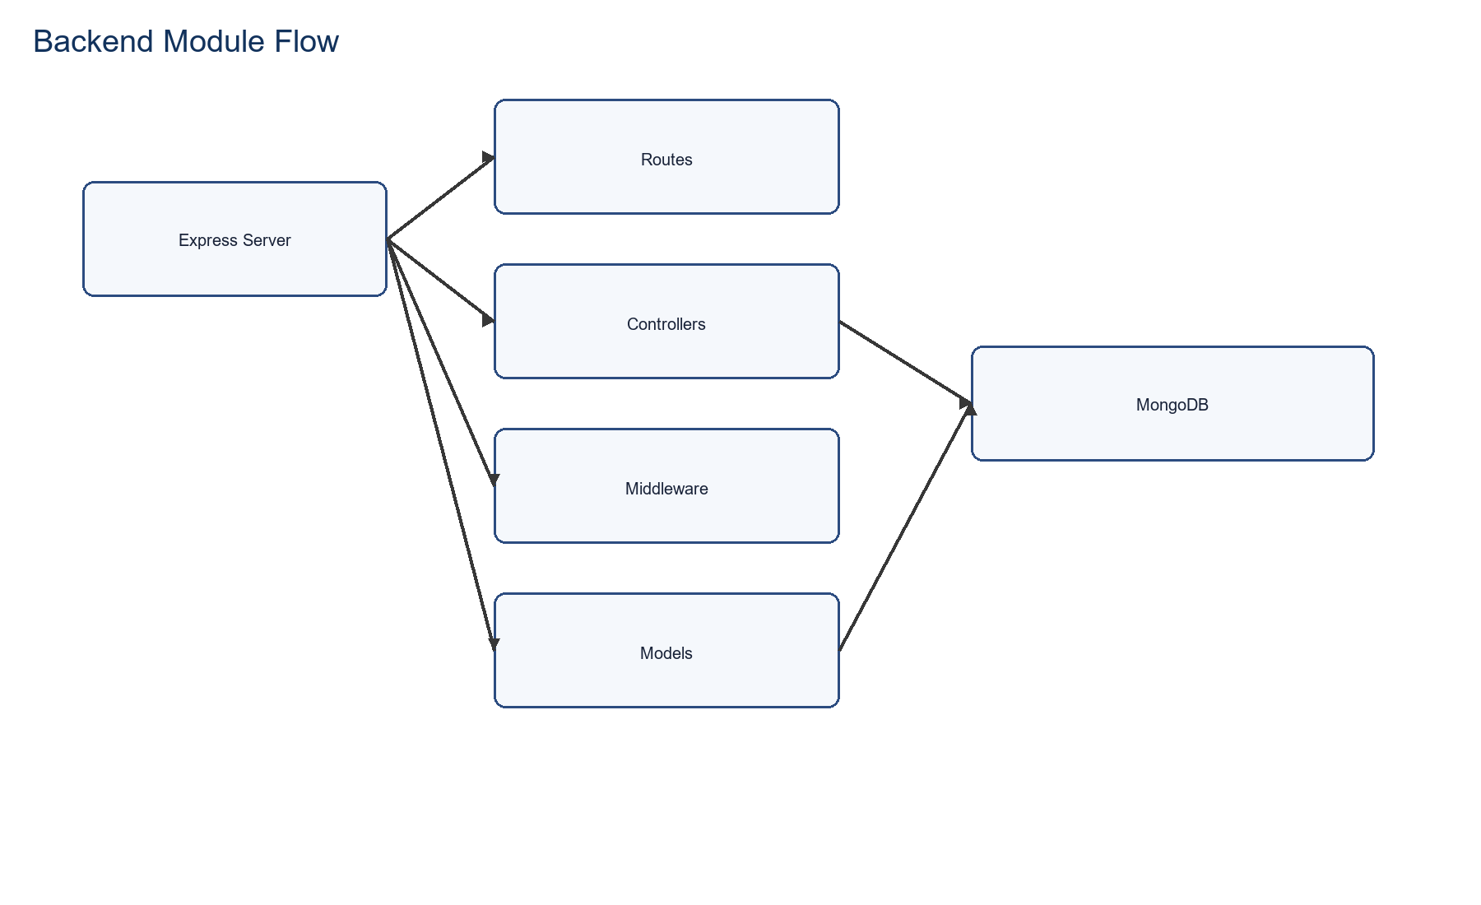

10. Database Design
MongoDB schemas define users, products, and orders with flexible but controlled document structures.
- Order includes status, paymentMethod, payment flags.
- Product includes category, subCategory, size and image arrays.
- User schema includes persistent cart object.

11. API Design
The API follows domain-based route grouping and clear naming conventions to improve maintainability and predictable client integration.
- User APIs: /register, /login, /admin.
- Product APIs: /add, /list, /remove, /single.
- Cart APIs: /add, /get, /update.
- Order APIs: /place, /list, /status, /userorders.

12. Authentication and Security
Security model combines JWT protection with admin credential checks. Additional hardening recommendations are included from OWASP and Express guidance.
- Secure token verification middleware.
- Credential secrets through environment variables.
- Recommended enhancements: rate limiting, helmet, audit logging.
Figure: Authentication flowchart
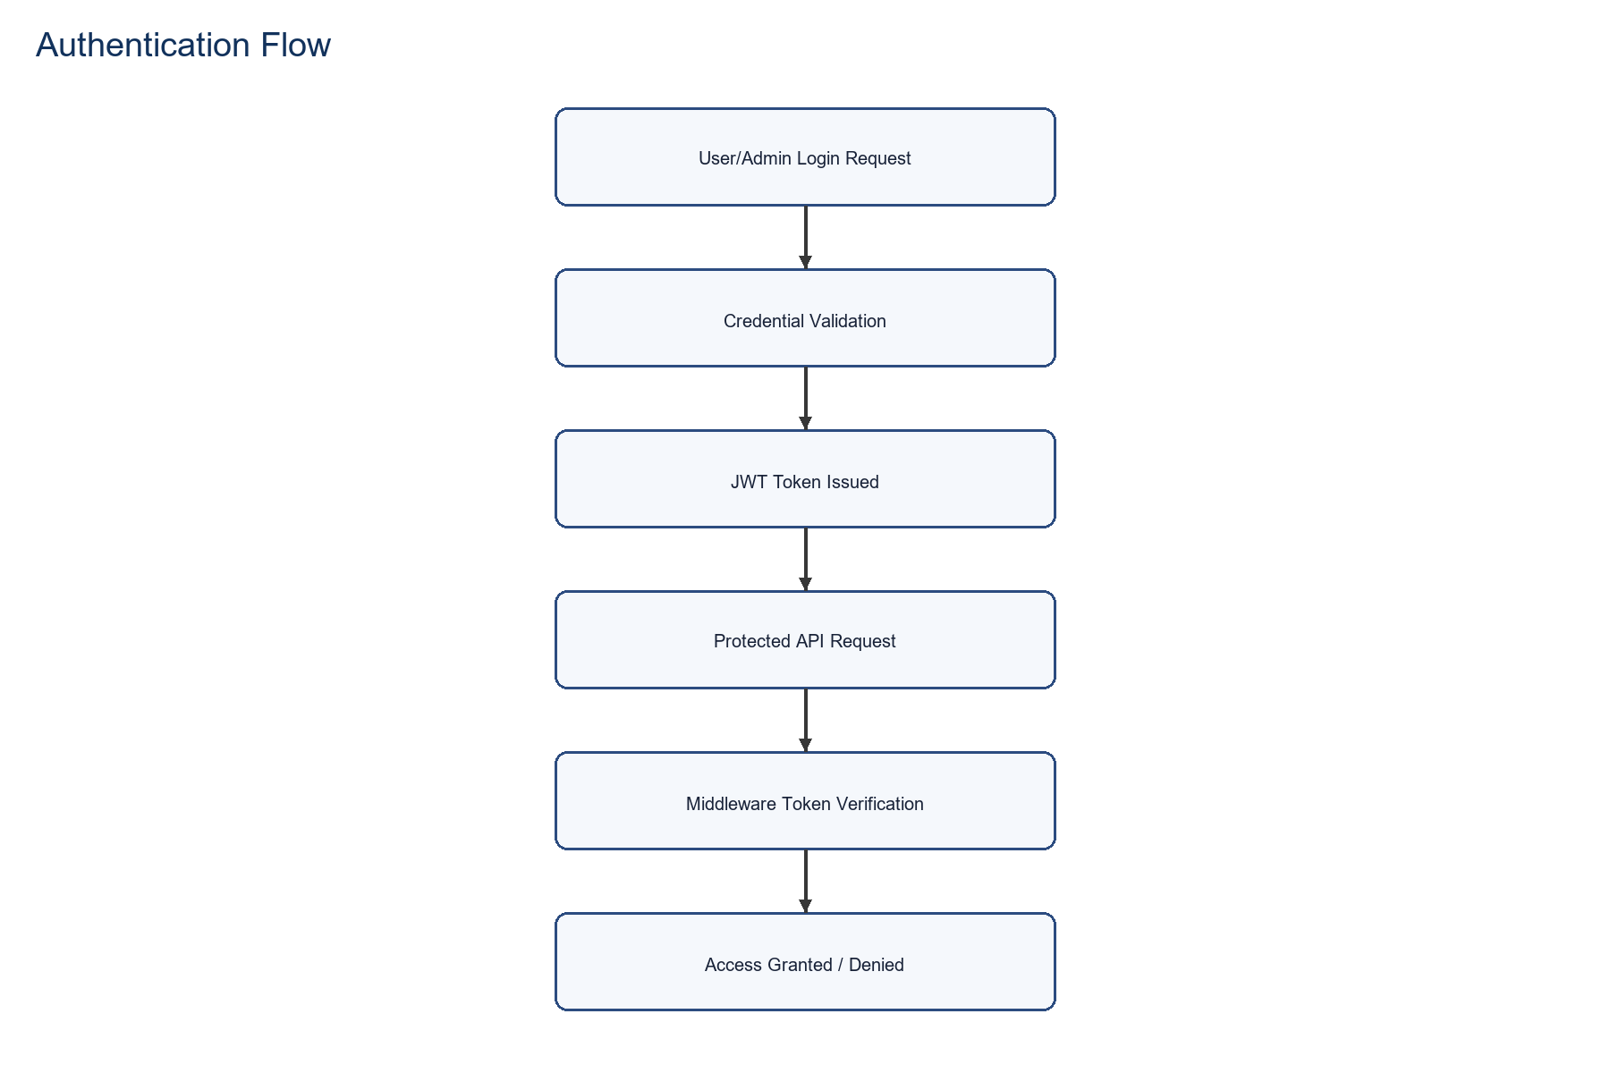

13. Checkout and COD Flow
The checkout pipeline has been simplified to COD-only mode for stable execution and reduced dependency risk.
- Collect address and order lines.
- Submit order to backend place endpoint.
- Persist order and clear cart on success.
Figure: COD checkout process flowchart
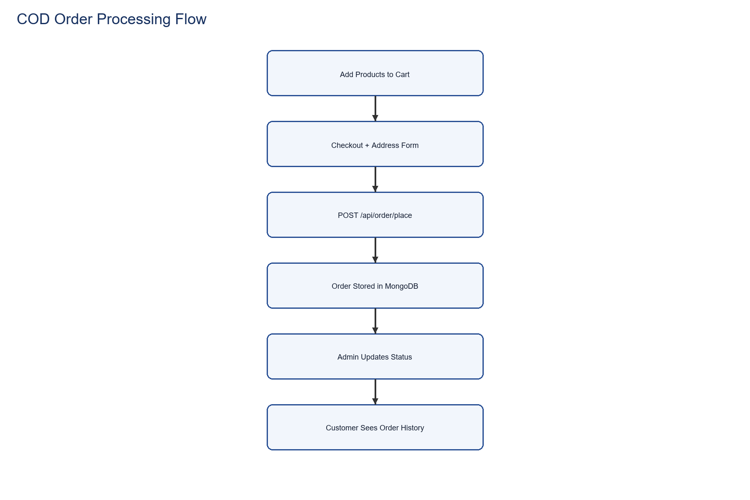

15. Result Analysis
Dataset-based analysis from available product data provides measurable project evidence. Total products: 52, average price: 547.69, min: 250, max: 860.
- Category balance helps UI filter behavior.
- Price spread supports realistic catalog simulation.
- Data quality enables meaningful viva discussion.
Figure: Product lifecycle flowchart
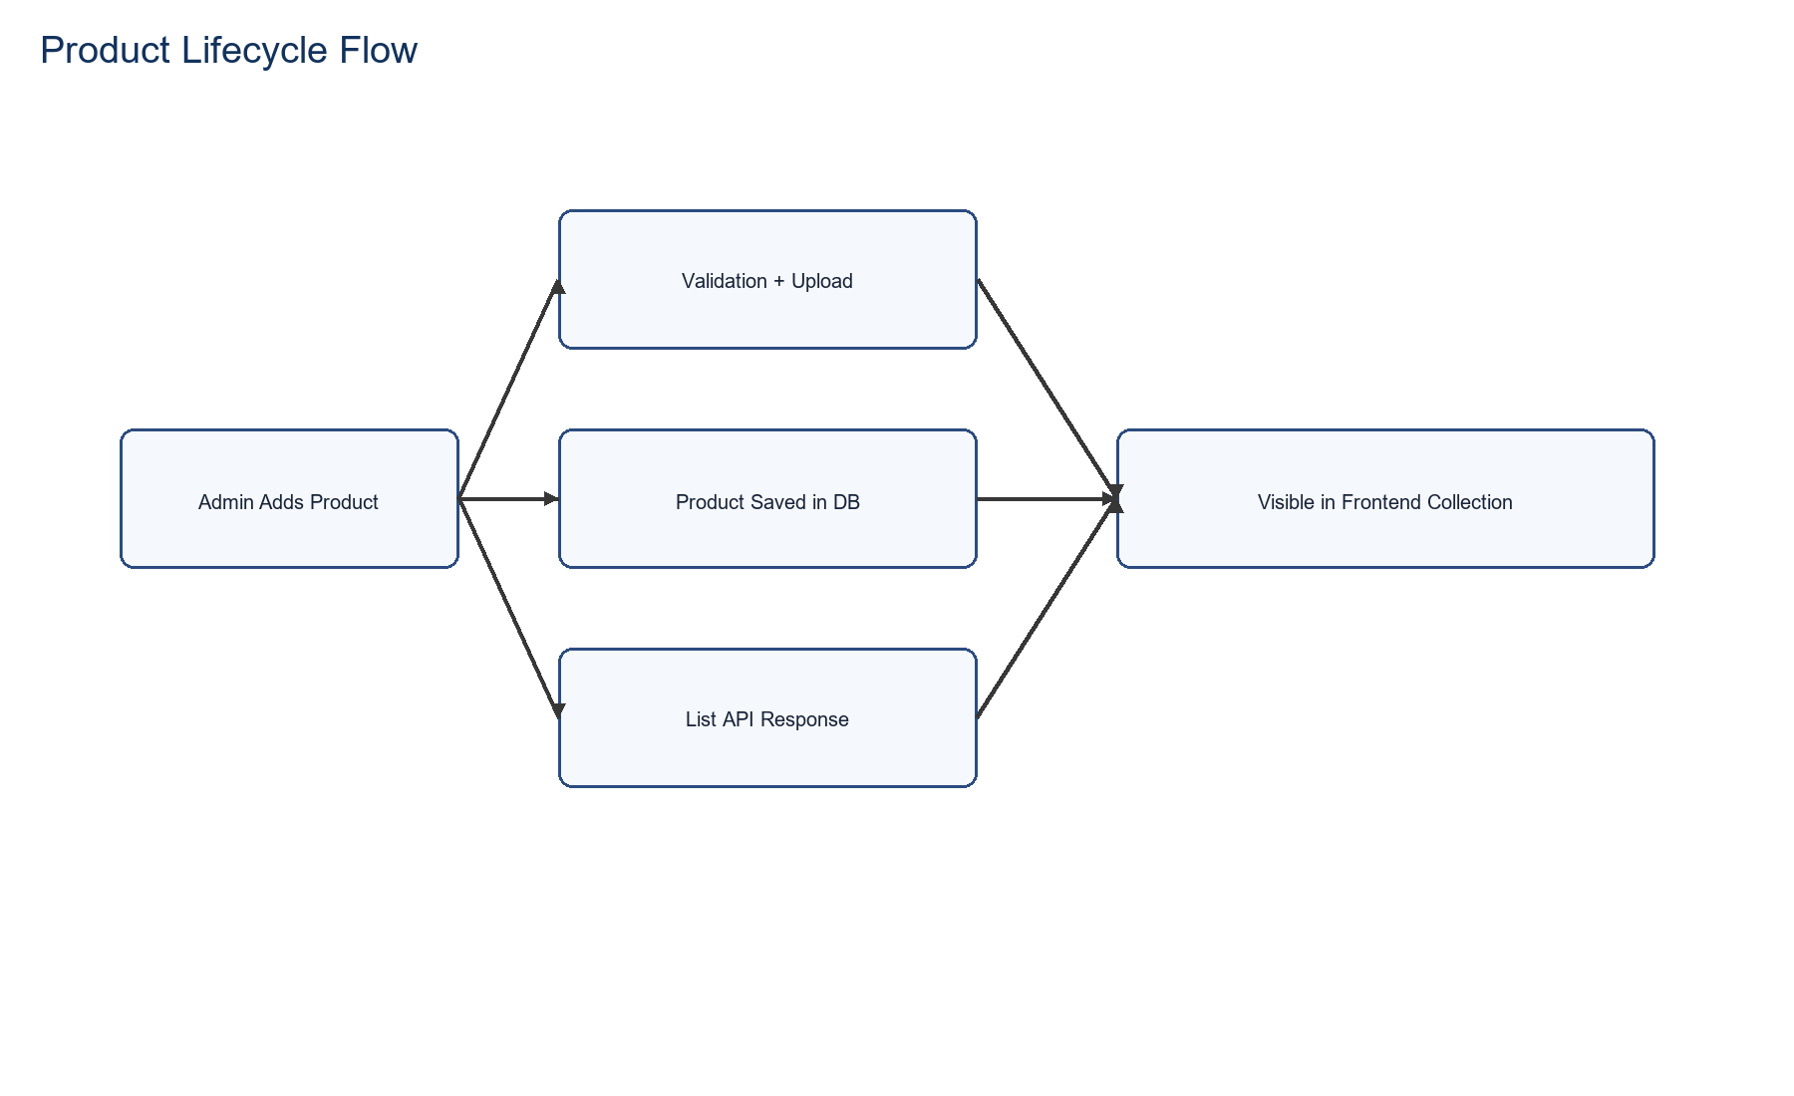

16. Deployment Guide
The deployment process is documented with separate startup commands and environment templates for each application.
- Run backend, frontend, and admin in separate terminals.
- Configure environment values from .env.example files.
- Seed products for first-time setup.

17. Viva Questions and Answers
This chapter prepares likely viva questions and concise technical answers for presentation confidence.
- Why COD-only? -> Simpler and stable release path.
- How is admin secured? -> Env credentials + JWT token route checks.
- How does cart sync work? -> Context state plus backend sync for authenticated users.

18. Future Enhancements
The platform is extensible and can evolve in phases based on project timeline and scope.
- Online payment reintroduction with secure gateway validation.
- Analytics dashboard and sales reporting.
- Inventory alerts and coupon engine.

19. Conclusion
The project demonstrates a complete full-stack ecommerce implementation with modular architecture, practical operational workflows, and professional documentation suitable for academic submission and viva evaluation.
- Functional completeness achieved for core commerce workflow.
- Professional documentation and presentation assets prepared.
- Ready for academic evaluation and demo.

20. References
The following references were used to align implementation decisions with widely accepted best practices:
- OWASP API Security Top 10: https://owasp.org/API-Security/
- Express Security Best Practices: https://expressjs.com/en/advanced/best-practice-security.html
- MongoDB Index Types: https://www.mongodb.com/docs/manual/core/indexes/index-types/

21. Appendix
Appendix A: Category Distribution
Category | Count
Kids | 18
Men | 20
Women | 14

Appendix B: Additional Flowcharts
Figure: Backend Module Flow


Figure: Authentication Flow


Figure: Product Lifecycle Flow



