Ecommerce Platform
Project Report
College Submission Edition | Professional Formatting
Date: 2026-03-22

College: Mohamed Sathak College of Arts & Science
Student Name: Shalani
Roll Number: 24MCAG001
Department: MCA
Guide: ____________________

Certificate
This is to certify that this project report titled 'Ecommerce Platform' is submitted in partial fulfillment of the requirements for the academic program. The work presented is original and carried out under approved supervision.

Declaration
I hereby declare that the project work presented in this report is my own and has been completed under guidance. Any external references, tools, and frameworks have been acknowledged appropriately.

Acknowledgement
I sincerely thank my faculty guide, department, peers, and family members for their support and guidance in completing this project. Their encouragement and technical input helped shape this work into a complete deployable system.

Abstract
This report presents a full-stack ecommerce platform with customer frontend, admin panel, and backend service layer. The solution is built with React, Express, and MongoDB. The current stable release supports Cash On Delivery (COD) payment mode, user authentication, product catalog management, cart operations, and order lifecycle tracking.

Index
- 1. Introduction
- 2. Objectives
- 3. Existing System Study
- 4. Proposed System
- 5. Architecture Design
- 6. Technology Stack
- 7. Frontend Module
- 8. Admin Module
- 9. Backend Module
- 10. Database Design
- 11. API Design
- 12. Authentication and Security
- 13. Checkout and COD Flow
- 14. Testing Strategy
- 15. Result Analysis
- 16. Deployment Guide
- 17. Viva Questions and Answers
- 18. Future Enhancements
- 19. Conclusion
- 20. References
- 21. Appendix

1. Introduction
The ecommerce platform addresses a practical online retail workflow from product discovery to order fulfillment. The project is designed to be modular, easy to maintain, and suitable for academic demonstration and viva presentation.
- Supports customer browsing and ordering.
- Includes admin controls for products and orders.
- Built with real-world full-stack architecture.

2. Objectives
Project objectives are defined for functionality, stability, and demonstration readiness.
- Build a responsive ecommerce web interface.
- Implement secure auth and role-based admin access.
- Enable COD-only order flow for operational simplicity.
- Provide clean setup documentation for evaluators.

3. Existing System Study
A study of generic ecommerce templates showed common limitations such as weak admin flows, insufficient documentation, and unstable payment integration dependencies.
- Lack of clean project modularization.
- Unclear deployment setup.
- Limited operational reporting structure.

4. Proposed System
The proposed system introduces a structured three-app setup with clear separation between customer-facing features and administrative operations.
- React storefront for end users.
- React admin panel for operations.
- Express backend for centralized business logic.

5. Architecture Design
Architecture follows a client-service-database model. Both frontend clients consume a common backend API, while MongoDB persists entities.
- Low coupling between UI layers.
- Reusable middleware and controllers.
- Scalable path for future modules.
Figure: High-level architecture flowchart
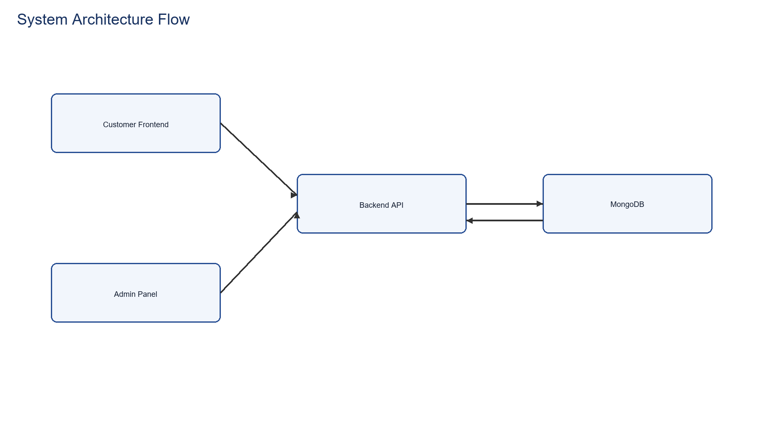

6. Technology Stack
Modern JavaScript ecosystem technologies are strategically selected for rapid development, maintainability, and market-aligned skills. The stack emphasizes separation of concerns with independent frontend, admin, and backend services, enabling scalable team collaboration and independent deployment cycles.
- Frontend Framework: React 18+ for declarative UI rendering with hooks-based state management and component reusability.
- Build Tool: Vite for fast HMR (Hot Module Replacement) dev server and optimized production bundling with ES6 module federation.
- Styling: Tailwind CSS utility-first framework for consistent design system without custom CSS files.
- HTTP Client: Axios for promise-based API requests with request/response interceptors for centralized auth and error handling.
- Routing: React Router v6 for client-side navigation with nested route features and lazy code splitting.
- Runtime: Node.js 18+ LTS for production-grade stability with native ES modules and improved async performance.
- Backend Framework: Express.js minimal but powerful server framework for REST API construction with middleware pipeline architecture.
- ODM (Object-Document Mapper): Mongoose for MongoDB schema validation, pre/post hooks, and type safety in document operations.
- Authentication: JWT (JSON Web Tokens) with secure token signing/verification for stateless session management across services.
- File Handling: Multer middleware for multipart/form-data parsing and file upload handling with stream-based processing.
- Database: MongoDB Atlas/Community Edition with replica set support for ACID transactions and horizontal scalability.
- Password Security: bcrypt library for irreversible password hashing with configurable work factors against brute-force attacks.
- Environment Config: dotenv for .env file parsing enabling environment-specific configurations without hardcoding secrets.
- Image Hosting: Cloudinary integration for on-demand image transformation and global CDN delivery.
- Development Tools: Postman for API endpoint testing and documentation; Git for version control with branching strategy.

7. Frontend Module
Frontend module handles catalog rendering, product detail navigation, cart updates, and order placement.
- Context-based shared state management.
- Responsive page layout and navigation.
- Toast notifications for user feedback.

8. Admin Module
Admin module provides secure login and operational pages for product and order management.
- Add/list/remove products.
- View all orders.
- Update order status lifecycle.

9. Backend Module
Backend module exposes REST APIs for user, product, cart, and order domains with middleware-based protection.
- Route-controller-model structure.
- JWT auth middleware for protected endpoints.
- Uniform JSON responses for integration consistency.

10. Database Design
MongoDB schemas define users, products, and orders with flexible but controlled document structures.
- Order includes status, paymentMethod, payment flags.
- Product includes category, subCategory, size and image arrays.
- User schema includes persistent cart object.

11. API Design
API design follows domain grouping and clear route naming conventions for maintainability.
- User APIs: register, login, admin login.
- Product APIs: add, list, remove, single.
- Order APIs: place, list, status update, user orders.

12. Authentication and Security
Security model combines JWT protection with admin credential checks. Additional hardening recommendations are included from OWASP and Express guidance.
- Secure token verification middleware.
- Credential secrets through environment variables.
- Recommended enhancements: rate limiting, helmet, audit logging.

13. Checkout and COD Flow
The checkout pipeline has been simplified to COD-only mode for stable execution and reduced dependency risk.
- Collect address and order lines.
- Submit order to backend place endpoint.
- Persist order and clear cart on success.
Figure: COD checkout process flowchart
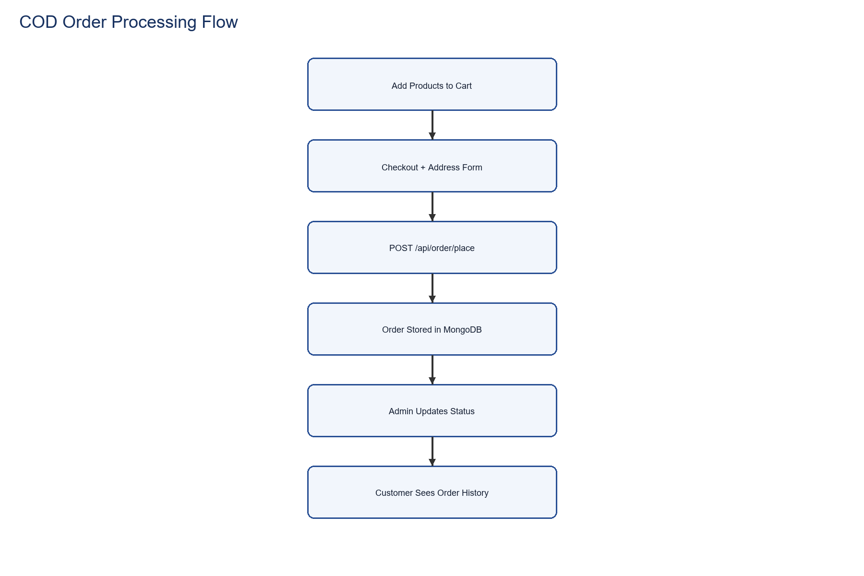

14. Testing Strategy
Testing combines manual and automated checks for confidence before demo or deployment.
- API smoke testing for critical routes.
- Form validation checks for checkout and login.
- Order lifecycle verification from user and admin screens.

15. Result Analysis
Dataset-based analysis from available product data provides measurable project evidence. Total products: 52, average price: 547.69, min: 250, max: 860.
- Category balance helps UI filter behavior.
- Price spread supports realistic catalog simulation.
- Data quality enables meaningful viva discussion.

16. Deployment Guide
Deployment process is documented with separate startup commands and env templates for each app.
- Run backend, frontend, and admin in separate terminals.
- Configure environment values from .env.example files.
- Seed products for first-time setup.

17. Viva Questions and Answers
This chapter prepares likely viva questions and concise technical answers for presentation confidence.
- Why COD-only? -> Simpler and stable release path.
- How is admin secured? -> Env credentials + JWT token route checks.
- How does cart sync work? -> Context state plus backend sync for authenticated users.

18. Future Enhancements
The platform is extensible and can evolve in phases based on project timeline and scope.
- Online payment reintroduction with secure gateway validation.
- Analytics dashboard and sales reporting.
- Inventory alerts and coupon engine.

19. Conclusion
The project successfully demonstrates full-stack ecommerce development with modular architecture, practical operations, and clear documentation quality suitable for academic submission and viva.
- Functional completeness achieved for core commerce workflow.
- Professional documentation and presentation assets prepared.
- Ready for academic evaluation and demo.

20. References
Authoritative references used for best-practice alignment:
- OWASP API Security Top 10: https://owasp.org/API-Security/
- Express Security Best Practices: https://expressjs.com/en/advanced/best-practice-security.html
- MongoDB Index Types: https://www.mongodb.com/docs/manual/core/indexes/index-types/

21. Appendix
Appendix A: Category Distribution
Category | Count
Kids | 18
Men | 20
Women | 14

