**JAVA FILE OUTPUT STREAM CLASS**

**import** java.io.FileOutputStream;

**public** **class** FileOutputStreamExample {

**public** **static** **void** main(String args[]){

**try**{

             FileOutputStream fout=**new** FileOutputStream("D:\\abc.txt");

             String s="Dhoni is my favourite player";

**byte** b[]=s.getBytes();//converting string into byte array

             fout.write(b);

             fout.close();

             System.out.println("success...");

            }**catch**(Exception e){System.out.println(e);}

      }

}

OUTPUT:

Success...

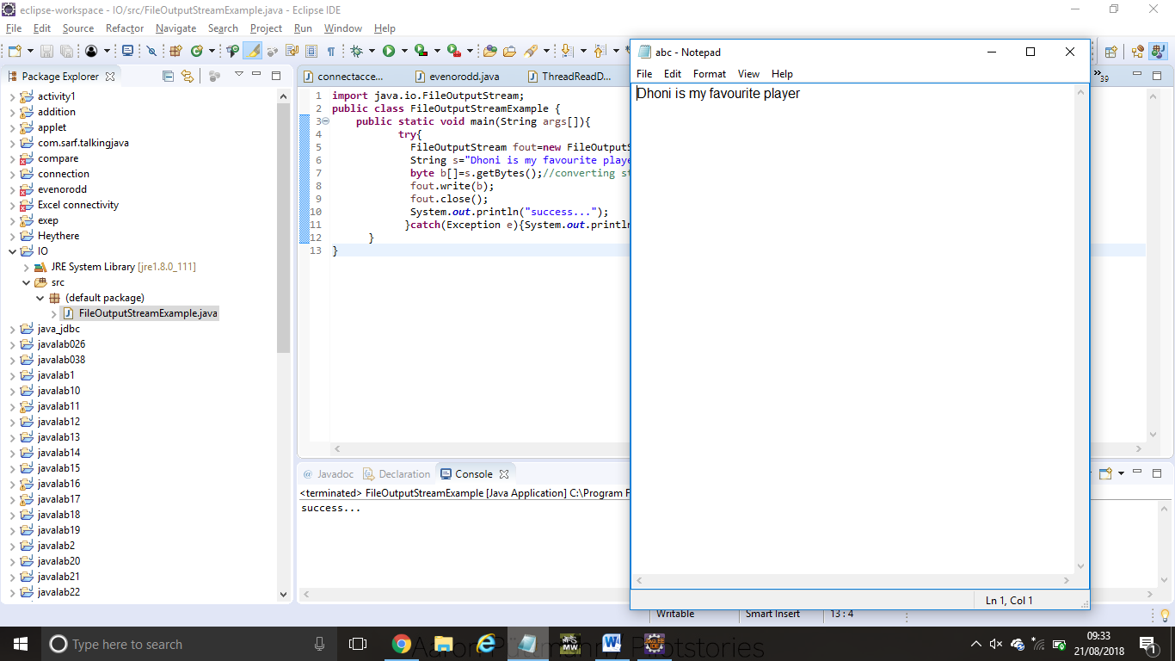

**FILE INPUT STREAM CLASS**

**import** java.io.*;

**public** **class** FilterExample {

**public** **static** **void** main(String[] args) **throws** IOException {

        File data = **new** File("D:\\testout.txt");

        FileInputStream  file = **new** FileInputStream(data);

        FilterInputStream filter = **new** BufferedInputStream(file);

**int** k =0;

**while**((k=filter.read())!=-1){

            System.out.print((**char**)k);

        }

        file.close();

        filter.close();

    }

}

OUTPUT:

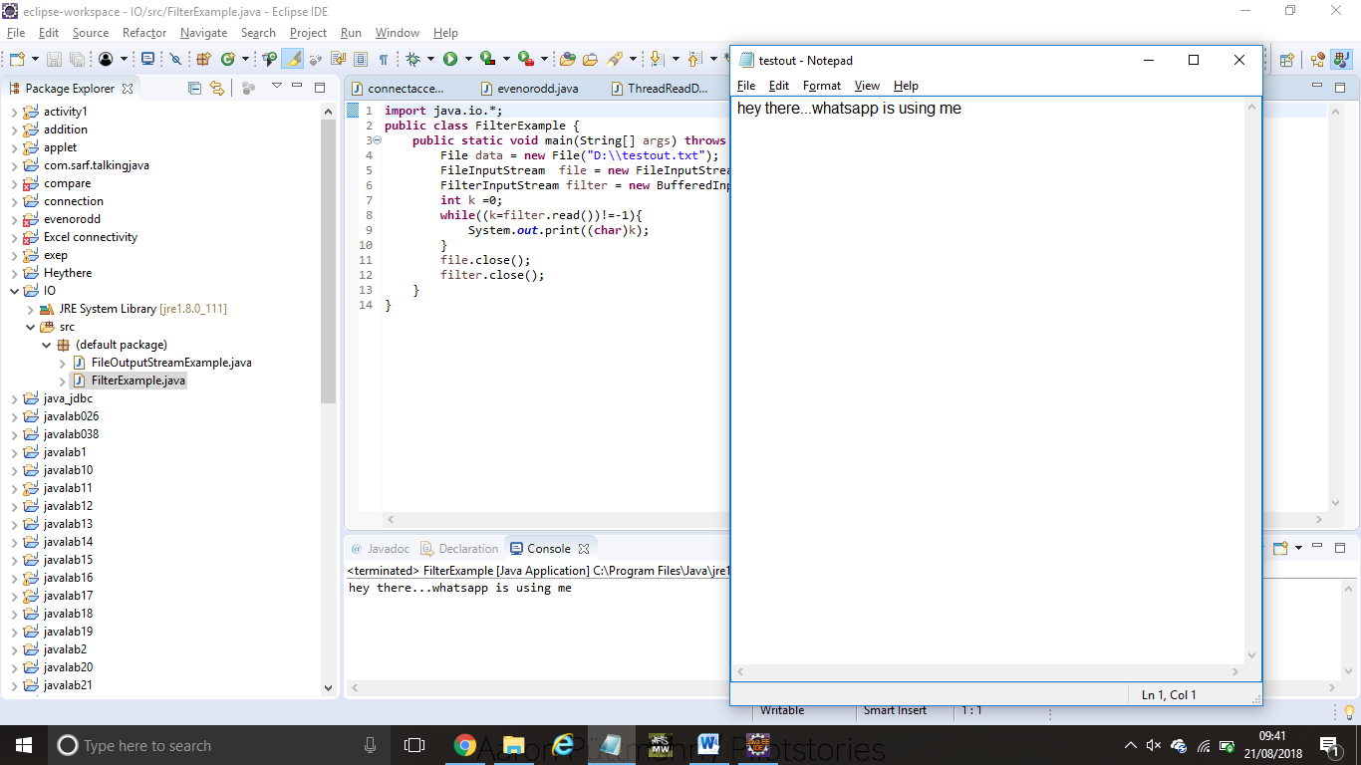

Welcome to javatpoint

**BYTE ARRAY OUTPUT STREAM EXAMPLE**

**package** com.javatpoint;

**import** java.io.*;

**public** **class** DataStreamExample {

**public** **static** **void** main(String args[])**throws** Exception{

      FileOutputStream fout1=**new** FileOutputStream("D:\\f1.txt");

      FileOutputStream fout2=**new** FileOutputStream("D:\\f2.txt");

      ByteArrayOutputStream bout=**new** ByteArrayOutputStream();

      bout.write(65);

      bout.writeTo(fout1);

      bout.writeTo(fout2);

      bout.flush();

      bout.close();//has no effect

      System.out.println("Success...");

     }

    }

OUTPUT:

Success...

f1:

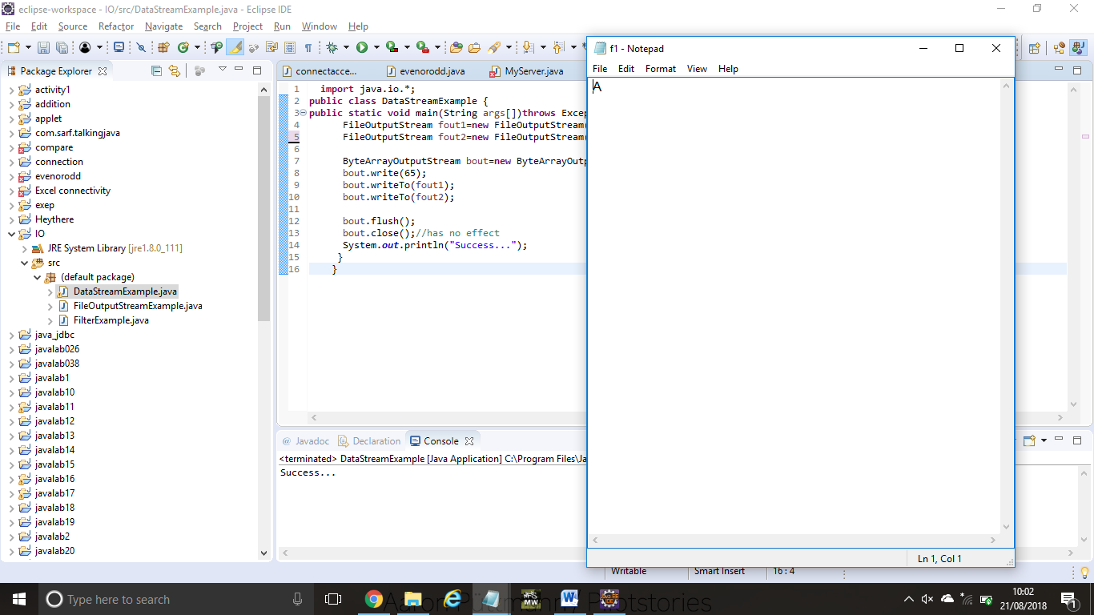

f2:

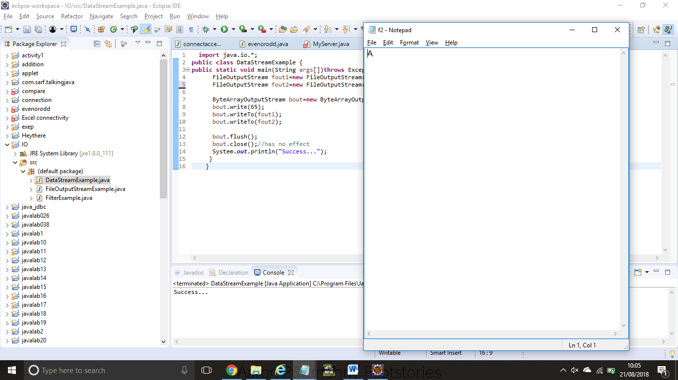

**SEQUENCE INPUT STREAM CLASS**

**import** java.io.*;

**class** InputStreamExample {

**public** **static** **void** main(String args[])**throws** Exception{

   FileInputStream input1=**new** FileInputStream("D:\\testin.txt");

   FileInputStream input2=**new** FileInputStream("D:\\testout.txt");

   SequenceInputStream inst=**new** SequenceInputStream(input1, input2);

**int** j;

**while**((j=inst.read())!=-1){

    System.out.print((**char**)j);

   }

   inst.close();

   input1.close();

   input2.close();

  }

}

OUTPUT:

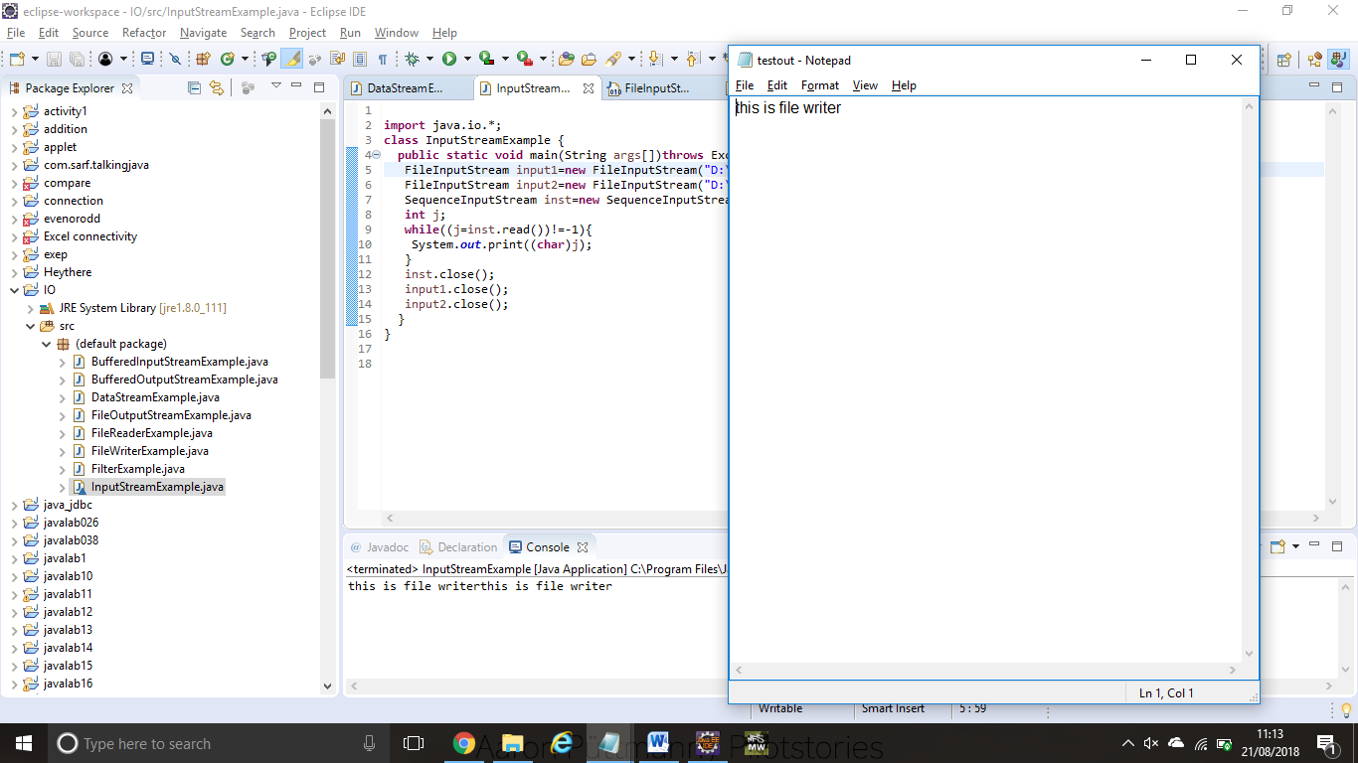

**BUFFERED OUTPUT STREAM CLASS**

**import** java.io.*;

**public** **class** BufferedOutputStreamExample{

**public** **static** **void** main(String args[])**throws** Exception{

     FileOutputStream fout=**new** FileOutputStream("D:\\testout.txt");

     BufferedOutputStream bout=**new** BufferedOutputStream(fout);

     String s="Welcome to javaTpoint.";

**byte** b[]=s.getBytes();

     bout.write(b);

     bout.flush();

     bout.close();

     fout.close();

     System.out.println("success");

}

}

OUTPUT:

Success

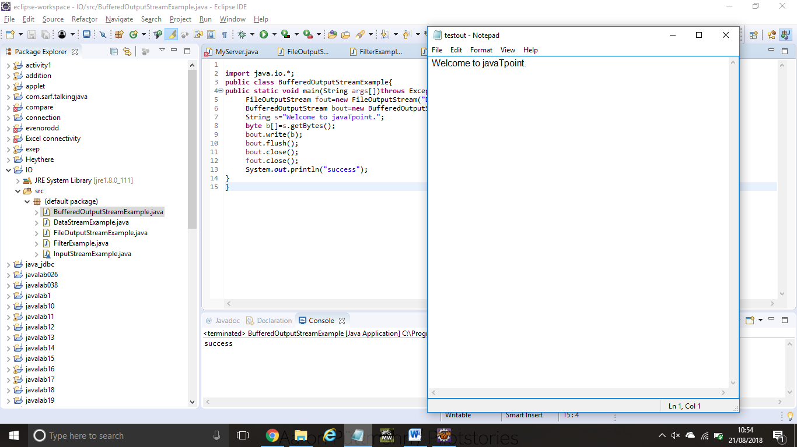

**JAVA BUFFERED INPUT STREAM**

**import** java.io.*;

**public** **class** BufferedInputStreamExample{

**public** **static** **void** main(String args[]){

**try**{

    FileInputStream fin=**new** FileInputStream("D:\\testout.txt");

    BufferedInputStream bin=**new** BufferedInputStream(fin);

**int** i;

**while**((i=bin.read())!=-1){

     System.out.print((**char**)i);

    }

    bin.close();

    fin.close();

  }**catch**(Exception e){System.out.println(e);}

 }

}

OUTPUT:

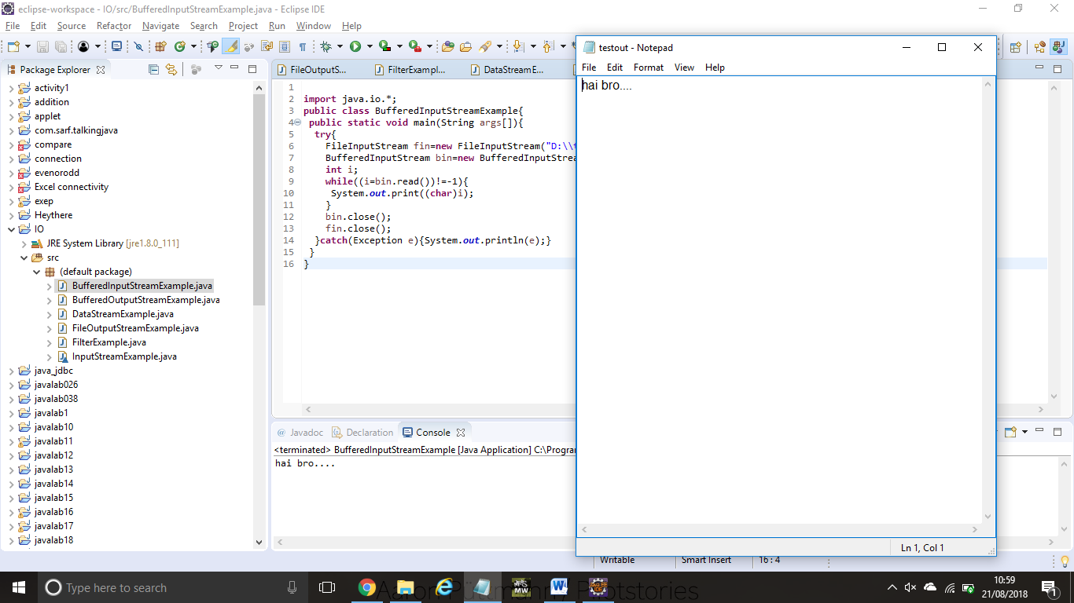

hai bro....

**FILE WRITER**

**package** com.javatpoint;

**import** java.io.FileWriter;

**public** **class** FileWriterExample {

**public** **static** **void** main(String args[]){

**try**{

           FileWriter fw=**new** FileWriter("D:\\testout.txt");

           fw.write("this is file writer");

           fw.close();

          }**catch**(Exception e){System.out.println(e);}

          System.out.println("Success...");

     }

}

OUTPUT:

Success...

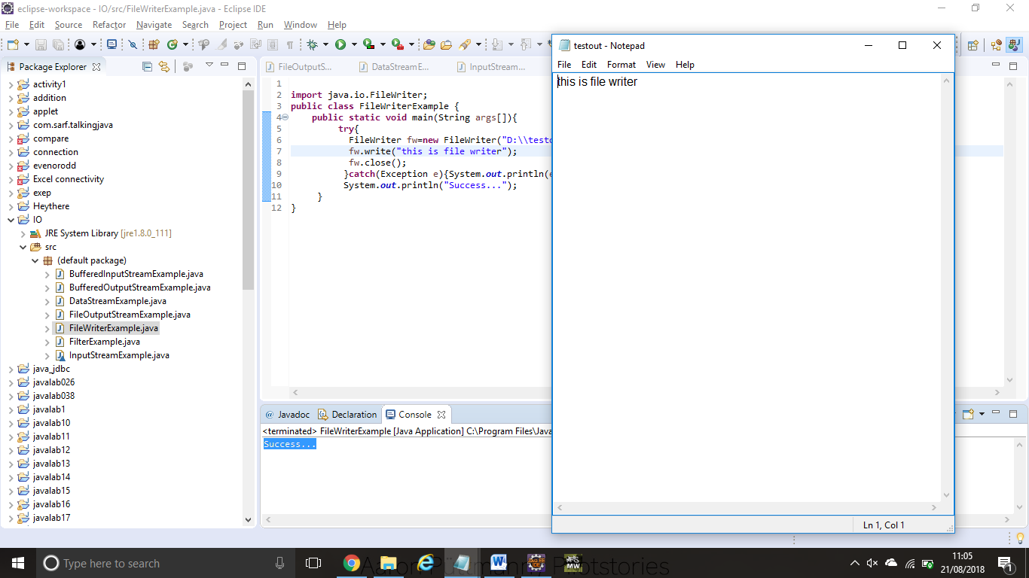

**FILE WRITER**

**import** java.io.FileReader;

**public** **class** FileReaderExample {

**public** **static** **void** main(String args[])**throws** Exception{

          FileReader fr=**new** FileReader("D:\\testout.txt");

**int** i;

**while**((i=fr.read())!=-1)

          System.out.print((**char**)i);

          fr.close();

    }

}

OUTPUT:

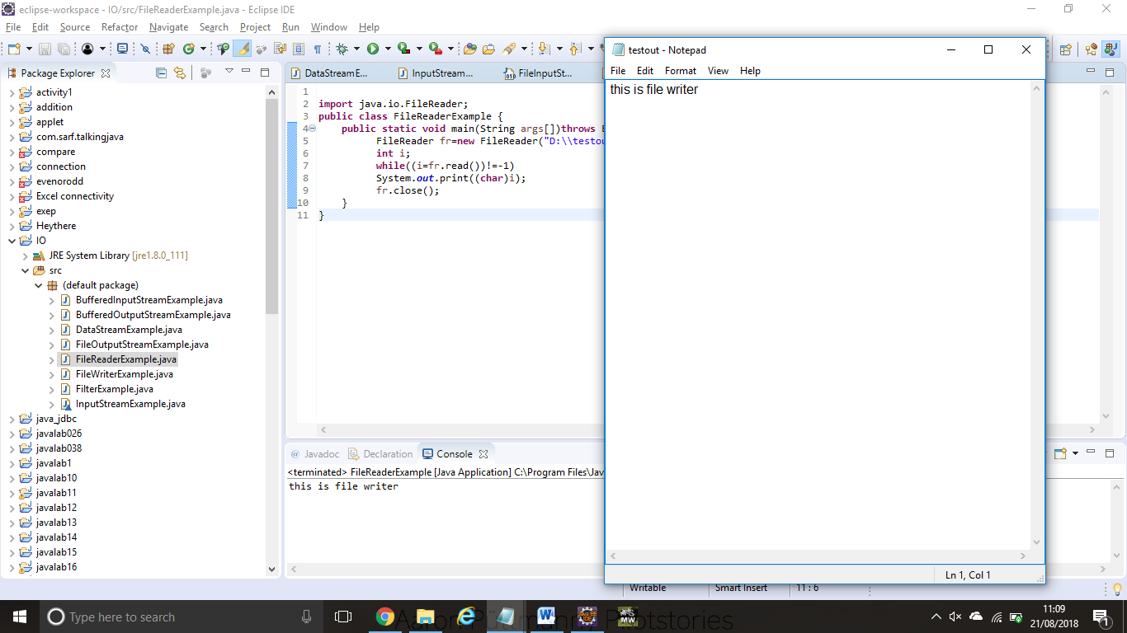

This is file writer

**CHAR ARRAY WRITER CLASS**

**import** java.io.CharArrayWriter;

**import** java.io.FileWriter;

**public** **class** CharArrayWriterExample {

**public** **static** **void** main(String args[])**throws** Exception{

          CharArrayWriter out=**new** CharArrayWriter();

          out.write("Welcome to javaTpoint");

          FileWriter f1=**new** FileWriter("D:\\a.txt");

          FileWriter f2=**new** FileWriter("D:\\b.txt");

          FileWriter f3=**new** FileWriter("D:\\c.txt");

          FileWriter f4=**new** FileWriter("D:\\d.txt");

          out.writeTo(f1);

          out.writeTo(f2);

          out.writeTo(f3);

          out.writeTo(f4);

          f1.close();

          f2.close();

          f3.close();

          f4.close();

          System.out.println("Success...");

         }

        }

OUTPUT:

Success...

a.txt:

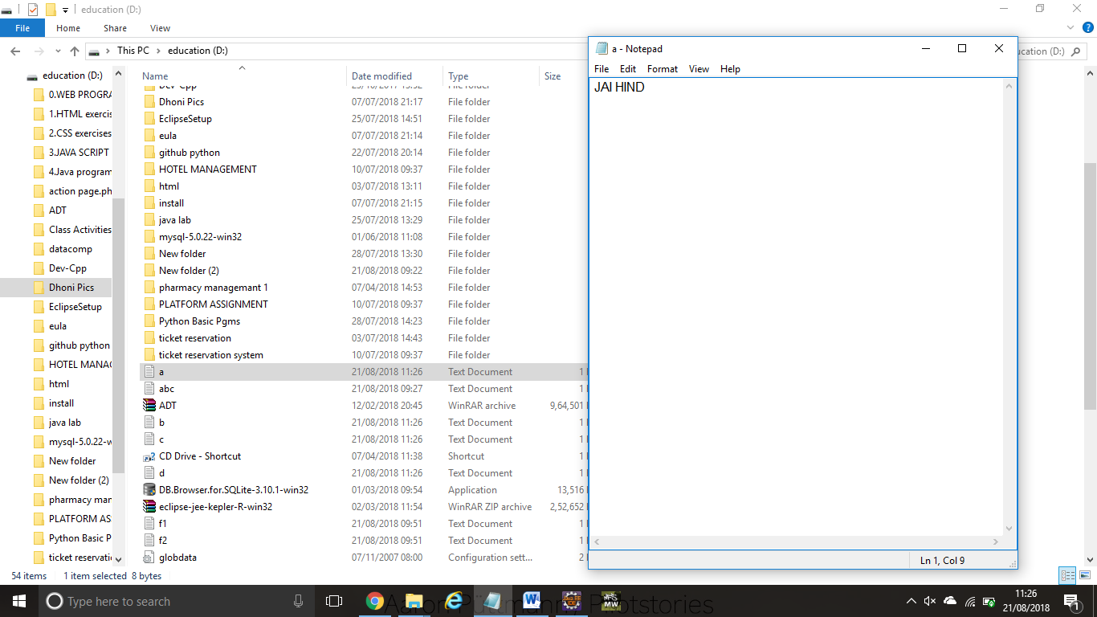

b.txt:



c.txt

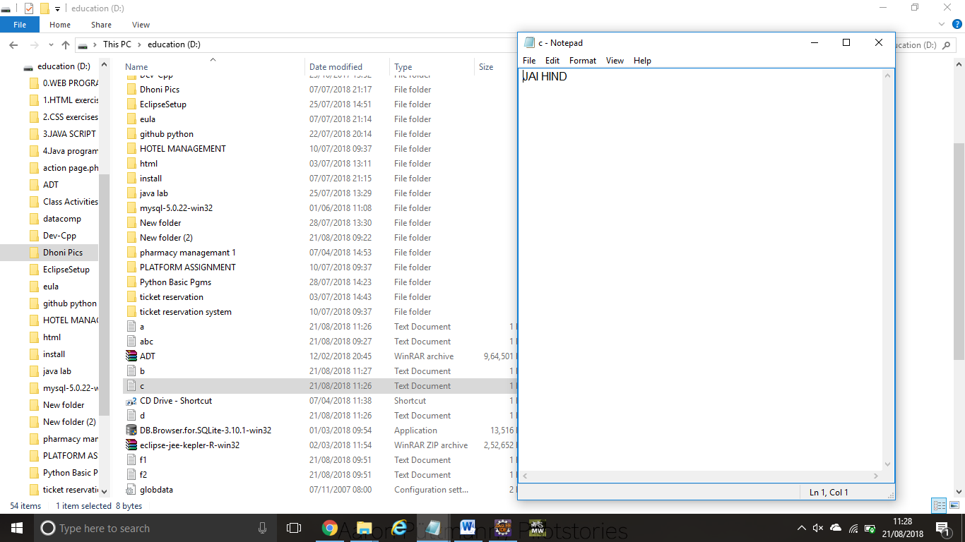

d.txt

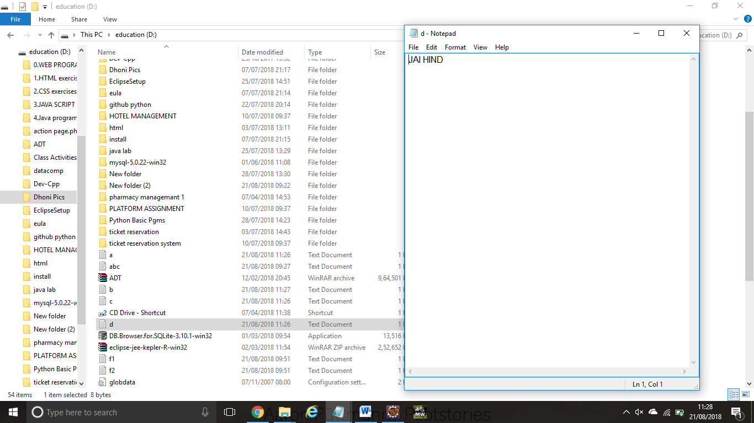

**INPUT STREAM READER AND BUFFERED READER CLASS**

**import** java.io.*;

**class** G5{

**public** **static** **void** main(String args[])**throws** Exception{

InputStreamReader r=**new** InputStreamReader(System.in);

BufferedReader br=**new** BufferedReader(r);

System.out.println("Enter your name");

String name=br.readLine();

System.out.println("Welcome "+name);

 }

}

OUTPUT:

Enter your name

SHAZIA

Welcome SHAZIA