Ex:140 **JAVA URL CONNECTION**

**import** java.io.*;

**import** java.net.*;

**public** **class** URLConnectionExample {

**public** **static** **void** main(String[] args){

**try**{

URL url=**new** URL("http://www.javatpoint.com/java-tutorial");

URLConnection urlcon=url.openConnection();

InputStream stream=urlcon.getInputStream();

**int** i;

**while**((i=stream.read())!=-1){

System.out.print((**char**)i);

}

}**catch**(Exception e){System.out.println(e);}

}

}

OUTPUT:

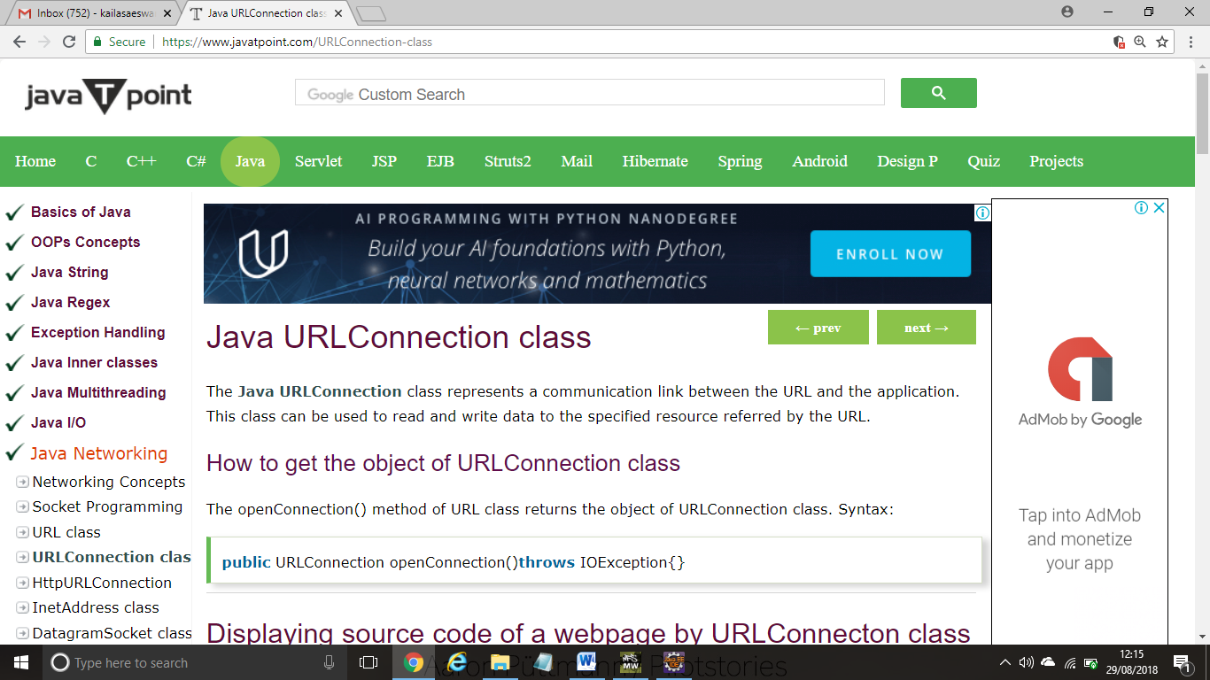

**JAVA SOCKET PROGRAMMING**

***My Server:***

**import** java.io.*;

**import** java.net.*;

**public** **class** MyServer {

**public** **static** **void** main(String[] args){

**try**{

ServerSocket ss=**new** ServerSocket(6666);

Socket s=ss.accept();//establishes connection

DataInputStream dis=**new** DataInputStream(s.getInputStream());

String  str=(String)dis.readUTF();

System.out.println("message= "+str);

ss.close();

}**catch**(Exception e){System.out.println(e);}

}

}

***My Client:***

**import** java.io.*;

**import** java.net.*;

**public** **class** MyClient {

**public** **static** **void** main(String[] args) {

**try**{

Socket s=**new** Socket("localhost",6666);

DataOutputStream dout=**new** DataOutputStream(s.getOutputStream());

dout.writeUTF("Hello Server");

dout.flush();

dout.close();

s.close();

}**catch**(Exception e){System.out.println(e);}

}

}

OUTPUT:

message= Hello Server

**JAVA INETADDRESS CLASS**

**import** java.io.*;

**import** java.net.*;

**public** **class** InetDemo{

**public** **static** **void** main(String[] args){

**try**{

InetAddress ip=InetAddress.getByName("www.javatpoint.com");

System.out.println("Host Name: "+ip.getHostName());

System.out.println("IP Address: "+ip.getHostAddress());

}**catch**(Exception e){System.out.println(e);}

}

}

OUTPUT:

Host Name: www.javatpoint.com

IP Address: 195.201.10.8

**AWT by INHERITANCE**

**import** java.awt.*;

**class** First **extends** Frame{

First(){

Button b=**new** Button("click me");

b.setBounds(30,100,80,30);// setting button position

add(b);//adding button into frame

setSize(300,300);//frame size 300 width and 300 height

setLayout(**null**);//no layout manager

setVisible(**true**);//now frame will be visible, by default not visible

}

**public** **static** **void** main(String args[]){

First f=**new** First();

}}

OUTPUT:

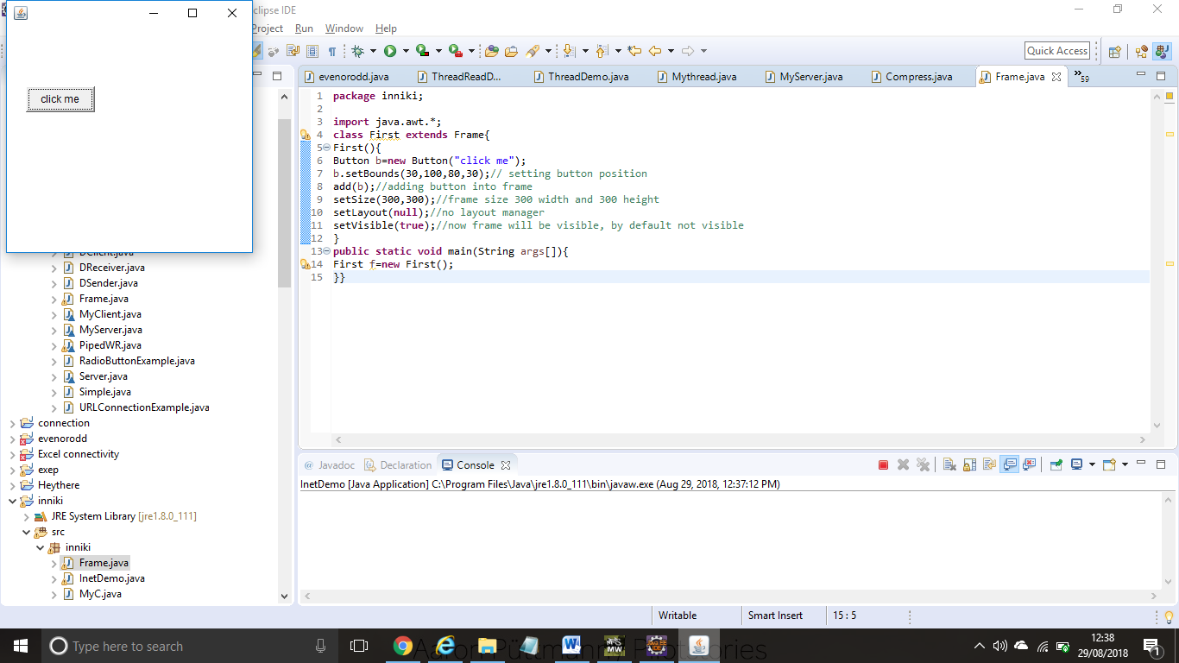

**EVENT HANDLING**

**import** java.awt.*;

**import** java.awt.event.*;

**class** AEvent **extends** Frame **implements** ActionListener{

TextField tf;

AEvent(){

//create components

tf=**new** TextField();

tf.setBounds(60,50,170,20);

Button b=**new** Button("click me");

b.setBounds(100,120,80,30);

//register listener

b.addActionListener(**this**);//passing current instance

//add components and set size, layout and visibility

add(b);add(tf);

setSize(300,300);

setLayout(**null**);

setVisible(**true**);

}

**public** **void** actionPerformed(ActionEvent e){

tf.setText("Welcome");

}

**public** **static** **void** main(String args[]){

**new** AEvent();

}

}

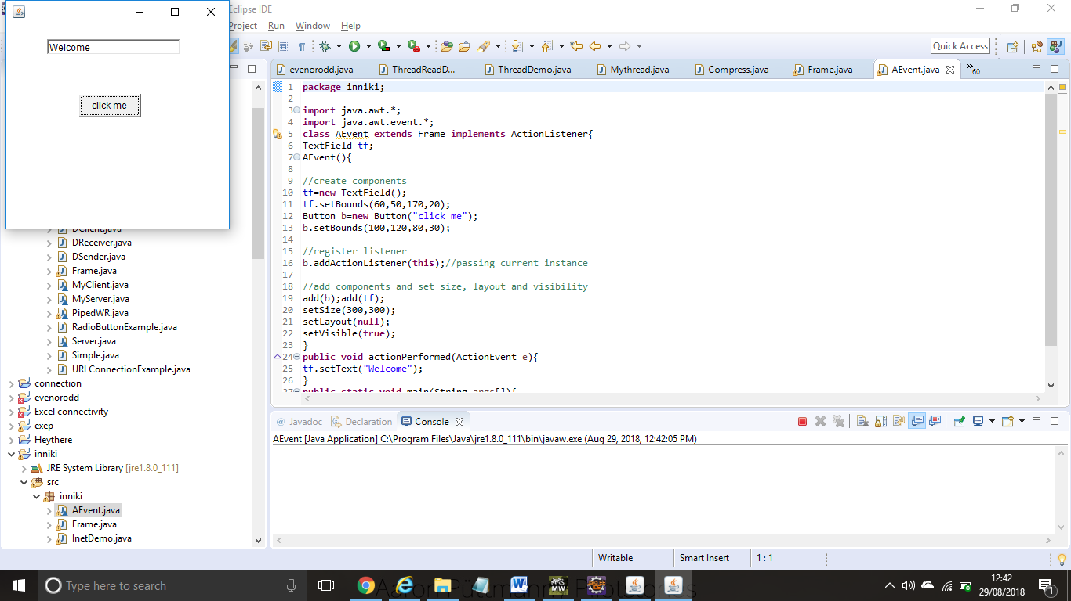

**SIMPLE JAVA SWING**

**import** javax.swing.*;

**public** **class** FirstSwingExample {

**public** **static** **void** main(String[] args) {

JFrame f=**new** JFrame();//creating instance of JFrame

JButton b=**new** JButton("click");//creating instance of JButton

b.setBounds(130,100,100, 40);//x axis, y axis, width, height

f.add(b);//adding button in JFrame

f.setSize(400,500);//400 width and 500 height

f.setLayout(**null**);//using no layout managers

f.setVisible(**true**);//making the frame visible

}

}

OUTPUT:

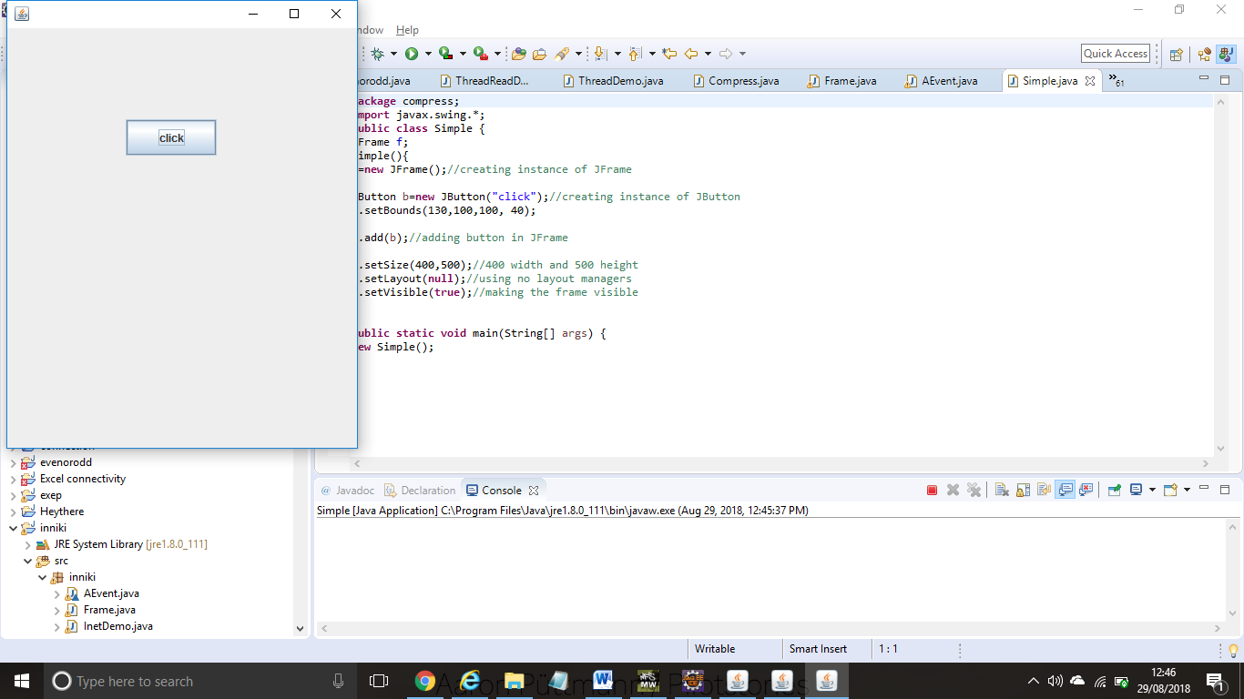

**JRADIO BUTTON CLASS**

**import** javax.swing.*;

**public** **class** RadioButtonExample {

JFrame f;

RadioButtonExample(){

f=**new** JFrame();

JRadioButton r1=**new** JRadioButton("A) Male");

JRadioButton r2=**new** JRadioButton("B) Female");

r1.setBounds(75,50,100,30);

r2.setBounds(75,100,100,30);

ButtonGroup bg=**new** ButtonGroup();

bg.add(r1);bg.add(r2);

f.add(r1);f.add(r2);

f.setSize(300,300);

f.setLayout(**null**);

f.setVisible(**true**);

}

**public** **static** **void** main(String[] args) {

**new** RadioButtonExample();

}

}

OUTPUT:

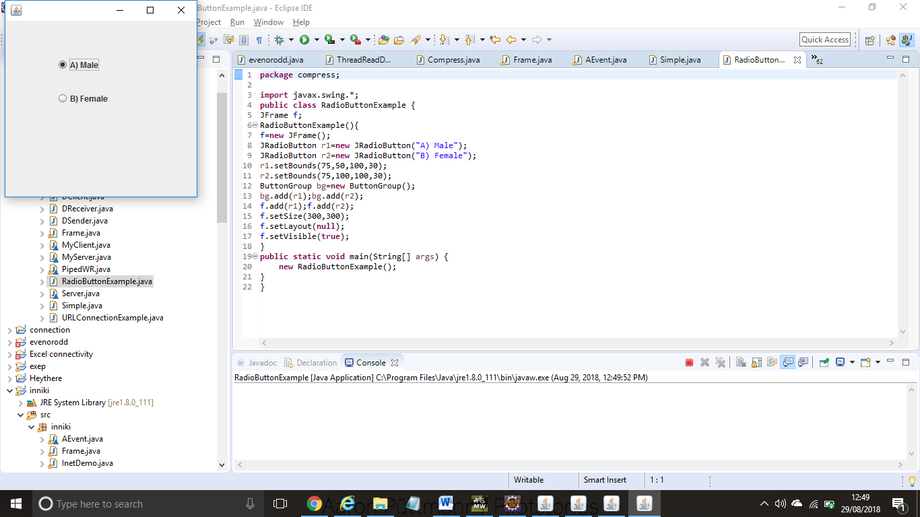

**JTEXTFILED CLASS**

**import** javax.swing.*;

**class** TextFieldExample

{

**public** **static** **void** main(String args[])

    {

    JFrame f= **new** JFrame("TextField Example");

    JTextField t1,t2;

    t1=**new** JTextField("Welcome to Javatpoint.");

    t1.setBounds(50,100, 200,30);

    t2=**new** JTextField("AWT Tutorial");

    t2.setBounds(50,150, 200,30);

    f.add(t1); f.add(t2);

    f.setSize(400,400);

    f.setLayout(**null**);

    f.setVisible(**true**);

    }

    }

OUTPUT:

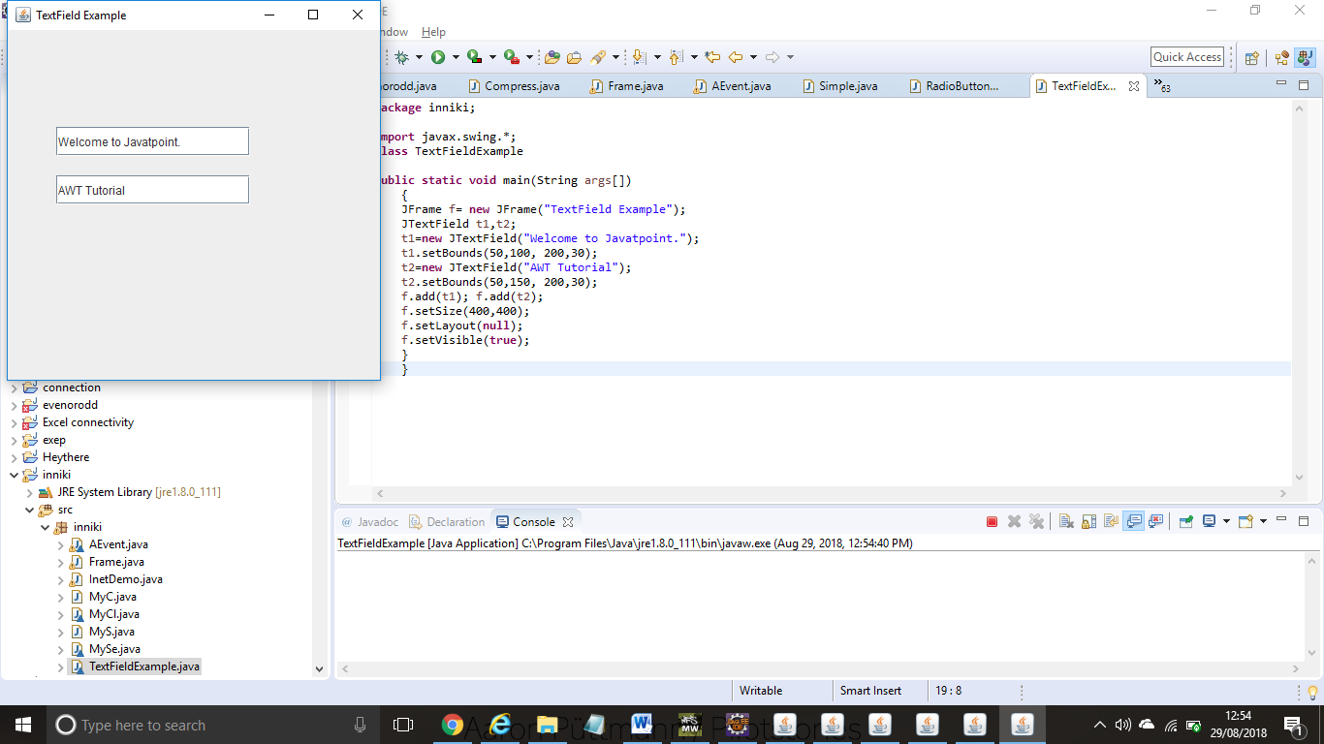

**JCOMBO CLASS**

**import** javax.swing.*;

**public** **class** ComboBoxExample {

JFrame f;

ComboBoxExample(){

    f=**new** JFrame("ComboBox Example");

    String country[]={"India","Aus","U.S.A","England","Newzealand"};

    JComboBox cb=**new** JComboBox(country);

    cb.setBounds(50, 50,90,20);

    f.add(cb);

    f.setLayout(**null**);

    f.setSize(400,500);

    f.setVisible(**true**);

}

**public** **static** **void** main(String[] args) {

**new** ComboBoxExample();

}

}

OUTPUT:

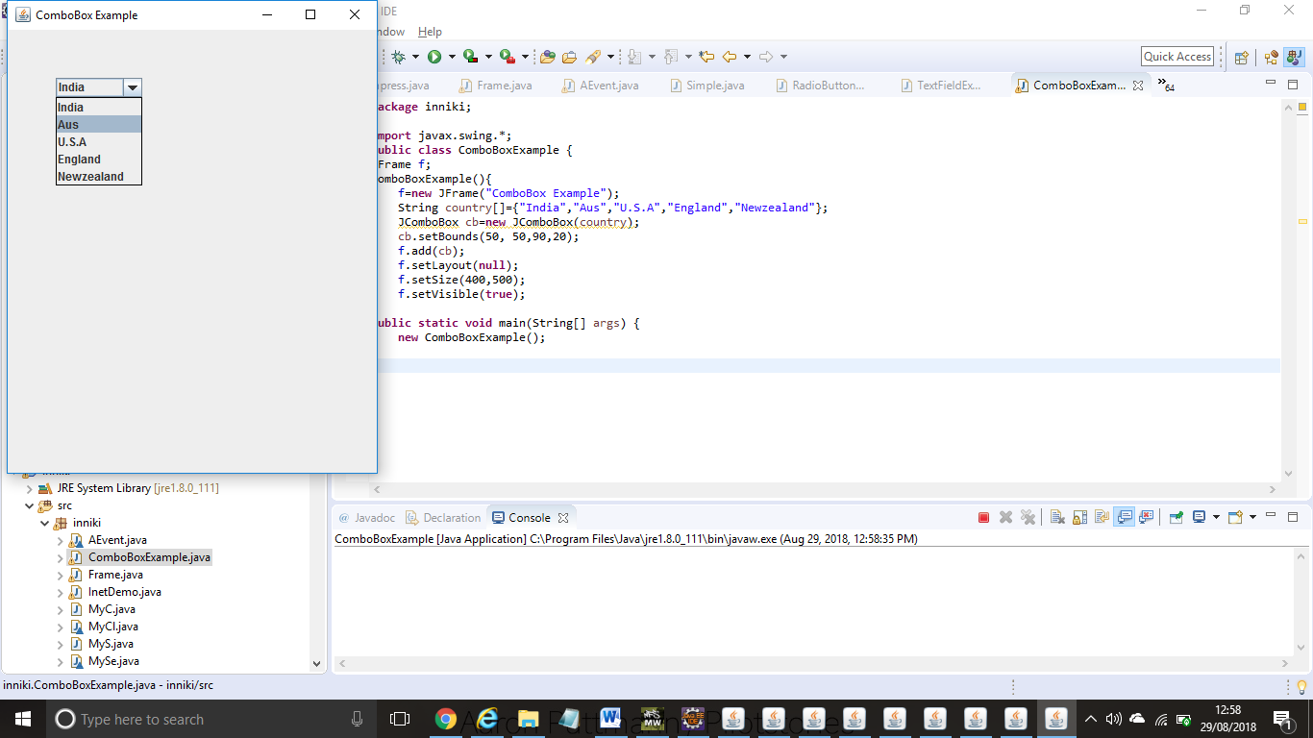

**JPROGRESS BAR**

**import** javax.swing.*;

**public** **class** ProgressBarExample **extends** JFrame{

JProgressBar jb;

**int** i=0,num=0;

ProgressBarExample(){

jb=**new** JProgressBar(0,2000);

jb.setBounds(40,40,160,30);

jb.setValue(0);

jb.setStringPainted(**true**);

add(jb);

setSize(250,150);

setLayout(**null**);

}

**public** **void** iterate(){

**while**(i<=2000){

  jb.setValue(i);

  i=i+20;

**try**{Thread.sleep(150);}**catch**(Exception e){}

}

}

**public** **static** **void** main(String[] args) {

    ProgressBarExample m=**new** ProgressBarExample();

    m.setVisible(**true**);

    m.iterate();

}

}

OUTPUT:

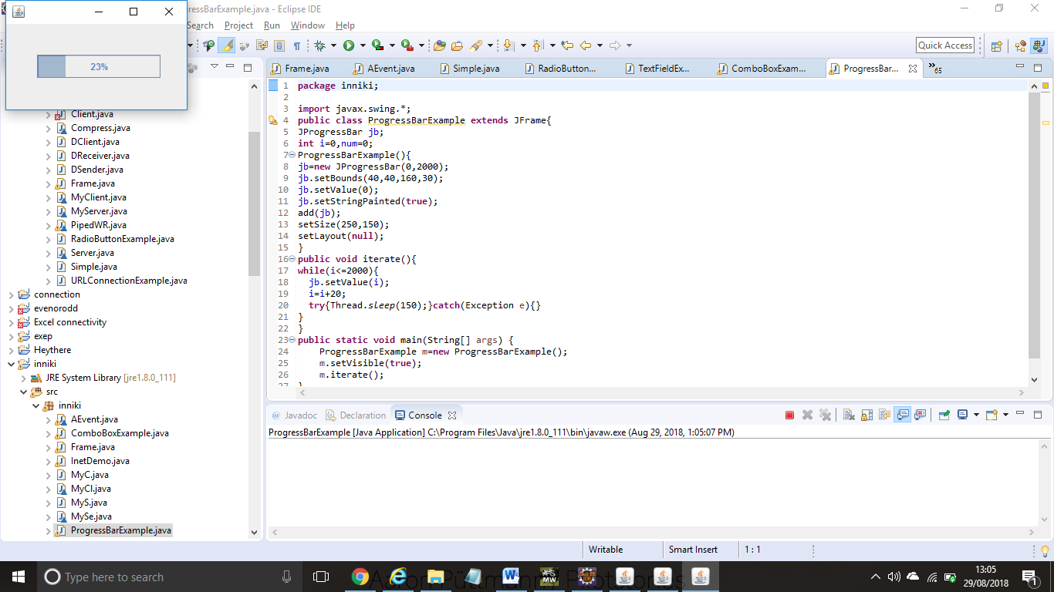

**JSLIDER**

**import** javax.swing.*;

**public** **class** SliderExample1 **extends** JFrame{

**public** SliderExample1() {

JSlider slider = **new** JSlider(JSlider.HORIZONTAL, 0, 50, 25);

JPanel panel=**new** JPanel();

panel.add(slider);

add(panel);

}

**public** **static** **void** main(String s[]) {

SliderExample1 frame=**new** SliderExample1();

frame.pack();

frame.setVisible(**true**);

}

}

OUTPUT:

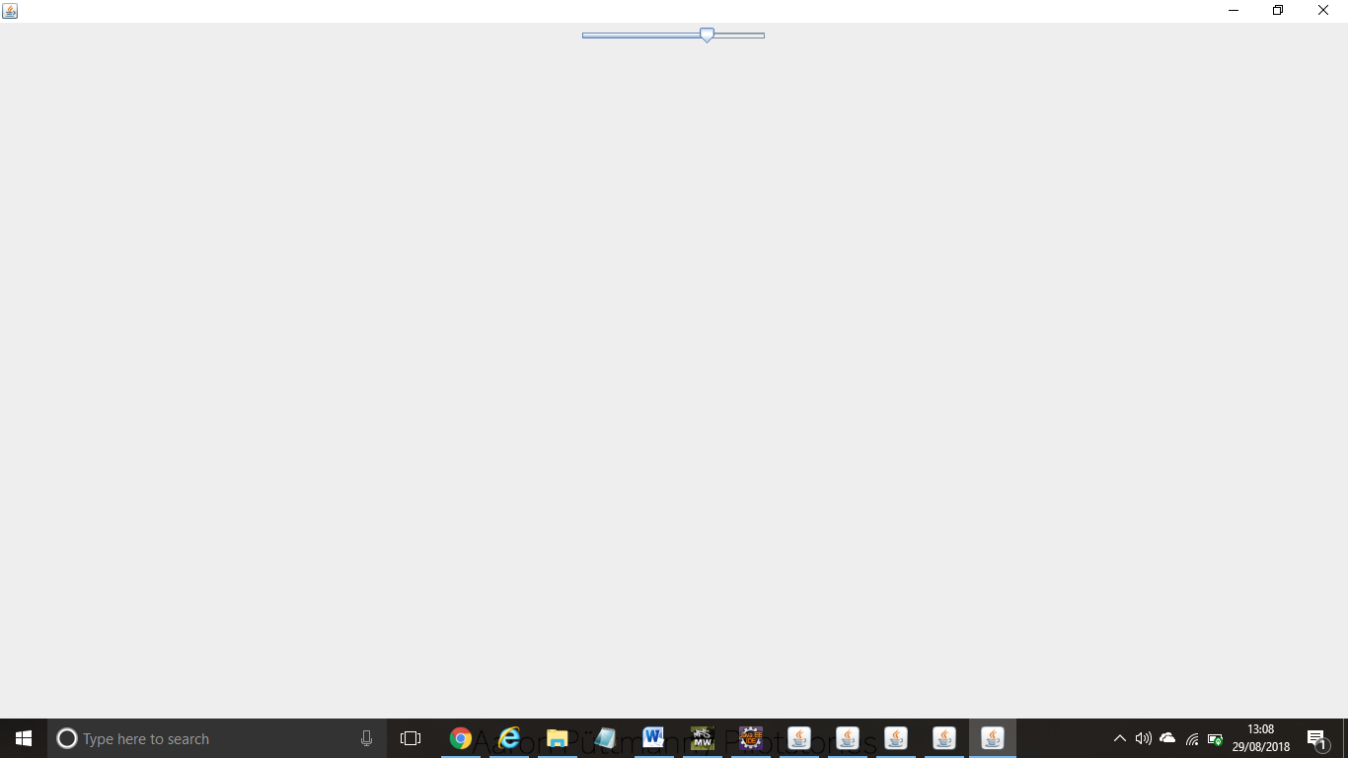

**import** javax.swing.*;

**import** java.awt.*;

**import** java.text.*;

**import** java.util.*;

**public** **class** DigitalWatch **implements** Runnable{

JFrame f;

Thread t=**null**;

**int** hours=0, minutes=0, seconds=0;

String timeString = "";

JButton b;

DigitalWatch(){

    f=**new** JFrame();

    t = **new** Thread(**this**);

        t.start();

    b=**new** JButton();

        b.setBounds(100,100,100,50);

    f.add(b);

    f.setSize(300,400);

    f.setLayout(**null**);

    f.setVisible(**true**);

}

**public** **void** run() {

**try** {

**while** (**true**) {

            Calendar cal = Calendar.getInstance();

            hours = cal.get( Calendar.HOUR_OF_DAY );

**if** ( hours > 12 ) hours -= 12;

            minutes = cal.get( Calendar.MINUTE );

            seconds = cal.get( Calendar.SECOND );

            SimpleDateFormat formatter = **new** SimpleDateFormat("hh:mm:ss");

            Date date = cal.getTime();

            timeString = formatter.format( date );

            printTime();

            t.sleep( 1000 );  // interval given in milliseconds

         }

      }

**catch** (Exception e) { }

 }

**public** **void** printTime(){

b.setText(timeString);

}

**public** **static** **void** main(String[] args) {

**new** DigitalWatch();

}

}

OUTPUT:

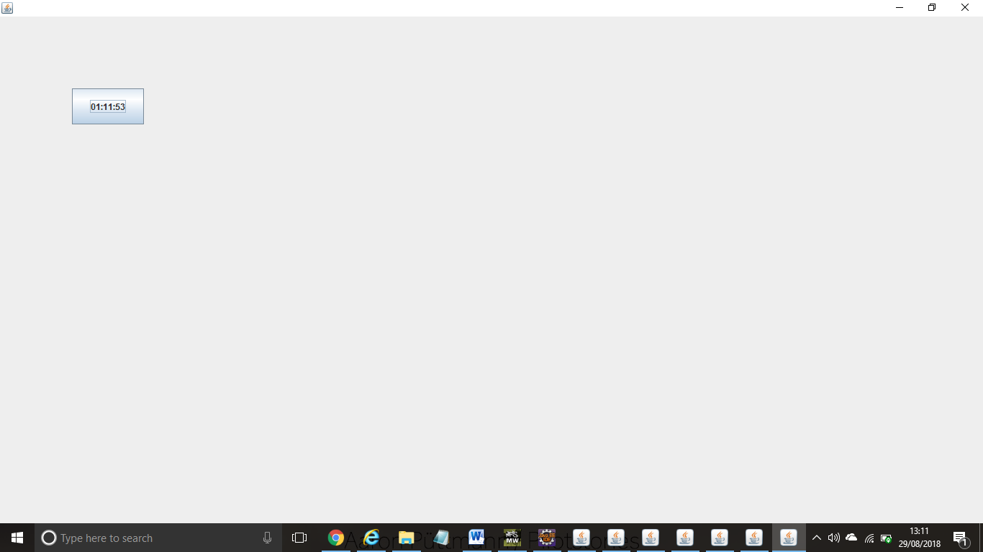

**import** java.awt.*;

**import** javax.swing.JFrame;

**public** **class** DisplayGraphics **extends** Canvas{

**public** **void** paint(Graphics g) {

        g.drawString("Hello",40,40);

        setBackground(Color.WHITE);

        g.fillRect(130, 30,100, 80);

        g.drawOval(30,130,50, 60);

        setForeground(Color.RED);

        g.fillOval(130,130,50, 60);

        g.drawArc(30, 200, 40,50,90,60);

        g.fillArc(30, 130, 40,50,180,40);

    }

**public** **static** **void** main(String[] args) {

        DisplayGraphics m=**new** DisplayGraphics();

        JFrame f=**new** JFrame();

        f.add(m);

        f.setSize(400,400);

        //f.setLayout(null);

        f.setVisible(**true**);

    }

}

OUTPUT:

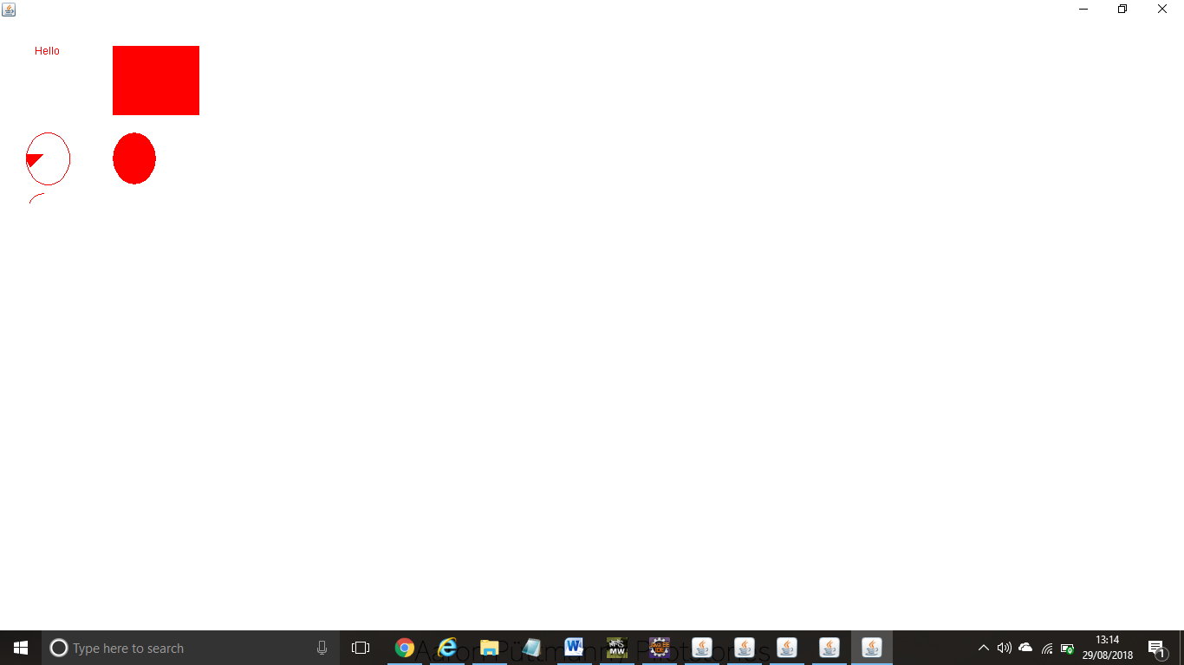

**import** java.awt.*;

**import** javax.swing.JFrame;

**public** **class** MyCanvas **extends** Canvas{

**public** **void** paint(Graphics g) {

        Toolkit t=Toolkit.getDefaultToolkit();

        Image i=t.getImage("p3.gif");

        g.drawImage(i, 120,100,**this**);

    }

**public** **static** **void** main(String[] args) {

        MyCanvas m=**new** MyCanvas();

        JFrame f=**new** JFrame();

        f.add(m);

        f.setSize(400,400);

        f.setVisible(**true**);

    }

}

OUTPUT:

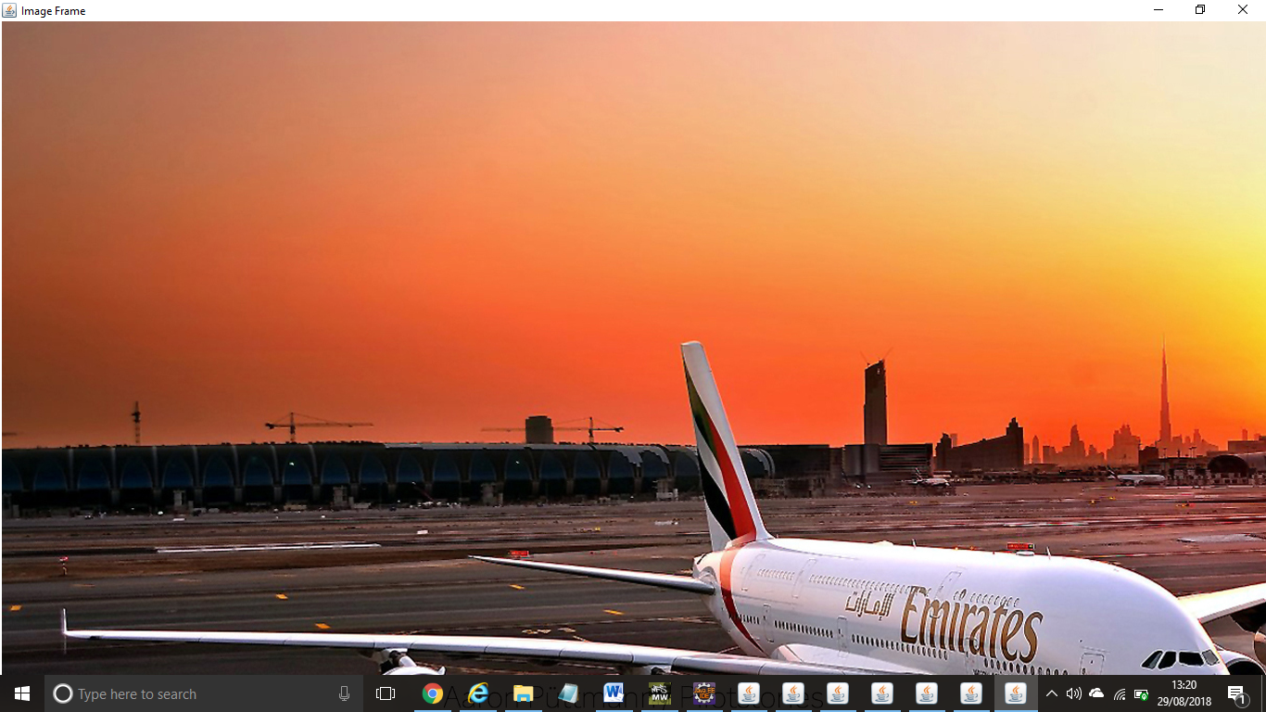

**import** javax.swing.*;

**import** java.awt.event.*;

**public** **class** Notepad **implements** ActionListener{

JFrame f;

JMenuBar mb;

JMenu file,edit,help;

JMenuItem cut,copy,paste,selectAll;

JTextArea ta;

Notepad(){

f=**new** JFrame();

cut=**new** JMenuItem("cut");

copy=**new** JMenuItem("copy");

paste=**new** JMenuItem("paste");

selectAll=**new** JMenuItem("selectAll");

cut.addActionListener(**this**);

copy.addActionListener(**this**);

paste.addActionListener(**this**);

selectAll.addActionListener(**this**);

mb=**new** JMenuBar();

mb.setBounds(5,5,400,40);

file=**new** JMenu("File");

edit=**new** JMenu("Edit");

help=**new** JMenu("Help");

edit.add(cut);edit.add(copy);edit.add(paste);edit.add(selectAll);

mb.add(file);mb.add(edit);mb.add(help);

ta=**new** JTextArea();

ta.setBounds(5,30,460,460);

f.add(mb);f.add(ta);

f.setLayout(**null**);

f.setSize(500,500);

f.setVisible(**true**);

}

**public** **void** actionPerformed(ActionEvent e) {

**if**(e.getSource()==cut)

ta.cut();

**if**(e.getSource()==paste)

ta.paste();

**if**(e.getSource()==copy)

ta.copy();

**if**(e.getSource()==selectAll)

ta.selectAll();

}

**public** **static** **void** main(String[] args) {

**new** Notepad();

}

}

OUTPUT:

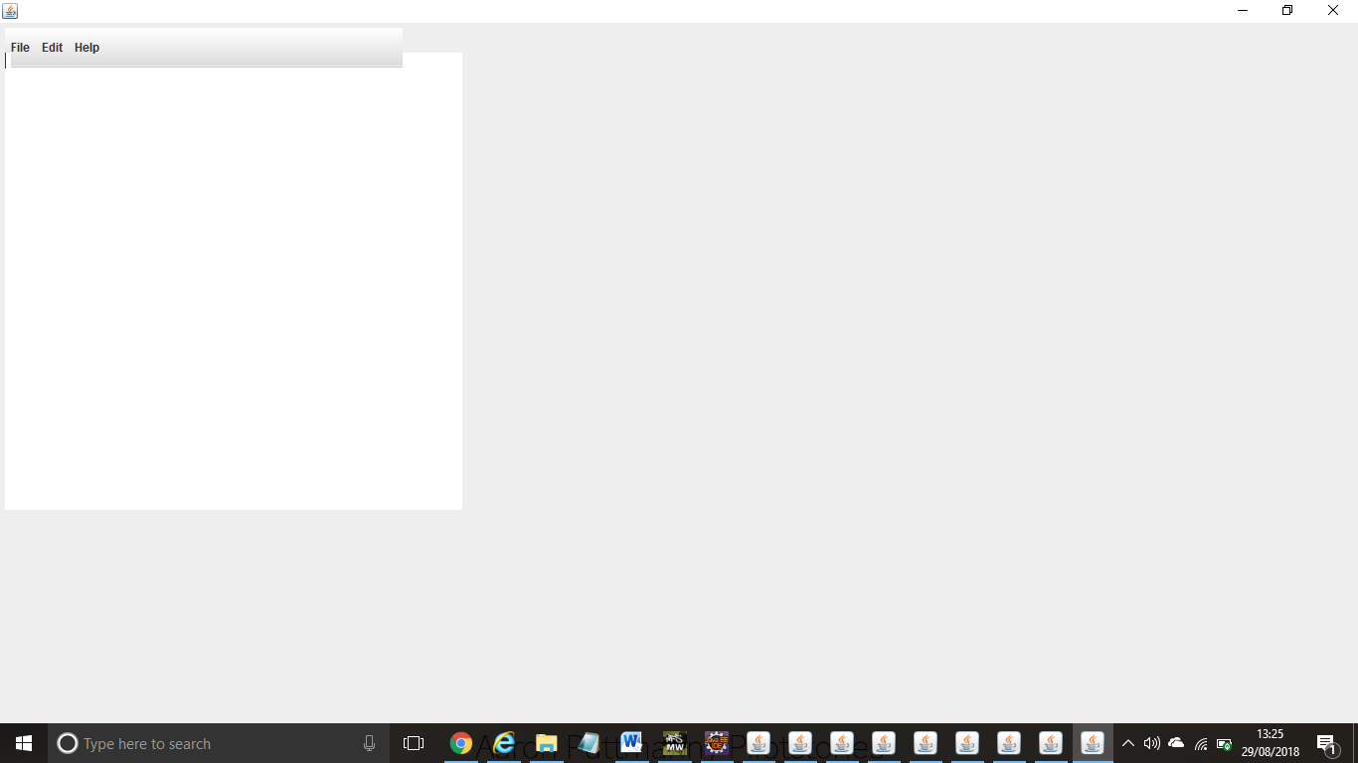

**import** java.awt.*;

**import** javax.swing.*;

**import** java.awt.event.*;

**import** java.io.*;

**public** **class** OpenMenu **extends** JFrame **implements** ActionListener{

JMenuBar mb;

JMenu file;

JMenuItem open;

JTextArea ta;

OpenMenu(){

open=**new** JMenuItem("Open File");

open.addActionListener(**this**);

file=**new** JMenu("File");

file.add(open);

mb=**new** JMenuBar();

mb.setBounds(0,0,800,20);

mb.add(file);

ta=**new** JTextArea(800,800);

ta.setBounds(0,20,800,800);

add(mb);

add(ta);

}

**public** **void** actionPerformed(ActionEvent e) {

**if**(e.getSource()==open){

openFile();

}

}

**void** openFile(){

JFileChooser fc=**new** JFileChooser();

**int** i=fc.showOpenDialog(**this**);

**if**(i==JFileChooser.APPROVE_OPTION){

File f=fc.getSelectedFile();

String filepath=f.getPath();

displayContent(filepath);

}

}

**void** displayContent(String fpath){

**try**{

BufferedReader br=**new** BufferedReader(**new** FileReader(fpath));

String s1="",s2="";

**while**((s1=br.readLine())!=**null**){

s2+=s1+"\n";

}

ta.setText(s2);

br.close();

}**catch** (Exception e) {e.printStackTrace();  }

}

**public** **static** **void** main(String[] args) {

    OpenMenu om=**new** OpenMenu();

    om.setSize(800,800);

    om.setLayout(**null**);

    om.setVisible(**true**);

    om.setDefaultCloseOperation(EXIT_ON_CLOSE);

}

}

OUTPUT:

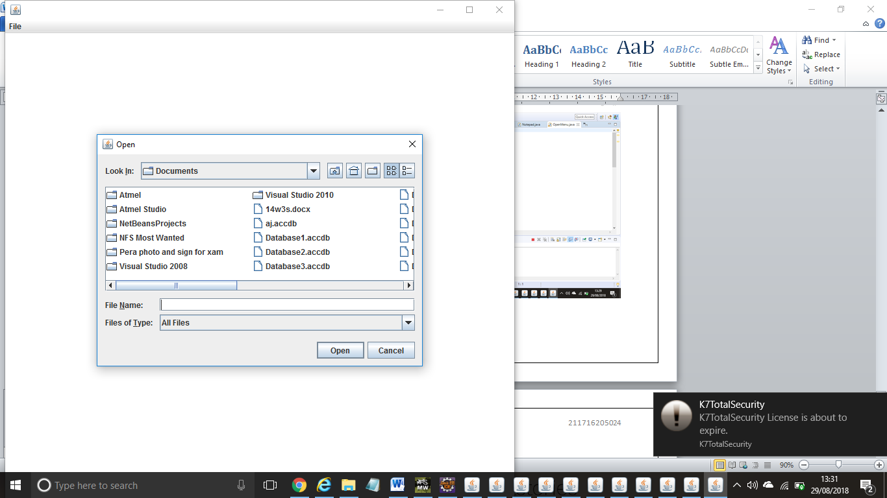

**import** java.awt.*;

**import** java.awt.event.*;

**import** javax.swing.JOptionPane;

**public** **class** Puzzle **extends** Frame **implements** ActionListener{

Button b1,b2,b3,b4,b5,b6,b7,b8,b9;

Puzzle(){

**super**("Puzzle - JavaTpoint");

    b1=**new** Button("1");

    b1.setBounds(50,100,40,40);

    b2=**new** Button("2");

    b2.setBounds(100,100,40,40);

    b3=**new** Button("3");

    b3.setBounds(150,100,40,40);

    b4=**new** Button("4");

    b4.setBounds(50,150,40,40);

    b5=**new** Button("5");

    b5.setBounds(100,150,40,40);

    b6=**new** Button("6");

    b6.setBounds(150,150,40,40);

    b7=**new** Button("7");

    b7.setBounds(50,200,40,40);

    b8=**new** Button("");

    b8.setBounds(100,200,40,40);

    b9=**new** Button("8");

    b9.setBounds(150,200,40,40);

    b1.addActionListener(**this**);

    b2.addActionListener(**this**);

    b3.addActionListener(**this**);

    b4.addActionListener(**this**);

    b5.addActionListener(**this**);

    b6.addActionListener(**this**);

    b7.addActionListener(**this**);

    b8.addActionListener(**this**);

    b9.addActionListener(**this**);

    add(b1);add(b2);add(b3);add(b4);add(b5);add(b6);add(b7);add(b8);add(b9);

    setSize(400,400);

    setLayout(**null**);

    setVisible(**true**);

}

**public** **void** actionPerformed(ActionEvent e){

**if**(e.getSource()==b1){

        String label=b1.getLabel();

**if**(b2.getLabel().equals("")){

            b2.setLabel(label);

            b1.setLabel("");

        }

**if**(b4.getLabel().equals("")){

            b4.setLabel(label);

            b1.setLabel("");

        }

    }

**if**(e.getSource()==b2){

        String label=b2.getLabel();

**if**(b1.getLabel().equals("")){

            b1.setLabel(label);

            b2.setLabel("");

        }

**if**(b3.getLabel().equals("")){

            b3.setLabel(label);

            b2.setLabel("");

        }

**if**(b5.getLabel().equals("")){

            b5.setLabel(label);

            b2.setLabel("");

        }

    }

**if**(e.getSource()==b3){

        String label=b3.getLabel();

**if**(b2.getLabel().equals("")){

            b2.setLabel(label);

            b3.setLabel("");

        }

**if**(b6.getLabel().equals("")){

            b6.setLabel(label);

            b3.setLabel("");

        }

    }

**if**(e.getSource()==b4){

        String label=b4.getLabel();

**if**(b1.getLabel().equals("")){

            b1.setLabel(label);

            b4.setLabel("");

        }

**if**(b7.getLabel().equals("")){

            b7.setLabel(label);

            b4.setLabel("");

        }

**if**(b5.getLabel().equals("")){

            b5.setLabel(label);

            b4.setLabel("");

        }

    }

**if**(e.getSource()==b5){

        String label=b5.getLabel();

**if**(b2.getLabel().equals("")){

            b2.setLabel(label);

            b5.setLabel("");

        }

**if**(b6.getLabel().equals("")){

            b6.setLabel(label);

            b5.setLabel("");

        }

**if**(b4.getLabel().equals("")){

            b4.setLabel(label);

            b5.setLabel("");

        }

**if**(b8.getLabel().equals("")){

            b8.setLabel(label);

            b5.setLabel("");

        }

    }

**if**(e.getSource()==b6){

        String label=b6.getLabel();

**if**(b9.getLabel().equals("")){

            b9.setLabel(label);

            b6.setLabel("");

        }

**if**(b3.getLabel().equals("")){

            b3.setLabel(label);

            b6.setLabel("");

        }

**if**(b5.getLabel().equals("")){

            b5.setLabel(label);

            b6.setLabel("");

        }

    }

**if**(e.getSource()==b7){

        String label=b7.getLabel();

**if**(b4.getLabel().equals("")){

            b4.setLabel(label);

            b7.setLabel("");

        }

**if**(b8.getLabel().equals("")){

            b8.setLabel(label);

            b7.setLabel("");

        }

    }

**if**(e.getSource()==b8){

        String label=b8.getLabel();

**if**(b9.getLabel().equals("")){

            b9.setLabel(label);

            b8.setLabel("");

        }

**if**(b7.getLabel().equals("")){

            b7.setLabel(label);

            b8.setLabel("");

        }

**if**(b5.getLabel().equals("")){

            b5.setLabel(label);

            b8.setLabel("");

        }

    }

**if**(e.getSource()==b9){

        String label=b9.getLabel();

**if**(b6.getLabel().equals("")){

            b6.setLabel(label);

            b9.setLabel("");

        }

**if**(b8.getLabel().equals("")){

            b8.setLabel(label);

            b9.setLabel("");

        }

    }

    //congrats code

**if**(b1.getLabel().equals("1")&&b2.getLabel().equals("2")&&b3.getLabel()

            .equals("3")&&b4.getLabel().equals("4")&&b5.getLabel().equals("5")

            &&b6.getLabel().equals("6")&&b7.getLabel().equals("7")&&b8.getLabel()

            .equals("8")&&b9.getLabel().equals("")){

            JOptionPane.showMessageDialog(**this**,"Congratulations! You won.");

    }

}

**public** **static** **void** main(String[] args) {

**new** Puzzle();

}

}

OUTPUT:

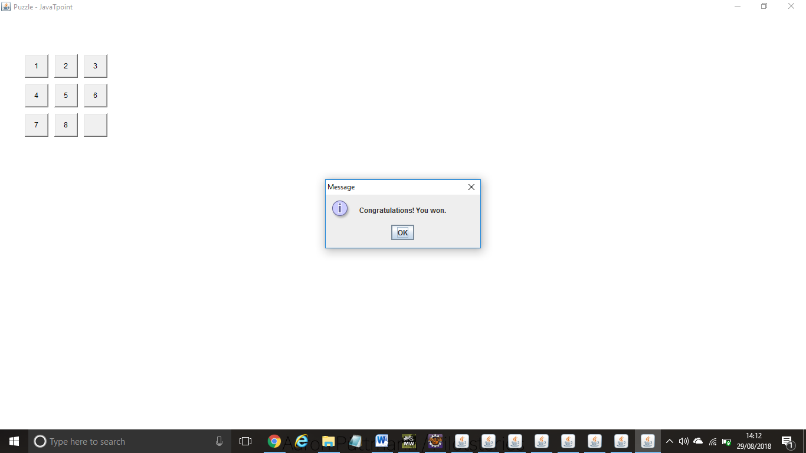

Ex:157 **TIC TAC TOE**

**import** java.awt.*;

**import** java.awt.event.*;

**import** javax.swing.*;

**class** TTT1 **extends** JFrame **implements** ItemListener, ActionListener{

**int** i,j,ii,jj,x,y,yesnull;

**int** a[][]={{10,1,2,3,11},{10,1,4,7,11},{10,1,5,9,11},{10,2,5,8,11},

                {10,3,5,7,11},{10,3,6,9,11},{10,4,5,6,11},

        {10,7,8,9,11} };

**int** a1[][]={{10,1,2,3,11},{10,1,4,7,11},{10,1,5,9,11},{10,2,5,8,11},

                {10,3,5,7,11},{10,3,6,9,11},{10,4,5,6,11},{10,7,8,9,11} };

**boolean** state,type,set;

Icon ic1,ic2,icon,ic11,ic22;

Checkbox c1,c2;

JLabel l1,l2;

JButton b[]=**new** JButton[9];

JButton reset;

**public** **void** showButton(){

x=10; y=10;j=0;

**for**(i=0;i<=8;i++,x+=100,j++){

 b[i]=**new** JButton();

**if**(j==3)

{j=0; y+=100; x=10;}

 b[i].setBounds(x,y,100,100);

add(b[i]);

b[i].addActionListener(**this**);

}//eof for

reset=**new** JButton("RESET");

reset.setBounds(100,350,100,50);

add(reset);

reset.addActionListener(**this**);

}//eof showButton

/*********************************************************/

**public**  **void** check(**int** num1){

**for**(ii=0;ii<=7;ii++){

**for**(jj=1;jj<=3;jj++){

**if**(a[ii][jj]==num1){ a[ii][4]=11;  }

   }//eof for jj

}//eof for ii

}//eof check

/**********************************************************/

/*********************************************************/

**public** **void** complogic(**int** num){

**for**(i=0;i<=7;i++){

**for**(j=1;j<=3;j++){

**if**(a[i][j]==num){  a[i][0]=11; a[i][4]=10;    }

      }

  }

**for**(i=0;i<=7;i++){              // for 1

     set=**true**;

**if**(a[i][4]==10){               //if 1

**int** count=0;

**for**(j=1;j<=3;j++){         //for 2

**if**(b[(a[i][j]-1)].getIcon()!=**null**){ //if 2

             count++;

               }                        //eof if 2

**else**{ yesnull=a[i][j]; }

        }                               //eof for 2

**if**(count==2){                     //if 2

         b[yesnull-1].setIcon(ic2);

**this**.check(yesnull); set=**false**;**break**;

         }                                  //eof if 2

      }                                     //eof if 1

**else**

**if**(a[i][0]==10){

**for**(j=1;j<=3;j++){         //for2

**if**(b[(a[i][j]-1)].getIcon()==**null**){ //if 1

                      b[(a[i][j]-1)].setIcon(ic2);

**this**.check(a[i][j]);

                         set=**false**;

**break**;

                    }                         //eof if1

                }                             //eof for 2

**if**(set==**false**)

**break**;

            }//eof elseif

**if**(set==**false**)

**break**;

 }//eof for 1

}//eof complogic

/*********************************************************/

TTT1(){

**super**("tic tac toe by ashwani");

CheckboxGroup cbg=**new** CheckboxGroup();

c1=**new** Checkbox("vs computer",cbg,**false**);

c2=**new** Checkbox("vs friend",cbg,**false**);  c1.setBounds(120,80,100,40);

c2.setBounds(120,150,100,40);

add(c1); add(c2);

c1.addItemListener(**this**);

c2.addItemListener(**this**);

state=**true**;type=**true**;set=**true**;

ic1=**new** ImageIcon("ic1.jpg");

ic2=**new** ImageIcon("ic2.jpg");

ic11=**new** ImageIcon("ic11.jpg");

ic22=**new** ImageIcon("ic22.jpg");

setLayout(**null**);

setSize(330,450);

setVisible(**true**);

setDefaultCloseOperation(JFrame.DISPOSE_ON_CLOSE);

}//eof constructor

/*************************************************************/

**public** **void** itemStateChanged(ItemEvent e){

**if**(c1.getState())

  {

 type=**false**;

 }

**else** **if**(c2.getState())

  { type=**true**;

  }

remove(c1);remove(c2);

 repaint(0,0,330,450);

 showButton();

}//eof itemstate

/************************************************************/

**public** **void** actionPerformed(ActionEvent e){

/********************************/

**if**(type==**true**)//logicfriend

{

**if**(e.getSource()==reset){

**for**(i=0;i<=8;i++){

   b[i].setIcon(**null**);

  }//eof for

}

**else**{

**for**(i=0;i<=8;i++){

**if**(e.getSource()==b[i]){

**if**(b[i].getIcon()==**null**){

**if**(state==**true**){ icon=ic2;

               state=**false**;} **else**{ icon=ic1; state=**true**; }

            b[i].setIcon(icon);

            }

       }

  }//eof for

}//eof else

}//eof logicfriend

**else** **if**(type==**false**){                           //  complogic

**if**(e.getSource()==reset){

**for**(i=0;i<=8;i++){

            b[i].setIcon(**null**);

          }//eof for

**for**(i=0;i<=7;i++)

**for**(j=0;j<=4;j++)

        a[i][j]=a1[i][j];   //again initialsing array

        }

**else**{  //complogic

**for**(i=0;i<=8;i++){

**if**(e.getSource()==b[i]){

**if**(b[i].getIcon()==**null**){

                           b[i].setIcon(ic1);

**if**(b[4].getIcon()==**null**){

                              b[4].setIcon(ic2);

**this**.check(5);

                              } **else**{

**this**.complogic(i);

                                 }

                    }

                 }

             }//eof for

        }

    }//eof complogic

**for**(i=0;i<=7;i++){

  Icon icon1=b[(a[i][1]-1)].getIcon();

  Icon icon2=b[(a[i][2]-1)].getIcon();

  Icon icon3=b[(a[i][3]-1)].getIcon();

**if**((icon1==icon2)&&(icon2==icon3)&&(icon1!=**null**)){

**if**(icon1==ic1){

                 b[(a[i][1]-1)].setIcon(ic11);

                 b[(a[i][2]-1)].setIcon(ic11);

                 b[(a[i][3]-1)].setIcon(ic11);

    JOptionPane.showMessageDialog(TTT1.**this**,"!!!YOU won!!! click reset");

**break**;

                   }

**else** **if**(icon1==ic2){

             b[(a[i][1]-1)].setIcon(ic22);

             b[(a[i][2]-1)].setIcon(ic22);

             b[(a[i][3]-1)].setIcon(ic22);

               JOptionPane.showMessageDialog(TTT1.**this**,"won! click reset");

**break**;

               }

         }

    }

}//eof actionperformed

/************************************************************/

**public** **static** **void** main(String []args){

**new** TTT1();

}//eof main

}//eof class

OUTPUT:

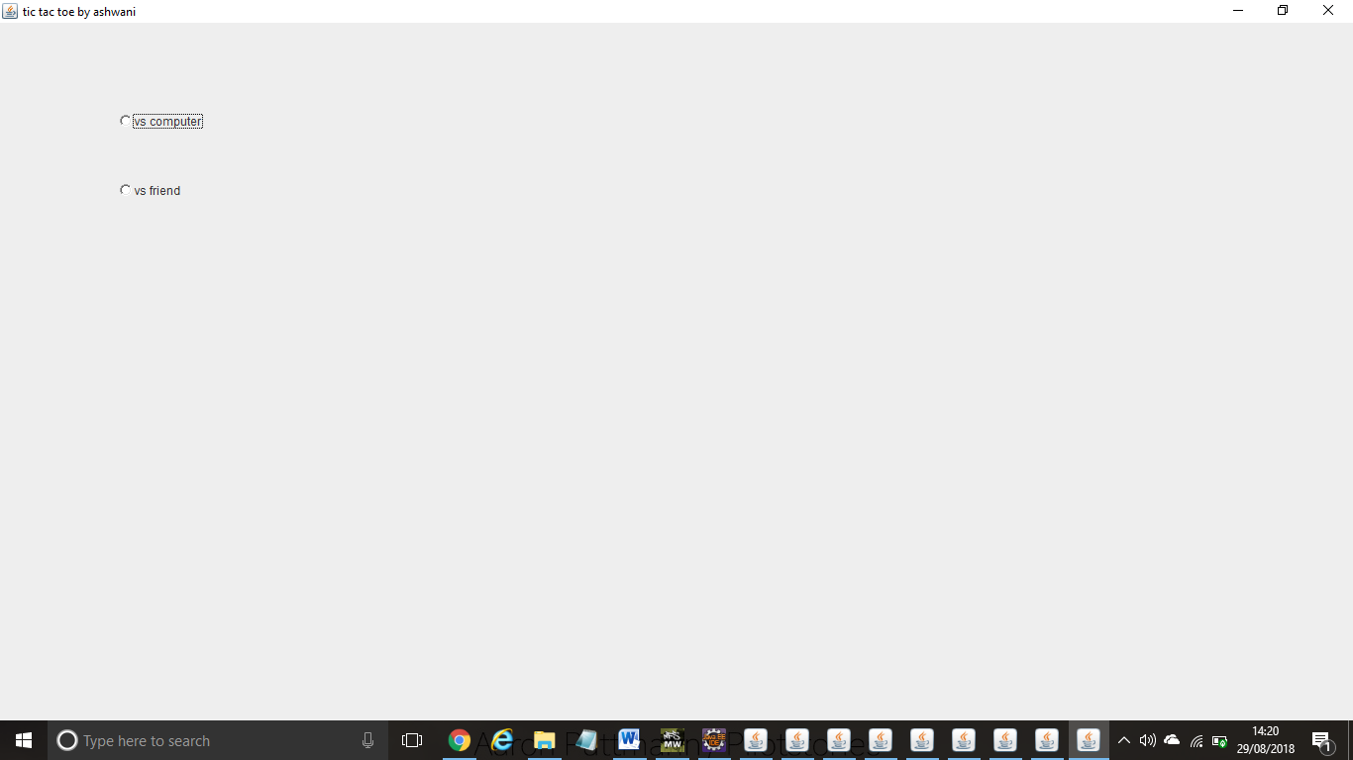

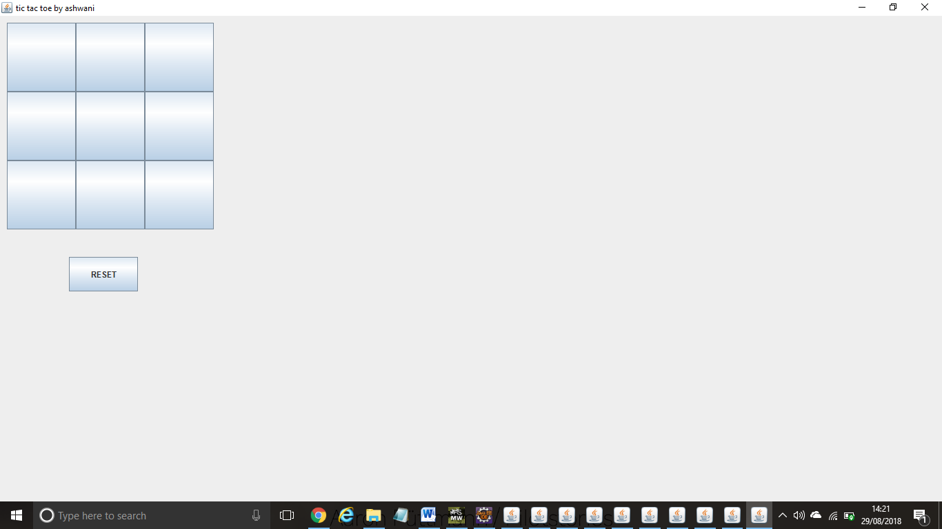

**import** java.awt.*;

**import** javax.swing.*;

**public** **class** Border {

JFrame f;

Border(){

    f=**new** JFrame();

    JButton b1=**new** JButton("NORTH");;

    JButton b2=**new** JButton("SOUTH");;

    JButton b3=**new** JButton("EAST");;

    JButton b4=**new** JButton("WEST");;

    JButton b5=**new** JButton("CENTER");;

    f.add(b1,BorderLayout.NORTH);

    f.add(b2,BorderLayout.SOUTH);

    f.add(b3,BorderLayout.EAST);

    f.add(b4,BorderLayout.WEST);

    f.add(b5,BorderLayout.CENTER);

    f.setSize(300,300);

    f.setVisible(**true**);

}

**public** **static** **void** main(String[] args) {

**new** Border();

}

}

OUTPUT:

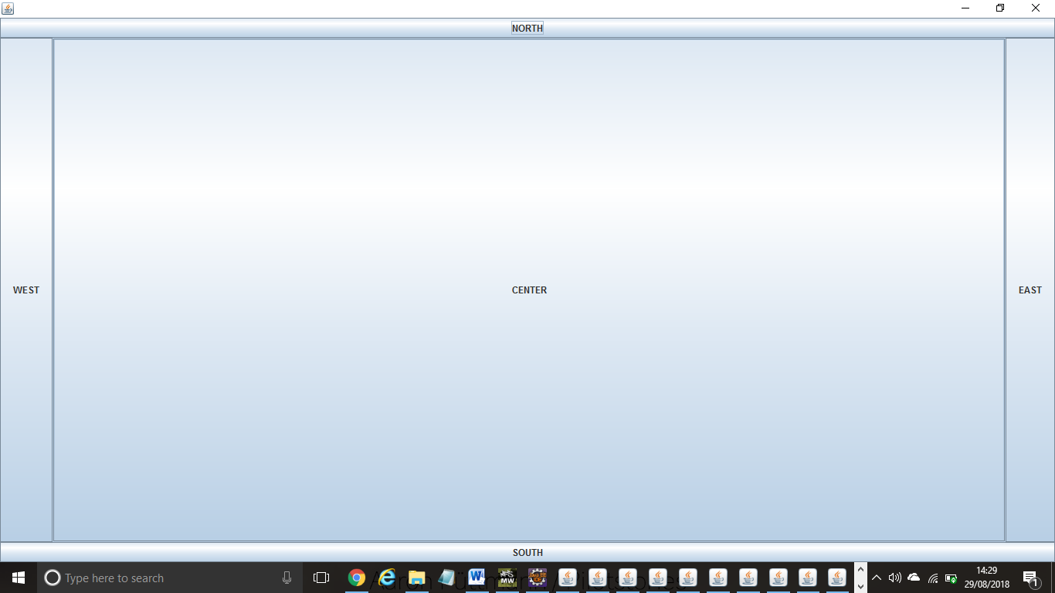

**import** java.awt.*;

**import** javax.swing.*;

**public** **class** MyGridLayout{

JFrame f;

MyGridLayout(){

    f=**new** JFrame();

    JButton b1=**new** JButton("1");

    JButton b2=**new** JButton("2");

    JButton b3=**new** JButton("3");

    JButton b4=**new** JButton("4");

    JButton b5=**new** JButton("5");

        JButton b6=**new** JButton("6");

        JButton b7=**new** JButton("7");

    JButton b8=**new** JButton("8");

        JButton b9=**new** JButton("9");

    f.add(b1);f.add(b2);f.add(b3);f.add(b4);f.add(b5);

    f.add(b6);f.add(b7);f.add(b8);f.add(b9);

    f.setLayout(**new** GridLayout(3,3));

    //setting grid layout of 3 rows and 3 columns

    f.setSize(300,300);

    f.setVisible(**true**);

}

**public** **static** **void** main(String[] args) {

**new** MyGridLayout();

}

}

OUTPUT:

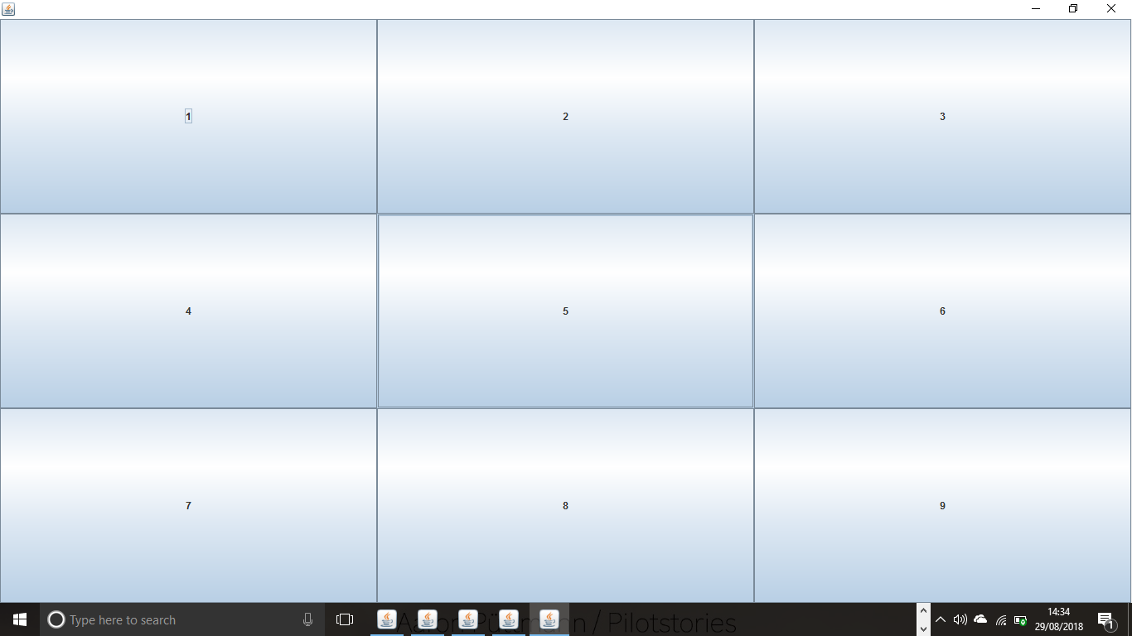

**import** java.awt.*;

**import** javax.swing.*;

**public** **class** MyFlowLayout{

JFrame f;

MyFlowLayout(){

    f=**new** JFrame();

    JButton b1=**new** JButton("1");

    JButton b2=**new** JButton("2");

    JButton b3=**new** JButton("3");

    JButton b4=**new** JButton("4");

    JButton b5=**new** JButton("5");

    f.add(b1);f.add(b2);f.add(b3);f.add(b4);f.add(b5);

    f.setLayout(**new** FlowLayout(FlowLayout.RIGHT));

    //setting flow layout of right alignment

    f.setSize(300,300);

    f.setVisible(**true**);

}

**public** **static** **void** main(String[] args) {

**new** MyFlowLayout();

}

}

OUTPUT:

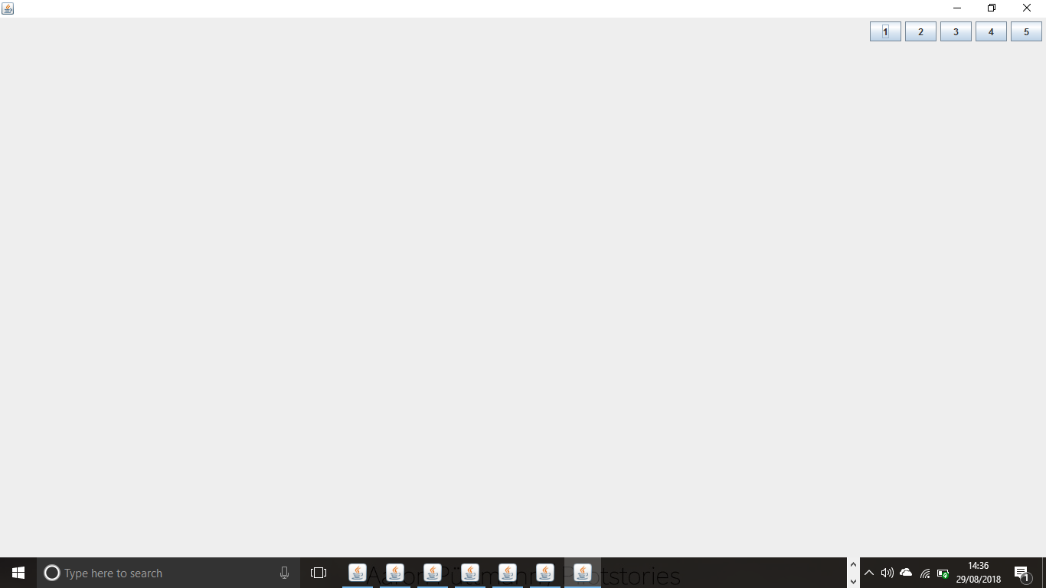

**import** java.awt.*;

**import** java.awt.event.*;

**import** javax.swing.*;

**public** **class** CardLayoutExample **extends** JFrame **implements** ActionListener{

CardLayout card;

JButton b1,b2,b3;

Container c;

    CardLayoutExample(){

        c=getContentPane();

        card=**new** CardLayout(40,30);

//create CardLayout object with 40 hor space and 30 ver space

        c.setLayout(card);

        b1=**new** JButton("Apple");

        b2=**new** JButton("Boy");

        b3=**new** JButton("Cat");

        b1.addActionListener(**this**);

        b2.addActionListener(**this**);

        b3.addActionListener(**this**);

        c.add("a",b1);c.add("b",b2);c.add("c",b3);

    }

**public** **void** actionPerformed(ActionEvent e) {

    card.next(c);

    }

**public** **static** **void** main(String[] args) {

        CardLayoutExample cl=**new** CardLayoutExample();

        cl.setSize(400,400);

        cl.setVisible(**true**);

        cl.setDefaultCloseOperation(EXIT_ON_CLOSE);

    }

}

OUTPUT:

